Experiment No.:2
Title: Constructing and Simulating a Quantum Circuit with Qiskit to Demonstrate Superposition and Measurement.
Aim: To Constructing and Simulating a Quantum Circuit with Qiskit to Demonstrate Superposition and Measurement
Theory:

Superposition in Quantum Computing
In classical computing, a bit can only exist in one of two states:
- 0 (low voltage)
- 1 (high voltage)
In quantum computing, the basic unit of information is a qubit (quantum bit). Unlike a classical bit, a qubit can exist not only in the states |0⟩ or |1⟩, but also in any linear combination (superposition) of these two states.
Mathematically, we write a general qubit state as:
∣ψ⟩=α∣0⟩+β∣1⟩
Here:
- α and β are complex probability amplitudes.
- They satisfy the condition:
∣α∣2+∣β∣2=1
This ensures that the total probability of measuring the qubit in either state is 100%.

The Hadamard (H) Gate
One of the simplest and most important quantum gates is the Hadamard gate (H).
- It transforms a definite basis state (like |0⟩ or |1⟩) into a balanced superposition of |0⟩ and |1⟩.
For example, applying H to |0⟩ gives:
∣0⟩→H∣0⟩+∣1⟩2|0\rangle \xrightarrow{H} \frac{|0\rangle + |1\rangle}{\sqrt{2}}∣0⟩H​2​∣0⟩+∣1⟩​
And applying H to |1⟩ gives:
∣1⟩→H∣0⟩−∣1⟩2|1\rangle \xrightarrow{H} \frac{|0\rangle - |1\rangle}{\sqrt{2}}∣1⟩H​2​∣0⟩−∣1⟩​
Interpretation:
- Before H: The qubit is definitely in |0⟩.
- After H: The qubit has a 50% chance of being measured as |0⟩ and a 50% chance of being measured as |1⟩.

Measurement in Quantum Computing
Measurement is how we extract information from a qubit.
When we measure a qubit in the computational basis (|0⟩ and |1⟩), two things happen:
- Collapse: The superposition disappears, and the qubit instantaneously collapses into one of the two basis states.
- Probability: The outcome is determined by the squared magnitudes of the amplitudes:
  - Probability of getting 0: ∣α∣2|\alpha|^2∣α∣2
  - Probability of getting 1: ∣β∣2|\beta|^2∣β∣2
For our example:
∣ψ⟩=∣0⟩+∣1⟩2|\psi\rangle = \frac{|0\rangle + |1\rangle}{\sqrt{2}}∣ψ⟩=2​∣0⟩+∣1⟩​
We have:
- α = 12\frac{1}{\sqrt{2}}2​1​, β = 12\frac{1}{\sqrt{2}}2​1​
- ∣α∣2=12|\alpha|^2 = \frac{1}{2}∣α∣2=21​ and ∣β∣2=12|\beta|^2 = \frac{1}{2}∣β∣2=21​
- That means a 50% chance of measuring 0, and a 50% chance of measuring 1.

Why This Matters in Quantum Computing
- Superposition allows parallelism: A qubit in superposition can represent both 0 and 1 at the same time.
- When you have n qubits, you can represent 2n2^n2n possible states simultaneously.
- This is one of the reasons quantum algorithms (like Shor’s or Grover’s) can outperform classical ones for certain problems.
Summary Flow:
- Start in a known state (|0⟩).
- Apply H → create a superposition.
- Measure → state collapses to |0⟩ or |1⟩, with probabilities given by amplitude squares.

Code:
Step 1: Import Required Libraries
!pip install qiskit pylatexenc qiskit_aer
from qiskit import QuantumCircuit
from qiskit_aer import Aer
from qiskit.visualization import plot_histogram
import matplotlib.pyplot as plt
import qiskit as qc
import pylatexenc

Step 2: Create a Circuit with 1 Qubit and 1 Classical Bit
qc = QuantumCircuit(1, 1) # 1 qubit, 1 classical bit
qc.h(0) # Apply Hadamard gate
qc.measure(0, 0) # Measure qubit into classical bit
qc.draw('mpl')

Step 3: Simulate the Circuit
backend = Aer.get_backend('qasm_simulator')
job = backend.run(qc, backend=backend, shots=1000)
result = job.result()
counts = result.get_counts()
print(counts)

Step 4: Visualize the Output
plot_histogram(counts)
plt.show()

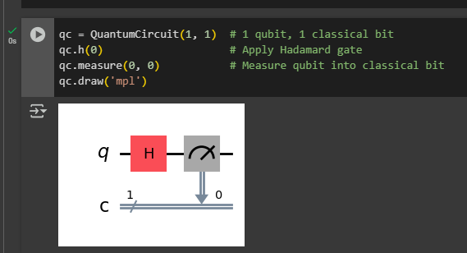
Output:
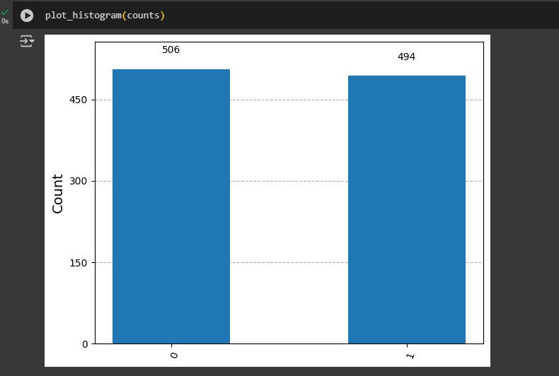

Conclusion:
This experiment demonstrates how the Hadamard gate creates a superposition state and how measurement collapses this state probabilistically. Repeating the experiment multiple times shows approximately equal chances of measuring 0 or 1, indicating the qubit was truly in a superposition.

