Experiment No.:3
Title: Implement Deutsch's Algorithm with a Basic Quantum Oracle to Demonstrate Quantum Parallelism.
Aim: To Implement Deutsch's Algorithm with a Basic Quantum Oracle to Demonstrate Quantum Parallelism.
Theory:

Deutsch’s Algorithm — Extended Explanation
Deutsch’s algorithm is one of the simplest examples that shows quantum advantage — solving a problem with fewer function evaluations than is possible classically.

1. Problem Statement
We are given a black-box function:
f:{0,1}→{0,1}
The function can be one of two types:
- Constant function:
f(0)=f(1)(either both 0 or both 1)
Example: f(x)=0 or f(x)=1
- Balanced function:
f(0)≠f(1)(one input gives 0, the other gives 1)
Example: f(x)=x or f(x)=xˉ
Classical approach:
You must check both f(0)and f(1) to be certain whether it’s constant or balanced → 2 evaluations.
Quantum approach:
With Deutsch’s Algorithm, you can determine the answer in 1 evaluation of the function using superposition and interference.

2. Quantum Circuit Setup
The algorithm uses two qubits:
- First qubit (input qubit): holds the superposition of inputs ∣0⟩and ∣1⟩
- Second qubit (output qubit): used by the function (oracle) to encode f(x)
We start with:
∣ψ0⟩=∣0⟩⊗∣1⟩|
(First qubit = 0, second qubit = 1)

3. Step-by-Step Process

Step 1: Apply Hadamard to both qubits
The Hadamard gate HHH creates superposition:
- On the first qubit:
∣0⟩→H∣0⟩+∣1⟩2|0\rangle \xrightarrow{H} \frac{|0\rangle + |1\rangle}{\sqrt{2}}∣0⟩H​2​∣0⟩+∣1⟩​
- On the second qubit:
∣1⟩→H∣0⟩−∣1⟩2|1\rangle \xrightarrow{H} \frac{|0\rangle - |1\rangle}{\sqrt{2}}∣1⟩H​2​∣0⟩−∣1⟩​
So after applying H to both qubits:
∣ψ1⟩=∣0⟩+∣1⟩2⊗∣0⟩−∣1⟩2| \psi_1 \rangle = \frac{|0\rangle + |1\rangle}{\sqrt{2}} \otimes \frac{|0\rangle - |1\rangle}{\sqrt{2}}∣ψ1​⟩=2​∣0⟩+∣1⟩​⊗2​∣0⟩−∣1⟩​

Step 2: Apply the Oracle UfU_fUf​
The oracle is a quantum operation that implements the function f(x)f(x)f(x) like this:
Uf∣x⟩∣y⟩=∣x⟩∣y⊕f(x)⟩
Here ⊕ is XOR.
Because of the way the second qubit was prepared (∣0⟩−∣1⟩|0\rangle - |1\rangle∣0⟩−∣1⟩), the oracle encodes f(x)f(x)f(x) as a phase shift:
- If f(x)=0, the state is unchanged.
- If f(x)=1, the state gets a minus sign (phase flip).
After this step, the state becomes:
12[(−1)f(0)∣0⟩+(−1)f(1)∣1⟩]⊗∣0⟩−∣1⟩2\frac{1}{\sqrt{2}} \left[ (-1)^{f(0)}|0\rangle + (-1)^{f(1)}|1\rangle \right] \otimes \frac{|0\rangle - |1\rangle}{\sqrt{2}}2​1​[(−1)f(0)∣0⟩+(−1)f(1)∣1⟩]⊗2​∣0⟩−∣1⟩​

Step 3: Apply Hadamard to the First Qubit
This transforms the interference pattern so that the result tells us if fff is constant or balanced.
If f is constant, the first qubit becomes ∣0⟩
If f is balanced, the first qubit becomes ∣1⟩

Step 4: Measure the First Qubit
- Measurement result = 0 → f is constant.
- Measurement result = 1 → f is balanced.
Only one evaluation of the oracle was needed.

4. Why This Works — Quantum Advantage
The trick is that superposition lets us feed both 0 and 1 simultaneously into the function, and interference extracts the property we want without knowing each output individually.
In classical computing:
- Must evaluate f(0) and f(1) separately → 2 calls
In quantum computing:
- 1 oracle call, because the input qubit is in a superposition of ∣0⟩and ∣1⟩.
Code:
Step 1: Import Required Libraries
!pip install qiskit
!pip install pylatexenc
!pip install qiskit-aer
from qiskit import QuantumCircuit
from qiskit.visualization import plot_histogram
import matplotlib.pyplot as plt

Step 2: Define the Deutsch Oracle
You can choose any one oracle from below:
🔹 Constant Oracle (returns 0 always)
def constant_oracle(qc):
# Does nothing — output remains 0
pass
🔹 Balanced Oracle (XOR gate)
def balanced_oracle(qc):
qc.cx(0, 1) # Controlled NOT

Step 3: Build Deutsch’s Algorithm Circuit
# Create 2-qubit, 1-classical-bit circuit
qc = QuantumCircuit(2, 1)

# Initialize second qubit to |1⟩
qc.x(1)

# Apply Hadamard to both qubits
qc.h(0)
qc.h(1)

# Apply oracle
balanced_oracle(qc) # or constant_oracle(qc)

# Apply Hadamard to first qubit
qc.h(0)

# Measure first qubit
qc.measure(0, 0)
from qiskit.visualization.circuit.matplotlib import MatplotlibDrawer
qc.draw('text')
Step 4: Simulate the Circuit
from qiskit_aer import Aer
from qiskit.visualization import plot_histogram
import matplotlib.pyplot as plt

# Execute the circuit on a simulator
backend=Aer.get_backend('qasm_simulator')
job=backend.run(qc,shots=1024)
result=job.result()
counts=result.get_counts()

# Plot the histogram of results
print(counts)
plot_histogram(counts)
plt.show()
Interpretation:
- Output '0' → The function is constant
- Output '1' → The function is balanced

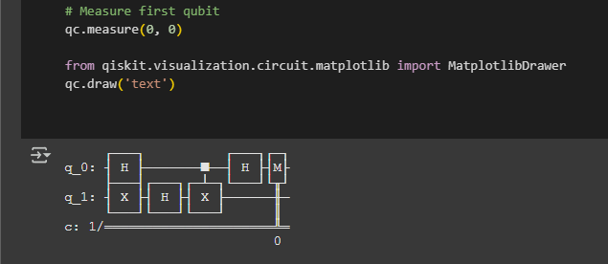
Output:
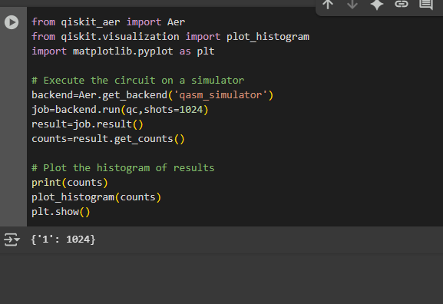

Conclusion:
Deutsch’s algorithm is a foundational quantum algorithm demonstrating quantum parallelism. It shows that a quantum computer can determine a global property of a function with fewer evaluations than classical computers, using superposition, oracle, and interference.

