Experiment No.:4
Title: Create Entangled Quantum States using Hadamard and CNOT Gates, and Measure the Correlation between Qubits.
Aim: To perform Create Entangled Quantum States using Hadamard and CNOT Gates, and Measure the Correlation between Qubits.
Theory:
Entanglement: Quantum Correlation beyond Classical Physics
- In classical systems, knowing everything about one system doesn’t automatically give you information about another unless they are explicitly linked.
- In quantum systems, entangled qubits are described by a joint state. Measurement on one instantly affects the outcome probabilities of the other — regardless of distance.
- Einstein famously called this “spooky action at a distance.”
Mathematics behind the Bell State
The Bell state:
∣Φ+⟩=2​1​(∣00⟩+∣11⟩)
- This state is not separable: it cannot be written as a tensor product of two individual qubit states.
Suppose we try:
∣ψ⟩=(a∣0⟩+b∣1⟩)⊗(c∣0⟩+d∣1⟩)
Expanding:
∣ψ⟩=ac∣00⟩+ad∣01⟩+bc∣10⟩+bd∣11⟩
This form includes cross terms like ∣01⟩|01\rangle∣01⟩ and ∣10⟩|10\rangle∣10⟩, which are absent in the Bell state unless b=0b = 0b=0 or d=0d = 0d=0. Therefore:

Code:
from qiskit import QuantumCircuit, Aer, execute
from qiskit.visualization import plot_histogram
import matplotlib.pyplot as plt
# Create a quantum circuit with 2 qubits and 2 classical bits
qc = QuantumCircuit(2, 2)

# Apply Hadamard to the first qubit
qc.h(0)

# Apply CNOT with control=0 and target=1
qc.cx(0, 1)

# Measure both qubits
qc.measure(0, 0)
qc.measure(1, 1)

qc.draw('mpl')
# Measure both qubits
qc.measure(0, 0)
qc.measure(1, 1)

qc.draw('mpl')
backend = Aer.get_backend('qasm_simulator')
job = backend.run(qc, backend=backend, shots=1024)
result = job.result()
counts = result.get_counts()
print(counts)
plot_histogram(counts)

Output
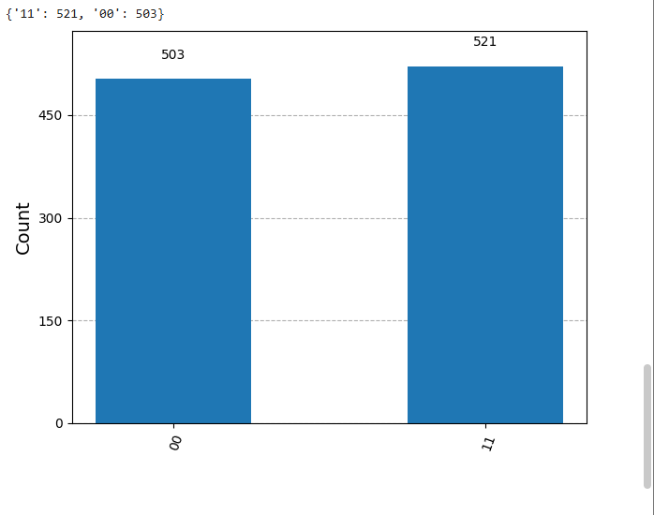
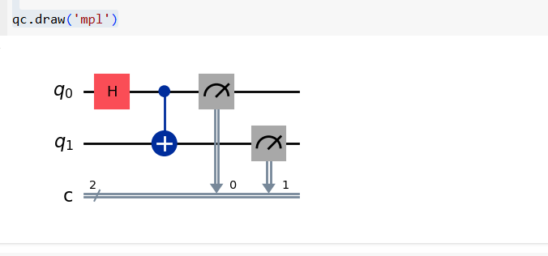

Conclusion:
In this experiment, we created a Bell state using Hadamard and CNOT gates. The measurements showed that the two qubits were entangled, as they always collapsed to either 00 or 11. This behavior proves that the qubits were not independent but rather part of a shared quantum state.

