Experiment No.:5
Title: Apply Grover’s Algorithm to Search a 2-Qubit Database Using Oracle and Diffuser.
Aim: To Apply Grover’s Algorithm to Search a 2-Qubit Database Using Oracle and Diffuser.
Theory:
Grover’s Algorithm
Grover’s algorithm is a quantum search algorithm that provides a quadratic speedup over classical search algorithms when searching for a specific item in an unstructured database of size N. While classical search requires O(N) steps on average, Grover’s algorithm can find the target in roughly O(\sqrt{N})O(N​)steps, making it one of the most celebrated quantum algorithms.

Basic Idea
For a database with N=2^n items (where n is the number of qubits), Grover’s algorithm starts with an equal superposition of all possible states:
∣ψ0​⟩=N​1​x=0∑N−1​∣x⟩
The goal is to amplify the probability amplitude of the target state ∣t⟩such that when measured, the target is found with high probability.

Key Components
- Oracle Uf
The oracle is a black-box quantum operation that "marks" the target state by flipping its phase:
Uf​∣x⟩={−∣x⟩,∣x⟩,​if x=t otherwise​
This selective phase inversion does not affect other states but inverts the amplitude of the target state.
- Diffuser (Inversion About the Mean) Us
The diffuser amplifies the probability amplitude of the marked state by reflecting all amplitudes about their average value. This operation can be expressed as:
Us​=2∣ψ0​⟩⟨ψ0​∣−I
where III is the identity operator. The diffuser effectively "pushes" the amplitude of the target state higher, increasing the probability of measuring it.

Algorithm Steps (for 2-qubit system, N=4):
- Initialize the system to ∣00⟩.
- Create uniform superposition using Hadamard gates on all qubits:
H⊗2∣00⟩=21​(∣00⟩+∣01⟩+∣10⟩+∣11⟩)
- Apply the oracle Uf to mark the target state by flipping its phase.
- Apply the diffuser Us to amplify the amplitude of the marked state.
- Repeat steps 3 and 4 approximately π/4×N​ times for optimal amplitude amplification (for 2 qubits, only one iteration is needed).
- Measure the qubits — the result will most likely be the target state.

Importance of Grover’s Algorithm
- Quadratic Speedup: Grover’s algorithm reduces the search time significantly compared to classical linear search.
- Generality: It works on any unstructured database and does not require prior knowledge of the data distribution.
- Building Block: It serves as a foundation for many other quantum algorithms and applications in optimization and cryptography.

Visualization in 2-Qubit System
For n=2, the four states are ∣00⟩,∣01⟩,∣10⟩,∣11⟩. Suppose the target is ∣10⟩:
- The oracle flips the phase of ∣10⟩.
- The diffuser redistributes the amplitudes to increase the likelihood of measuring ∣10⟩.
- After one iteration, the probability of measuring ∣10⟩ increases close to 1.
Code:
Step 1: Import Required Libraries
!pip install qiskit
!pip install qiskit [visualization]
!pip install pylatexenc
!pip install qiskit-aer
from qiskit import *
from qiskit.visualization import plot_bloch_multivector, plot_histogram
#from qiskit_textbook.tools import array_to_latex
#from qiskit.quantum_info import Statevector
import matplotlib.pyplot as plt
#Step 2: Define the Oracle for Marking |11⟩ as the Solution
def grover_oracle(circuit):
circuit.cz(0, 1) # Flip sign of |11⟩

#Step 3: Define the Diffuser
def diffuser(circuit):
circuit.h([0, 1])
circuit.x([0, 1])
circuit.h(1)
circuit.cx(0, 1)
circuit.h(1)
circuit.x([0, 1])
circuit.h([0, 1])

#Step 4: Build the Grover Circuit
qc = QuantumCircuit(2, 2)

# Step 1: Initialize in superposition
qc.h([0, 1])

# Step 2: Apply Oracle
grover_oracle(qc)

# Step 3: Apply Diffuser
diffuser(qc)

# Step 4: Measure
qc.measure([0, 1], [0, 1])
qc.draw('mpl')

from qiskit_aer import Aer
simulator = Aer.get_backend('aer_simulator')
compiled = transpile(qc, simulator)
job = simulator.run(compiled, shots=1024)

# Get results
result = job.result()
counts = result.get_counts()
print(counts)
plot_histogram(counts)
plt.show()

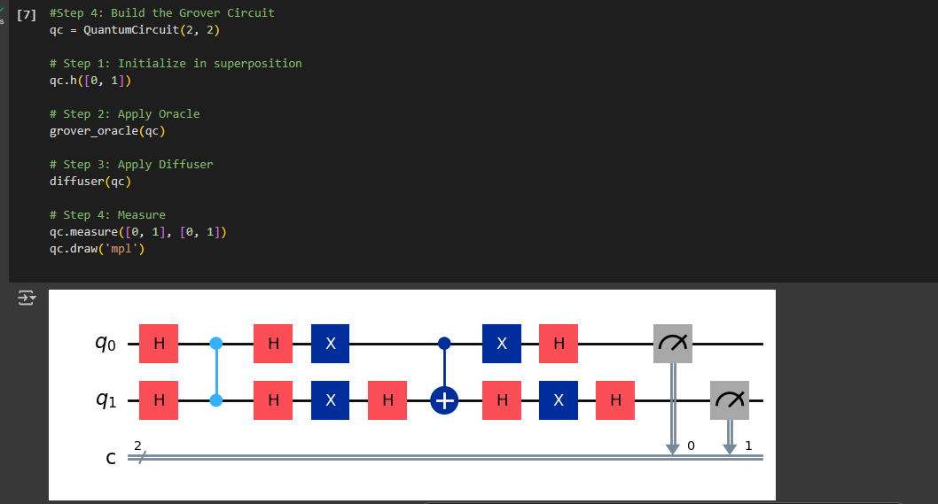
Output:

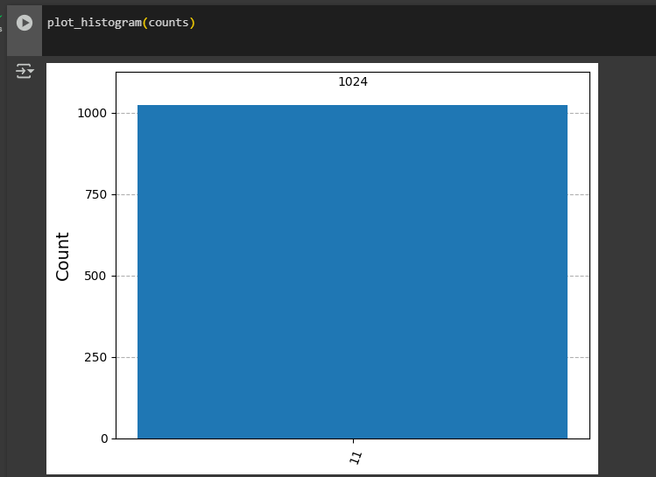
Conclusion:
Deutsch’s algorithm is a foundational quantum algorithm demonstrating quantum parallelism. It shows that a quantum computer can determine a global property of a function with fewer evaluations than classical computers, using superposition, oracle, and interference.

