Experiment No.:6
Title: Simulate Quantum Teleportation to Transmit Qubit State Using Entanglement and Classical Communication.
Aim: To simulate quantum teleportation using Qiskit, where a qubit's quantum state is transmitted from one location to another using an entangled pair and classical communication.
Theory:
Quantum teleportation is a protocol that allows the transfer of an unknown quantum state from one location (Alice) to another (Bob) without physically sending the particle that holds that state. This is a fundamental process in quantum communication and quantum computing.

The Goal
- Transfer the quantum state ∣ψ⟩=α∣0⟩+β∣1, where α\alphaα and β\betaβ are complex amplitudes, from Alice’s qubit to Bob’s qubit.
- The state ∣ψ⟩is unknown and cannot be measured directly without disturbing it (due to the no-cloning theorem).

Ingredients of the Protocol
- Entangled Bell Pair:
  - Alice and Bob share an entangled pair of qubits, often prepared in one of the four Bell states, for example:
∣Φ+⟩=​∣00⟩+∣11⟩​/root(2)
  - This shared entanglement is a resource that enables teleportation.
- Initial State Setup:
  - Alice has the qubit in the unknown state ∣ψ⟩=α∣0⟩+β∣1⟩
  - The combined initial state of the system (Alice's unknown qubit + Alice's entangled qubit + Bob's entangled qubit) can be expressed as a tensor product.
- Alice’s Operations (Quantum Gates and Measurement):
  - Alice performs a joint measurement on her unknown qubit and her half of the entangled pair in the Bell basis.
  - Before measurement, Alice applies:
    - A CNOT gate between the unknown qubit (control) and her entangled qubit (target).
    - A Hadamard gate to the unknown qubit.
  - These operations entangle Alice’s two qubits, preparing them for measurement.
- Measurement and Classical Communication:
  - Alice measures her two qubits (in the Bell basis), collapsing their state and obtaining 2 classical bits of information.
  - These 2 bits encode which of the four Bell states resulted from the measurement.
  - Alice sends these 2 classical bits to Bob over a classical communication channel.
- Bob’s Conditional Operations:
  - Bob’s qubit is now in a state that is related to the original ∣ψ⟩|\psi\rangle∣ψ⟩ but transformed depending on the measurement outcome.
  - Upon receiving the 2 classical bits, Bob applies a corresponding Pauli operation (one of {I,X,Z,XZ}\{I, X, Z, XZ\}{I,X,Z,XZ}) to his qubit to recover the original state ∣ψ⟩
    - For example:
      - If Alice sends "00", Bob applies III (identity, no change).
      - If "01", Bob applies XXX (bit flip).
      - If "10", Bob applies ZZZ (phase flip).
      - If "11", Bob applies XZXZXZ.

Why Teleportation Doesn’t Violate the No-Cloning Theorem
- The original qubit’s state is destroyed during Alice’s measurement.
- Measurement collapses the superposition, so the quantum information is not duplicated but transferred.
- The qubit on Bob’s side assumes the original quantum state ∣ψ⟩|\psi\rangle∣ψ⟩ after the correction.
- Because classical bits are sent, information is transmitted at or below the speed of light, so no faster-than-light communication occurs.
Code:
Step 1: Import Required Libraries
!pip install qiskit
!pip install qiskit [visualization]
!pip install qiskit-aer
from qiskit import *
from qiskit.visualization import plot_bloch_multivector, plot_histogram
from qiskit.quantum_info import Statevector
import matplotlib.pyplot as plt

#Step 2 Step 2: Build the Teleportation Circuit
# Create 3 qubits: 0 - sender qubit (to teleport)
# 1 - Alice's entangled qubit
# 2 - Bob's entangled qubit
qc = QuantumCircuit(3, 2)
# Step A: Prepare the state to be teleported (|+⟩ state)
qc.h(0)
# Step B: Create entangled Bell pair between qubits 1 & 2
qc.h(1)
qc.cx(1, 2)
# Step C: Apply teleportation protocol
qc.cx(0, 1)
qc.h(0)
# Step D: Measure Alice’s qubits (0 & 1)
qc.measure(0, 0)
qc.measure(1, 1)
# Step E: Conditional operations on Bob’s qubit
qc.cx(1, 2)
qc.cz(0, 2)
qc.draw('mpl')

#Step 3: Simulate The Circuit
#Simulate the Circuit
from qiskit_aer import Aer
simulator = Aer.get_backend('aer_simulator')
compiled = transpile(qc, simulator)
job = simulator.run(compiled, shots=1024)
result = job.result()
counts = result.get_counts()
print(counts)
plot_histogram(counts)

Output:
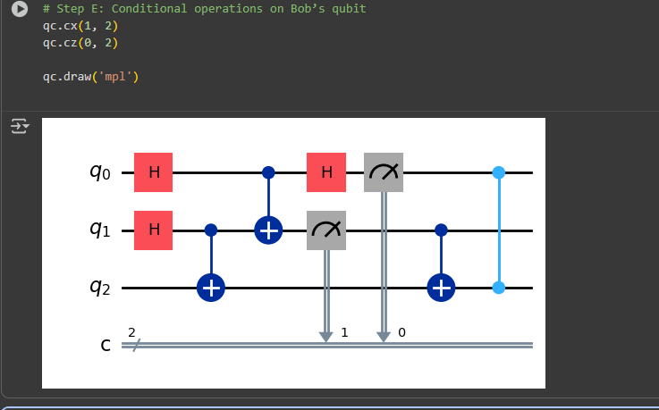
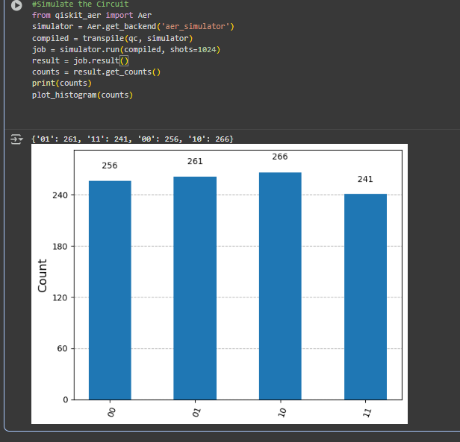
Conclusion: Quantum teleportation demonstrates how quantum information can be transmitted using a combination of entanglement and classical communication. The original qubit’s state is destroyed, maintaining the no-cloning principle, and accurately reappears at the target qubit.

