Experiment No.:7
Title: Simulate Quantum Fourier Transform (QFT) Circuit using Qiskit and Verify the Output.
Aim: To Simulate Quantum Fourier Transform (QFT) Circuit using Qiskit and Verify the Output.
Theory:

Quantum Fourier Transform (QFT) — Expanded Theory

1. Introduction and Context
The Quantum Fourier Transform (QFT) is a key quantum algorithmic subroutine, analogous to the classical Discrete Fourier Transform (DFT). It acts on quantum states to transform the state vector from the computational (standard) basis to the Fourier (frequency) basis. This transform is a cornerstone of several important quantum algorithms, most famously Shor’s factoring algorithm, which can factor large integers exponentially faster than the best-known classical algorithms.

2. Mathematical Definition

For an nnn-qubit quantum system, the Hilbert space has dimension N=2n. The QFT acts on computational basis states ∣x⟩, where xxx is an integer between 0 and N−1, transforming them into superpositions of all basis states ∣y⟩:
QFT:∣x⟩↦N​1​y=0∑N−1​e2πiNxy​∣y⟩
where
- N=2nN = 2^nN=2n is the dimension of the Hilbert space,
- x,y∈{0,1,…,N−1},
- e2πixy is a complex phase factor encoding frequency information.
3. Interpretation
- The QFT transforms the discrete "time-domain" information encoded in the amplitudes of ∣x⟩ states into the "frequency-domain" representation encoded in the amplitudes of ∣y⟩states.
- Similar to classical Fourier analysis, this is a basis change that reveals periodicity or frequency characteristics hidden in the quantum state.

4. Example
For a 2-qubit system (N=4), the QFT acts as:
∣x⟩↦21​y=0∑3​e2πi4xy​∣y⟩
If x=1,

∣1⟩↦21​(∣0⟩+i∣1⟩−∣2⟩−i∣3⟩)

5. Matrix Representation
The QFT can be represented as an N×N unitary matrix F with entries
Fy,x​=N​1​e2πiNxy​
This matrix is unitary, i.e., F†F=I, ensuring the transformation is reversible (a fundamental property of quantum operations).

6. Circuit Implementation
The QFT can be efficiently implemented on a quantum computer using a combination of:
- Hadamard gates (H): create superpositions.
- Controlled phase rotation gates (Rk​): introduce relative phases depending on the value of control qubits.
Stepwise:
- Apply a Hadamard gate to the most significant qubit.
- Apply controlled phase rotations between this qubit and the less significant qubits.
- Repeat the above steps for the remaining qubits, moving from most significant to least significant.
- At the end, reverse the order of the qubits (often called "bit-reversal") to complete the QFT.
The total number of gates grows as O(n2) which is exponentially faster compared to the classical FFT which runs in O(NlogN), or O(n2n)O(n 2^n)O(n2n)time.

7. Why is QFT Important?
- Shor’s Algorithm: The QFT is the key step in period-finding, which enables efficient integer factorization and discrete logarithm calculations.
- Phase Estimation: QFT is used to estimate eigenvalues of unitary operators—a fundamental quantum algorithmic primitive.
- Quantum Signal Processing: The QFT can analyze frequency components in quantum states, akin to classical signal processing but exponentially faster.
Code:
Step 1: Import Required Libraries
!pip install qiskit
!pip install qiskit [visualization]
!pip install pylatexenc
!pip install qiskit-aer
from qiskit import *
from qiskit.visualization import plot_bloch_multivector, plot_histogram
#from qiskit_textbook.tools import array_to_latex
#from qiskit.quantum_info import Statevector
import matplotlib.pyplot as pltStep 2: Define the QFT Function
def apply_qft(circuit, n):
for j in range(n):
circuit.h(j)
for k in range(j+1, n):
angle = np.pi / (2 ** (k - j))
circuit.cp(angle, k, j)
# Swap qubits to reverse order
for i in range(n // 2):
circuit.swap(i, n - i - 1)

Step 3: Build and Apply QFT to a 3-Qubit Circuit
qc = QuantumCircuit(3, 3)

# Initialize input state |001⟩
qc.x(0)

# Apply QFT
apply_qft(qc, 3)

# Measure the qubits
qc.measure([0, 1, 2], [0, 1, 2])

qc.draw('mpl')

Step 4: Simulate the Circuit
from qiskit_aer import Aer
simulator = Aer.get_backend('aer_simulator')
compiled= transpile(qc,simulator)
job = simulator.run(compiled, shots=1024)
result = job.result()
counts = result.get_counts()
print(counts)
plot_histogram(counts)

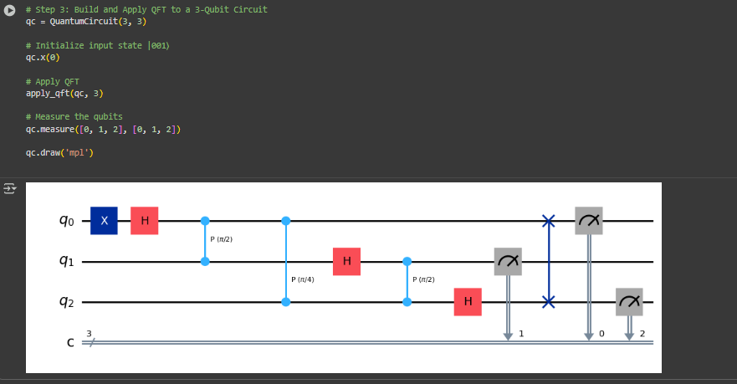
Output:

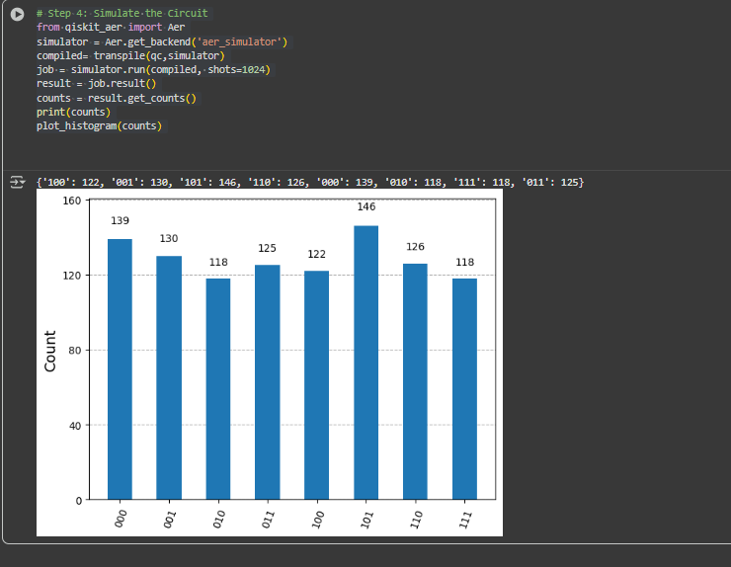

Conclusion:
The QFT circuit was successfully simulated and verified using Qiskit. This experiment introduced the basic mechanics of the QFT, such as the controlled phase shifts and qubit swapping for proper ordering. Understanding QFT is foundational for algorithms like Shor’s and quantum phase estimation.

