Experiment No. 1

Title: Introduction to Cloud Computing

Objective:
- To Learn about the basics of Cloud computing.(Meaning and Definition)
- To know the various cloud computing technique available
- To create a Dashboard in one cloud computing platform.

Q.1 What is cloud Computing?
Cloud computing is a general term for the delivery of hosted computing services and IT resources over the internet with pay-as-you-go pricing. Users can obtain technology services such as processing power, storage and databases from a cloud provider, eliminating the need for purchasing, operating and maintaining on-premises physical data centers and servers.

Q.2 Various Cloud Computing Service providers?
- Amazon Web Services
- Microsoft Azure
- Google Service Provider
- Oracle Cloud
- IBM Cloud
- Linode

Q.3 Characteristics of Cloud Computing?
- Self-service provisioning. End users can spin up compute resources for almost any type of workload on demand.
- Elasticity. Companies can freely scale up as computing needs increase and scale down as demands decrease. This eliminates the need for massive investments in local infrastructure, which might not remain active.
- Pay per use. Compute resources are measured at a granular level, letting users pay only for the resources and workloads they use.
- Migration flexibility. Organizations can move certain workloads to or from the cloud or to different cloud platforms automatically.
- Broad network access. A user can access cloud data or upload data to the cloud from anywhere with an internet connection using any device.
- Multi-tenancy and resource pooling. Multi-tenancy lets several customers share the same physical infrastructures or the same applications, yet still retain privacy and security over their own data. With resource pooling, cloud providers service numerous customers from the same physical resources. The resource pools of the cloud providers should be large and flexible enough so they can service the requirements of multiple customers.
- Security. Security is integral in cloud computing and most providers prioritize the application and maintenance of security measures to ensure confidentiality, integrity and availability of data being hosted on their platforms. Along with strong security features, providers also offer various compliance certifications to ensure that their services adhere to industry standards and regulations.
Q.4 Difference between Cloud Services?
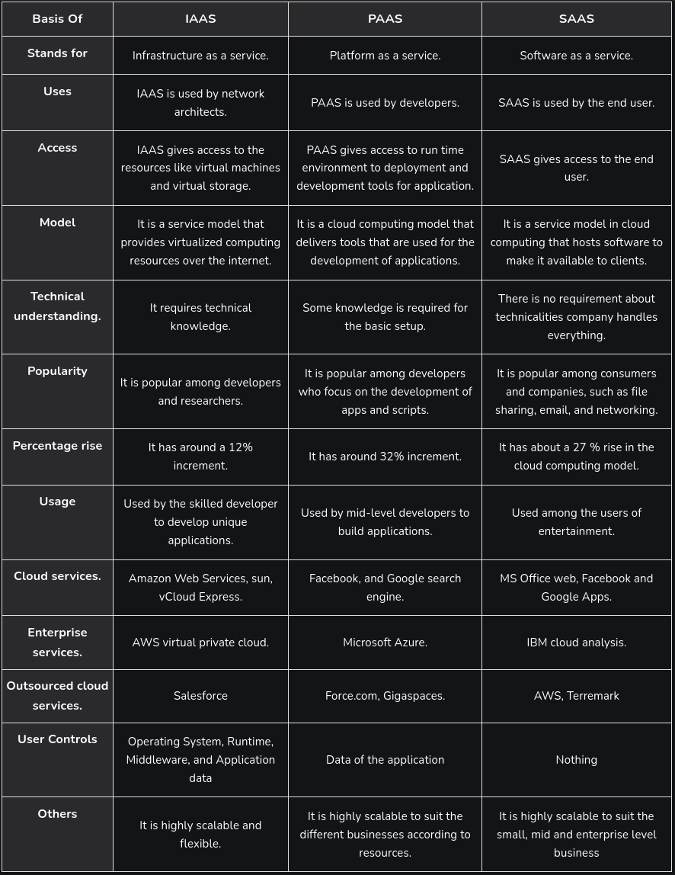

Q.5 Do programming Skills required for Cloud Services Justify.
Yes, programming skills are often required for working with cloud services. They are essential for automating infrastructure, developing cloud applications, setting up DevOps pipelines, and integrating cloud services through APIs. Skills in languages like Python, JavaScript, and shell scripting are particularly important for tasks such as managing resources, creating serverless functions, and automating processes in cloud environments.

Q.6 What is a Network Simulator?
Network simulation is one of the methods used in computer network research work. And in this, there is a software program that examines the various network entities’ relationships and then forms the network performance. And various network entities include switch, links, nodes, routers, and access points. In the analysis lab, there is a monitoring of the services, different applications, supports, and performance of the network. For evaluation of network or protocol performance in different conditions, various surrounding features can also be modified in the controlled environment.

Q.7 What is the difference between Distributed and Cloud Computing?
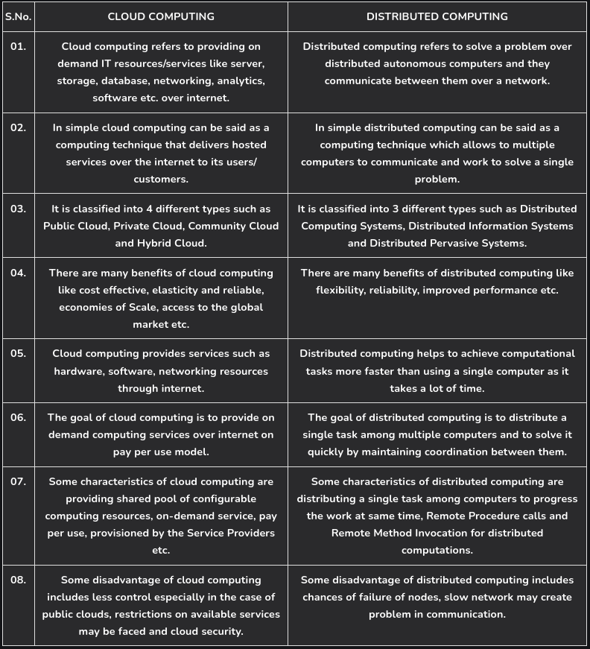

Additional Learning:
- Differences between the Cloud Services.
- Coding Skills are required for Cloud Computing.

Outcomes:
1. I have an understanding of cloud computing.
2. I came to know about various platform:
a. Google Cloud
b. Microsoft Azure
c. AWS

