Experiment No. 2
Title: Install Virtual Box / VMware Workstation with different flavors of Linux or Windows OS on top of windows 7 or 8.

Objectives :-
To learn and understand about virtualization
To understand how it is applied in local visions or systems .
To install a virtual box and workstation.
Using,VM install one service(PAAS).

Theory:-
What is virtualization?
🡪We can only see but we cannot touch and feel .In simple terms, "virtualization" means creating a digital copy or simulation of something real, like a computer, so that you can use multiple versions of it on a single physical device, essentially acting like you have multiple computers even though you only have one; think of it like having multiple "virtual rooms" within a single physical room, each with its own distinct purpose and environment.

WHAT IS VIRTUALISATION IN CC?
🡪 Virtualization is a technology that creates virtual versions of physical hardware, like servers, storage, and networks. It's a key component of cloud computing that allows for more efficient use of resources.
Virtualization is used to create a virtual version of an underlying service With the help of Virtualization, multiple operating systems and applications can run on the same machine and its same hardware at the same time, increasing the utilization and flexibility of hardware. It was initially developed during the mainframe era.

Installation of virtual box and workstation.

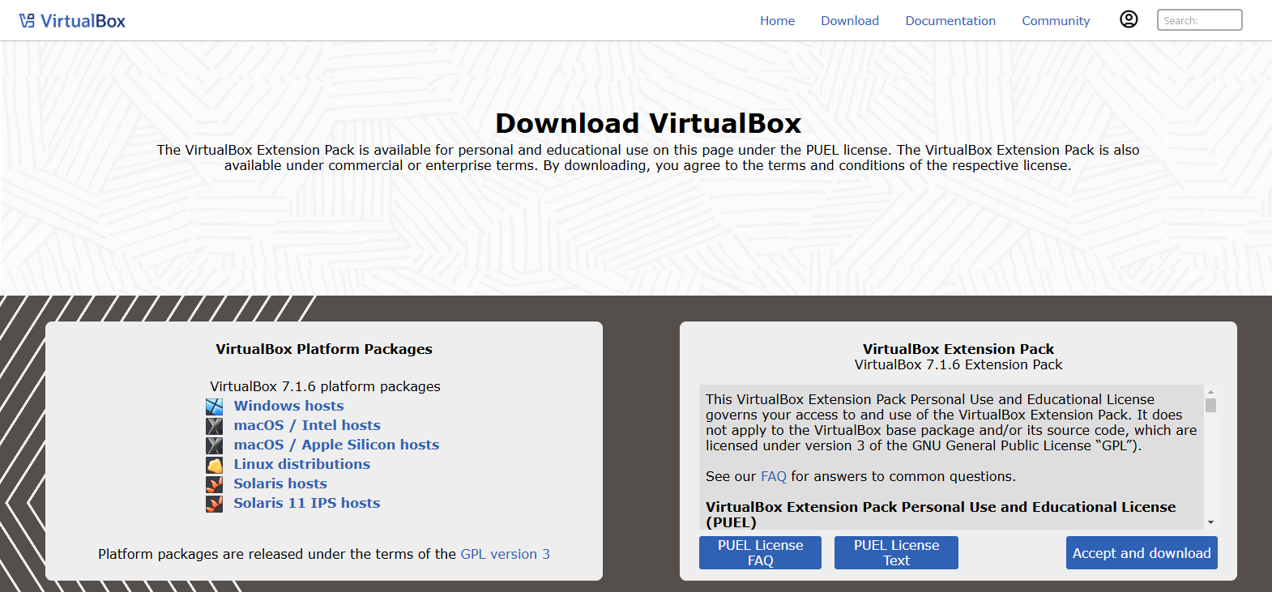
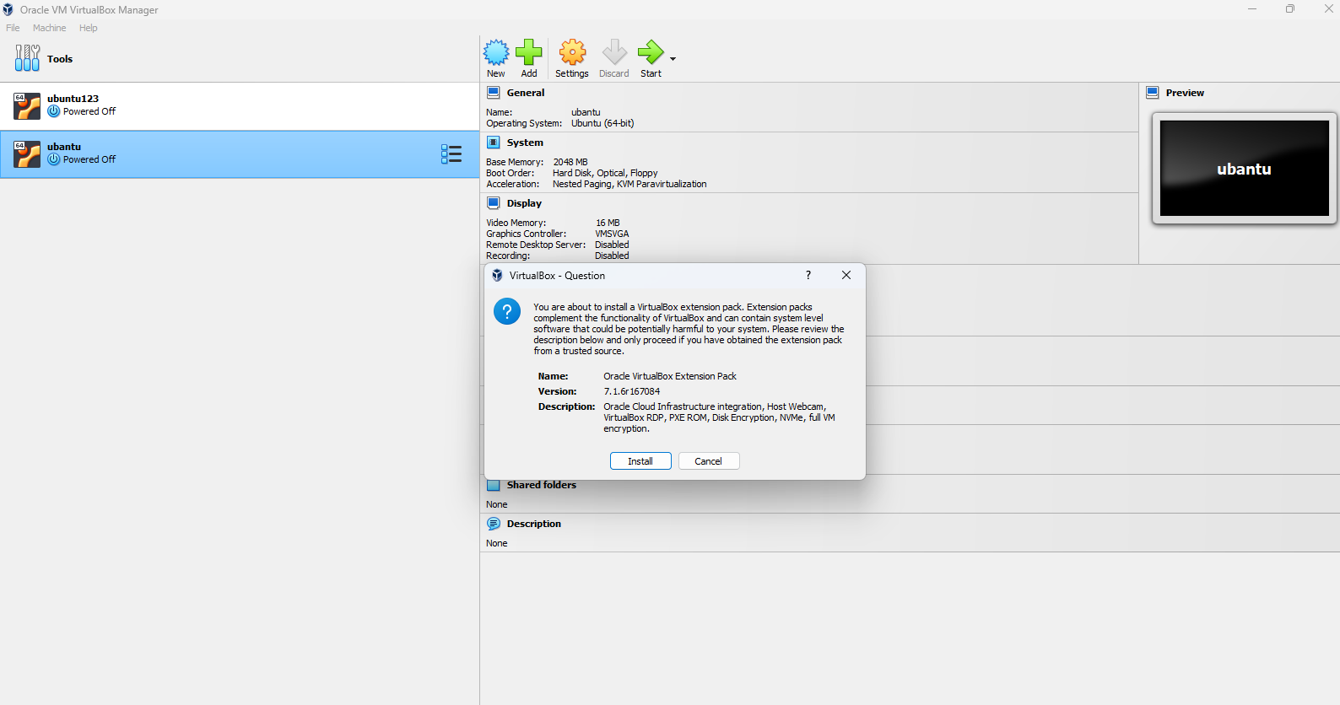

Using ,VMware install one service, (PAAS).
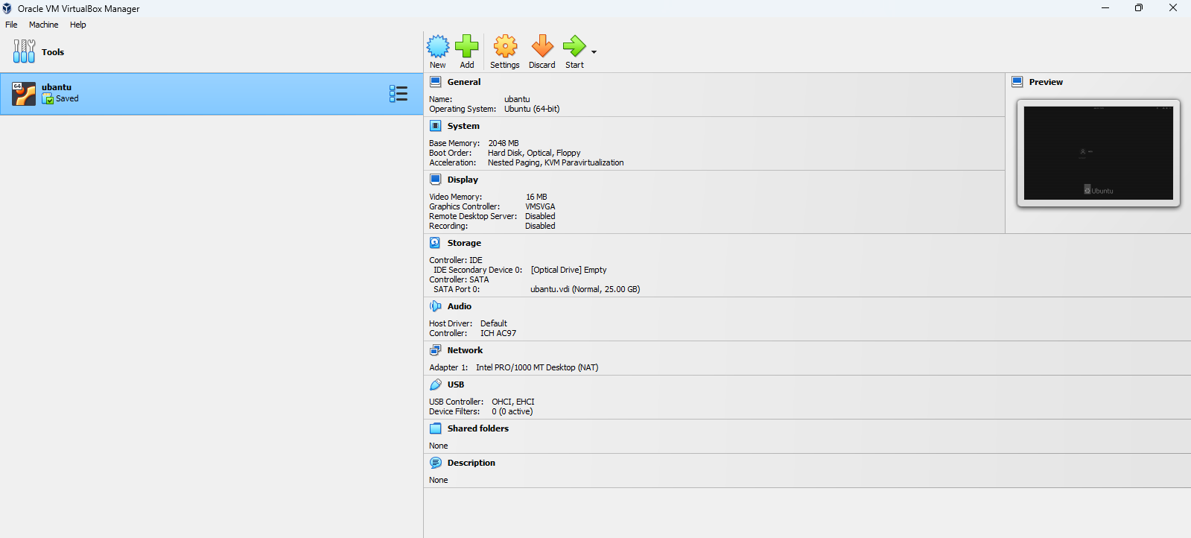

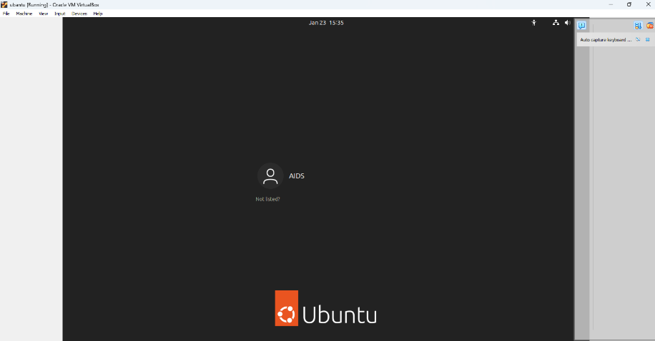

Additional learning:-
1)What is diskimg?
🡪 A disk image file is a compressed copy of a computer's hard drive or other storage media. It contains all the data and structure information from the original storage device.
2)Microsoft office comes under which cc service?
🡪 saas(software as a service).
3)Tools available for virtualization?
🡪 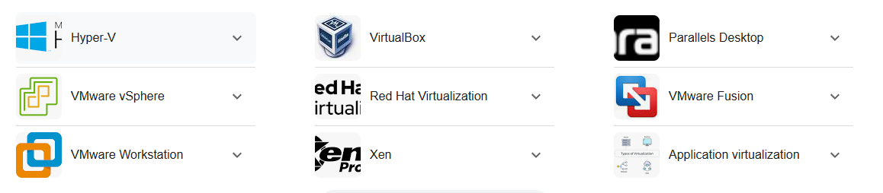

RESULT:-
Thus we studied about virtualization and also installed VMware workstation & installed a PAAS service using VMware workstation.

