EXPERIMENT NO. : 03
TITLE: Install a C compiler in the virtual machine created using virtual box and execute simple program.

What is a virtual machine?
A Virtual Machine (VM) is a compute resource that uses software instead of a physical computer to run programs and deploy apps. One or more virtual “guest” machines run on a physical “host” machine. Each virtual machine runs its own operating system and functions separately from the other VMs, even when they are all running on the same host. This means that, for example, a virtual MacOS virtual machine can run on a physical PC.
Virtual machine technology is used for many use cases across on-premises and cloud environments. More recently, public cloud services are using virtual machines to provide virtual application resources to multiple users at once, for even more cost efficient and flexible compute.

Creating services in virtual machine:
- Edit the VirtualMachine manifest to add the label for service creation.
- Save the VirtualMachine manifest file to apply your changes.
- Create a Service manifest to expose the VM
- Save the Service manifest file.
- Create the service by running the following command
- Start the VM. If the VM is already running, restart it.

3 services:
- Virtual machine can offer 3 basic services:
- Infrastructure as a Service(IaaS)(CPU,memory,storage)
- Platform as a Service(PaaS)(windows,linux,mac,android)
- Application as a Service(AaaS)(office,3D designing,etc.) and also it is compatible to programming languages such as c,cpp,java,python and much more

Infrastructure as a Service [IaaS]:
Infrastructure as a service (IaaS) is a service model that delivers computer infrastructure on an outsourced basis to support various operations. Typically IaaS is a service where infrastructure is provided as outsourcing to enterprises such as networking equipment, devices, database, and web servers.
It is also known as Hardware as a Service (HaaS).

Platform as a Service[PaaS]:
PaaS is a category of cloud computing that provides a platform and environment to allow developers to build applications and services over the internet. PaaS services are hosted in the cloud and accessed by users simply via their web browser.

Application as a Service[AaaS]:
"Application as a Service" (AaaS) refers to a cloud-based model where users access and utilize applications hosted on a remote server, without needing to install, manage, or maintain the software on their own devices.

Additional learning
Basic commands in linux:
- sudo apt install
- ls
- man

Operations of file:
- Creation
- Editing
- append
- delete

Directory operations:
- create
- add subfolders on file
- changing privilges
- delete

OUTCOMES:
- I learned how to set up and manage a virtual machine.
- I came to know how to create and configure various services within a virtual machine.
- I understood the concepts of Infrastructure-as-a-Service (IaaS), Platform as a Service (PaaS), and how to install and manage operating systems and applications within a virtual machine.
- I learned how to install a C compiler on a Linux virtual machine and create a simple arithmetic calculator using a C program.

OUTPUT:
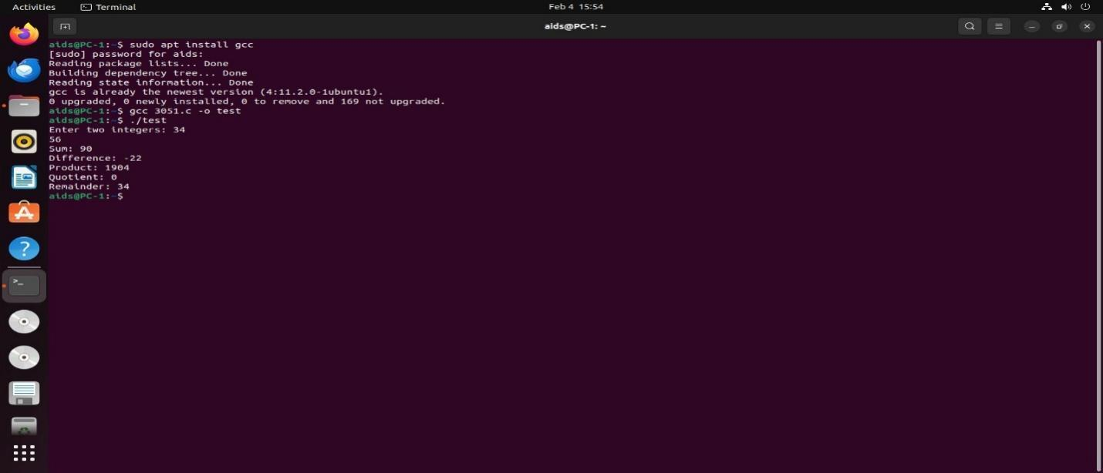
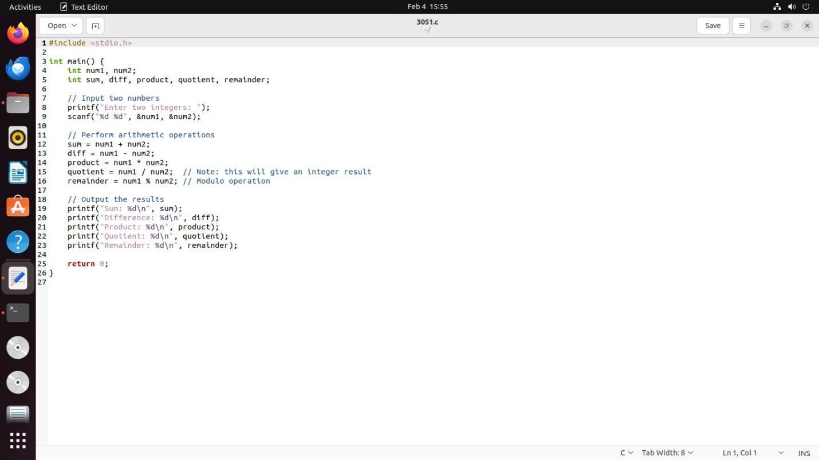

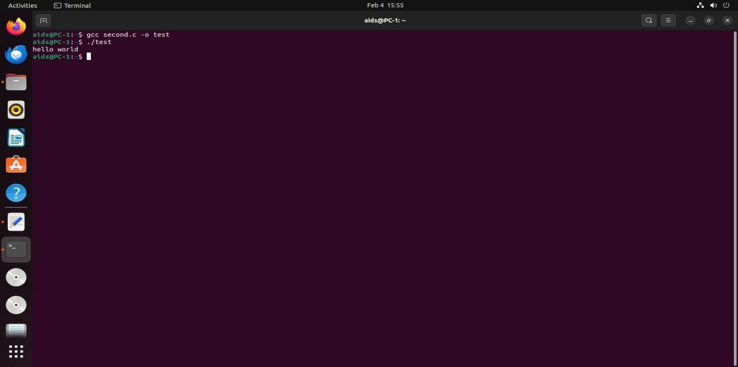

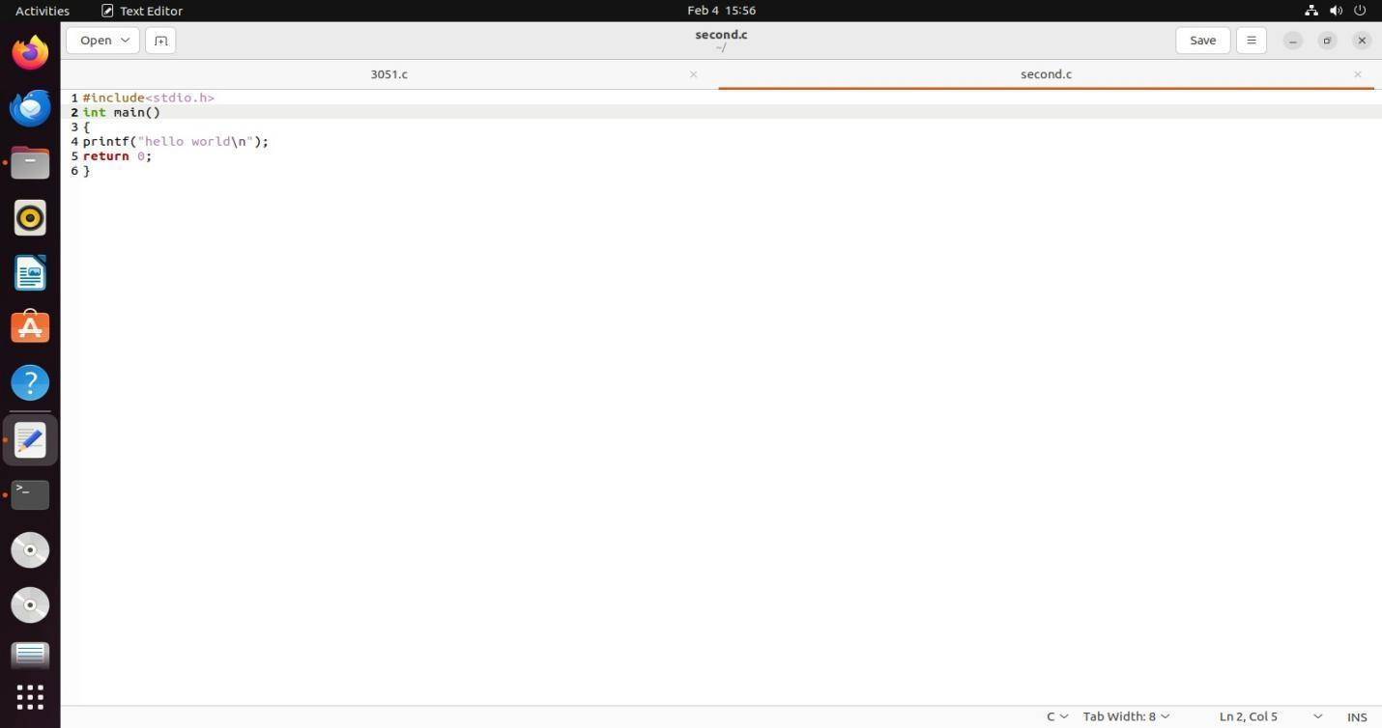

RESULT: Thus the simple hello world! c program and calculator c program is executed successfully.

