Experiment No.4
Title: Installing Google App Engine, Creating a Hello World App, and Developing Simple Web Applications Using Python/Java
Objective:

Objective:-
  - To know understand about the google cloud
  - To create a google cloud dashboard(upi or debit card free and no auto deduction mood)
  - To learn and understand google cloud services.
  - Installation of google app engine.
  - To run program and application using google cloud engine.
Theory:
Google App Engine (GAE) is a platform as a service (PaaS) that allows developers to build and deploy web applications on Google's infrastructure. It supports multiple programming languages, including Python, Java, PHP, and Go. With GAE, developers can focus on writing code without worrying about managing servers or scaling their applications.
GAE automatically handles traffic distribution, load balancing, and scaling based on the application's needs. It also integrates with other Google Cloud services, such as Cloud Storage, Datastore, and Firestore.
Installation of Google App Engine:
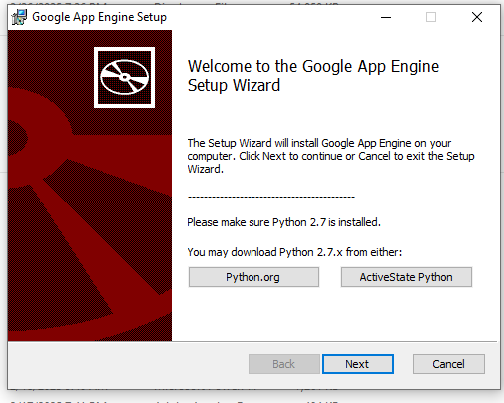
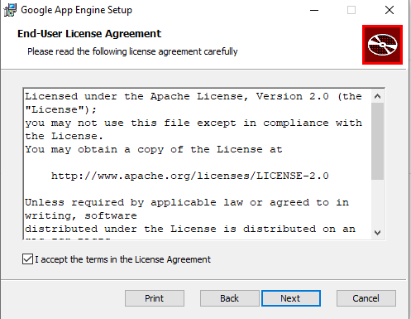
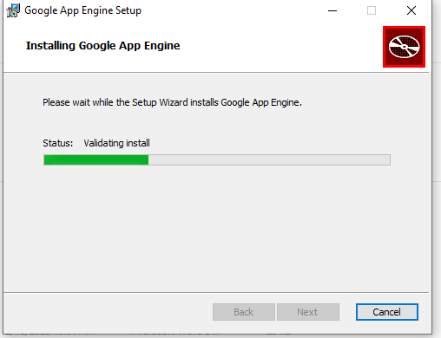
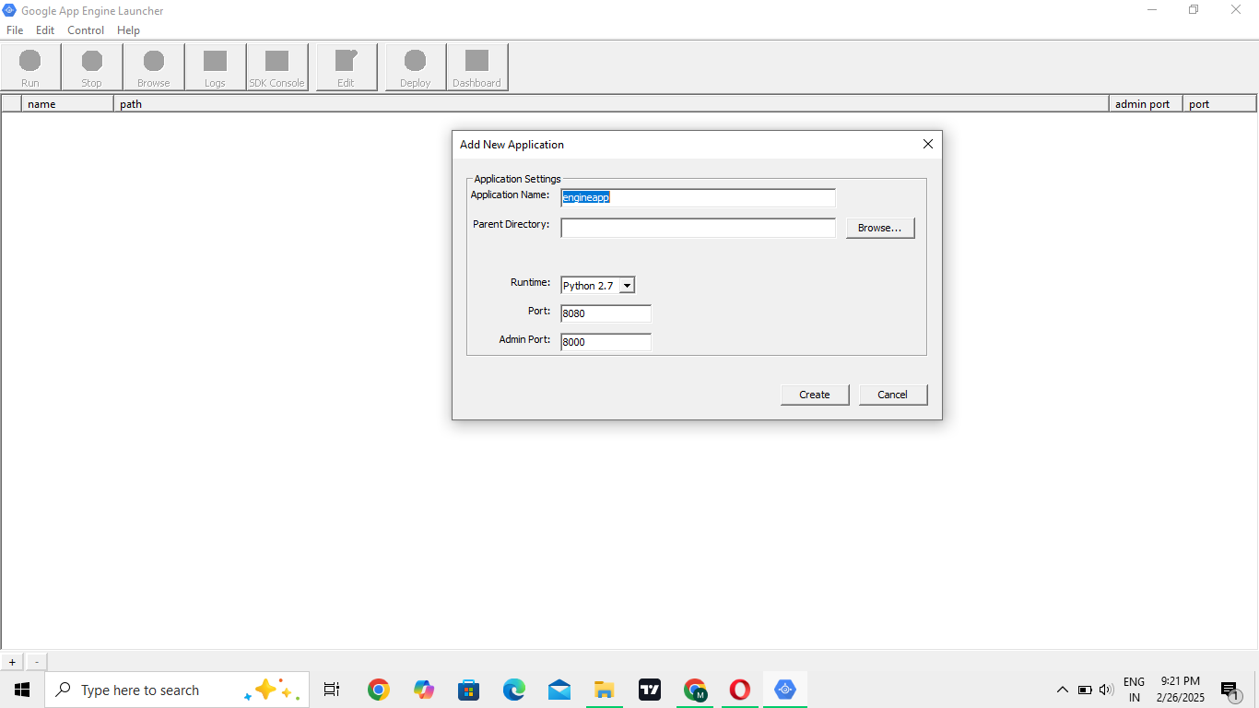

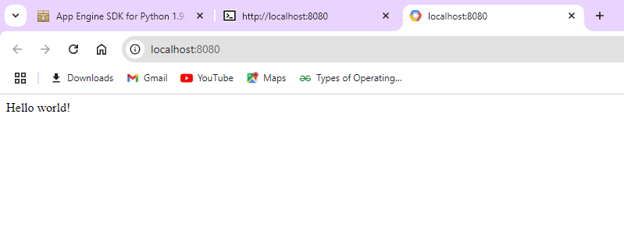

- RESULT:
To install Google App Engine (GAE), first install the Google Cloud SDK and set up your project in the Google Cloud Console. Then, deploy a simple "Hello World" app by creating a Python or Java web application, configuring it, and deploying it using the gcloud app deploy command.

