Experiment No 5
Title: To launch the web applications by using the GAE launcher.

Objectives:
- Set up Google App Engine (GAE) environment for web application deployment.
- Configure the web application to be compatible with GAE's deployment structure.
- Create and organize the application’s configuration files (e.g., app.yaml).
- Implement necessary backend services and ensure they meet GAE requirements.
- Test the application locally using the GAE launcher to ensure proper functionality.
- Deploy the application to Google Cloud using the GAE launcher for production.

Theory:

1.Simulation and simulation environment
- Simulation
A model of a set of problems or events that can be used to teach someone how to do something, or the process of making such a model.
- Simulation environment
A simulation environment is a virtual space that mimics a real-world system or process. It's created using a computer program and can be used to analyze, design, and optimize systems.
2.Differences between simulation, emulation, virtualization

1. Simulation:
- Creates a conceptual model of a system, often used to analyze complex scenarios and predict outcomes by manipulating variables within the model.

- Can be highly detailed, including internal workings and interactions between components.

- Examples: simulating a traffic flow in a city, simulating a chemical reaction in a lab.

2. Emulation:
- Aims to replicate the behavior of a specific hardware or software system, allowing you to run software designed for one platform on another.

- Focuses on achieving the same results as the original system without necessarily mimicking its internal logic.

- Example: using an emulator to play a game designed for a different console on your current system.

3. Virtualization:
- Creates virtual instances of physical hardware, allowing multiple operating systems to run concurrently on a single physical machine by partitioning resources.

- Primarily used for efficient resource management and to isolate different applications from each other.

- Example: setting up multiple virtual servers on a single physical server to host different websites.

Procedures:
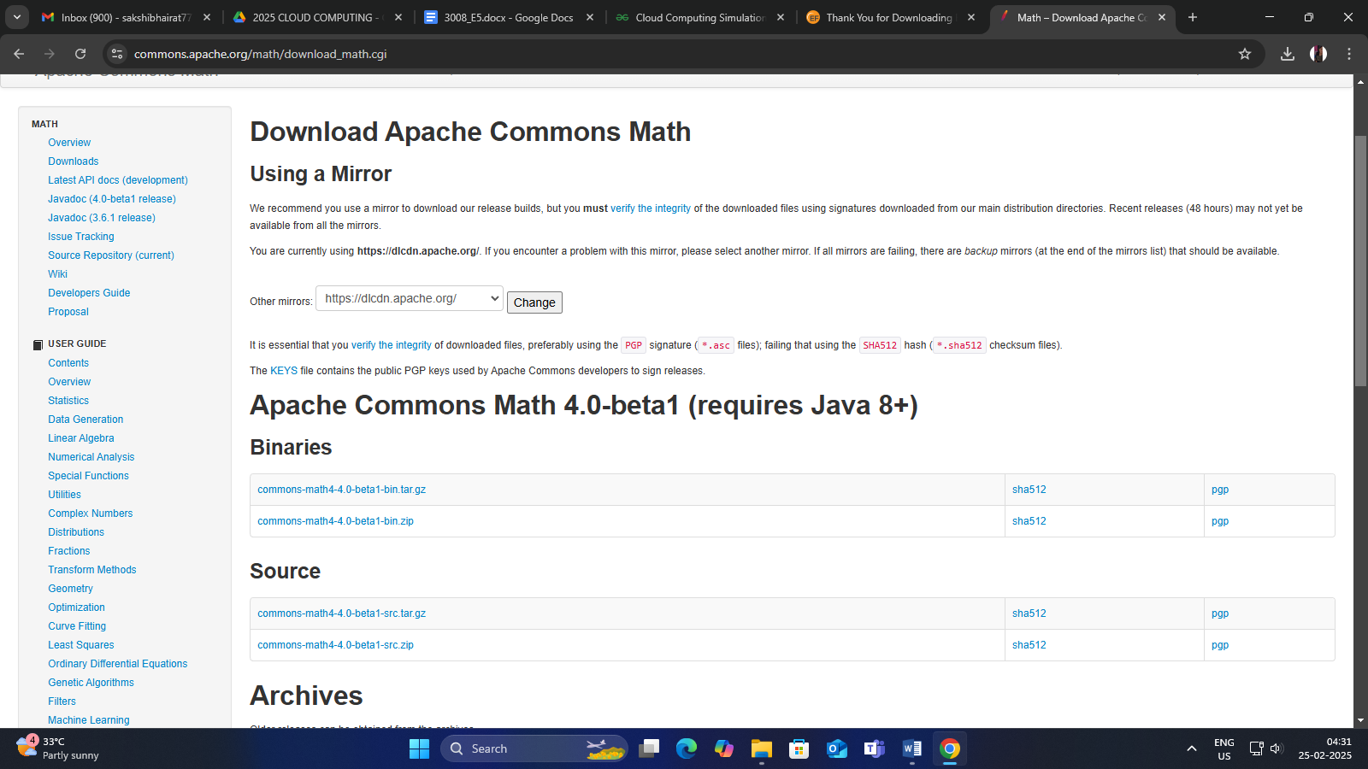

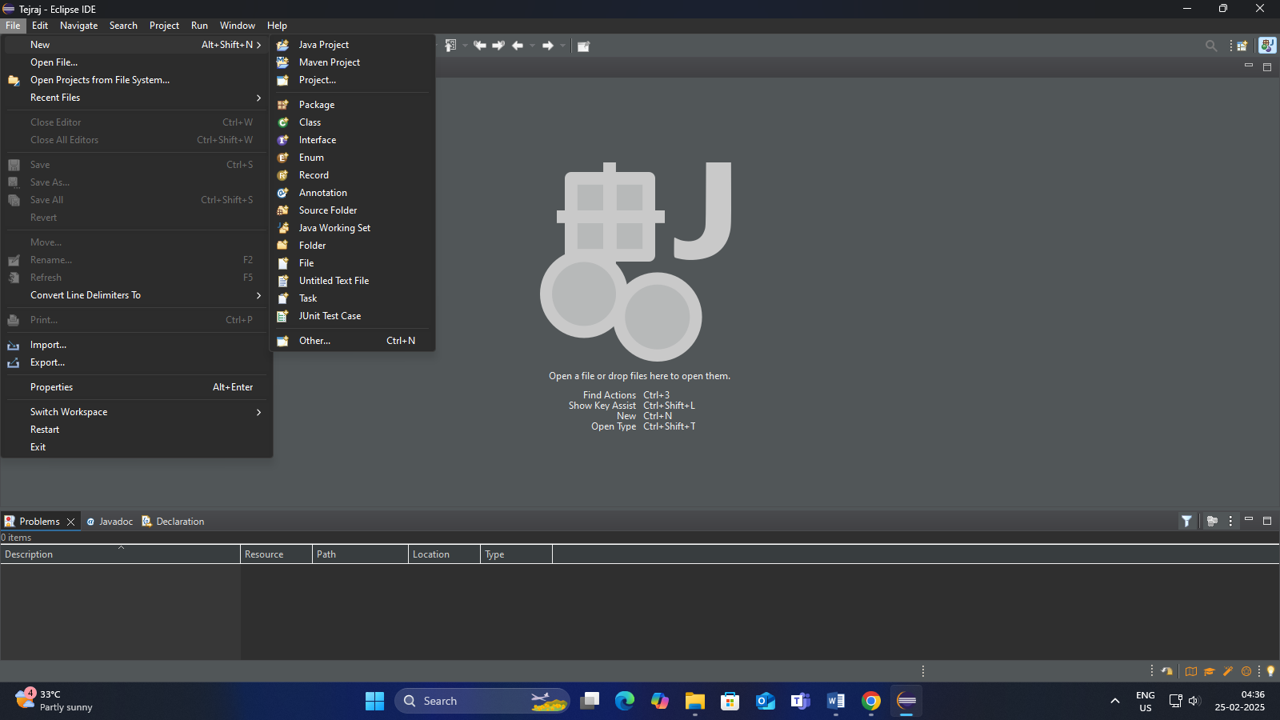

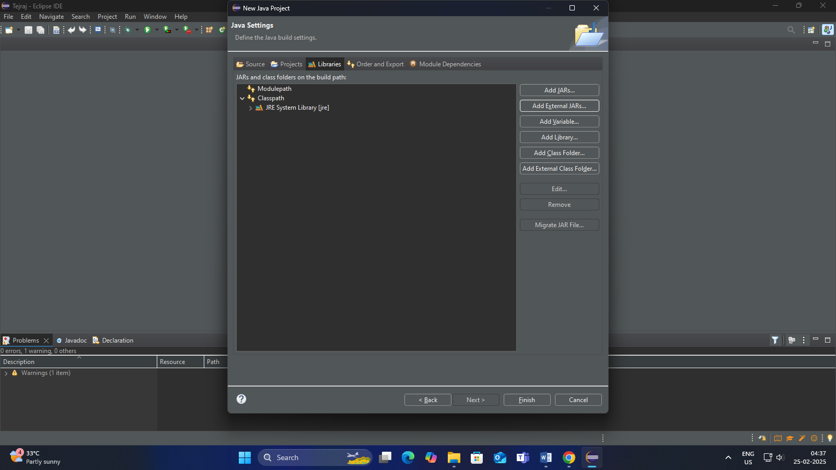
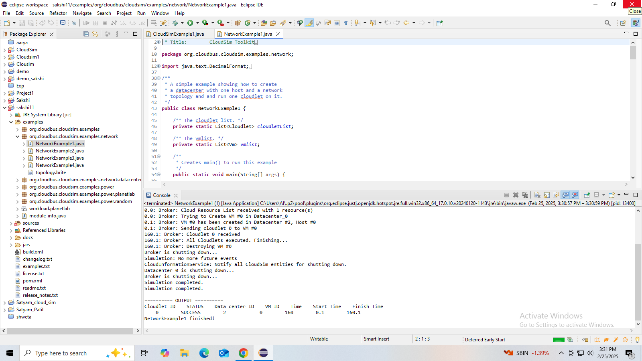

Outcomes:
- I learned and understand about simulation environment.
- I came to know about the differences between simulation, emulation, virtualization
- I came to know about how to download and install cloud simulator (windows, Linux).
- I learned about creating an application or program in the simulated environment.
- I learned about how to fetch result in the simulated environment.

Result:
Thus the simulation of a cloud scenario using CloudSim and run a scheduling algorithm that is not present in CloudSim is done and the output is obtained successfully.

