Experiment No. 6
- Title: Find a procedure to transfer the files from virtual machine to Host machine.
- Objectives:
- To open the virtual machine in a network using VirtualBox.
- To Assign The IP Address For Virtual Machine.
- Create a shared folder in a virtual machine / host machine.
- Test the connectivity by ping command.
- Copy the files from vm to host.
- Theory:
Virtual Machine:
A Virtual Machine (VM) is a software-based emulation of a physical computer. It runs an operating system and applications just like a physical computer, but it's hosted on a real physical machine called the host. The VM itself is called the guest.
Ping Command:
The ping command is a network utility used to test connectivity between your computer and another device (like a website or server) over a network.
When you run ping, your computer sends ICMP (Internet Control Message Protocol) echo request packets to the target IP address or hostname.
If the target is reachable, it replies with echo reply packets.
Installation Steps:
Step 1: install ssh server in VMware
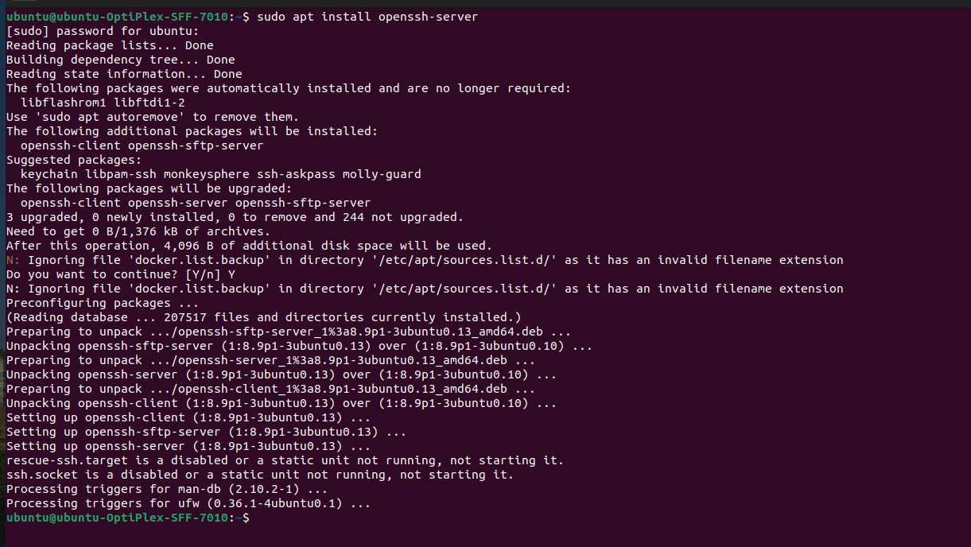
Step 2: Enable ssh server in Ubuntu
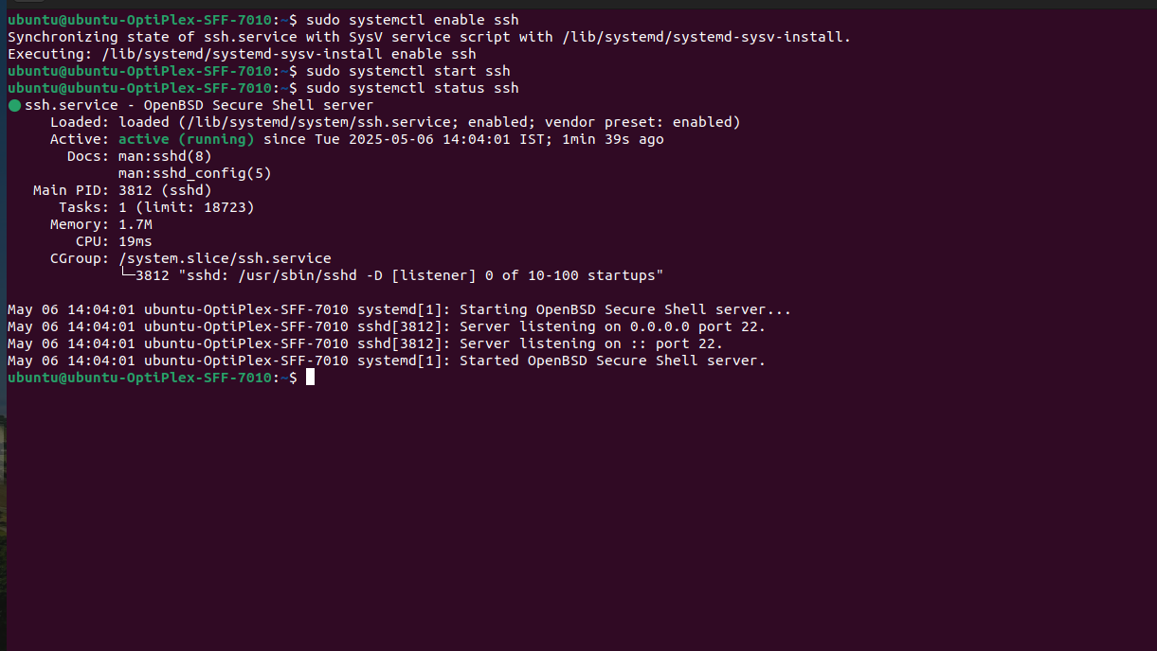
Step 3: Copy the file to the VM using command line
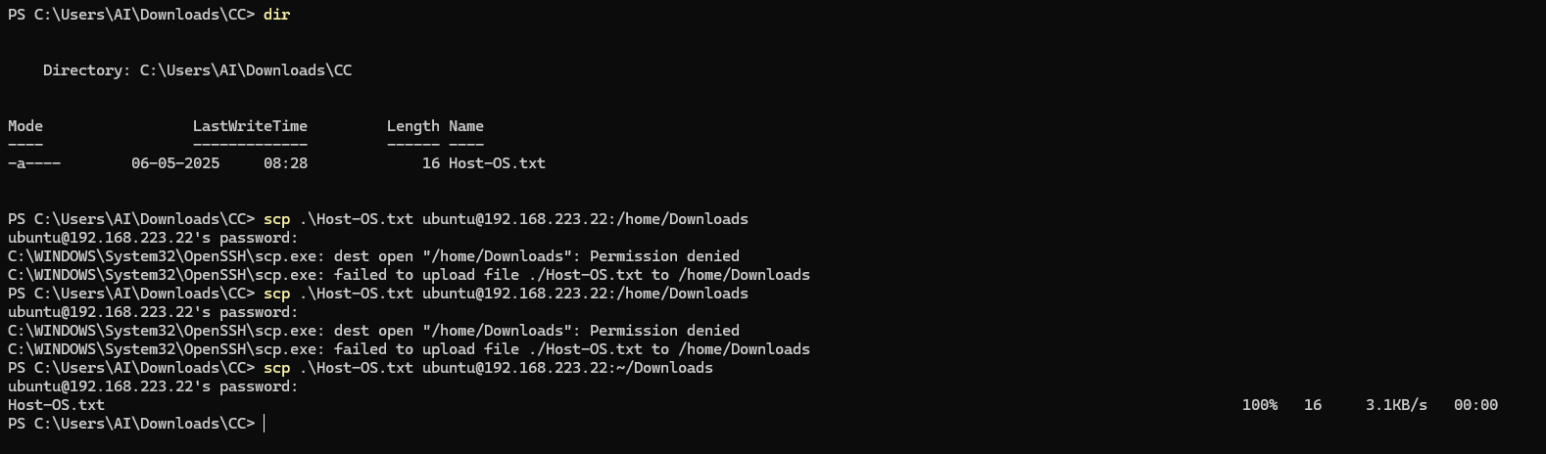
Step 4: Transfer Files successfully
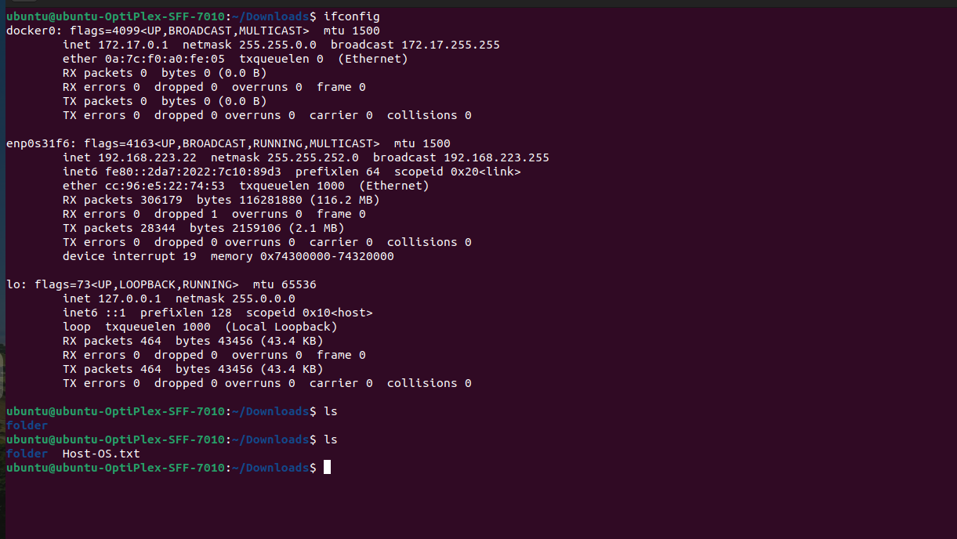

- Ooutcomes:
Successfully learn to find a procedure to transfer the files from one virtual machine to another virtual machine.

