Experiment No. 7
- Title: Find a procedure to launch a virtual machine using trystack (Online Openstack Demo Version).
- Objectives:
- Creating and using a local OpenStack environment.
- Access The Dashboard of OpenStack.
- Launch VM Using the OpenStack Dashboard.
- Theory:
TryStack:
TryStack was a free, public OpenStack sandbox, a community-maintained OpenStack cloud, designed to allow users to experiment with OpenStack and test applications without needing their own hardware. However, it has been discontinued.
OpenStack:
OpenStack is an open-source cloud operating system that provides Infrastructure-as-a-Service (IaaS) functionality, allowing organizations to build and manage both public and private clouds by managing compute, storage, and networking resources.
Steps:
Use DevStack for a Local OpenStack Environment
DevStack is a lightweight way to install OpenStack on your local machine, mainly for development and testing. Here’s a basic outline:
- Prepare Your Machine:
- Use a Linux environment, ideally Ubuntu 20.04 or a later version.
- Ensure that you have at least 8GB of RAM, 2 vCPUs, and enough storage (at least 20GB free).
- Clone the DevStack Repository:
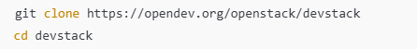
- Configure DevStack:
Create a configuration file named local.conf:

or Add the following configuration to the file:
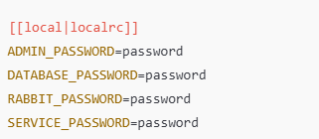
- Run the Installation:
- Access OpenStack Dashboard:
- Once DevStack has finished, open a browser and go to http://localhost/dashboard.
- Log in with the username admin and the password you set in local.conf.
- Launch a VM in the Dashboard:
- Navigate to the “Project” tab > “Compute” > “Instances.”
- Click “Launch Instance” and configure your VM, such as selecting an image, flavor, network, etc.
- Click “Launch” to start the VM.
- Access the Dashboard:
Open a browser and go to http://<vm-ip-address>/dashboard.

- Outcomes:
Successfully learn to find a procedure to launch virtual machine using trystack (Online Openstack Demo Version).

