Experiment No. 8
- Title: Install Hadoop Single Node Cluster and Run Simple Application.
- Objectives:
- To learn and understand about Hadoop and HDFS.
- Downloading and installing the Latest Version of Hadoop.
- Downloading and installing the Latest Version of JDK and JRE.
- Configuring environment variables.
- Formatting the node names.
- Theory:
Apache Hadoop is a framework for processing and storing big data. It is designed to be deployed across a network of hundreds or even thousands of dedicated servers. All these machines work together to deal with the massive volume and variety of incoming datasets.
Deploying Hadoop services on a single node is a great way to get acquainted with basic commands and concepts.
Installation Steps:
- Install JDK using command – ‘sudo apt install openjdk-11-jdk’
- Create Hadoop user using command ‘sudo adduser hadoop’
- Switch to the newly created user
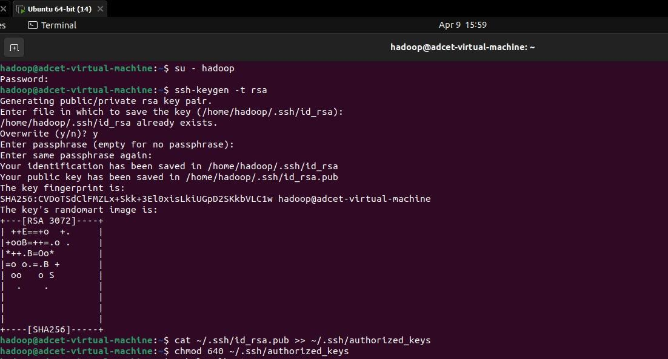
- Generate an SSH key pair and define the location it is to be stored in

- Use the cat command to store the public key as authorized_keys in the ssh directory:

- Set the file permissions for your user with the chmod command:

- Verify everything is set up correctly by using the hdoop user to SSH to localhost:’ssh localhost’
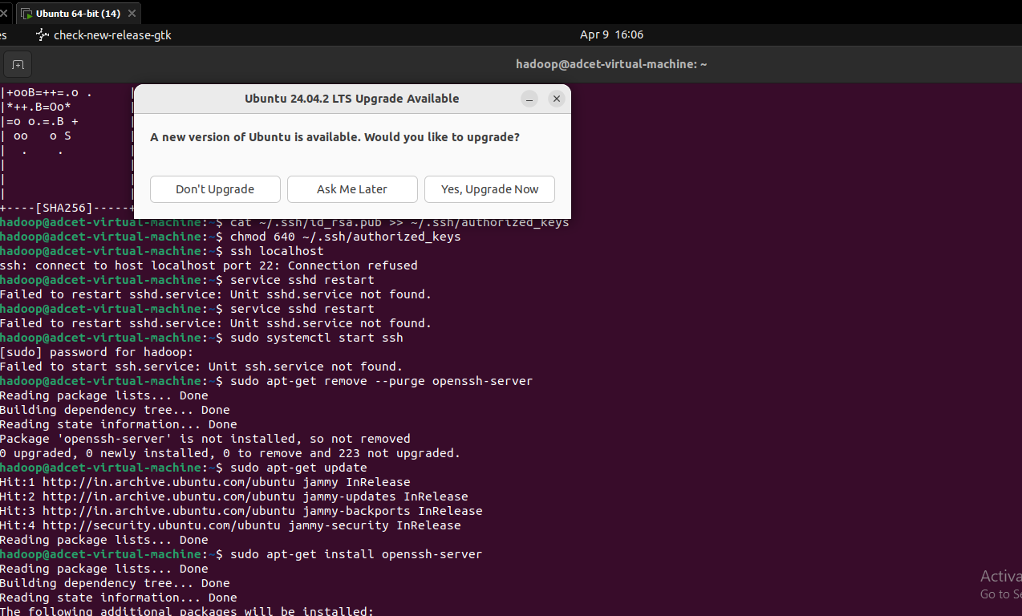
- Download and install hadoop on ubuntu
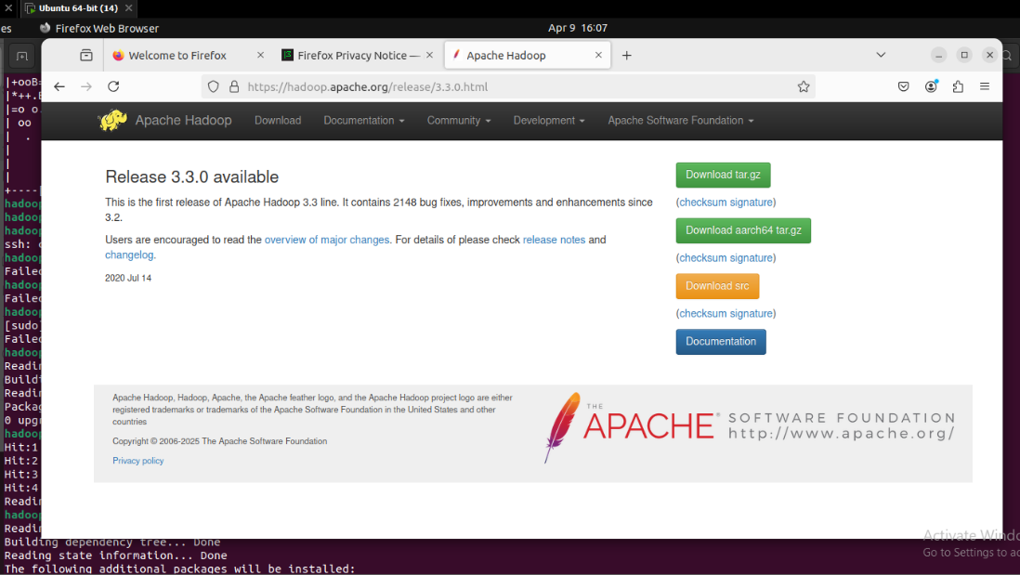
- Configure a Hadoop environment by editing a set of configuration files:
-.bashrc
-hadoop-env.sh
-core-site.xml
-hdfs-site.xml
-mapred-site-xml
-yarn-site.xml
- Format HDFS namenode

- Start the hadoop cluster
- Execute the following command to start the NameNode and DataNode
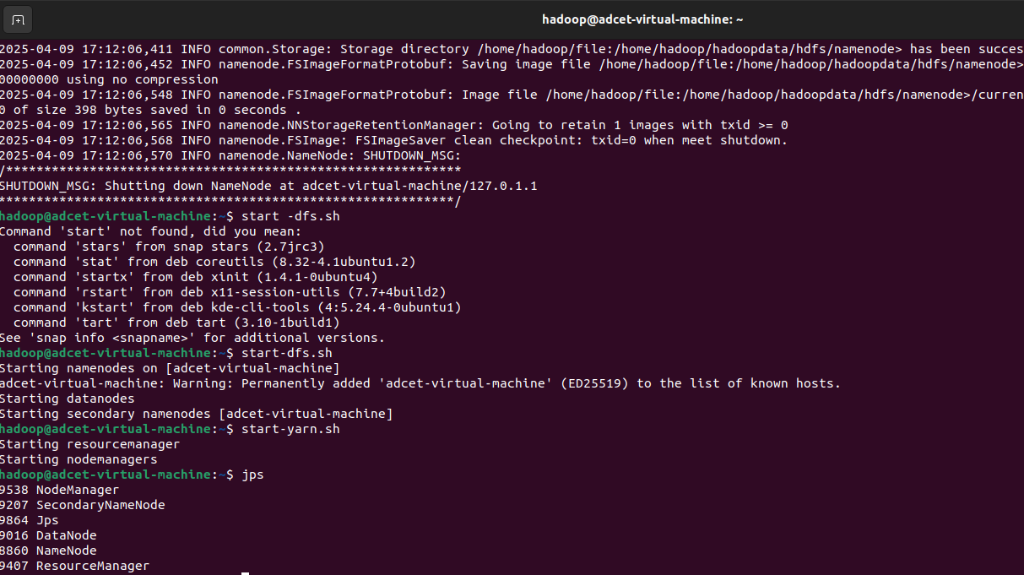
- Once the namenode, datanodes, and secondary namenode are up and running, start the YARN resource and nodemanagers by typing:

- Run the following command to check if all the daemons are active and running as Java processes:


- Access hadoop from the browser
- The NameNode user interface provides a comprehensive overview of the entire cluster.
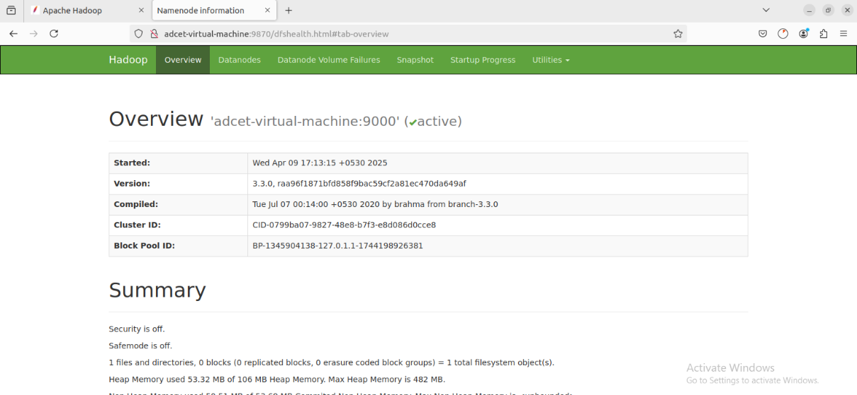
- The Resource Manager is an invaluable tool that allows you to monitor all running processes in your Hadoop cluster.
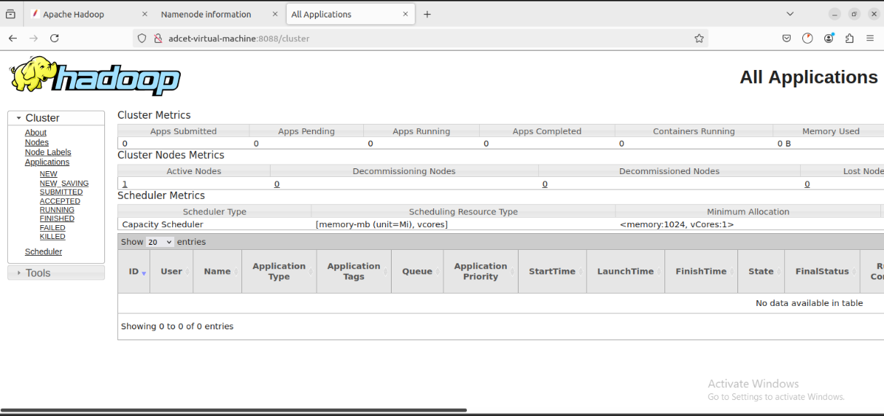
- Ooutcomes:
- I Learned and understood about Hadoop and HDFS.
- Downloaded and installed the Latest Version of Hadoop.
- Downloaded and installed the Latest Version of JDK and JRE.
- Configured environment variables.

