Experiment No. 1

Title: Introduction to Cloud Computing

Objective:
- To Learn about the basics of Cloud computing.(Meaning and Definition)
- To know the various cloud computing technique available
- To create a Dashboard in one cloud computing platform.

Q.1 What is cloud Computing?
Cloud computing is a general term for the delivery of hosted computing services and IT resources over the internet with pay-as-you-go pricing. Users can obtain technology services such as processing power, storage and databases from a cloud provider, eliminating the need for purchasing, operating and maintaining on-premises physical data centers and servers.

Q.2 Various Cloud Computing Service providers?
- Amazon Web Services
- Microsoft Azure
- Google Service Provider
- Oracle Cloud
- IBM Cloud
- Linode

Q.3 Characteristics of Cloud Computing?
- Self-service provisioning. End users can spin up compute resources for almost any type of workload on demand.
- Elasticity. Companies can freely scale up as computing needs increase and scale down as demands decrease. This eliminates the need for massive investments in local infrastructure, which might not remain active.
- Pay per use. Compute resources are measured at a granular level, letting users pay only for the resources and workloads they use.
- Migration flexibility. Organizations can move certain workloads to or from the cloud or to different cloud platforms automatically.
- Broad network access. A user can access cloud data or upload data to the cloud from anywhere with an internet connection using any device.
- Multi-tenancy and resource pooling. Multi-tenancy lets several customers share the same physical infrastructures or the same applications, yet still retain privacy and security over their own data. With resource pooling, cloud providers service numerous customers from the same physical resources. The resource pools of the cloud providers should be large and flexible enough so they can service the requirements of multiple customers.
- Security. Security is integral in cloud computing and most providers prioritize the application and maintenance of security measures to ensure confidentiality, integrity and availability of data being hosted on their platforms. Along with strong security features, providers also offer various compliance certifications to ensure that their services adhere to industry standards and regulations.
Q.4 Difference between Cloud Services?
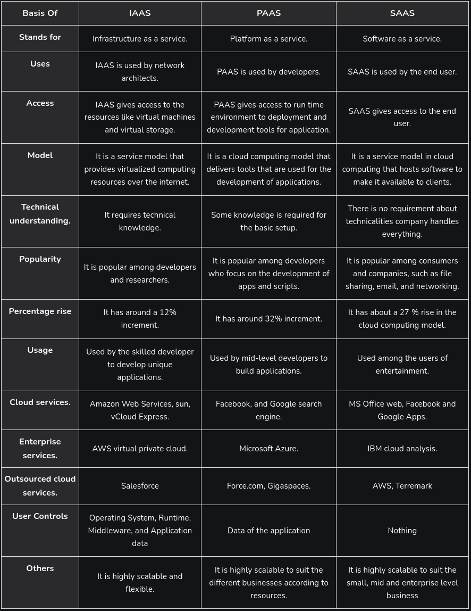

Q.5 Do programming Skills required for Cloud Services Justify.
Yes, programming skills are often required for working with cloud services. They are essential for automating infrastructure, developing cloud applications, setting up DevOps pipelines, and integrating cloud services through APIs. Skills in languages like Python, JavaScript, and shell scripting are particularly important for tasks such as managing resources, creating serverless functions, and automating processes in cloud environments.

Q.6 What is a Network Simulator?
Network simulation is one of the methods used in computer network research work. And in this, there is a software program that examines the various network entities’ relationships and then forms the network performance. And various network entities include switch, links, nodes, routers, and access points. In the analysis lab, there is a monitoring of the services, different applications, supports, and performance of the network. For evaluation of network or protocol performance in different conditions, various surrounding features can also be modified in the controlled environment.

Q.7 What is the difference between Distributed and Cloud Computing?
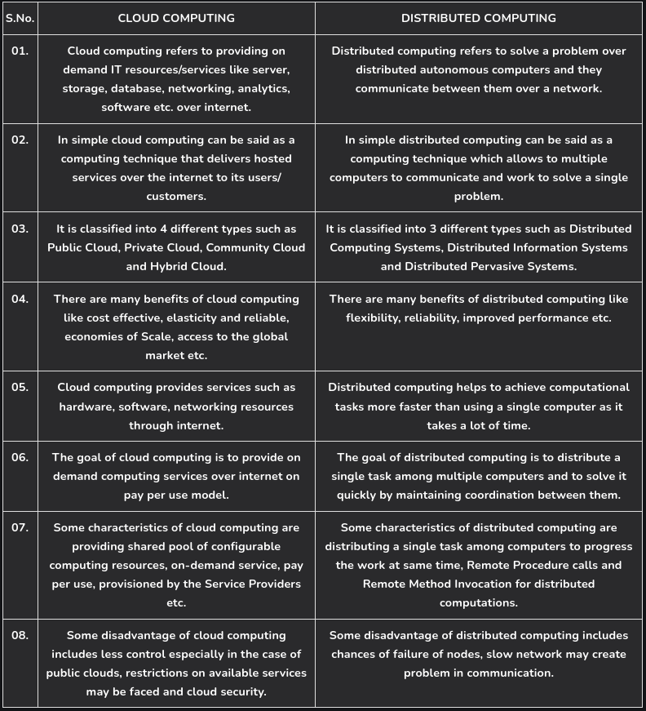

Additional Learning:
- Differences between the Cloud Services.
- Coding Skills are required for Cloud Computing.

Outcomes:
1. I have an understanding of cloud computing.
2. I came to know about various platform:
a. Google Cloud
b. Microsoft Azure
c. AWS

Experiment No. 2
Title: Install Virtual Box / VMware Workstation with different flavors of Linux or Windows OS on top of windows 7 or 8.

Objectives :-
To learn and understand about virtualization
To understand how it is applied in local visions or systems .
To install a virtual box and workstation.
Using,VM install one service(PAAS).

Theory:-
What is virtualization?
🡪We can only see but we cannot touch and feel .In simple terms, "virtualization" means creating a digital copy or simulation of something real, like a computer, so that you can use multiple versions of it on a single physical device, essentially acting like you have multiple computers even though you only have one; think of it like having multiple "virtual rooms" within a single physical room, each with its own distinct purpose and environment.

WHAT IS VIRTUALISATION IN CC?
🡪 Virtualization is a technology that creates virtual versions of physical hardware, like servers, storage, and networks. It's a key component of cloud computing that allows for more efficient use of resources.
Virtualization is used to create a virtual version of an underlying service With the help of Virtualization, multiple operating systems and applications can run on the same machine and its same hardware at the same time, increasing the utilization and flexibility of hardware. It was initially developed during the mainframe era.

Installation of virtual box and workstation.

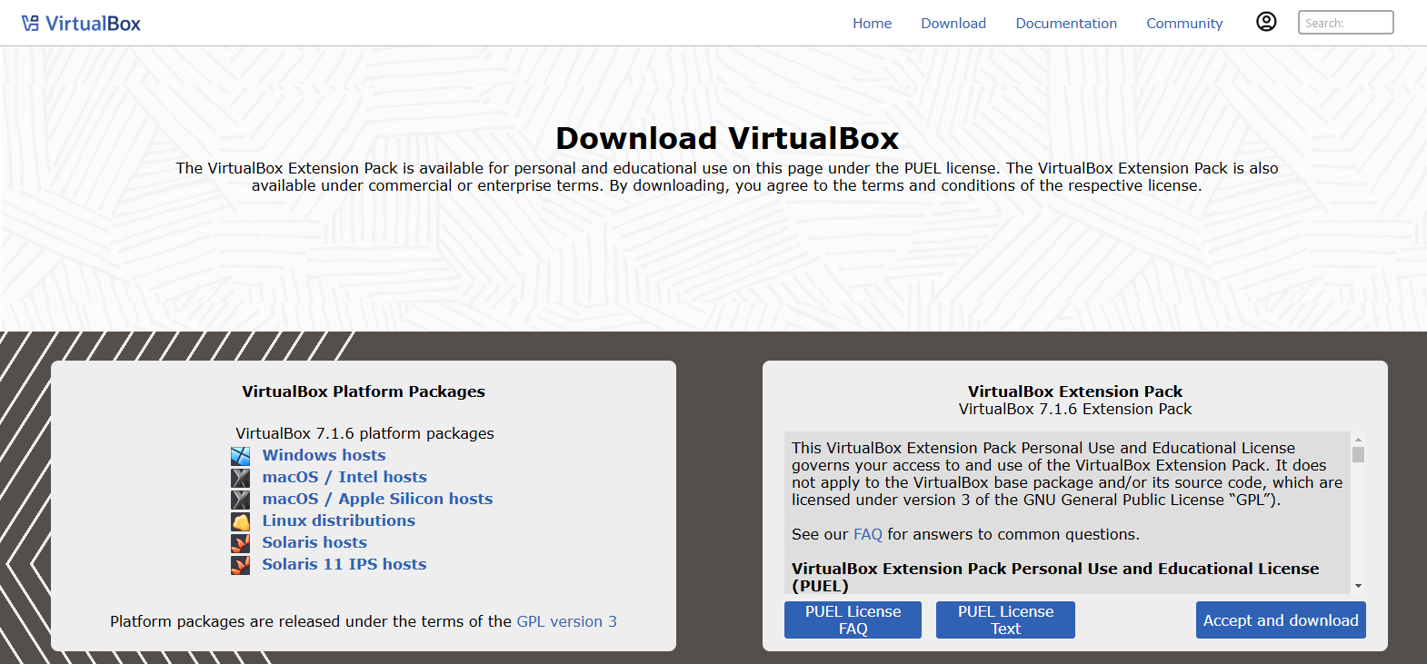
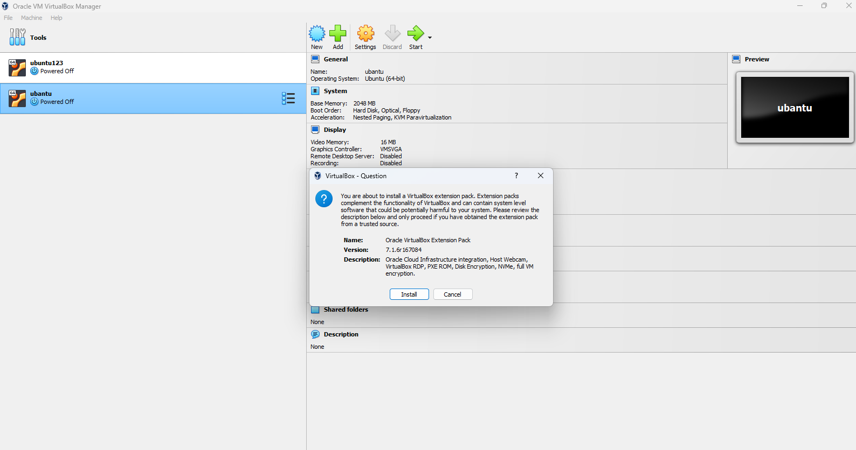

Using ,VMware install one service, (PAAS).
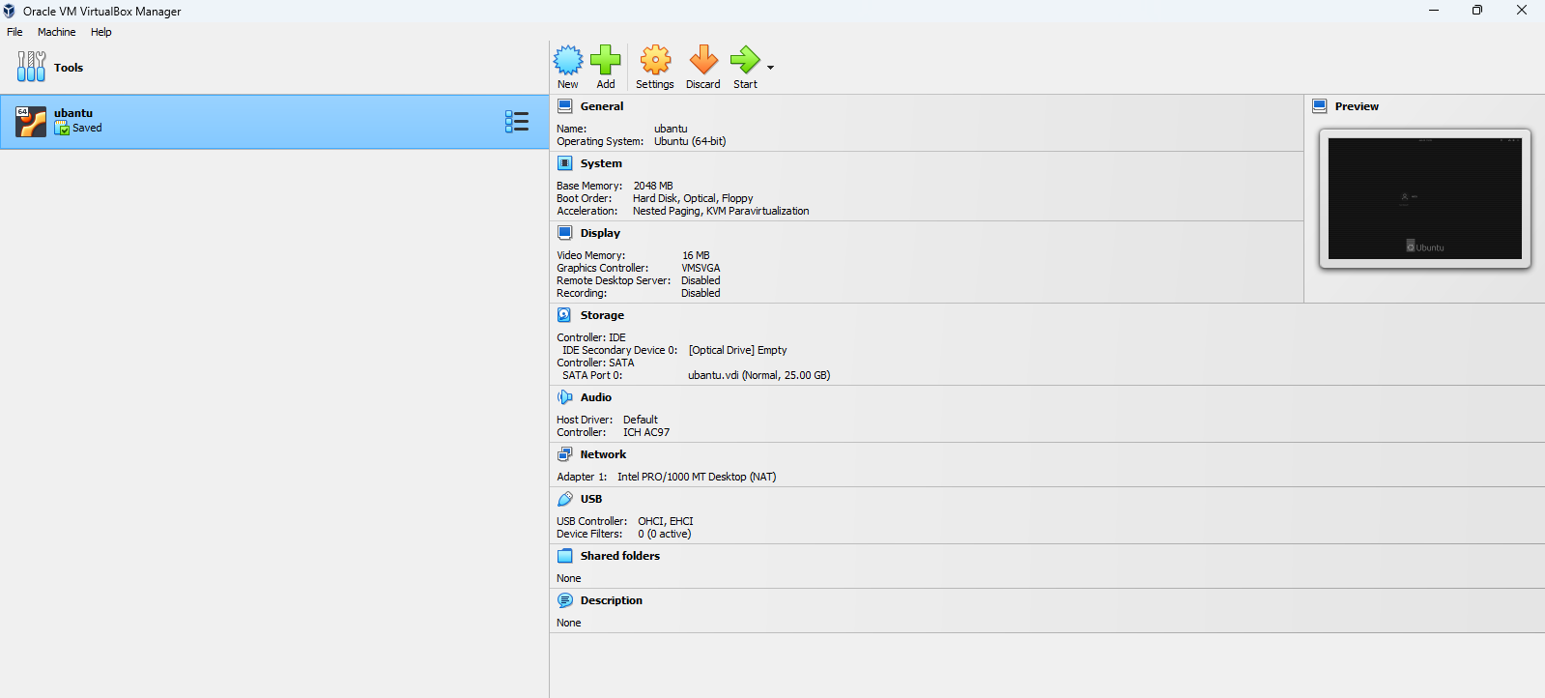

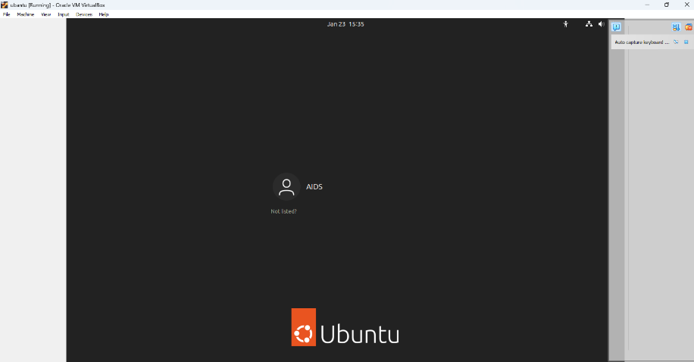

Additional learning:-
1)What is diskimg?
🡪 A disk image file is a compressed copy of a computer's hard drive or other storage media. It contains all the data and structure information from the original storage device.
2)Microsoft office comes under which cc service?
🡪 saas(software as a service).
3)Tools available for virtualization?
🡪 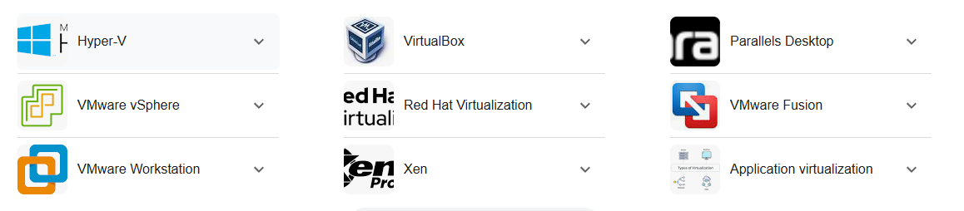

RESULT:-
Thus we studied about virtualization and also installed VMware workstation & installed a PAAS service using VMware workstation.

EXPERIMENT NO. : 03
TITLE: Install a C compiler in the virtual machine created using virtual box and execute simple program.

What is a virtual machine?
A Virtual Machine (VM) is a compute resource that uses software instead of a physical computer to run programs and deploy apps. One or more virtual “guest” machines run on a physical “host” machine. Each virtual machine runs its own operating system and functions separately from the other VMs, even when they are all running on the same host. This means that, for example, a virtual MacOS virtual machine can run on a physical PC.
Virtual machine technology is used for many use cases across on-premises and cloud environments. More recently, public cloud services are using virtual machines to provide virtual application resources to multiple users at once, for even more cost efficient and flexible compute.

Creating services in virtual machine:
- Edit the VirtualMachine manifest to add the label for service creation.
- Save the VirtualMachine manifest file to apply your changes.
- Create a Service manifest to expose the VM
- Save the Service manifest file.
- Create the service by running the following command
- Start the VM. If the VM is already running, restart it.

3 services:
- Virtual machine can offer 3 basic services:
- Infrastructure as a Service(IaaS)(CPU,memory,storage)
- Platform as a Service(PaaS)(windows,linux,mac,android)
- Application as a Service(AaaS)(office,3D designing,etc.) and also it is compatible to programming languages such as c,cpp,java,python and much more

Infrastructure as a Service [IaaS]:
Infrastructure as a service (IaaS) is a service model that delivers computer infrastructure on an outsourced basis to support various operations. Typically IaaS is a service where infrastructure is provided as outsourcing to enterprises such as networking equipment, devices, database, and web servers.
It is also known as Hardware as a Service (HaaS).

Platform as a Service[PaaS]:
PaaS is a category of cloud computing that provides a platform and environment to allow developers to build applications and services over the internet. PaaS services are hosted in the cloud and accessed by users simply via their web browser.

Application as a Service[AaaS]:
"Application as a Service" (AaaS) refers to a cloud-based model where users access and utilize applications hosted on a remote server, without needing to install, manage, or maintain the software on their own devices.

Additional learning
Basic commands in linux:
- sudo apt install
- ls
- man

Operations of file:
- Creation
- Editing
- append
- delete

Directory operations:
- create
- add subfolders on file
- changing privilges
- delete

OUTCOMES:
- I learned how to set up and manage a virtual machine.
- I came to know how to create and configure various services within a virtual machine.
- I understood the concepts of Infrastructure-as-a-Service (IaaS), Platform as a Service (PaaS), and how to install and manage operating systems and applications within a virtual machine.
- I learned how to install a C compiler on a Linux virtual machine and create a simple arithmetic calculator using a C program.

OUTPUT:
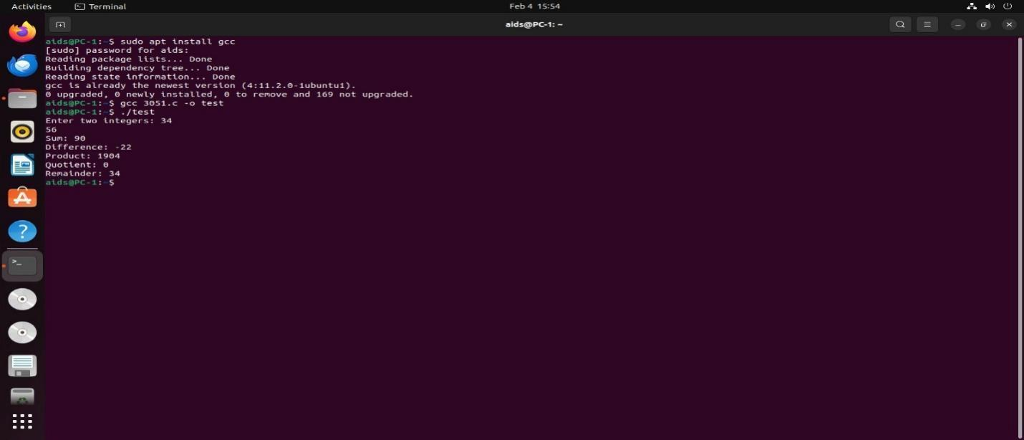
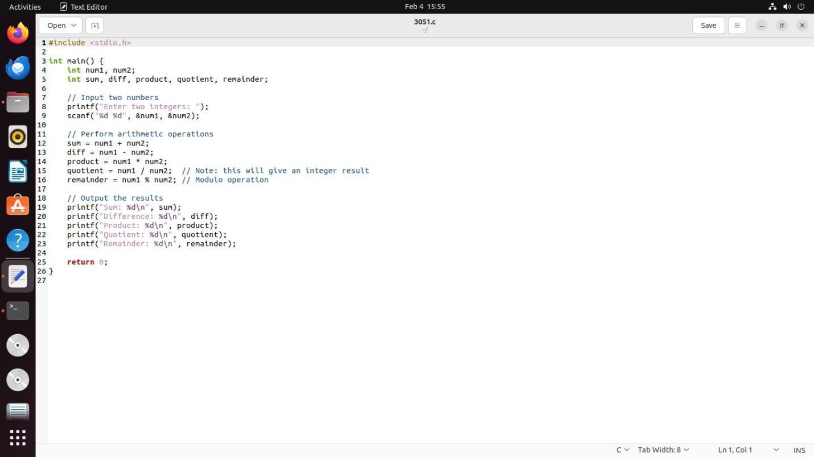

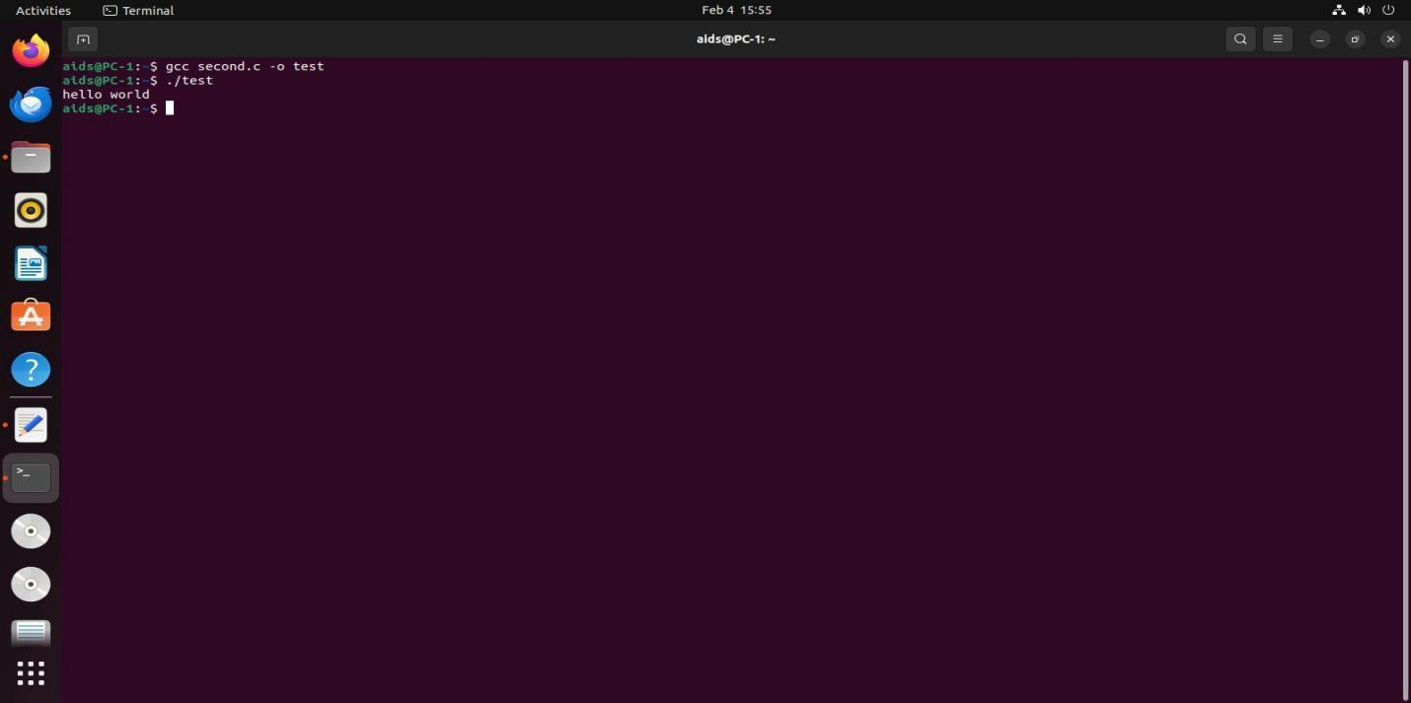

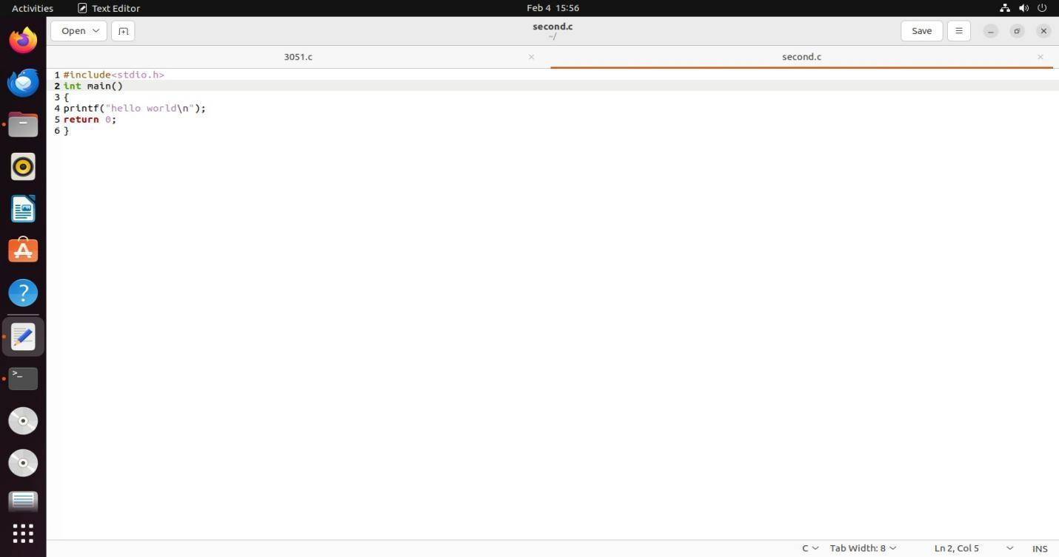

RESULT: Thus the simple hello world! c program and calculator c program is executed successfully.

Experiment No.4
Title: Installing Google App Engine, Creating a Hello World App, and Developing Simple Web Applications Using Python/Java
Objective:

Objective:-
  - To know understand about the google cloud
  - To create a google cloud dashboard(upi or debit card free and no auto deduction mood)
  - To learn and understand google cloud services.
  - Installation of google app engine.
  - To run program and application using google cloud engine.
Theory:
Google App Engine (GAE) is a platform as a service (PaaS) that allows developers to build and deploy web applications on Google's infrastructure. It supports multiple programming languages, including Python, Java, PHP, and Go. With GAE, developers can focus on writing code without worrying about managing servers or scaling their applications.
GAE automatically handles traffic distribution, load balancing, and scaling based on the application's needs. It also integrates with other Google Cloud services, such as Cloud Storage, Datastore, and Firestore.
Installation of Google App Engine:
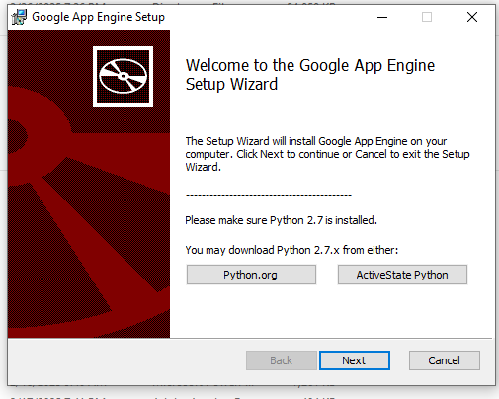
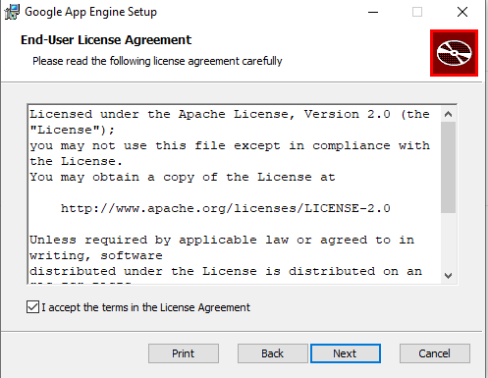
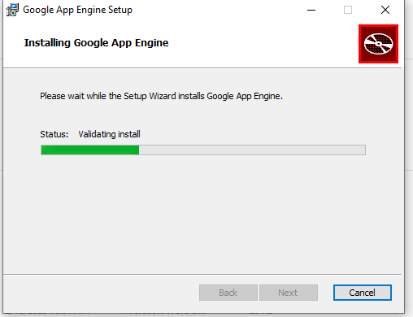
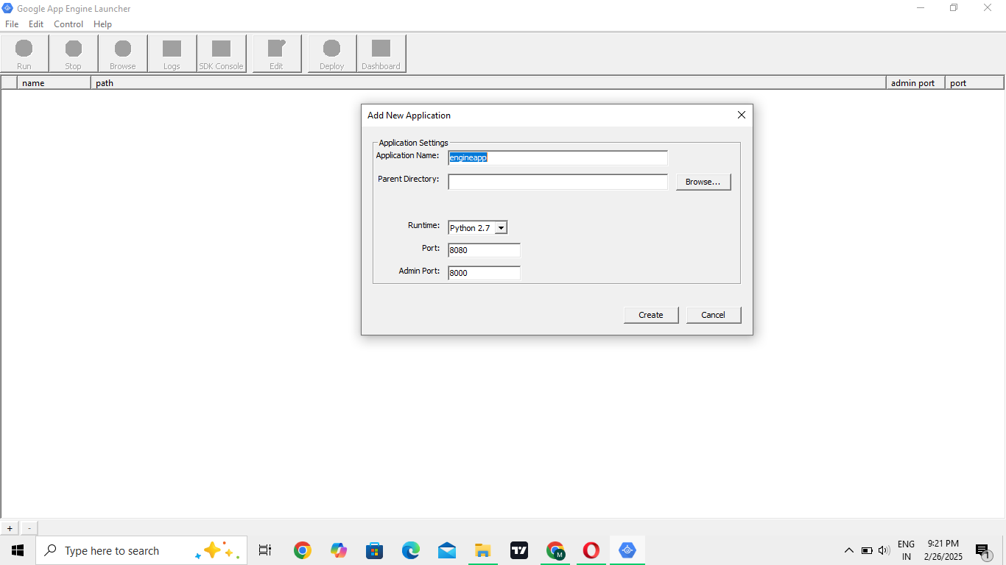

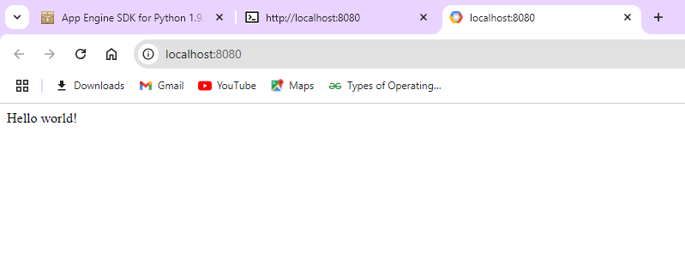

- RESULT:
To install Google App Engine (GAE), first install the Google Cloud SDK and set up your project in the Google Cloud Console. Then, deploy a simple "Hello World" app by creating a Python or Java web application, configuring it, and deploying it using the gcloud app deploy command.

Experiment No 5
Title: To launch the web applications by using the GAE launcher.

Objectives:
- Set up Google App Engine (GAE) environment for web application deployment.
- Configure the web application to be compatible with GAE's deployment structure.
- Create and organize the application’s configuration files (e.g., app.yaml).
- Implement necessary backend services and ensure they meet GAE requirements.
- Test the application locally using the GAE launcher to ensure proper functionality.
- Deploy the application to Google Cloud using the GAE launcher for production.

Theory:

1.Simulation and simulation environment
- Simulation
A model of a set of problems or events that can be used to teach someone how to do something, or the process of making such a model.
- Simulation environment
A simulation environment is a virtual space that mimics a real-world system or process. It's created using a computer program and can be used to analyze, design, and optimize systems.
2.Differences between simulation, emulation, virtualization

1. Simulation:
- Creates a conceptual model of a system, often used to analyze complex scenarios and predict outcomes by manipulating variables within the model.

- Can be highly detailed, including internal workings and interactions between components.

- Examples: simulating a traffic flow in a city, simulating a chemical reaction in a lab.

2. Emulation:
- Aims to replicate the behavior of a specific hardware or software system, allowing you to run software designed for one platform on another.

- Focuses on achieving the same results as the original system without necessarily mimicking its internal logic.

- Example: using an emulator to play a game designed for a different console on your current system.

3. Virtualization:
- Creates virtual instances of physical hardware, allowing multiple operating systems to run concurrently on a single physical machine by partitioning resources.

- Primarily used for efficient resource management and to isolate different applications from each other.

- Example: setting up multiple virtual servers on a single physical server to host different websites.

Procedures:
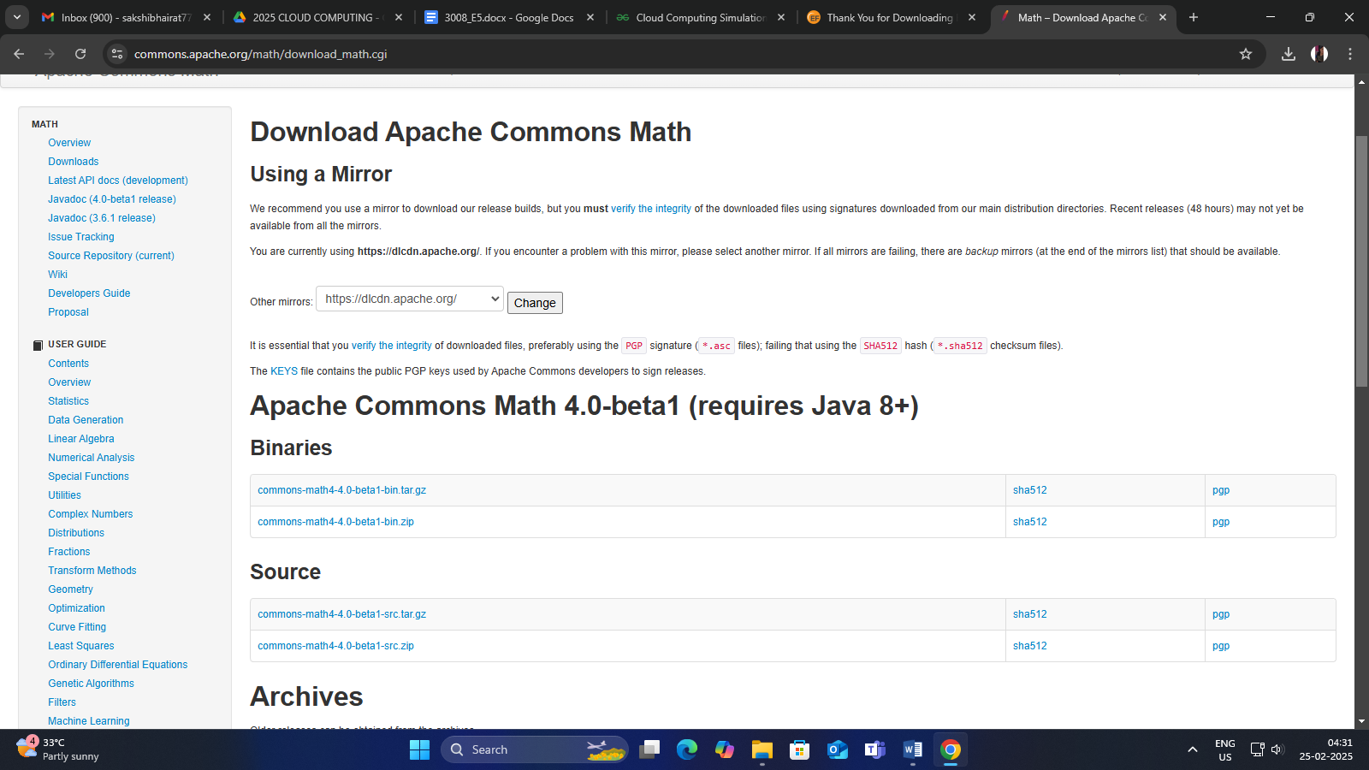

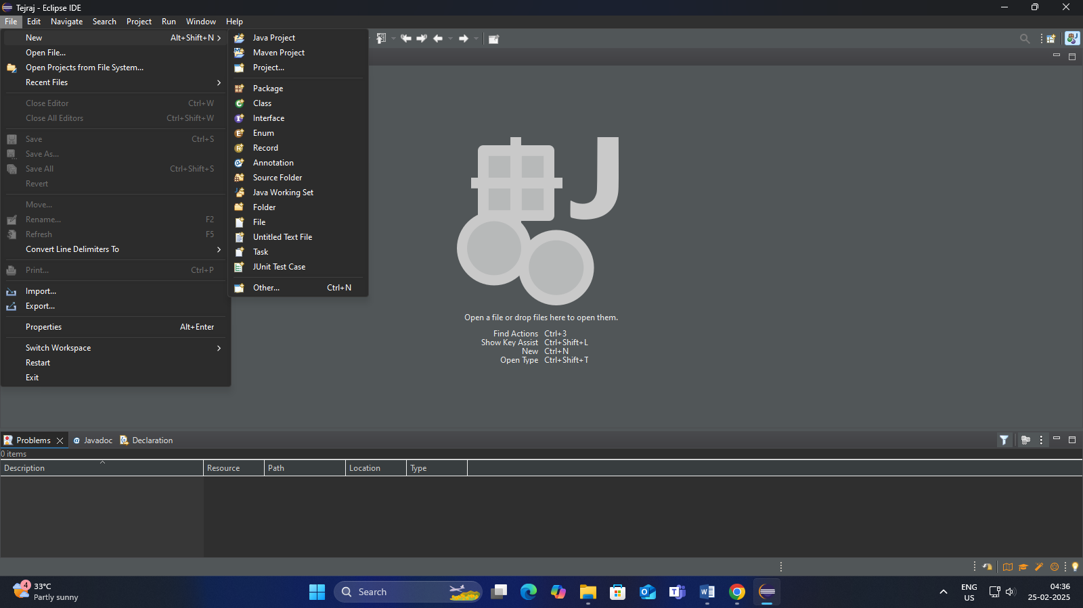

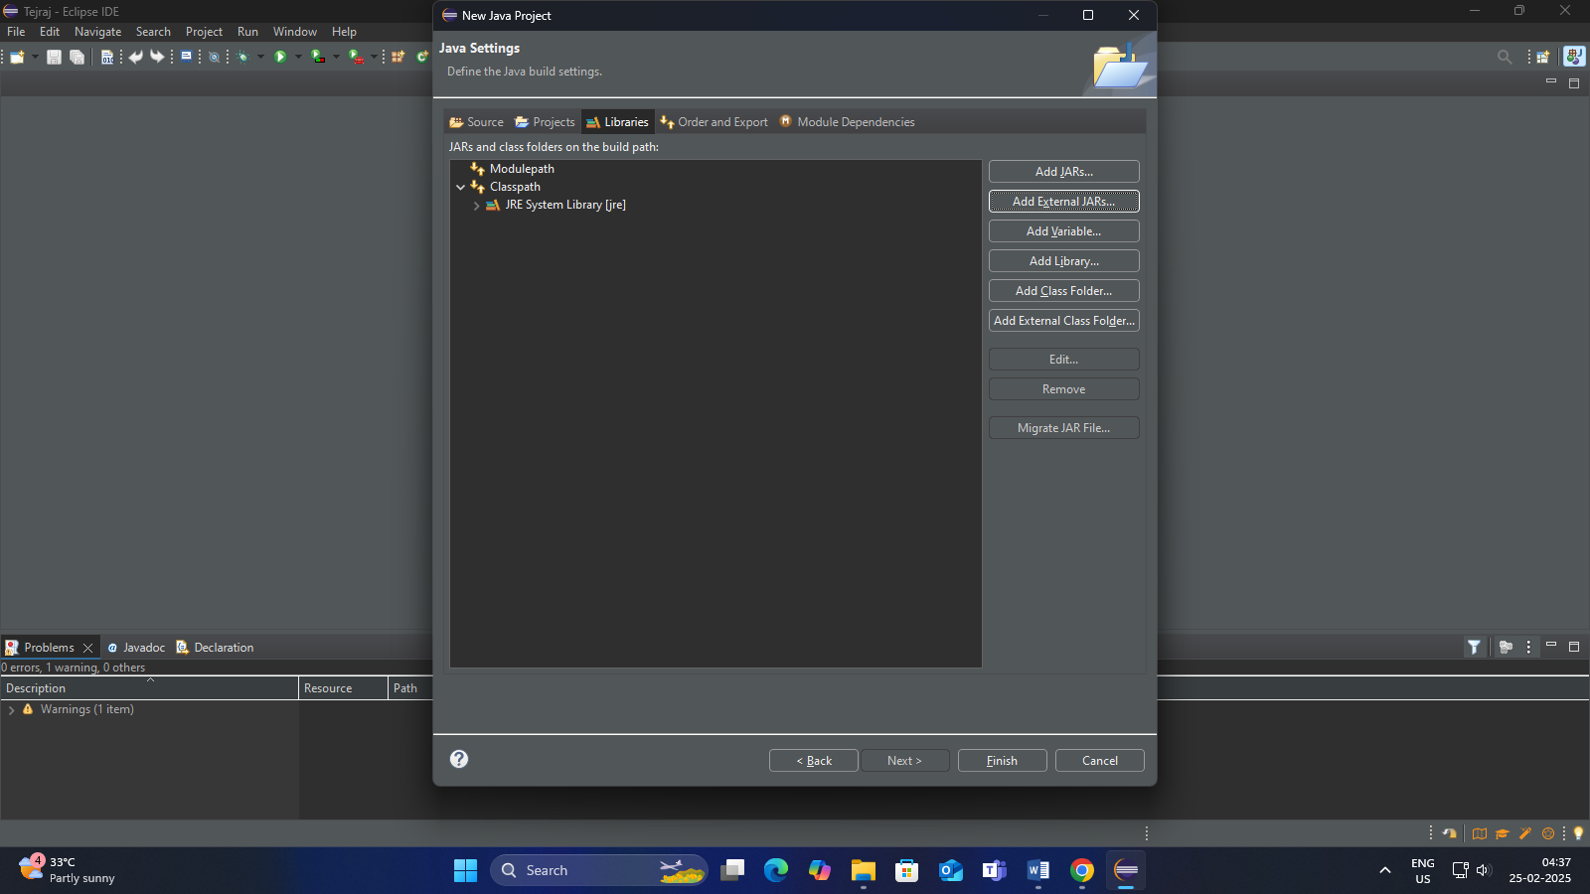
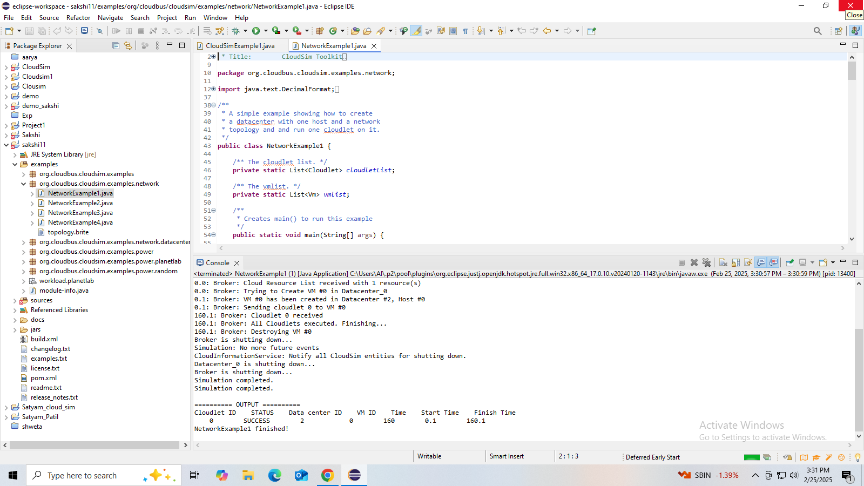

Outcomes:
- I learned and understand about simulation environment.
- I came to know about the differences between simulation, emulation, virtualization
- I came to know about how to download and install cloud simulator (windows, Linux).
- I learned about creating an application or program in the simulated environment.
- I learned about how to fetch result in the simulated environment.

Result:
Thus the simulation of a cloud scenario using CloudSim and run a scheduling algorithm that is not present in CloudSim is done and the output is obtained successfully.

Experiment No. 6
- Title: Find a procedure to transfer the files from virtual machine to Host machine.
- Objectives:
- To open the virtual machine in a network using VirtualBox.
- To Assign The IP Address For Virtual Machine.
- Create a shared folder in a virtual machine / host machine.
- Test the connectivity by ping command.
- Copy the files from vm to host.
- Theory:
Virtual Machine:
A Virtual Machine (VM) is a software-based emulation of a physical computer. It runs an operating system and applications just like a physical computer, but it's hosted on a real physical machine called the host. The VM itself is called the guest.
Ping Command:
The ping command is a network utility used to test connectivity between your computer and another device (like a website or server) over a network.
When you run ping, your computer sends ICMP (Internet Control Message Protocol) echo request packets to the target IP address or hostname.
If the target is reachable, it replies with echo reply packets.
Installation Steps:
Step 1: install ssh server in VMware
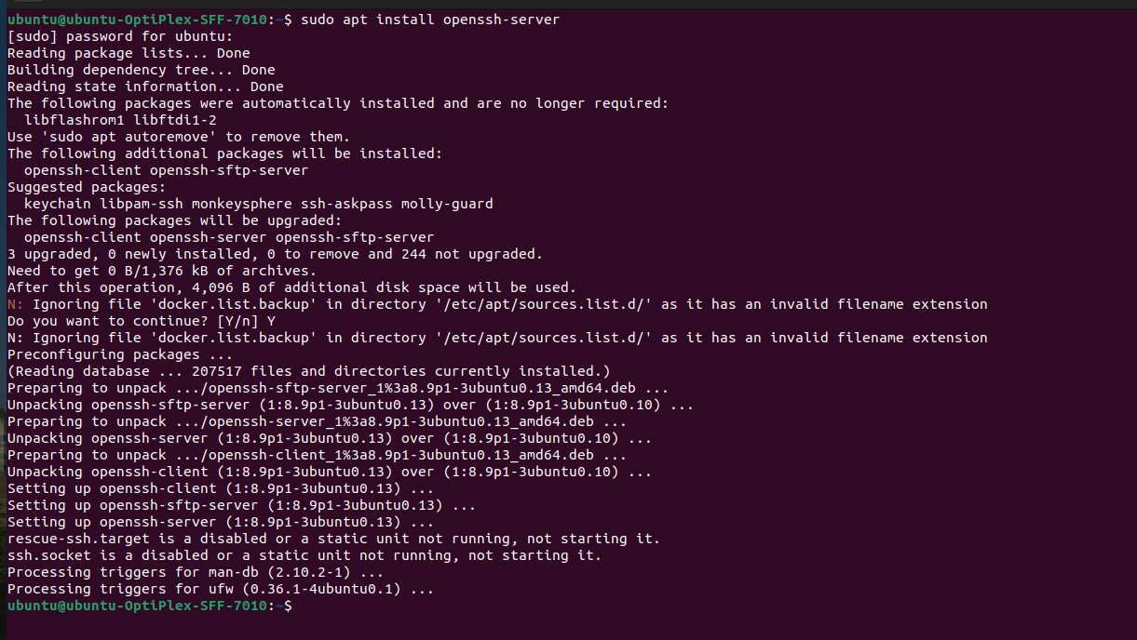
Step 2: Enable ssh server in Ubuntu
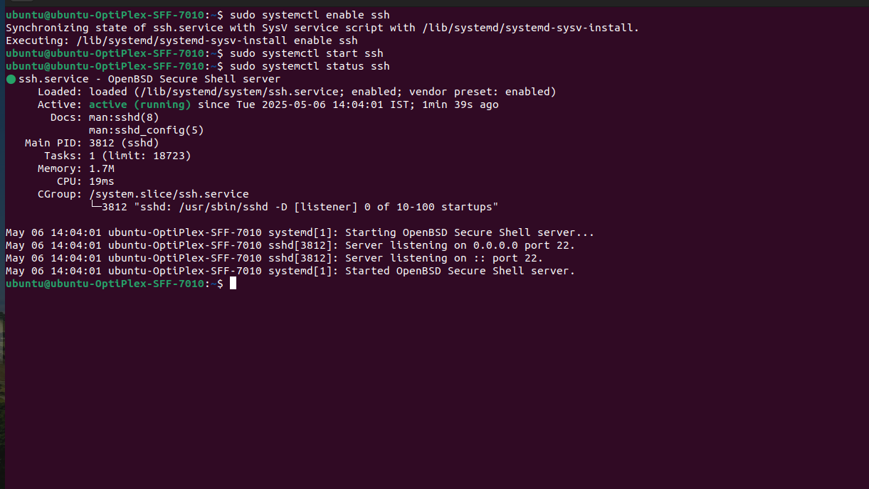
Step 3: Copy the file to the VM using command line
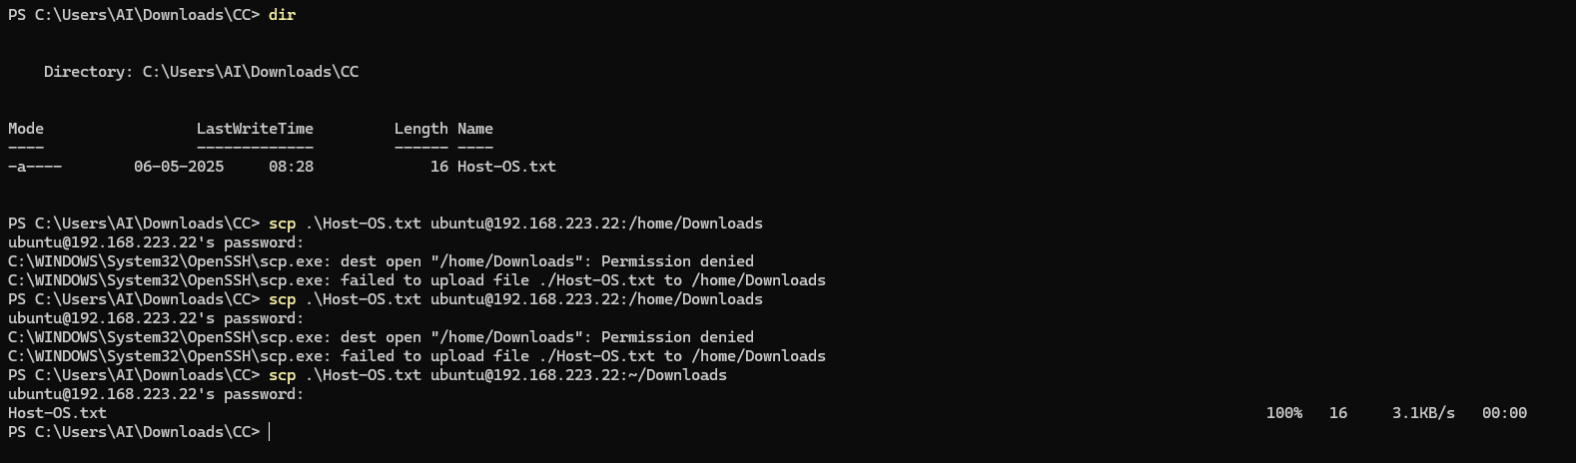
Step 4: Transfer Files successfully
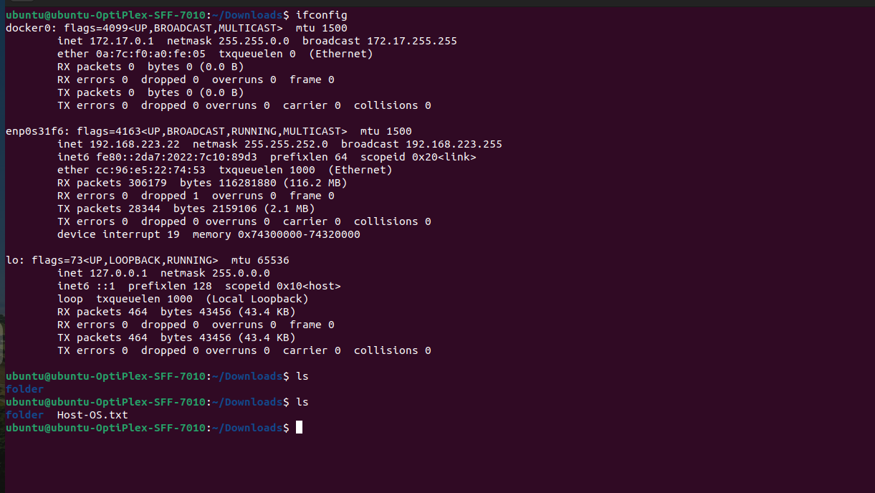

- Ooutcomes:
Successfully learn to find a procedure to transfer the files from one virtual machine to another virtual machine.

Experiment No. 7
- Title: Find a procedure to launch a virtual machine using trystack (Online Openstack Demo Version).
- Objectives:
- Creating and using a local OpenStack environment.
- Access The Dashboard of OpenStack.
- Launch VM Using the OpenStack Dashboard.
- Theory:
TryStack:
TryStack was a free, public OpenStack sandbox, a community-maintained OpenStack cloud, designed to allow users to experiment with OpenStack and test applications without needing their own hardware. However, it has been discontinued.
OpenStack:
OpenStack is an open-source cloud operating system that provides Infrastructure-as-a-Service (IaaS) functionality, allowing organizations to build and manage both public and private clouds by managing compute, storage, and networking resources.
Steps:
Use DevStack for a Local OpenStack Environment
DevStack is a lightweight way to install OpenStack on your local machine, mainly for development and testing. Here’s a basic outline:
- Prepare Your Machine:
- Use a Linux environment, ideally Ubuntu 20.04 or a later version.
- Ensure that you have at least 8GB of RAM, 2 vCPUs, and enough storage (at least 20GB free).
- Clone the DevStack Repository:
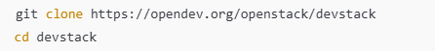
- Configure DevStack:
Create a configuration file named local.conf:

or Add the following configuration to the file:
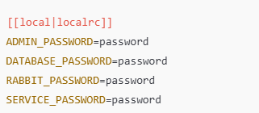
- Run the Installation:
- Access OpenStack Dashboard:
- Once DevStack has finished, open a browser and go to http://localhost/dashboard.
- Log in with the username admin and the password you set in local.conf.
- Launch a VM in the Dashboard:
- Navigate to the “Project” tab > “Compute” > “Instances.”
- Click “Launch Instance” and configure your VM, such as selecting an image, flavor, network, etc.
- Click “Launch” to start the VM.
- Access the Dashboard:
Open a browser and go to http://<vm-ip-address>/dashboard.

- Outcomes:
Successfully learn to find a procedure to launch virtual machine using trystack (Online Openstack Demo Version).

Experiment No. 8
- Title: Install Hadoop Single Node Cluster and Run Simple Application.
- Objectives:
- To learn and understand about Hadoop and HDFS.
- Downloading and installing the Latest Version of Hadoop.
- Downloading and installing the Latest Version of JDK and JRE.
- Configuring environment variables.
- Formatting the node names.
- Theory:
Apache Hadoop is a framework for processing and storing big data. It is designed to be deployed across a network of hundreds or even thousands of dedicated servers. All these machines work together to deal with the massive volume and variety of incoming datasets.
Deploying Hadoop services on a single node is a great way to get acquainted with basic commands and concepts.
Installation Steps:
- Install JDK using command – ‘sudo apt install openjdk-11-jdk’
- Create Hadoop user using command ‘sudo adduser hadoop’
- Switch to the newly created user
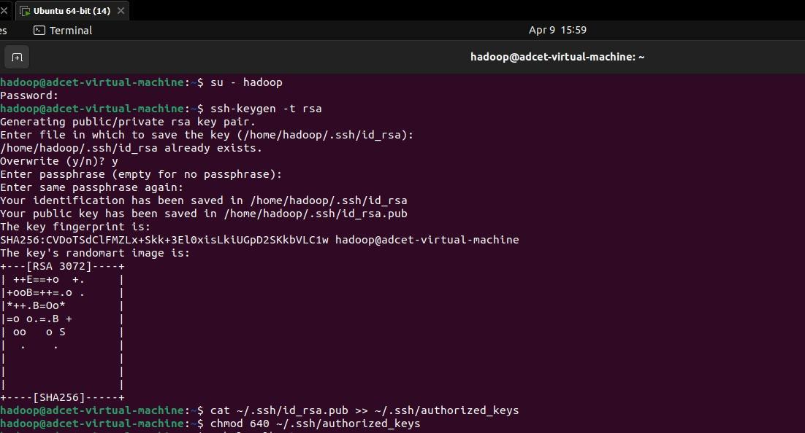
- Generate an SSH key pair and define the location it is to be stored in

- Use the cat command to store the public key as authorized_keys in the ssh directory:

- Set the file permissions for your user with the chmod command:

- Verify everything is set up correctly by using the hdoop user to SSH to localhost:’ssh localhost’
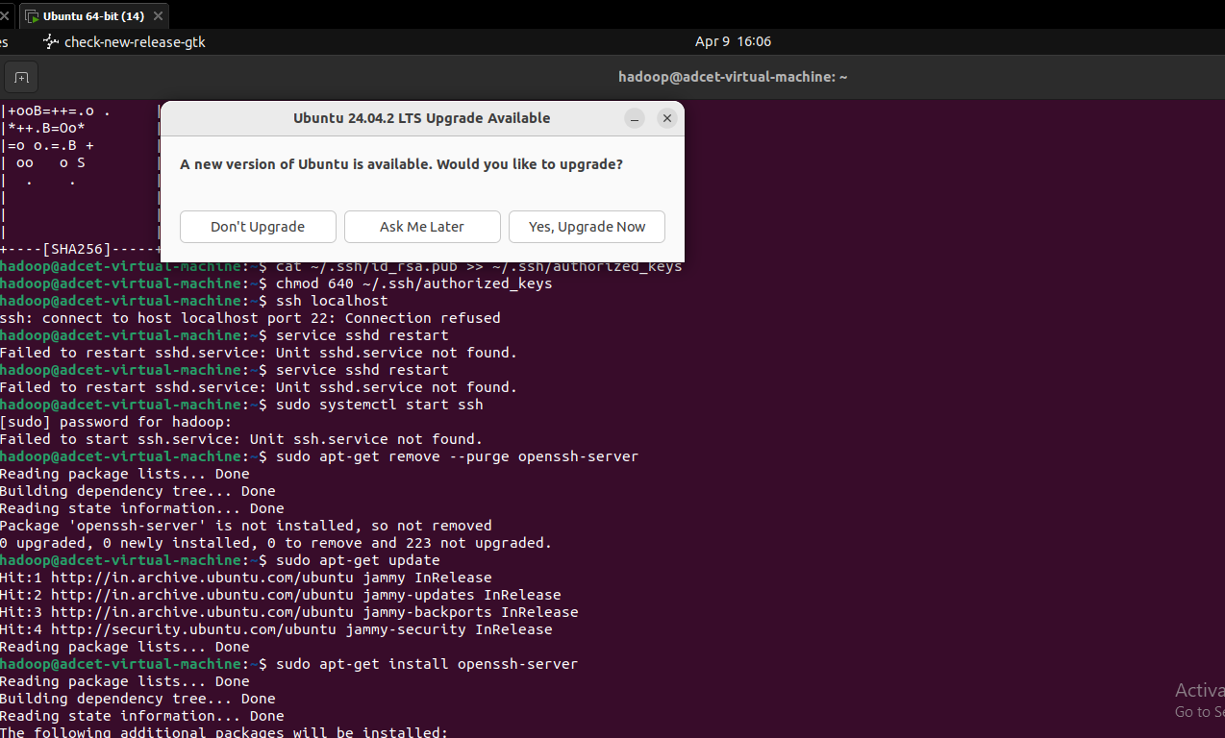
- Download and install hadoop on ubuntu
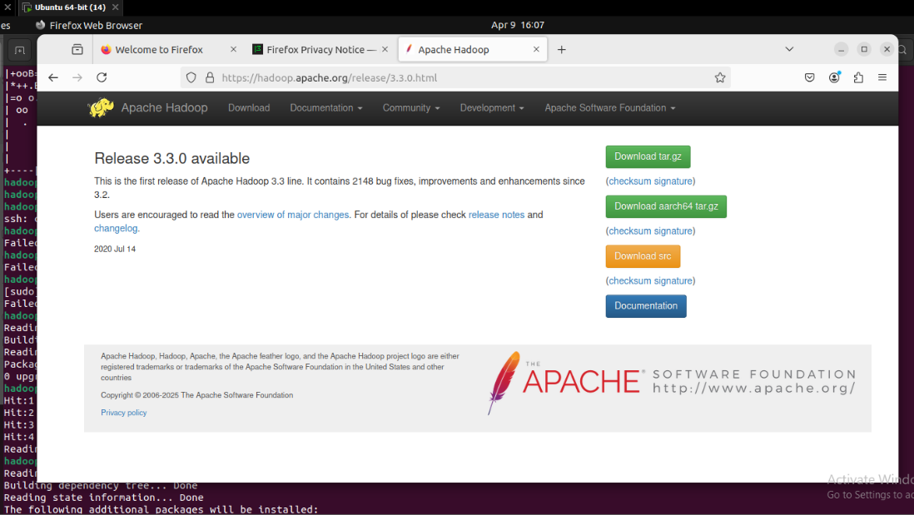
- Configure a Hadoop environment by editing a set of configuration files:
-.bashrc
-hadoop-env.sh
-core-site.xml
-hdfs-site.xml
-mapred-site-xml
-yarn-site.xml
- Format HDFS namenode

- Start the hadoop cluster
- Execute the following command to start the NameNode and DataNode
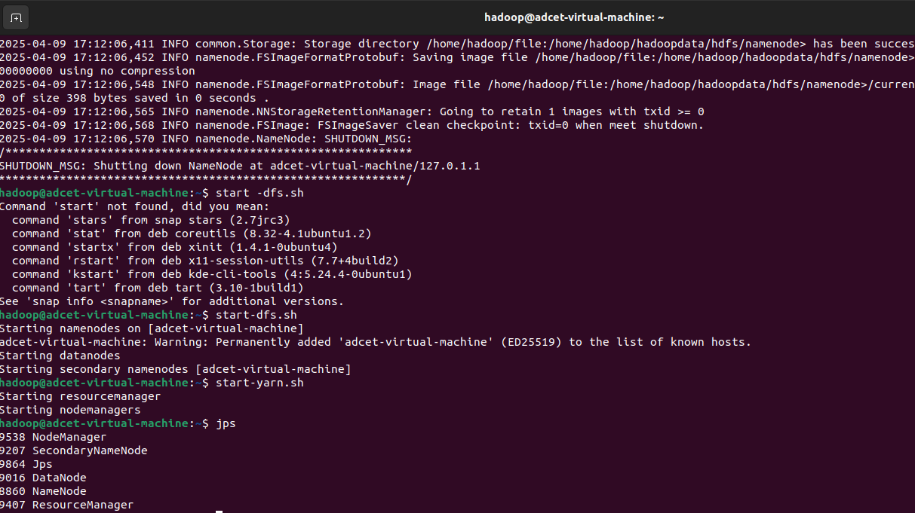
- Once the namenode, datanodes, and secondary namenode are up and running, start the YARN resource and nodemanagers by typing:

- Run the following command to check if all the daemons are active and running as Java processes:


- Access hadoop from the browser
- The NameNode user interface provides a comprehensive overview of the entire cluster.
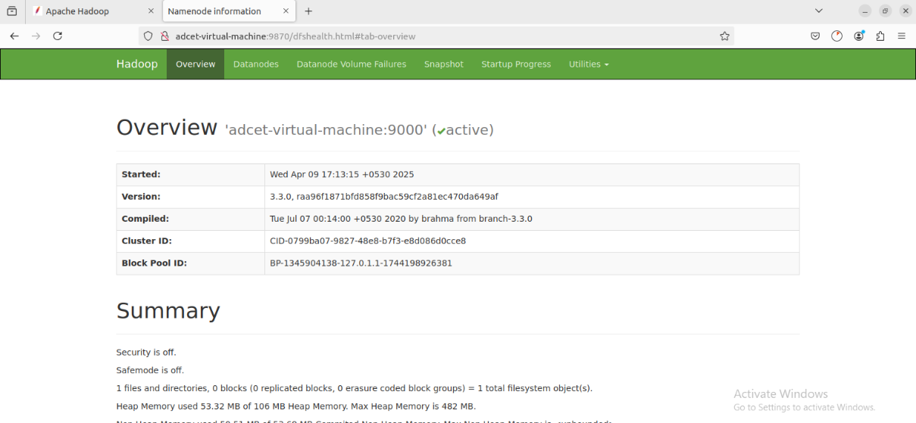
- The Resource Manager is an invaluable tool that allows you to monitor all running processes in your Hadoop cluster.
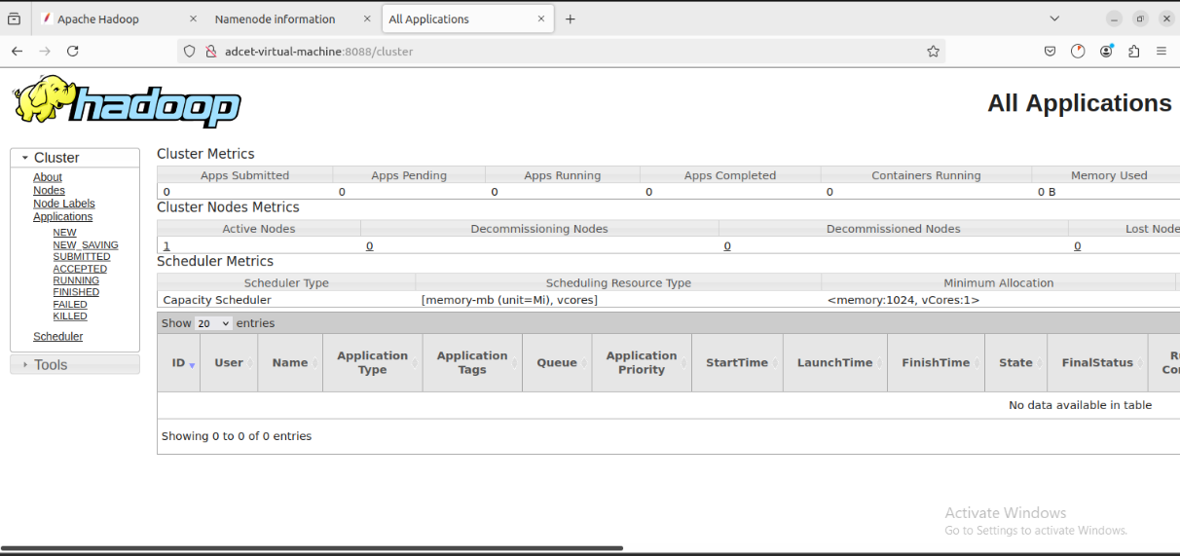
- Ooutcomes:
- I Learned and understood about Hadoop and HDFS.
- Downloaded and installed the Latest Version of Hadoop.
- Downloaded and installed the Latest Version of JDK and JRE.
- Configured environment variables.

Experiment No - 09

- Title - Perform Case study on Platform as a service for Google app engine/ Facebook .

Objectives -
  - To learn and understand the different models of cloud computing Iaas, Pass, Saas.
  - To know in detail about platform as a service.
  - To learn and understand the basics of Google App Engine (GAE).
  - To learn and understand the Overview of Facebook
  - To implement or deploy or test any one platform as a service.

Different modules of cloud computing -

  - Infrastructure as a Service (IaaS) : IaaS delivers on-demand infrastructure resources, such as compute, storage, networking, and virtualization. With IaaS, the service provider owns and operates the infrastructure, but customers will need to purchase and manage software, such as operating systems, middleware, data, and applications.

  - Platform as a Service (PaaS) : PaaS delivers and manages hardware and software resources for developing, testing, delivering, and managing cloud applications. Providers typically offer middleware, development tools, and cloud databases within their PaaS offerings.
  - Software as a Service (SaaS) : SaaS provides a full application stack as a service that customers can access and use. SaaS solutions often come as ready-to-use applications, which are managed and maintained by the cloud service provider.

Platform as a Service (PaaS) -
Platform as a Service, also known as PaaS, is a type of cloud computing service model that offers a flexible, scalable cloud platform to develop, deploy, run, and manage apps. PaaS provides everything developers need for application development without the headaches of updating the operating system and development tools or maintaining hardware. Instead, the entire PaaS environment—or platform—is delivered by a third-party service provider via the cloud.
PaaS helps businesses avoid the hassle and cost of installing hardware or software to develop or host new custom applications. Development teams simply purchase pay-as-you-go access to everything they need to build custom apps, including infrastructure, development tools, operating systems, and more.

Advantages -
- Faster time to market
- Low maintenance
- Cost-effective pricing
- Flexible access
- Shared security

Google App Engine (GAE) -
A scalable runtime environment, Google App Engine is mostly used to run Web applications. These dynamic scales as demand change over time because of Google’s vast computing infrastructure. Because it offers a secure execution environment in addition to a number of services, App Engine makes it easier to develop scalable and high-performance Web apps. Google’s applications will scale up and down in response to shifting demand. Croon tasks, communications, scalable data stores, work queues, and in-memory caching are some of these services.
The App Engine SDK facilitates the testing and professionalization of applications by emulating the production runtime environment and allowing developers to design and test applications on their own PCs. When an application is finished being produced, developers can quickly migrate it to App Engine, put in place quotas to control the cost that is generated, and make the programmer available to everyone. Python, Java, and Go are among the languages that are currently supported.

Overview of Facebook –
Facebook is a social networking website that was founded in February 2004 by Harvard University students Chris Hughes, Andrew McCollum, Dustin Moskovitz, Eduardo Saverin and Mark Zuckerberg. The idea behind Facebook was to provide an online book of faces for university students to connect and share information. It was initially a social network for Harvard and expanded in the following years to any university. It eventually became a social network for anyone, anywhere in the world. Users post information, status updates and pictures of themselves on social networks. These items are shared with friends, family and communities of interest.

Implement any one Platform as a Service - Google App Engine (GAE) -
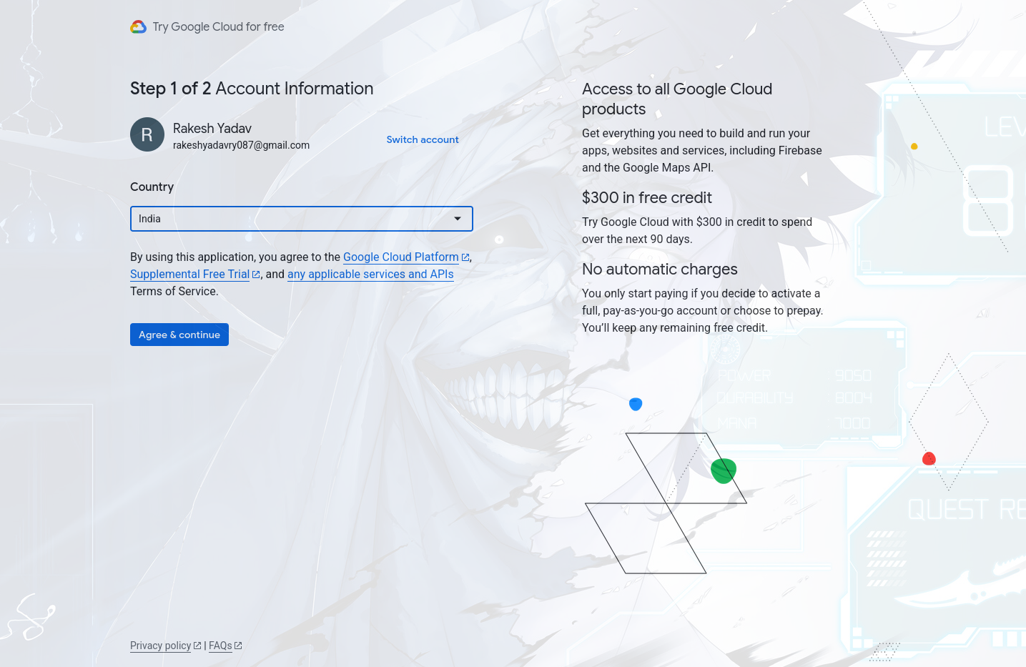
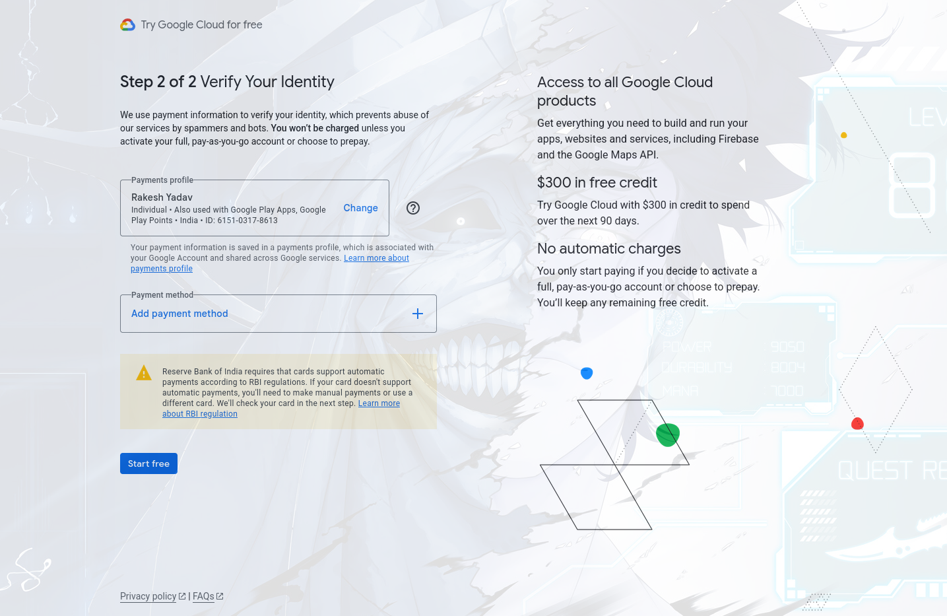

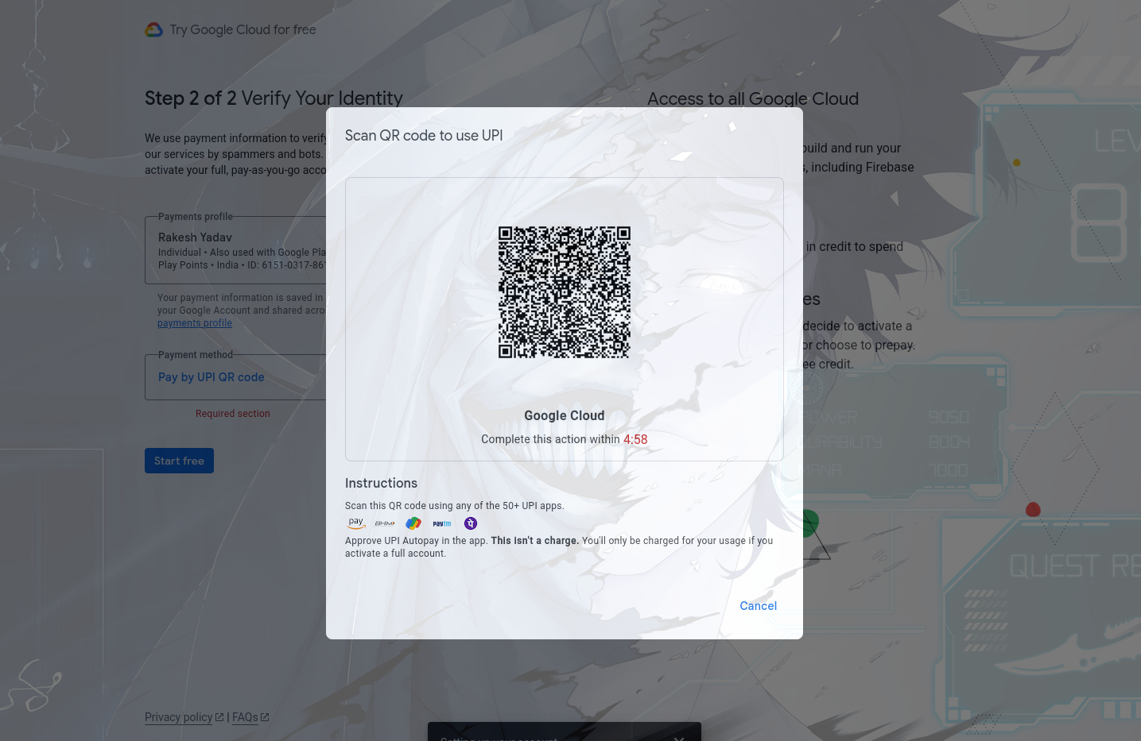

Outcome:-
Successfully learn how to Perform Case study on Platform as a service for Google app engine/ Facebook .

Result:-
Thus, we completed the experiment on Perform Case study on Platform as a service for Google app engine/ Facebook .

Experiment No 10
- Title – Case study on public, private cloud.

- Aim – To case study on public, private cloud.

Objectives –

  - To learn and understand about cloud deployment models (PPH).
  - To learn and understand about public cloud environments.
  - To test / create/ login dashboard in a private cloud.
  - To learn and understand about hybrid computing model.
  - Using various metrics identify best suitable cloud environment (public / private).
  - To test the private cloud in any of this platforms (AWS/ Goggle/ Alibaba/ Azure).

Cloud deployment models (PPH) -
A cloud deployment model fundamentally determines where the infrastructure for your deployment exists and who owns and controls that infrastructure. It also figures out the nature and intention of the cloud. The initial stop for any business seeking to embrace cloud services is to be familiar with the deployment models that are available. When these are familiar, an improved choice can be made as to which avenues the company should pursue. Every model will provide its strengths and weaknesses in governance, scalability, security, flexibility, cost, and management.

  - Public Cloud : The public cloud makes it possible for anybody to access systems and services. The public cloud may be less secure as it is open to everyone. The public cloud is one in which cloud infrastructure services are provided over the internet to the general people or major industry groups. The infrastructure in this cloud model is owned by the entity that delivers the cloud services, not by the consumer. It is a type of cloud hosting that allows customers and users to easily access systems and services.

  - Private Cloud : The private cloud deployment model is the exact opposite of the public cloud deployment model. It’s a one-on-one environment for a single user (customer). There is no need to share your hardware with anyone else. The distinction between private and public clouds is in how you handle all of the hardware. It is also called the “internal cloud” & it refers to the ability to access systems and services within a given border or organization.

  - Hybrid Cloud : By bridging the public and private worlds with a layer of proprietary software, hybrid cloud computing gives the best of both worlds. With a hybrid solution, you may host the app in a safe environment while taking advantage of the public cloud’s cost savings. Organizations can move data and applications between different clouds using a combination of two or more cloud deployment methods, depending on their needs.

Public cloud environments –
A public cloud is an IT model where public cloud service providers make computing services including compute and storage, develop-and-deploy environments, and applications available on-demand to organizations and individuals over the public internet. Public cloud is a type of computing where resources are offered by a third-party provider via the internet and shared by organizations and individuals who want to use or purchase them. Some public cloud computing resources are available for free, while customers may pay for other resources through subscription or pay-per-usage pricing models.
Public clouds contrast with private cloud models, where the resources are available only to a single organization and the data center is managed either on-premises or off-site by a vendor. For organizations looking for an alternative to traditional on-premises IT architectures or other types of cloud computing, the public cloud offers nearly infinite scalability and self-service provisioning to meet workload and user demands.

Advantages of Public Cloud

- Public cloud allows high scalability as the computing resources are available virtually unlimited.
- As the data centers are located across various regions and geographies public cloud provides high availability and fault tolerance to users.
- Public cloud allows use of resources on pay as you go model which provides cost efficiency.

Disadvantages of Public Cloud

- Public cloud is less secure and private as compared to other deployment models as the infrastructure is managed and owned by third party.
- It provides limited control over infrastructure as compared to private cloud deployments.
- Vendor lock in can happen because of using services from single cloud service provider.

Hybrid computing model –
A hybrid cloud combines public and private cloud services, giving businesses the best of both worlds scalability from public clouds and security from private clouds. This setup allows companies to store sensitive data privately while using cost-effective public cloud resources for non-sensitive workloads. For example, in software development, teams often use a public cloud to host projects and a private cloud for secure testing. This approach offers flexibility, cost savings, and better control over data and applications.

Advantages of Hybrid Cloud :

- Flexibility : It provides flexibility to use both cloud environments, such as public and private cloud.
- Security : It provides a private cloud to secure sensitive data or information.
- Cost effective : Hybrid cloud costs are less than those of private cloud. It helps the business or organization save money, which is useful for both application support and infrastructure.

Disadvantages of Hybrid Cloud :

- Slow Internet connection : The internet is complex because of public and private clouds. There is too much load on the server.
- Visibility : There is a visibility issue because of the complications of cloud environments. It breaks the environment into multiple clouds, making it tough to view.
- Implementation : In hybrid clouds, the implementation is difficult because storage and servers are required. That's why the implementation takes a lot of time because of the private and public clouds.

References:-
- Difference between public ,private and hybrid cloud gfg.
- Public and private services and matrix from google cloud.
- Public,private and hybrid cloud from alibaba cloud community.
- Creating alibaba free private cloud.

Steps:-
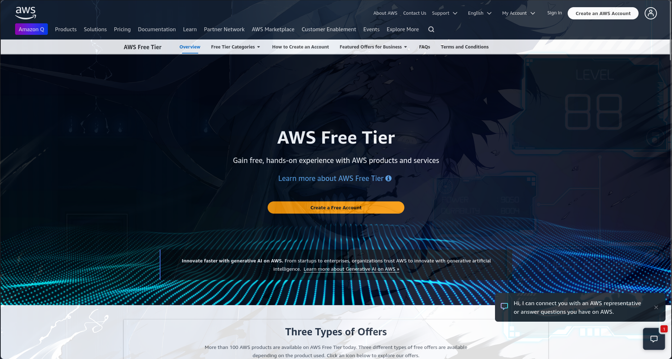

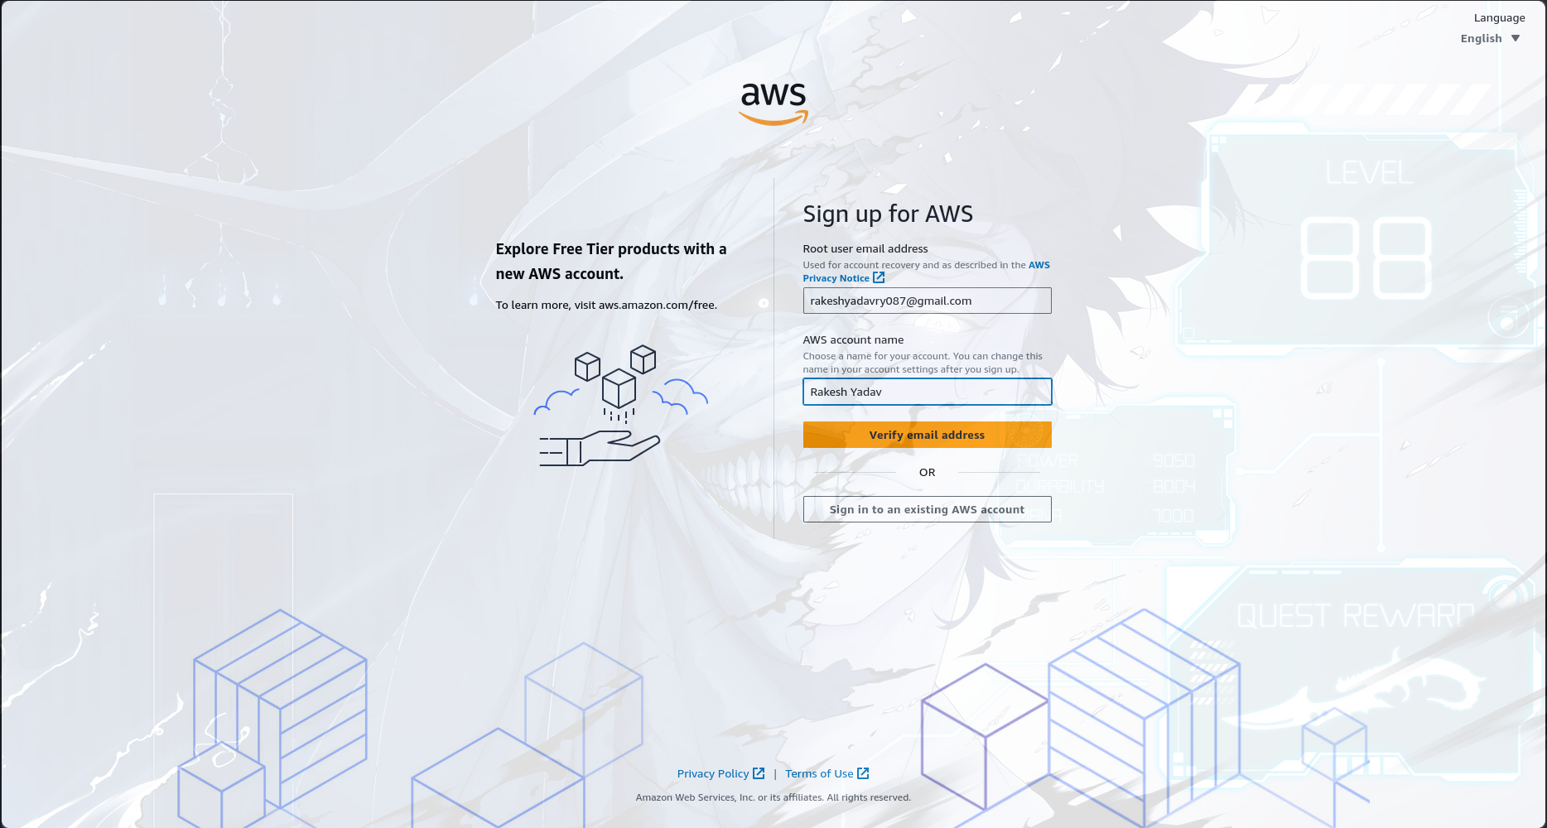

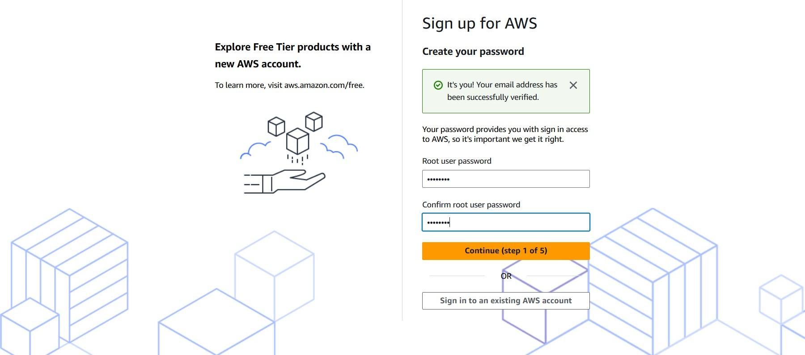

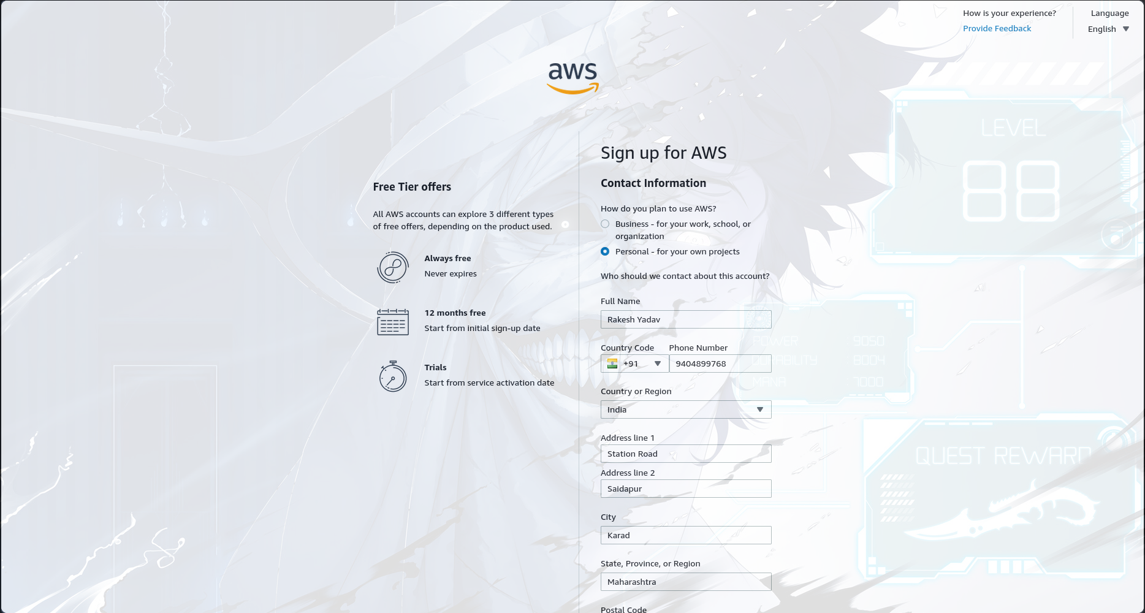

Outcome:-
Successfully learn Case study on public, private cloud.

Result:-
Thus, we completed the experiment on Case study on public, private cloud.

