Iris Analysis

Rakha Hafish Setiawan

2022-08-19

## Species Sepal_Length Sepal_Width Petal_Length Petal_Width ID  
## 1 setosa 5.1 3.5 1.4 0.2 1  
## 2 setosa 4.9 3.0 1.4 0.2 2  
## 3 setosa 4.7 3.2 1.3 0.2 3  
## 4 setosa 4.6 3.1 1.5 0.2 4  
## 5 setosa 5.0 3.6 1.4 0.2 5  
## 6 setosa 5.4 3.9 1.7 0.4 6  
## 7 setosa 4.6 3.4 1.4 0.3 7  
## 8 setosa 5.0 3.4 1.5 0.2 8  
## 9 setosa 4.4 2.9 1.4 0.2 9  
## 10 setosa 4.9 3.1 1.5 0.1 10  
## 11 setosa 5.4 3.7 1.5 0.2 11  
## 12 setosa 4.8 3.4 1.6 0.2 12  
## 13 setosa 4.8 3.0 1.4 0.1 13  
## 14 setosa 4.3 3.0 1.1 0.1 14  
## 15 setosa 5.8 4.0 1.2 0.2 15  
## 16 setosa 5.7 4.4 1.5 0.4 16  
## 17 setosa 5.4 3.9 1.3 0.4 17  
## 18 setosa 5.1 3.5 1.4 0.3 18  
## 19 setosa 5.7 3.8 1.7 0.3 19  
## 20 setosa 5.1 3.8 1.5 0.3 20  
## 21 setosa 5.4 3.4 1.7 0.2 21  
## 22 setosa 5.1 3.7 1.5 0.4 22  
## 23 setosa 4.6 3.6 1.0 0.2 23  
## 24 setosa 5.1 3.3 1.7 0.5 24  
## 25 setosa 4.8 3.4 1.9 0.2 25  
## 26 setosa 5.0 3.0 1.6 0.2 26  
## 27 setosa 5.0 3.4 1.6 0.4 27  
## 28 setosa 5.2 3.5 1.5 0.2 28  
## 29 setosa 5.2 3.4 1.4 0.2 29  
## 30 setosa 4.7 3.2 1.6 0.2 30  
## 31 setosa 4.8 3.1 1.6 0.2 31  
## 32 setosa 5.4 3.4 1.5 0.4 32  
## 33 setosa 5.2 4.1 1.5 0.1 33  
## 34 setosa 5.5 4.2 1.4 0.2 34  
## 35 setosa 4.9 3.1 1.5 0.2 35  
## 36 setosa 5.0 3.2 1.2 0.2 36  
## 37 setosa 5.5 3.5 1.3 0.2 37  
## 38 setosa 4.9 3.6 1.4 0.1 38  
## 39 setosa 4.4 3.0 1.3 0.2 39  
## 40 setosa 5.1 3.4 1.5 0.2 40  
## 41 setosa 5.0 3.5 1.3 0.3 41  
## 42 setosa 4.5 2.3 1.3 0.3 42  
## 43 setosa 4.4 3.2 1.3 0.2 43  
## 44 setosa 5.0 3.5 1.6 0.6 44  
## 45 setosa 5.1 3.8 1.9 0.4 45  
## 46 setosa 4.8 3.0 1.4 0.3 46  
## 47 setosa 5.1 3.8 1.6 0.2 47  
## 48 setosa 4.6 3.2 1.4 0.2 48  
## 49 setosa 5.3 3.7 1.5 0.2 49  
## 50 setosa 5.0 3.3 1.4 0.2 50  
## 51 versicolor 7.0 3.2 4.7 1.4 51  
## 52 versicolor 6.4 3.2 4.5 1.5 52  
## 53 versicolor 6.9 3.1 4.9 1.5 53  
## 54 versicolor 5.5 2.3 4.0 1.3 54  
## 55 versicolor 6.5 2.8 4.6 1.5 55  
## 56 versicolor 5.7 2.8 4.5 1.3 56  
## 57 versicolor 6.3 3.3 4.7 1.6 57  
## 58 versicolor 4.9 2.4 3.3 1.0 58  
## 59 versicolor 6.6 2.9 4.6 1.3 59  
## 60 versicolor 5.2 2.7 3.9 1.4 60  
## 61 versicolor 5.0 2.0 3.5 1.0 61  
## 62 versicolor 5.9 3.0 4.2 1.5 62  
## 63 versicolor 6.0 2.2 4.0 1.0 63  
## 64 versicolor 6.1 2.9 4.7 1.4 64  
## 65 versicolor 5.6 2.9 3.6 1.3 65  
## 66 versicolor 6.7 3.1 4.4 1.4 66  
## 67 versicolor 5.6 3.0 4.5 1.5 67  
## 68 versicolor 5.8 2.7 4.1 1.0 68  
## 69 versicolor 6.2 2.2 4.5 1.5 69  
## 70 versicolor 5.6 2.5 3.9 1.1 70  
## 71 versicolor 5.9 3.2 4.8 1.8 71  
## 72 versicolor 6.1 2.8 4.0 1.3 72  
## 73 versicolor 6.3 2.5 4.9 1.5 73  
## 74 versicolor 6.1 2.8 4.7 1.2 74  
## 75 versicolor 6.4 2.9 4.3 1.3 75  
## 76 versicolor 6.6 3.0 4.4 1.4 76  
## 77 versicolor 6.8 2.8 4.8 1.4 77  
## 78 versicolor 6.7 3.0 5.0 1.7 78  
## 79 versicolor 6.0 2.9 4.5 1.5 79  
## 80 versicolor 5.7 2.6 3.5 1.0 80  
## 81 versicolor 5.5 2.4 3.8 1.1 81  
## 82 versicolor 5.5 2.4 3.7 1.0 82  
## 83 versicolor 5.8 2.7 3.9 1.2 83  
## 84 versicolor 6.0 2.7 5.1 1.6 84  
## 85 versicolor 5.4 3.0 4.5 1.5 85  
## 86 versicolor 6.0 3.4 4.5 1.6 86  
## 87 versicolor 6.7 3.1 4.7 1.5 87  
## 88 versicolor 6.3 2.3 4.4 1.3 88  
## 89 versicolor 5.6 3.0 4.1 1.3 89  
## 90 versicolor 5.5 2.5 4.0 1.3 90  
## 91 versicolor 5.5 2.6 4.4 1.2 91  
## 92 versicolor 6.1 3.0 4.6 1.4 92  
## 93 versicolor 5.8 2.6 4.0 1.2 93  
## 94 versicolor 5.0 2.3 3.3 1.0 94  
## 95 versicolor 5.6 2.7 4.2 1.3 95  
## 96 versicolor 5.7 3.0 4.2 1.2 96  
## 97 versicolor 5.7 2.9 4.2 1.3 97  
## 98 versicolor 6.2 2.9 4.3 1.3 98  
## 99 versicolor 5.1 2.5 3.0 1.1 99  
## 100 versicolor 5.7 2.8 4.1 1.3 100  
## 101 virginica 6.3 3.3 6.0 2.5 101  
## 102 virginica 5.8 2.7 5.1 1.9 102  
## 103 virginica 7.1 3.0 5.9 2.1 103  
## 104 virginica 6.3 2.9 5.6 1.8 104  
## 105 virginica 6.5 3.0 5.8 2.2 105  
## 106 virginica 7.6 3.0 6.6 2.1 106  
## 107 virginica 4.9 2.5 4.5 1.7 107  
## 108 virginica 7.3 2.9 6.3 1.8 108  
## 109 virginica 6.7 2.5 5.8 1.8 109  
## 110 virginica 7.2 3.6 6.1 2.5 110  
## 111 virginica 6.5 3.2 5.1 2.0 111  
## 112 virginica 6.4 2.7 5.3 1.9 112  
## 113 virginica 6.8 3.0 5.5 2.1 113  
## 114 virginica 5.7 2.5 5.0 2.0 114  
## 115 virginica 5.8 2.8 5.1 2.4 115  
## 116 virginica 6.4 3.2 5.3 2.3 116  
## 117 virginica 6.5 3.0 5.5 1.8 117  
## 118 virginica 7.7 3.8 6.7 2.2 118  
## 119 virginica 7.7 2.6 6.9 2.3 119  
## 120 virginica 6.0 2.2 5.0 1.5 120  
## 121 virginica 6.9 3.2 5.7 2.3 121  
## 122 virginica 5.6 2.8 4.9 2.0 122  
## 123 virginica 7.7 2.8 6.7 2.0 123  
## 124 virginica 6.3 2.7 4.9 1.8 124  
## 125 virginica 6.7 3.3 5.7 2.1 125  
## 126 virginica 7.2 3.2 6.0 1.8 126  
## 127 virginica 6.2 2.8 4.8 1.8 127  
## 128 virginica 6.1 3.0 4.9 1.8 128  
## 129 virginica 6.4 2.8 5.6 2.1 129  
## 130 virginica 7.2 3.0 5.8 1.6 130  
## 131 virginica 7.4 2.8 6.1 1.9 131  
## 132 virginica 7.9 3.8 6.4 2.0 132  
## 133 virginica 6.4 2.8 5.6 2.2 133  
## 134 virginica 6.3 2.8 5.1 1.5 134  
## 135 virginica 6.1 2.6 5.6 1.4 135  
## 136 virginica 7.7 3.0 6.1 2.3 136  
## 137 virginica 6.3 3.4 5.6 2.4 137  
## 138 virginica 6.4 3.1 5.5 1.8 138  
## 139 virginica 6.0 3.0 4.8 1.8 139  
## 140 virginica 6.9 3.1 5.4 2.1 140  
## 141 virginica 6.7 3.1 5.6 2.4 141  
## 142 virginica 6.9 3.1 5.1 2.3 142  
## 143 virginica 5.8 2.7 5.1 1.9 143  
## 144 virginica 6.8 3.2 5.9 2.3 144  
## 145 virginica 6.7 3.3 5.7 2.5 145  
## 146 virginica 6.7 3.0 5.2 2.3 146  
## 147 virginica 6.3 2.5 5.0 1.9 147  
## 148 virginica 6.5 3.0 5.2 2.0 148  
## 149 virginica 6.2 3.4 5.4 2.3 149  
## 150 virginica 5.9 3.0 5.1 1.8 150

## # A tibble: 3 × 2  
## Species Count  
## <fct> <int>  
## 1 setosa 50  
## 2 versicolor 50  
## 3 virginica 50

Data summary

|  |  |
| --- | --- |
| Name | iris |
| Number of rows | 150 |
| Number of columns | 5 |
| _______________________ |  |
| Column type frequency: |  |
| factor | 1 |
| numeric | 4 |
| ________________________ |  |
| Group variables | None |

**Variable type: factor**

| skim_variable | n_missing | complete_rate | ordered | n_unique | top_counts |
| --- | --- | --- | --- | --- | --- |
| Species | 0 | 1 | FALSE | 3 | set: 50, ver: 50, vir: 50 |

**Variable type: numeric**

| skim_variable | n_missing | complete_rate | mean | sd | p0 | p25 | p50 | p75 | p100 | hist |
| --- | --- | --- | --- | --- | --- | --- | --- | --- | --- | --- |
| Sepal.Length | 0 | 1 | 5.84 | 0.83 | 4.3 | 5.1 | 5.80 | 6.4 | 7.9 | ▆▇▇▅▂ |
| Sepal.Width | 0 | 1 | 3.06 | 0.44 | 2.0 | 2.8 | 3.00 | 3.3 | 4.4 | ▁▆▇▂▁ |
| Petal.Length | 0 | 1 | 3.76 | 1.77 | 1.0 | 1.6 | 4.35 | 5.1 | 6.9 | ▇▁▆▇▂ |
| Petal.Width | 0 | 1 | 1.20 | 0.76 | 0.1 | 0.3 | 1.30 | 1.8 | 2.5 | ▇▁▇▅▃ |

## vars n mean sd median trimmed mad min max range skew  
## Sepal.Length 1 150 5.84 0.83 5.80 5.81 1.04 4.3 7.9 3.6 0.31  
## Sepal.Width 2 150 3.06 0.44 3.00 3.04 0.44 2.0 4.4 2.4 0.31  
## Petal.Length 3 150 3.76 1.77 4.35 3.76 1.85 1.0 6.9 5.9 -0.27  
## Petal.Width 4 150 1.20 0.76 1.30 1.18 1.04 0.1 2.5 2.4 -0.10  
## Species* 5 150 2.00 0.82 2.00 2.00 1.48 1.0 3.0 2.0 0.00  
## kurtosis se  
## Sepal.Length -0.61 0.07  
## Sepal.Width 0.14 0.04  
## Petal.Length -1.42 0.14  
## Petal.Width -1.36 0.06  
## Species* -1.52 0.07

pairs.panels(iris[1:4])

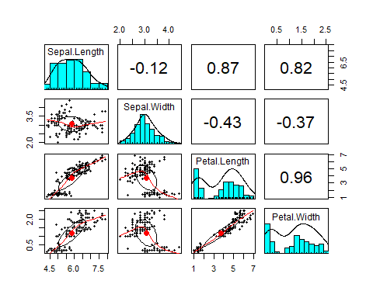

## Warning: Ignoring unknown parameters: binwidth, bins, pad

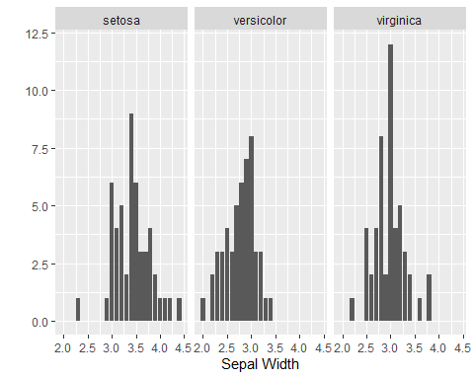

## Warning: Ignoring unknown parameters: binwidth, bins, pad

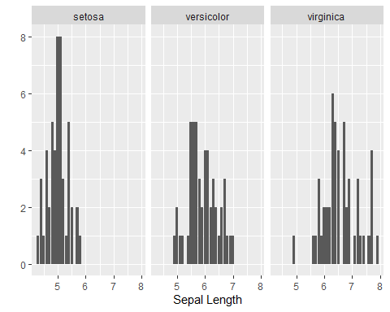

VAL <- validator(  
 Sepal.Length > 5.84,  
 Sepal.Width > 3.06,  
 Petal.Length > 3.76,  
 Petal.Width > 1.20  
 )

## Object of class 'validation'  
## Call:  
## confront(dat = iris, x = VAL)  
##   
## Rules confronted: 4  
## With fails : 4  
## With missings: 0  
## Threw warning: 0  
## Threw error : 0

## Warning: The 'barplot' method for confrontation objects is deprecated. Use  
## 'plot' instead

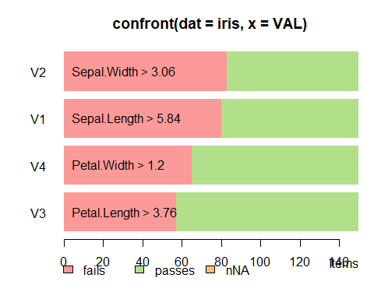

summary(lm(Sepal.Width~Sepal.Length, data = iris))

##   
## Call:  
## lm(formula = Sepal.Width ~ Sepal.Length, data = iris)  
##   
## Residuals:  
## Min 1Q Median 3Q Max   
## -1.1095 -0.2454 -0.0167 0.2763 1.3338   
##   
## Coefficients:  
## Estimate Std. Error t value Pr(>|t|)   
## (Intercept) 3.41895 0.25356 13.48 <2e-16 ***  
## Sepal.Length -0.06188 0.04297 -1.44 0.152   
## ---  
## Signif. codes: 0 '***' 0.001 '**' 0.01 '*' 0.05 '.' 0.1 ' ' 1  
##   
## Residual standard error: 0.4343 on 148 degrees of freedom  
## Multiple R-squared: 0.01382, Adjusted R-squared: 0.007159   
## F-statistic: 2.074 on 1 and 148 DF, p-value: 0.1519