UNIVERSITY INSTITUTE OF ENGINEERING

ASSIGNMENT-1
Subject Name – System Design
Subject Code – 23CST- 314
Submitted To: | Submitted By:
Er. Alok Kumar | Name: Rakhi Channa
(E17196) | UID: 23BCS10431
Section: KRG_2-B

ASSIGNMENT:1
Q1. Explain the role of interfaces and Enums in software design with proper examples.
- Interfaces
Role in Software Design
- An interface defines a contract for classes without providing implementation.
- It specifies what a class should do, not how it does it.
- Interfaces are used for:
  - Achieving abstraction.
  - Supporting polymorphism.
  - Enabling loose coupling between components.
  - Allowing multiple inheritance of type (since a class can implement multiple interfaces).
Example
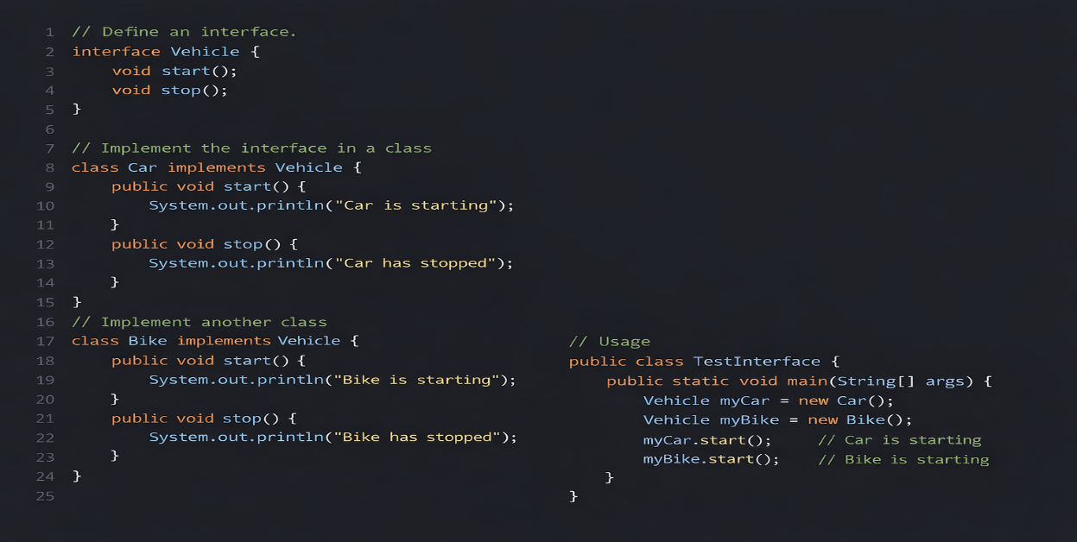

- Enums
Role in Software Design
- Enum (enumeration) is a special data type that represents a fixed set of constants.
- Enums improve readability, type safety, and reduce errors compared to using integers or strings.
- Useful when a variable can only take specific predefined values.
Example
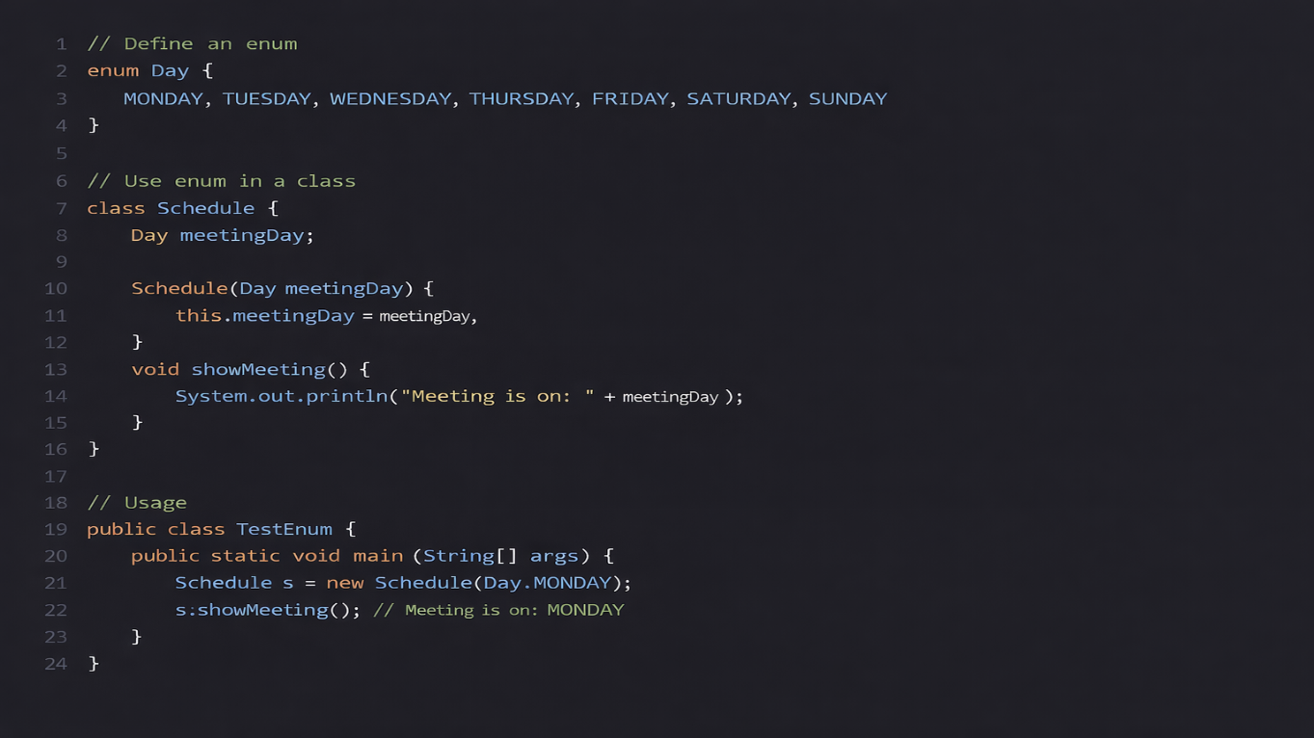

Q2. Discuss how interfaces enable loose coupling with example.

Loose Coupling
Definition
- Loose coupling means that components of a system depend on abstractions, not concrete implementations.
- It makes the system flexible, maintainable, and easy to extend.

- Changes in one part of the system don’t affect other parts if they interact through interfaces.

How Interfaces Enable Loose Coupling
- An interface acts as a contract.
  - The client code knows what operations are available, not how they are implemented.
- The client can interact with any class that implements the interface.
  - It doesn’t care about the actual implementation.
- New implementations can be added without changing existing client code.

Example: Payment System
Problem: We have an e-commerce app that can support multiple payment methods (Credit Card, PayPal, UPI).

Step 1: Define an Interface
interface Payment {
void pay(double amount);
}

Step 2: Implement Multiple Payment Methods
class CreditCardPayment implements Payment {
public void pay(double amount) {
System.out.println("Paid " + amount + " using Credit Card");
}
}

class PayPalPayment implements Payment {
public void pay(double amount) {
System.out.println("Paid " + amount + " using PayPal");
}
}

class UPIPayment implements Payment {
public void pay(double amount) {
System.out.println("Paid " + amount + " using UPI");
}
}

Step 3: Use Interface in Client Code
class ShoppingCart {
private Payment paymentMethod;

// Constructor injection
public ShoppingCart(Payment paymentMethod) {
this.paymentMethod = paymentMethod;
}

public void checkout(double amount) {
paymentMethod.pay(amount); // Only depends on Payment interface
}
}

// Usage
public class TestPayment {
public static void main(String[] args) {
Payment credit = new CreditCardPayment();
Payment paypal = new PayPalPayment();

ShoppingCart cart1 = new ShoppingCart(credit);
ShoppingCart cart2 = new ShoppingCart(paypal);

cart1.checkout(500); // Paid 500 using Credit Card
cart2.checkout(1200); // Paid 1200 using PayPal
}
}

Why This is Loose Coupling
- ShoppingCart depends only on Payment interface, not on concrete classes.
- Adding new payment methods (e.g., BitcoinPayment) doesn’t require changing ShoppingCart.
- Implementation details of CreditCardPayment or PayPalPayment are hidden from ShoppingCart.

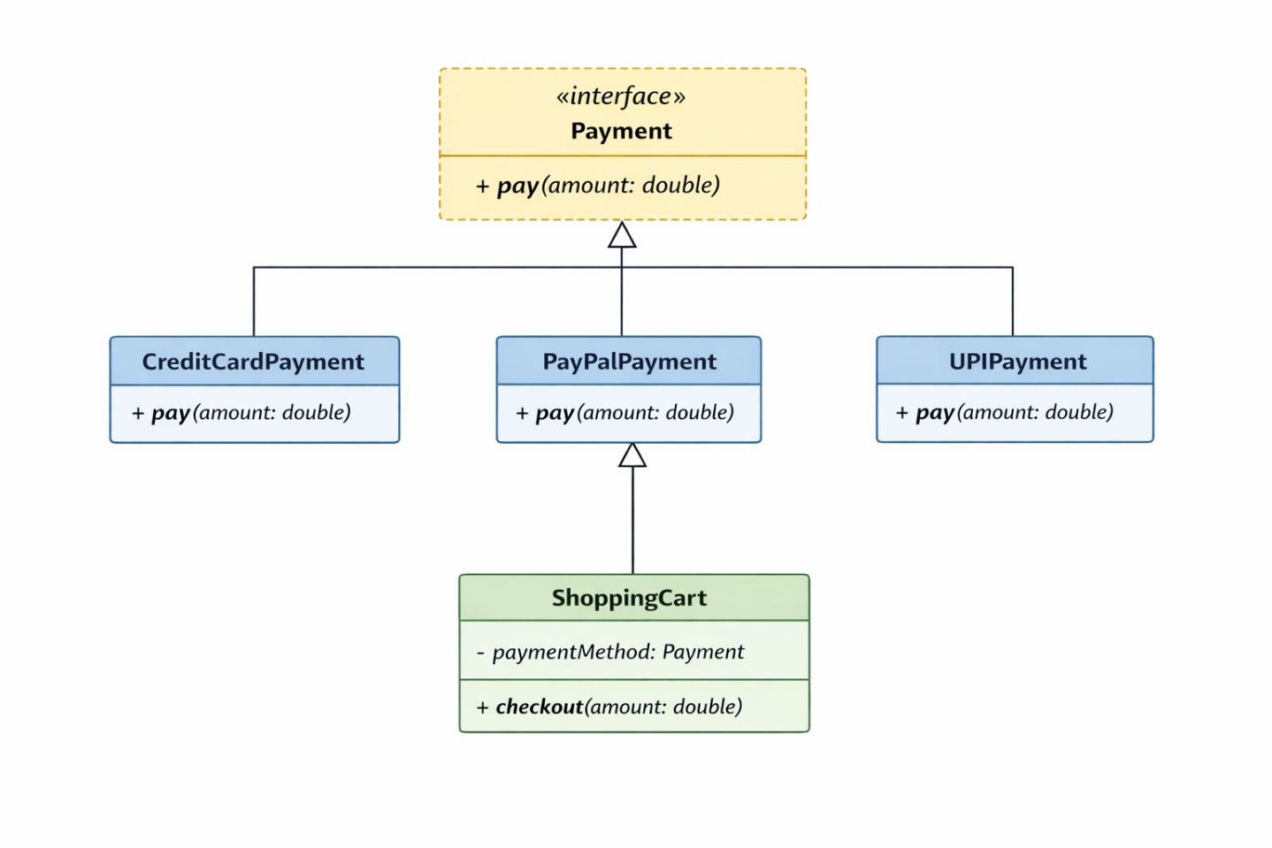

Q3. Design an HLD for a Payment Processing System, showing where interfaces would be used.

Functional Requirements (What system should do)

- User Authentication
  - Verify user identity before payment.
  - Support login/session validation.
- Payment Processing
  - Accept multiple payment modes (Card, UPI, Wallet, Net Banking).
  - Process payment requests.
- Transaction Management
  - Generate transaction ID.
  - Track payment status (Pending, Success, Failed).
- Fraud Detection
  - Check suspicious transactions.
  - Block risky payments.
- Refund Handling

  - Allow refund requests.
  - Track refund status.
- Notification Service
  - Send payment confirmation/failure alerts.
- Payment Gateway Integration
  - Connect with external payment providers.

Non-Functional Requirements (How system should perform)
- Scalability
  - Handle thousands/millions of transactions.
- Security
  - Data encryption.
  - PCI-DSS compliance.
  - Secure authentication.
- Reliability
  - Payment must not fail or lose data.
- Availability
  - 24/7 uptime.
- Performance
  - Fast payment response time.
- Maintainability
  - Easy to add new payment methods using interfaces.
- Fault Tolerance
  - System should recover from failures.

Where Interfaces Are Used in HLD
- IPaymentProcessor → Common interface for all payment methods
- IGateway → Interface for external payment providers
- IFraudCheck → Interface for fraud detection modules
- IAuth → Interface for authentication services
These help in loose coupling and easy extension.

Designed the required HLD in attached .drawio file.

