PRACTICAL - 8

Title
Simulation of Disk Scheduling Algorithms
Requirements
● Computer System
● Operating System: Windows / Linux / macOS
● Python 3.8 or higher
● Any code editor (VS Code / PyCharm / IDLE)

Theory
One of the responsibilities of an operating system is to use hardware efficiently. For hard disk drives (HDDs), this involves minimizing access time and maximizing data transfer rate.
Disk access time mainly consists of:
● Seek Time: Time taken by the disk arm to move the head to the required cylinder.
● Rotational Latency: Time taken for the disk to rotate the required sector under the head.
When multiple I/O requests are present, they are placed in a queue. Disk scheduling algorithms are designed to reduce seek time and improve disk I/O performance by deciding the order in which disk requests are serviced. Different algorithms provide different trade-offs between seek time, fairness, and starvation.

Disk Scheduling Algorithms

1. First Come First Serve (FCFS)
● Requests are serviced in the order they arrive in the queue
● Disk head moves sequentially from one request to the next
● Simple and easy to implement
● No starvation
● Fair scheduling
● May cause large head movement
● Poor average seek time

2. Shortest Seek Time First (SSTF)
● Selects the request closest to the current head position
● Reduces head movement and seek time
● Provides better performance than FCFS
● May cause starvation for distant requests
● More complex than FCFS

3. SCAN (Elevator Algorithm)
● Disk head moves in one direction servicing requests along the path
● After reaching the end of the disk, it reverses direction
● Provides better performance than FCFS
● Eliminates starvation
● Provides more uniform waiting time
● Head moves to disk end even if no requests exist

4. C-SCAN (Circular SCAN)
● Disk head moves in only one direction
● After reaching the end, it jumps to the beginning
● Requests are serviced again in the same direction
● Provides uniform waiting time
● Better fairness than SCAN
● Extra movement due to jump from end to beginning

Performance Comparison
The performance of disk scheduling algorithms is measured using total seek time.
● Lower seek time → Better performance
● SSTF usually gives minimum seek time
● SCAN and C-SCAN provide better fairness and avoid starvation

Code:
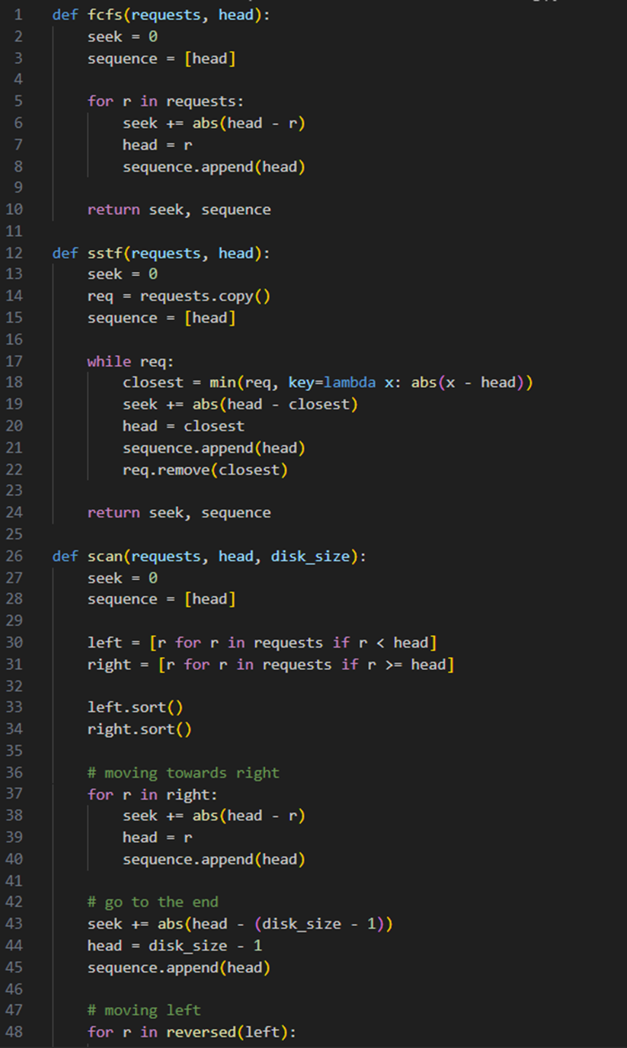

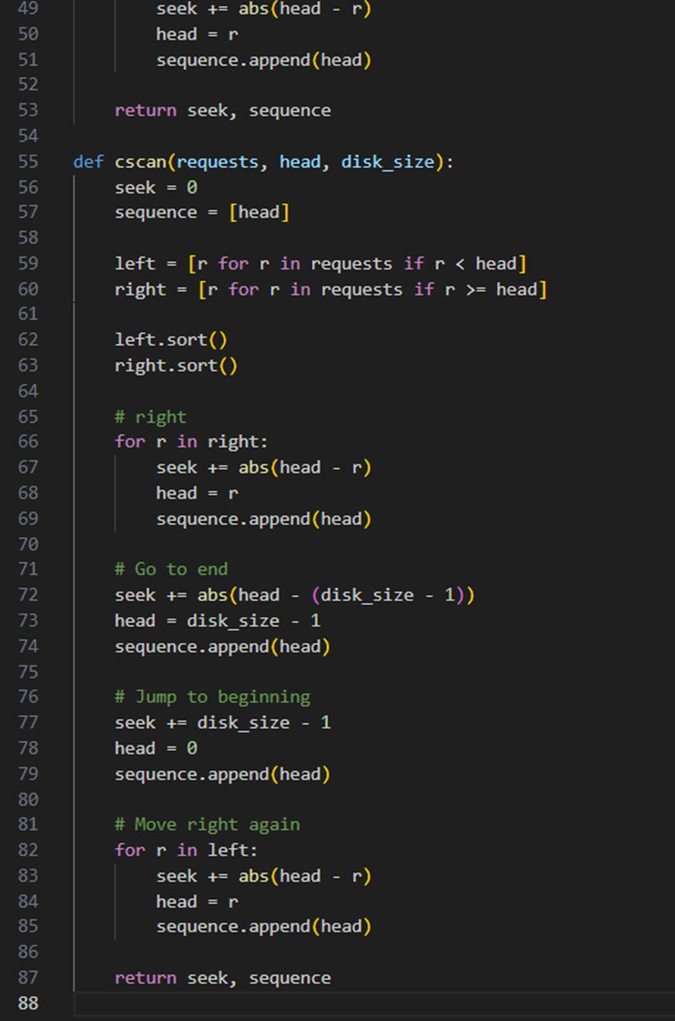

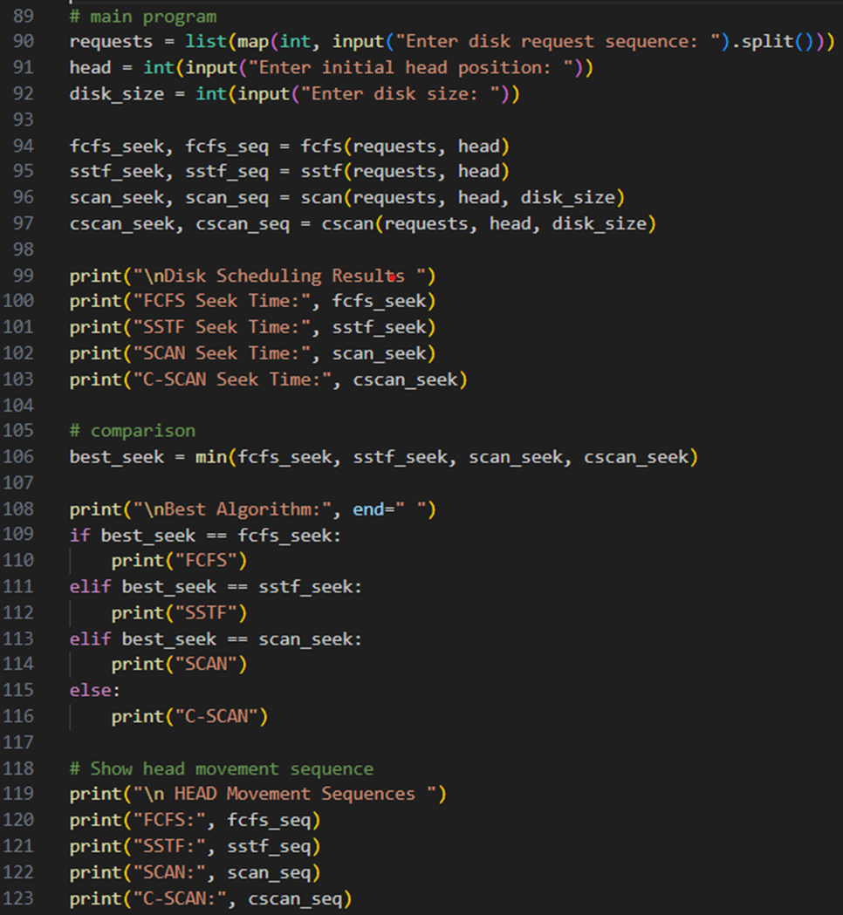

Output:
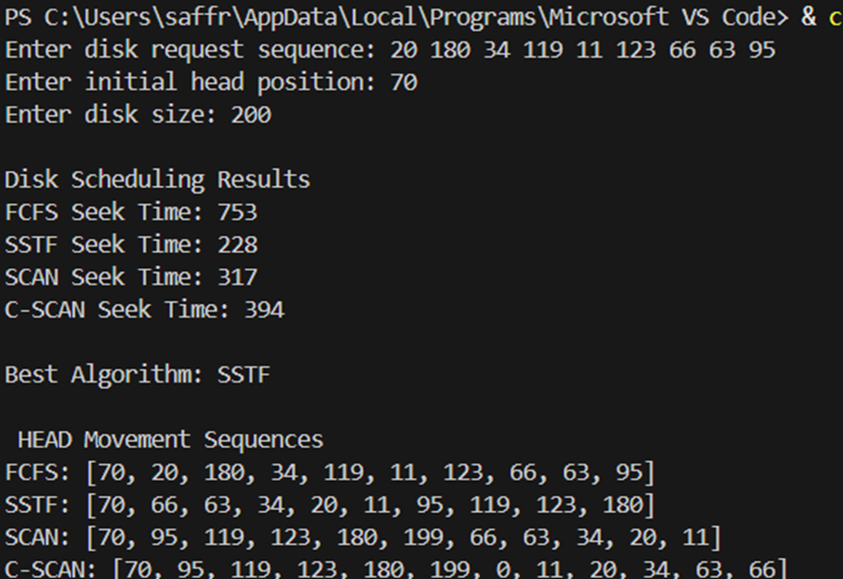

Conclusion
Disk scheduling algorithms were studied and implemented using a simulator. FCFS, SSTF, SCAN, and C-SCAN were compared based on total seek time. It was observed that SSTF gives minimum seek time, while SCAN and C-SCAN provide better fairness and more uniform waiting time.

