PRACTICAL - 5

TITLE:
- To understand memory management techniques in operating systems.
- To simulate memory allocation algorithms and page replacement algorithms.
- To analyse and compare their performance.
REQUIREMENTS:
- Operating System: Windows / Linux / macOS
- Compiler: GCC (g++ compiler) or any C++ compiler
- IDE/Text Editor: VS Code / CodeBlocks / Dev C++
THEORY:
Introduction to Memory Management
Memory management is a crucial function of an operating system that manages the allocation and deallocation of memory space to processes. It ensures that multiple processes can run efficiently without interfering with each other while maximizing memory utilization.The operating system keeps track of each memory location, whether it is allocated or free, and assigns memory dynamically based on process requirements.

Dynamic Memory Allocation
Dynamic memory allocation refers to the allocation of memory blocks to processes at runtime. Unlike static allocation, memory is assigned as per the need of processes, making it more flexible and efficient.However, improper allocation may lead to fragmentation, where memory is wasted in small unusable blocks.
Memory Allocation Algorithms
These algorithms are used to allocate memory blocks to processes efficiently.

1. First Fit Algorithm
- Allocates the first available block that is large enough for the process
- Simple and fast
- May lead to external fragmentation

2. Best Fit Algorithm
- Allocates the smallest block that satisfies the process requirement
- Minimizes unused memory
- Requires searching the entire memory list (slower)

3. Worst Fit Algorithm
- Allocates the largest available block
- Leaves large free spaces for future use
- Can lead to inefficient memory utilization over time
Fragmentation
Fragmentation is the wastage of memory due to inefficient allocation.

Types:
- Internal Fragmentation → Wasted space inside allocated block
- External Fragmentation → Free memory exists but is scattered
Paging
Paging is a memory management technique that divides:
- Memory → into frames
- Processes → into pages
Each page is mapped to a frame, allowing efficient use of memory and eliminating external fragmentation.

6. Page Fault
A page fault occurs when a process tries to access a page that is not currently in memory. The operating system then loads the required page from secondary storage into memory.
Frequent page faults reduce system performance.
Page Replacement Algorithms
When memory frames are full, the OS must decide which page to replace. This is done using page replacement algorithms.

1. FIFO (First In First Out)
- Replaces the oldest page in memory
- Simple to implement
- May lead to Belady’s Anomaly (more frames → more faults)

2. LRU (Least Recently Used)
- Replaces the page that has not been used for the longest time
- Based on the principle of locality
- Better performance than FIFO
3. Optimal Page Replacement
- Replaces the page that will not be used for the longest time in future
- Gives minimum number of page faults
- Not practical (future knowledge required)
Performance Metrics:To evaluate algorithms, the following metrics are used:
- Page Faults → Number of times pages are replaced
- Page Hits → Number of successful accesses
- Memory Utilization → Efficient use of memory
- Execution Efficiency → Overall system performance
9. Comparison of Algorithms
Algorithm | Speed | Efficiency | Drawback
First Fit | Fast | Moderate | Fragmentation
Best Fit | Slow | Better | High search time
Worst Fit | Moderate | Poor | Wastage
FIFO | Simple | Low | Belady’s anomaly
LRU | Moderate | Good | Costly implementation
Optimal | Theoretical | Best | Not practical

Task 1: Memory Allocation Algorithm:
Input number of blocks and their sizes
Input number of processes and their sizes
Apply:
- First Fit
- Best Fit
- Worst Fit
Allocate memory
Display results

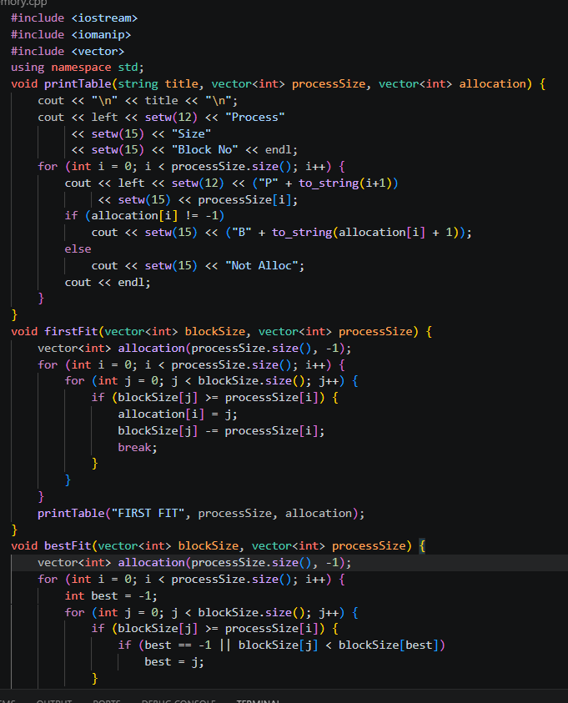

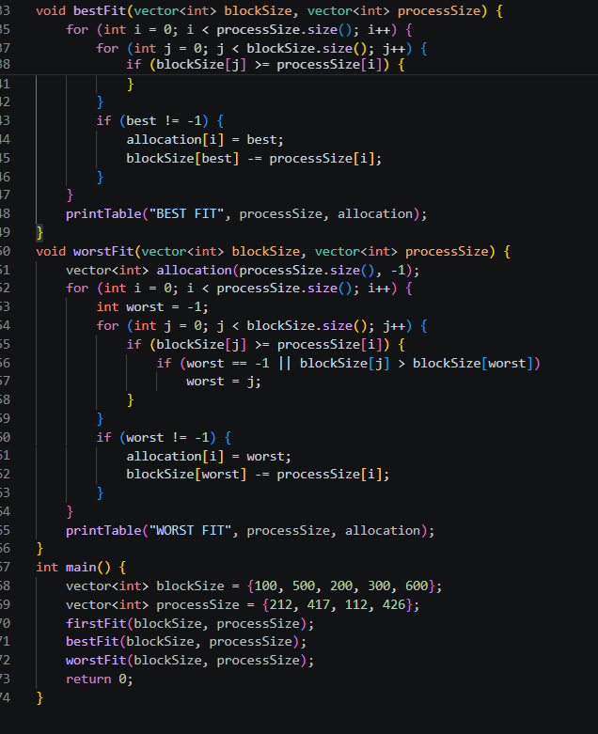

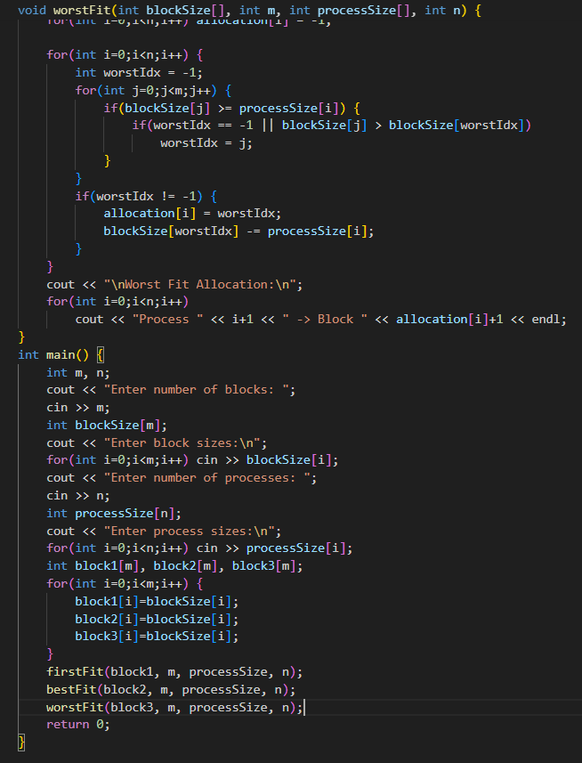

Output:
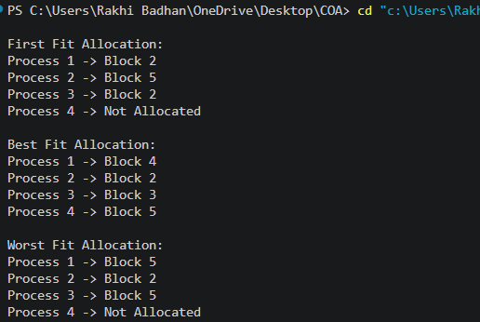

Task 2: Page Replacement Algorithms
- Input number of frames
- Input page reference string
- Apply:
  - FIFO
  - LRU
  - Optimal
- Count page faults and hits
- Compare results
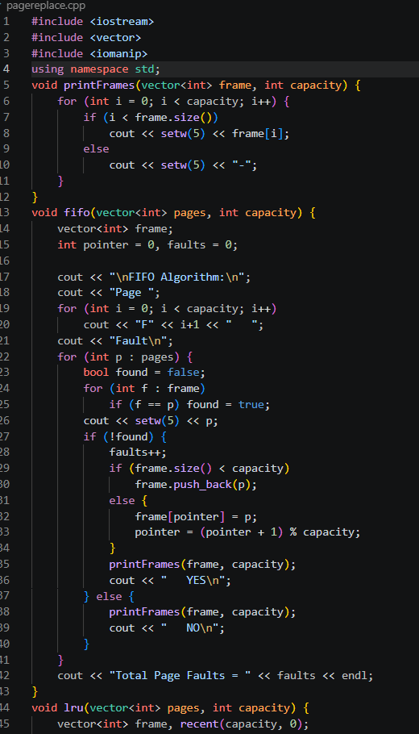
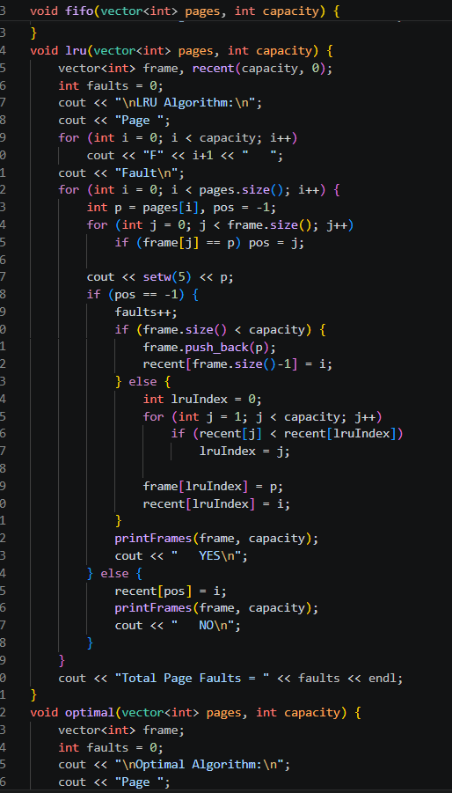
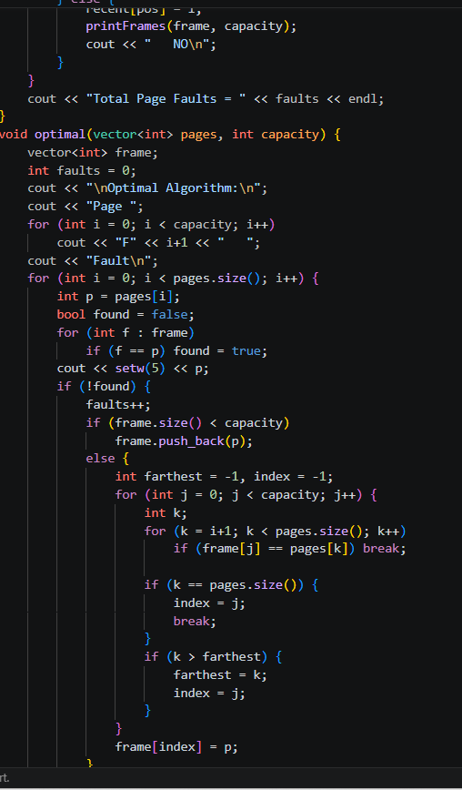

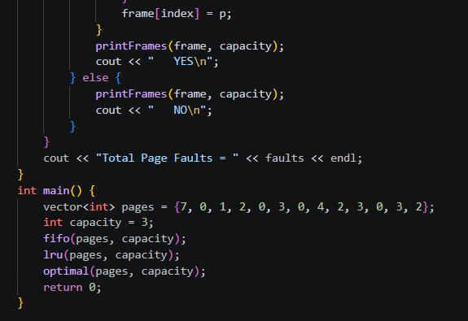

Output:

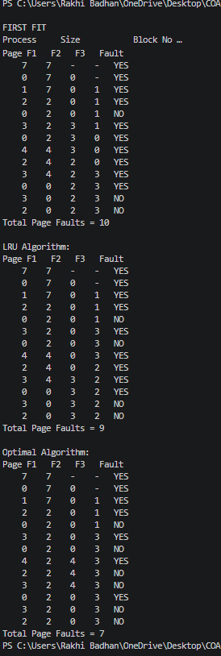
Result:
- Memory allocation algorithms successfully allocate processes
- Page replacement algorithms compute page faults
- Performance comparison shows:
  - Optimal → Best
  - LRU → Moderate
  - FIFO → Least efficient

Conclusion:
- Memory allocation strategies affect memory utilization
- Page replacement algorithms impact system performance
- Choosing the right algorithm improves efficiency

