PRACTICAL - 6

Title:
- To understand process creation in Linux using the fork() system call.
- To implement parent, child, and grandchild process creation.
- To synchronize processes so that messages are displayed in the correct order.
Requirements:
Operating System: Linux / Ubuntu / WSL (Windows Subsystem for Linux)
Compiler: GCC (g++)
Terminal
Theory:

Process in Operating System
A process is a program in execution. Each process has its own memory space, program counter, and system resources. The operating system manages processes to ensure efficient execution and resource sharing.
Process Creation
Process creation is the mechanism by which new processes are created from existing ones. In Linux/Unix systems, this is primarily done using the fork() system call.

fork() System Call
fork() is used to create a new process (child process).
- The newly created process is called the child process
- The process that created it is called the parent process
After fork():
- Both parent and child execute the same code
- They run independently

Return Values of fork()
- 0 → Returned to child process
- Positive value → Returned to parent (child PID)
- -1 → Fork failed

Process Hierarchy
Processes form a hierarchy:
Parent Process
↓
Child Process
↓
Grandchild Process
Each process can create its own child, forming a tree-like structure.

Process Synchronization using wait()
When multiple processes run concurrently, their execution order is not guaranteed.
The wait() system call is used to:
- Pause the parent process
- Allow child process to finish execution first
This ensures proper execution order and avoids unpredictable output.

Need for Synchronization
Without synchronization:
- Output may appear in random order
- Processes may terminate incorrectly
With wait():
- Grandchild executes first
- Then child
- Then parent

Algorithm:
- Start the program
- Call fork() to create child process
- In child process:
  - Call fork() again to create grandchild
- In grandchild process:
  - Print message
  - Exit
- Child waits for grandchild using wait()
- Child prints message and exits
- Parent waits for child using wait()
- Parent prints message
- Stop
Code:
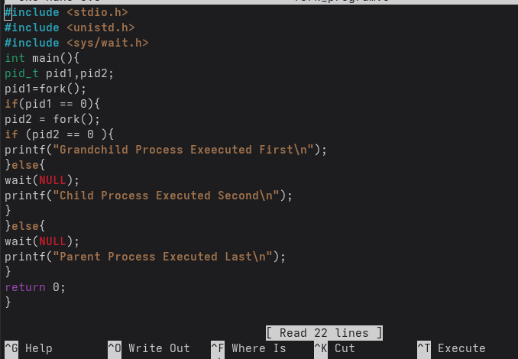

Output:
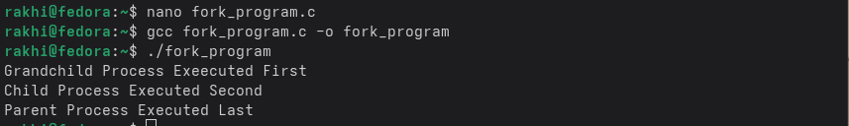

Result:
- Parent, child, and grandchild processes were created successfully
- Synchronization using wait() ensured correct execution order
- Output was displayed in the required sequence

Conclusion:
- The fork() system call is used to create new processes
- Process hierarchy can be formed (parent → child → grandchild)
- Synchronization using wait() ensures controlled execution
- Proper process management is essential in operating systems

