JAVA LAB: EXPERIMENT 2

Date: 01-09-2020 -RAKHI(11912086)

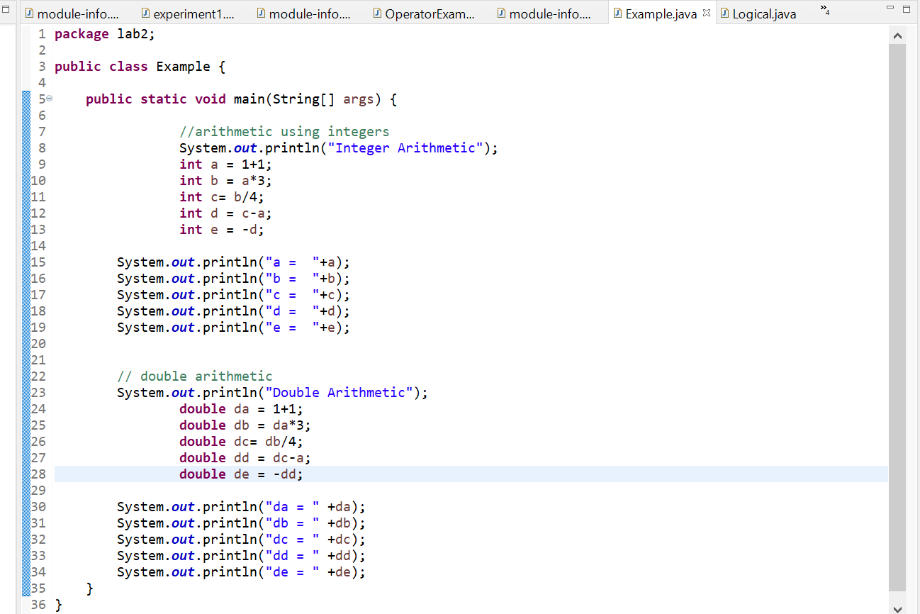

In this example Arithmetic Operators are used with int and double data type(they are binary in nature means they operate on two operand).(In int no point value is seen but in double it is present because double is floating point datatype) First operator is addition operator ,second is multiplication , third is division here difference is seen according to the data type ie., int division ignore decimal values or values after point but in case of double we easily store the decimal or floating value that is why dc and c have different values , after that subtraction and after that negative of number ie., if number is positive then it will convert into negative and vice-versa.

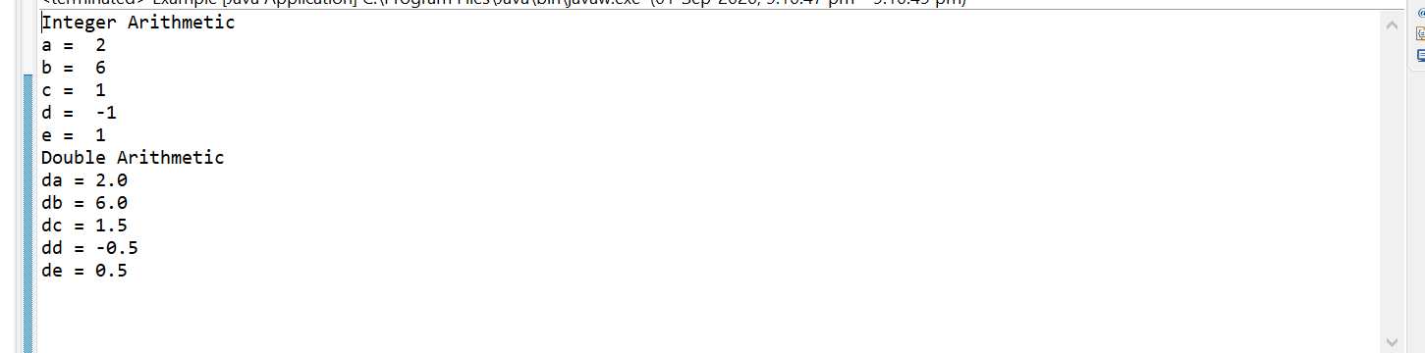

\*\*\*\*\*\*\*\*\*\*\*\*\*\*\*\*\*\*\*\*\*\*\*\*\*\*\*\*\*\*\*\*\*\*\*\*\*\*\*\*\*\*\*\*\*\*\*\*\*\*

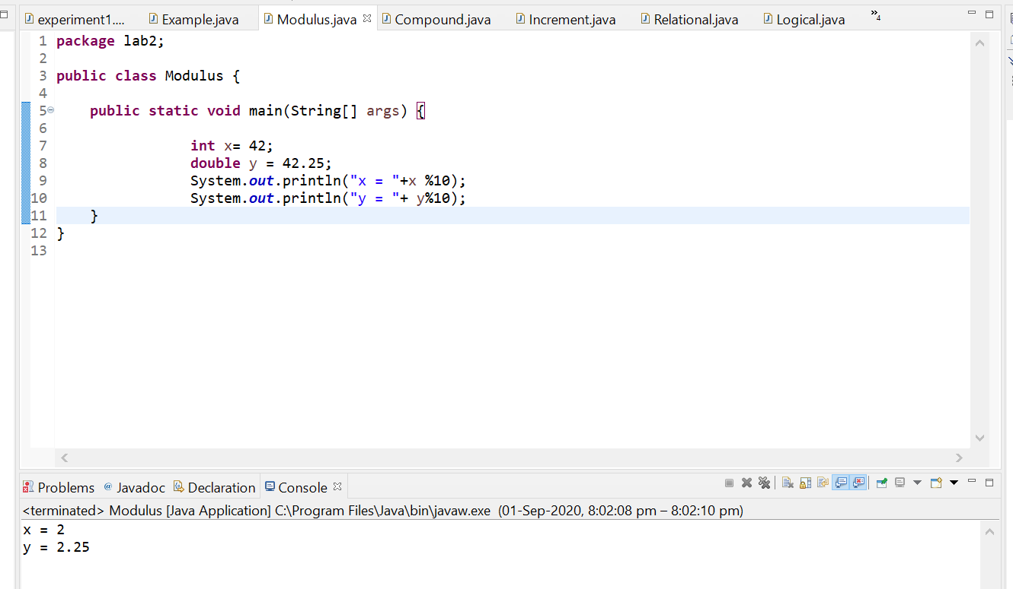

In this modulus operator is used. It is used to find remainder as in example x%10 = 2 as x is int and y%10 = 2.25 as it is double.

\*\*\*\*\*\*\*\*\*\*\*\*\*\*\*\*\*\*\*\*\*\*\*\*\*\*\*\*\*\*\*\*\*\*\*\*\*\*\*\*\*\*\*\*\*\*\*\*\*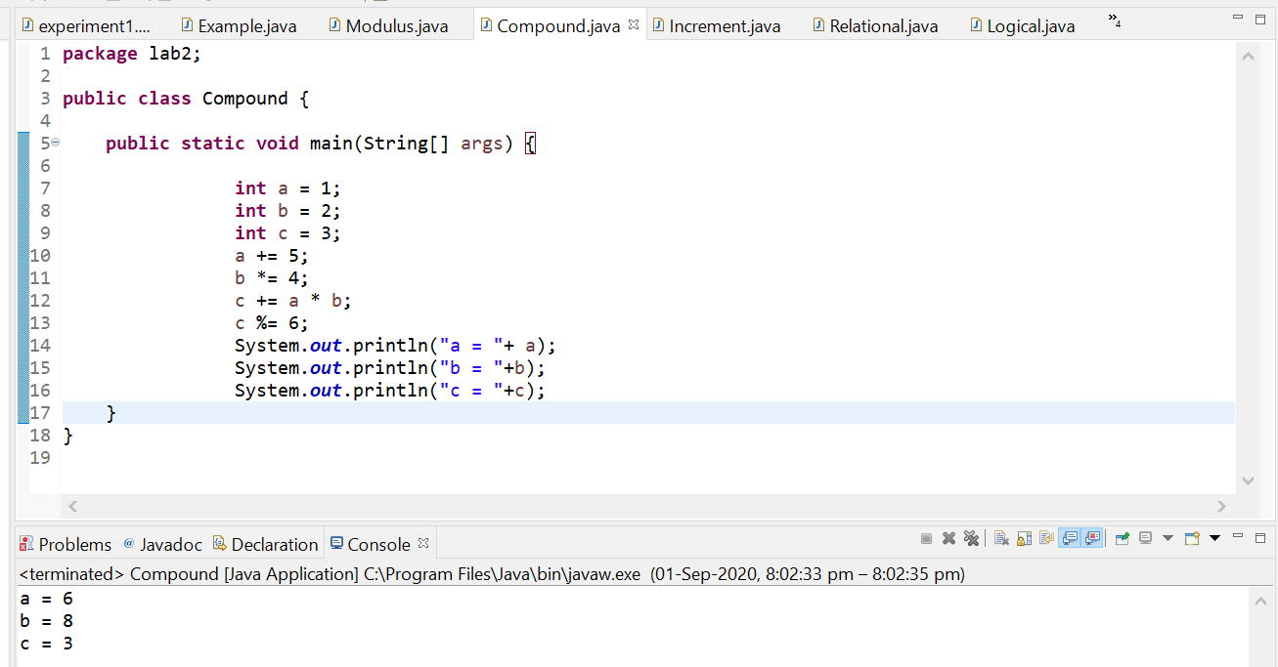

In this example compound operator are used or we can say that short hand tools. a += 5 is equivalent to a = a+5 similarly other.

\*\*\*\*\*\*\*\*\*\*\*\*\*\*\*\*\*\*\*\*\*\*\*\*\*\*\*\*\*\*\*\*\*\*\*\*\*\*\*\*\*\*\*\*\*\*\*\*\*\*

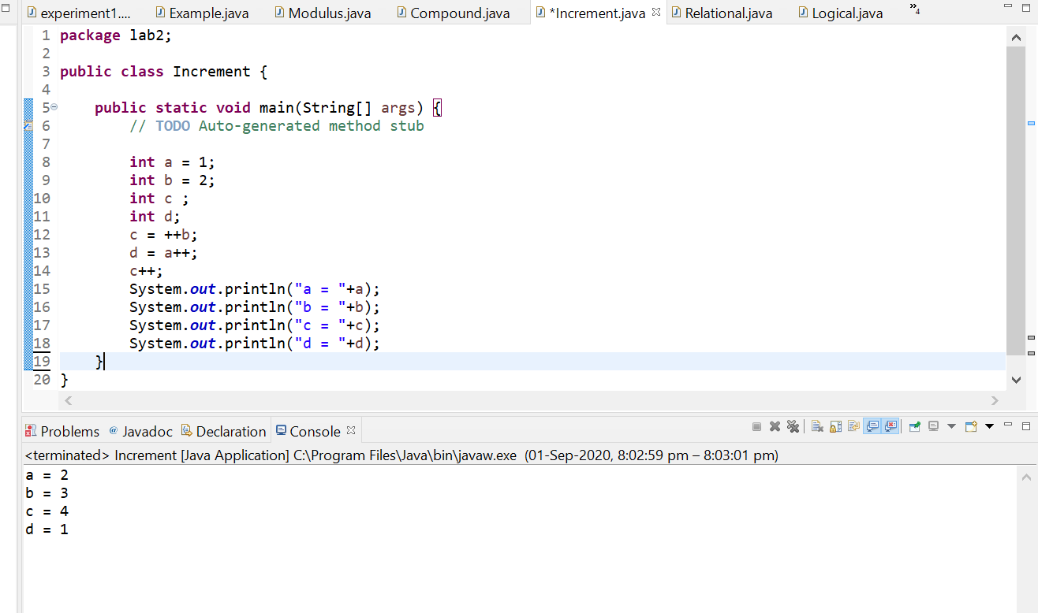

In this increment operators are explained. They are of types pre-increment(change and use) and post-increment(use and change). As explained in the example , value of a and b are increase by 1 and it is permanently increased. First we print the value of a that is 2 because in line 13 it is incremented (post-incremented) after that b which is incremented in line 12 and after that c which is obtained from increment of b and after that c is also incremented and after that d.

\*\*\*\*\*\*\*\*\*\*\*\*\*\*\*\*\*\*\*\*\*\*\*\*\*\*\*\*\*\*\*\*\*\*\*\*\*\*\*\*\*\*\*\*\*\*\*\*\*\*

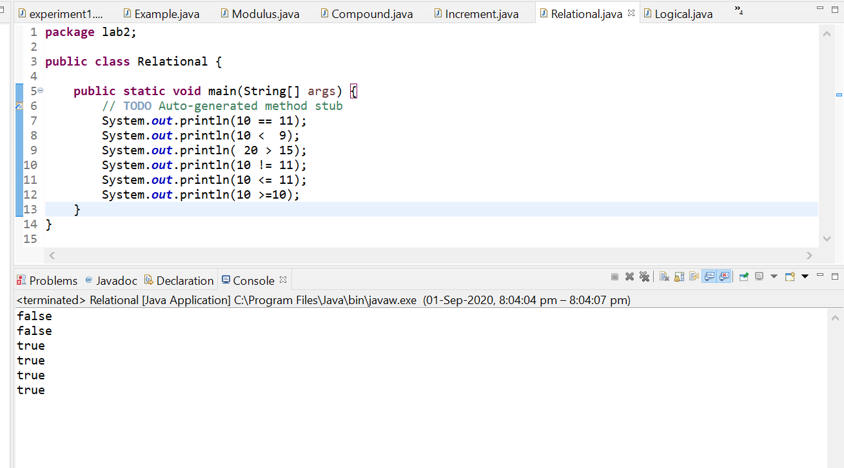

In this relational operators are covered they are also binary operators(specially for comparison ). It return or print Boolean value like 10==11 this is false so it print false.

Similarly others : != , >,<,<=,>=

\*\*\*\*\*\*\*\*\*\*\*\*\*\*\*\*\*\*\*\*\*\*\*\*\*\*\*\*\*\*\*\*\*\*\*\*\*\*\*\*\*\*\*\*\*\*\*\*\*\*

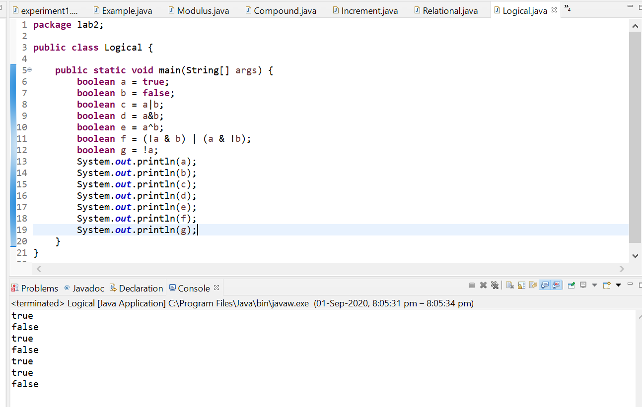

In this bitwise logical operator examples are explained, ! (not), ^(bitwise XOR), &(bitwise AND), |(bitwise OR). They are also return Boolean value(either true or false).

Ques 1: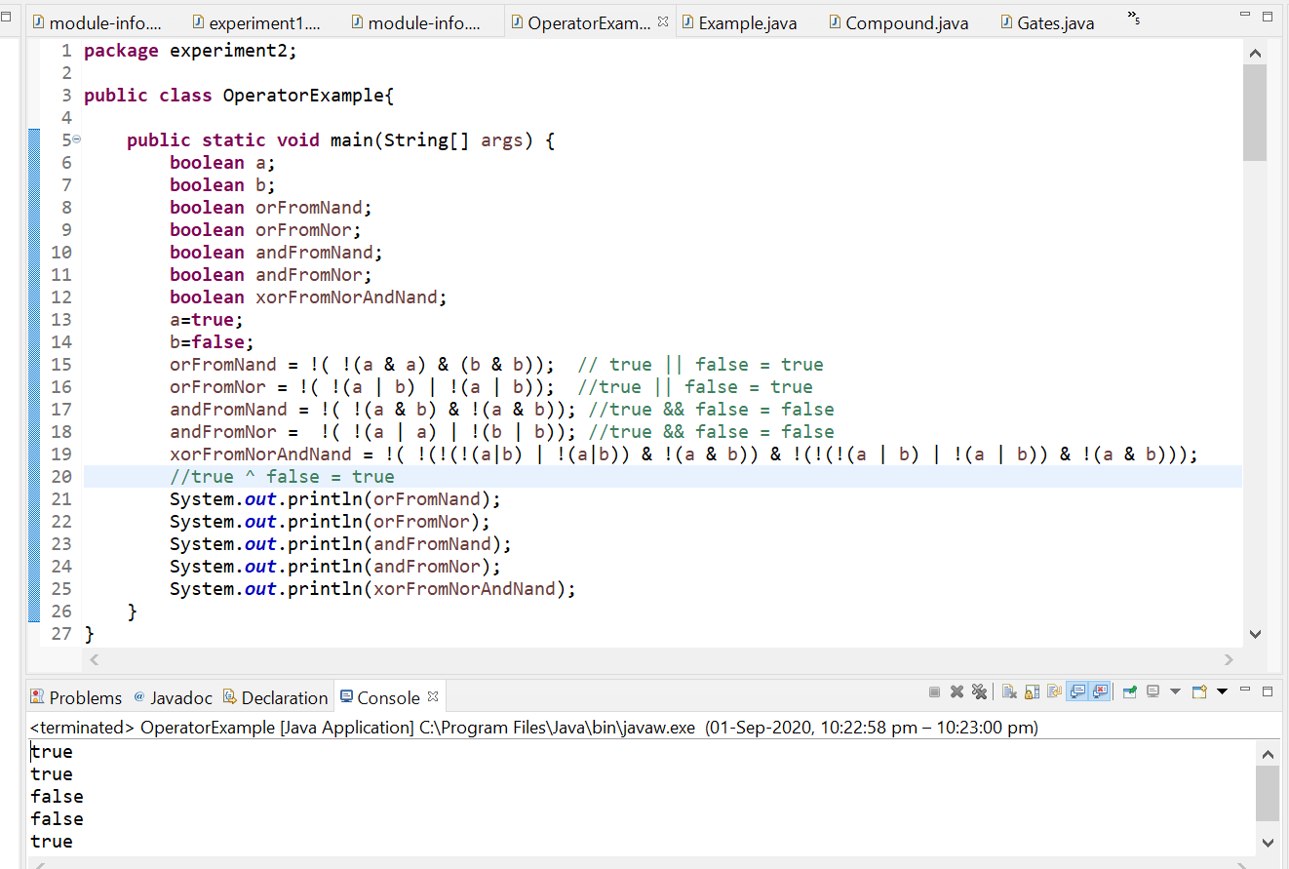

Ques 2:

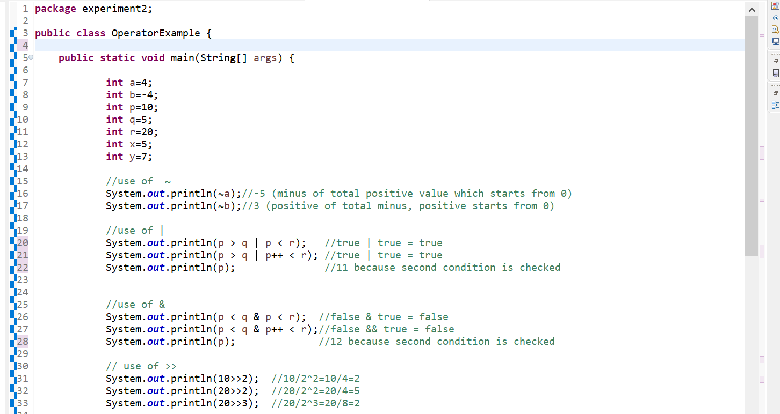

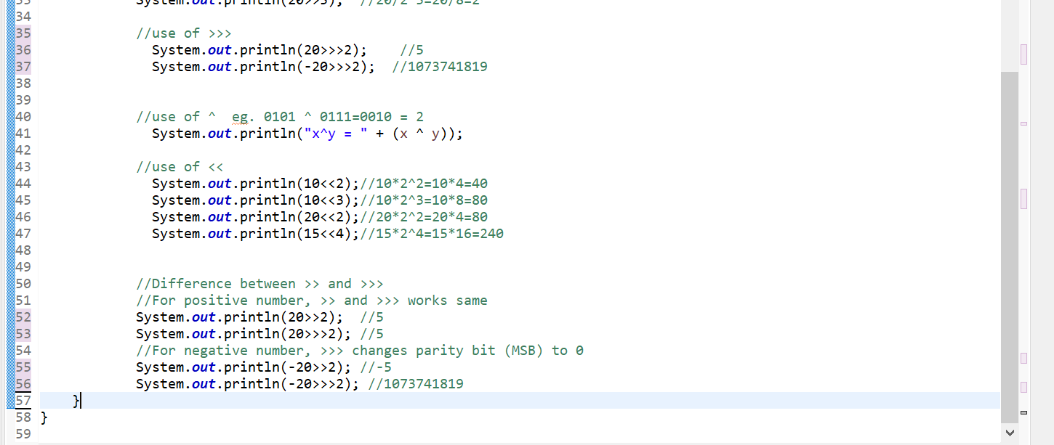

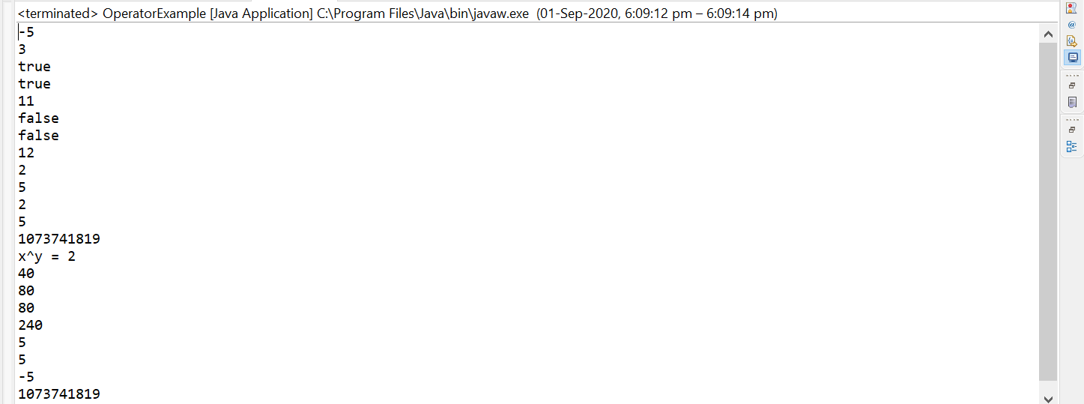

Ques 3:

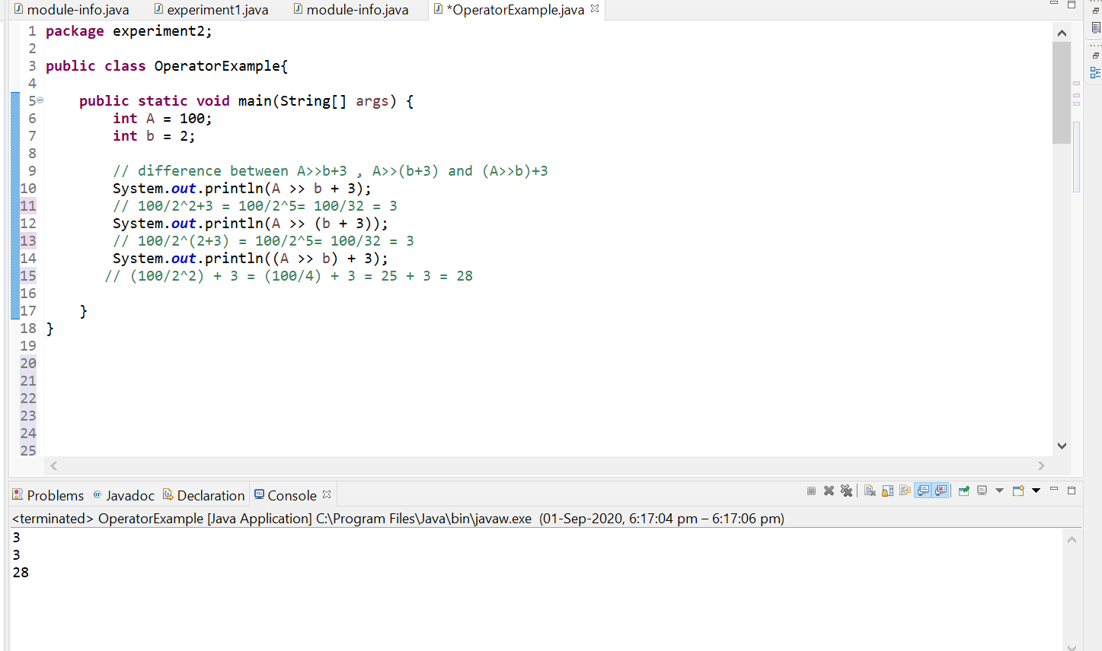

Ques 4: