JAVA LAB : EXPERIMENT 1

Date: 24-08-2020 -Rakhi(11912086)

Ques 1: a) Byte :

MINIMUM : -128

MAXIMUM: 127

b) Short

MINIMUM : -32768

MAXIMUM: 32767

c) Int

MINIMUM : -2147483648

MAXIMUM: 2147483647

d) Long

MINIMUM : -9223372036854775

MAXIMUM: 9223372036854774

Ques 2: 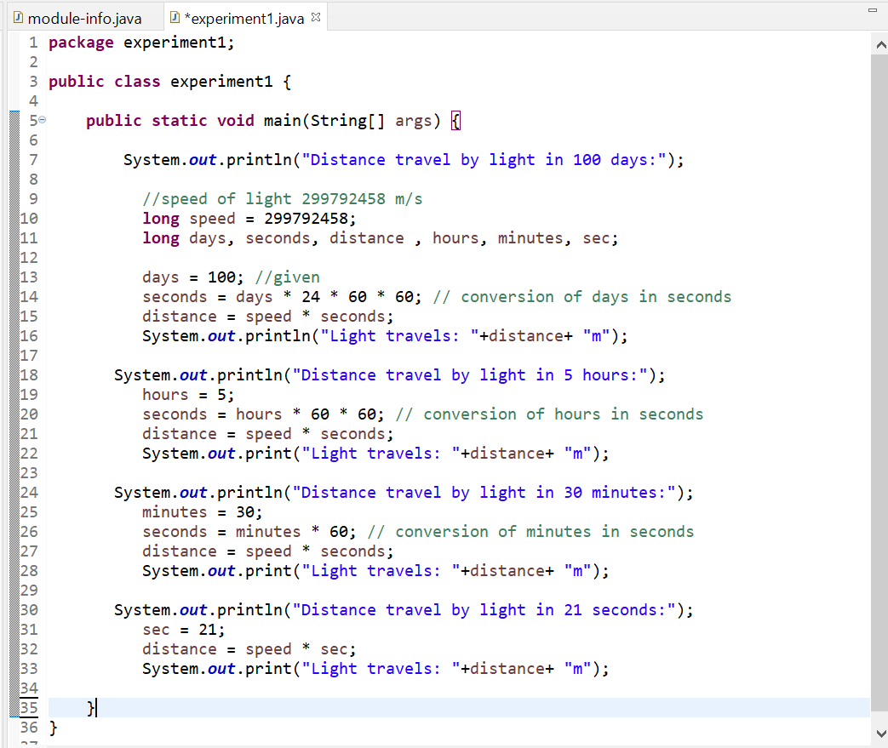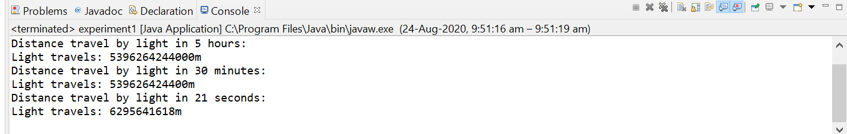

Ques 3: 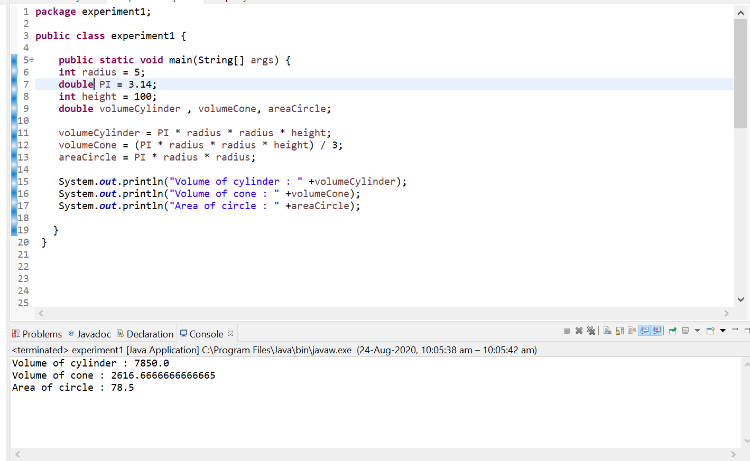

Ques 4: Range of character variable : ‘ \u0000 ’ to ‘ \uffff ’ ie., 0 to 65535

Ques 5: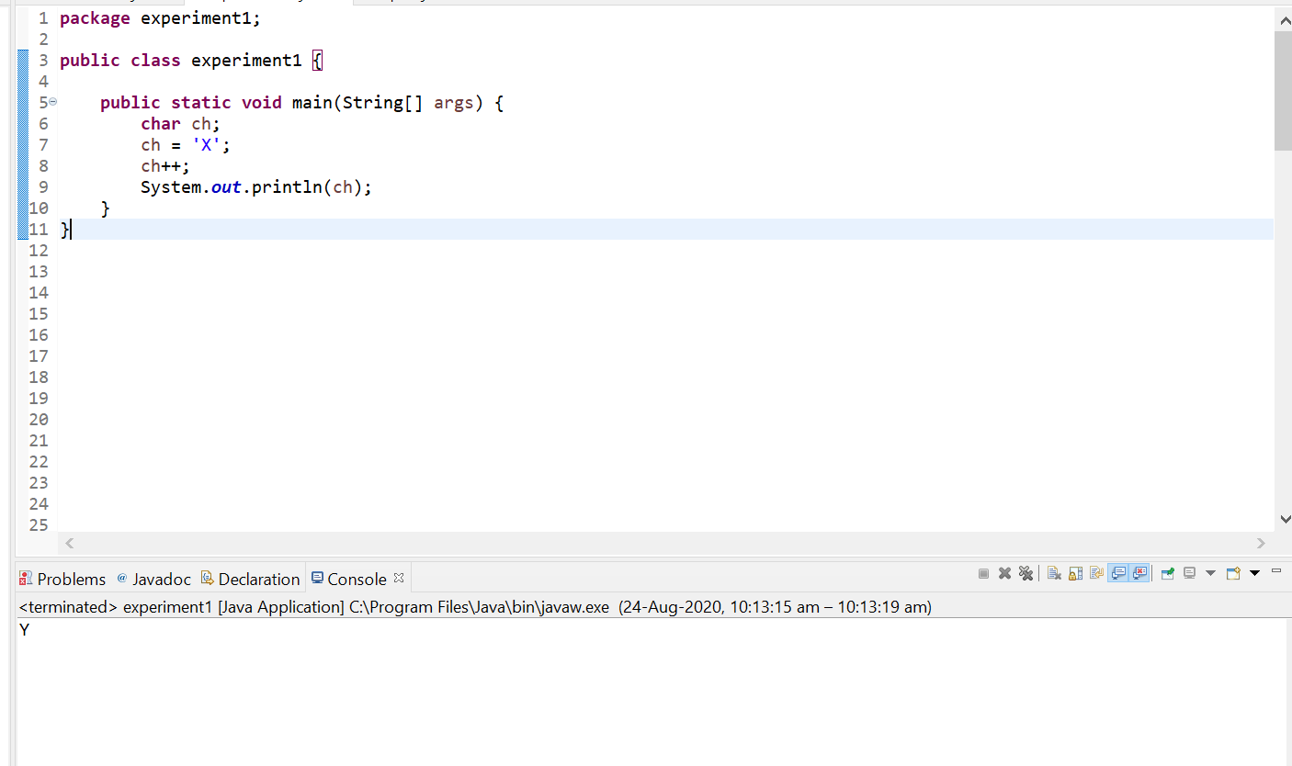

**It’s output is ‘Y’ because we increase the value of character variable ch by one so it works as – first it convert ch value in ASCII code then increase by one and again convert it into a char .**

**Ques 6:**