
MILITARY INSTITUTE OF SCIENCE AND TECHNOLOGY
DEPARTMENT OF COMPUTER SCIENCE AND ENGINEERING
CSE 307 OPERATING SYSTEM TERM PAPER
Disk Scheduling with a Learned Scheduler Selector

Course | Operating System (CSE 307)
Submitted To | Lec Khaled Hasan Irfan
Submitted By | Rakibul Islam Rony  Student ID: 202414033
Submission Date | 4 October 2026

Disk Scheduling with a Learned Scheduler Selector

1. Problem and aim
A disk scheduler decides which request the disk head handles next. The best choice can change with the request pattern. I compared four familiar methods and trained a small model to pick one for each batch. I then checked what happened when the requests changed from sequential to bursty. The definitions and trade-offs of SSTF, SCAN, and C-SCAN follow Arpaci-Dusseau and Arpaci-Dusseau [1].

2. What I built
I implemented FCFS, SCAN, C-SCAN, and SSTF in Python. FCFS keeps the request order. SCAN moves across the disk and reverses when needed. C-SCAN wraps around to the other end. SSTF picks the nearest request next. I counted all head movement, including movement to the end and the wrap when needed.
The learned part is a small NumPy logistic regression model. It looks at the requests' positions, spread, order, and close groups. Its training label is the method with the shortest seek distance for each batch. A fixed order settles ties. The model also gives a confidence score for its pick.

3. How I tested it
The simulated disk has cylinders 0 to 199. Each batch has 20 requests, and the head starts at cylinder 100, moving upward. I made sequential, random, and two-cluster bursty batches with seed 3072026. I used 900 batches to train, 300 to adjust confidence, and 300 for the final test.
I also made a 60-batch timeline: 30 sequential batches followed by 30 bursty ones. I ran every scheduler on the same requests and measured head movement in cylinders. This is my simple estimate of seek time.

4. Results

Held-out test
The table shows total seek distance across the 300 test batches. Lower is better.
Method | Total seek distance (cylinders)
FCFS | 203,924
SCAN | 71,913
C-SCAN | 100,140
SSTF | 45,834
Learned selector | 46,734
The selector picked a method with the shortest seek distance in 91% of the test batches. Even so, its total was 900 cylinders higher than SSTF. A few wrong picks cost more movement than its good switches saved. The best possible choice for every batch would total 45,318 cylinders, so there was only a small gap below SSTF in this test.

When the request pattern changed
On the 60-batch timeline, the selector averaged 68.2 cylinders per sequential batch and 92.3 per bursty batch. Its correct-choice rate fell from 96.7% to 93.3%. FCFS changed much more: its average rose from 79.6 to 503.5 cylinders per batch. SSTF rose from 71.1 to 87.5. The bursty requests were spread across two groups, so following their given order caused FCFS to cross the disk again and again. The selector stayed much closer to SSTF, but it did not improve on SSTF after the shift.

5. Confidence and limits
The model was more confident when it was right. On the held-out test, average confidence was 0.873 for correct picks and 0.786 for wrong ones. The five-bin calibration error was 0.045. On the shift timeline it was 0.126, so confidence matched the outcomes less closely there. This matters because a high score does not always mean the selected scheduler will be best after the pattern changes.
These are simulated requests, not measurements from a real disk. I counted seek distance only. I did not include rotation time, data transfer time, requests arriving while a batch is running, or fairness. C-SCAN may help with fairness, but that benefit is not shown by this seek-only test. The results are therefore useful for comparing this setup, not for claiming which scheduler is best on a real machine. Linux also exposes contemporary I/O schedulers such as mq-deadline, BFQ, and Kyber, so this simulation should not be read as a Linux scheduler benchmark [2].

6. Conclusion
I found that a small model can usually choose a low-seek scheduler from the request pattern. But in this experiment, plain SSTF still had the lower total seek distance. The workload shift also made the model's confidence less reliable. If I continued this work, I would test live arrivals and waiting time as well as seek distance, and check whether a selector is useful when fairness is included.

GitHub repository
Repository URL: add your GitHub link after upload.

References
[1] R. H. Arpaci-Dusseau and A. C. Arpaci-Dusseau, “Hard Disk Drives,” Operating Systems: Three Easy Pieces, version 1.10, 2023. https://pages.cs.wisc.edu/~remzi/OSTEP/file-disks.pdf
[2] The Linux Kernel documentation, “Switching Scheduler.” https://docs.kernel.org/block/switching-sched.html (accessed 4 October 2026).

Figures
Figure 1. Mean seek distance per batch before and after the request-pattern change.
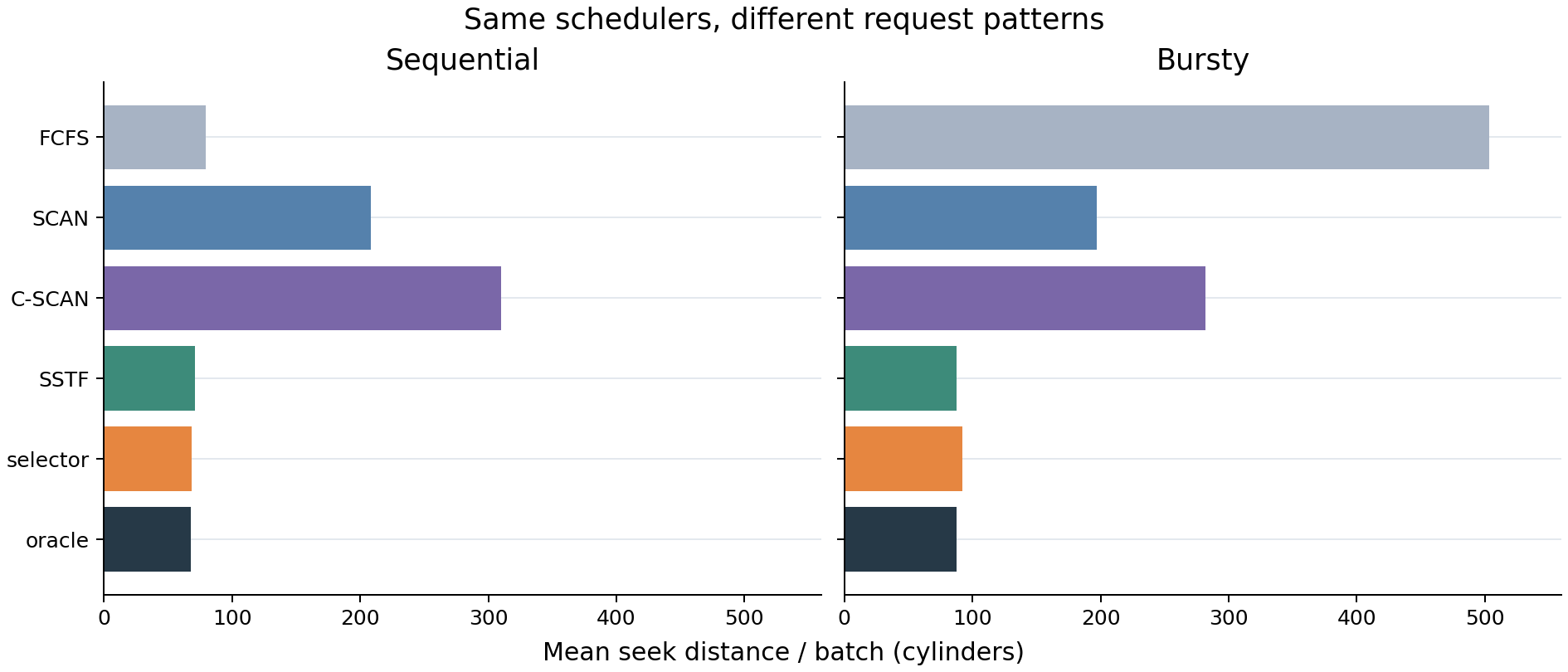
Figure 2. Workload shift: the same algorithms process each request batch.
