SQARMA Project Architecture and Pipeline Guide
Rfam seed alignments versus original STAR3D structural alignment — how the pilot actually works
2026-10-09 (state of branch v4-validation-2026-10-09)
Written for a PhD student joining the project. Prepared by an AI research agent (Claude) from the repository and its validated outputs; it has not yet been reviewed by the researcher or the professor. Every path below is relative to rfam_star3d_pilot_v2/ unless stated otherwise. Values quoted as results come from the tables named next to them. Anything not implemented is marked (planned), and commands that were not executed while preparing this guide are marked (untested).

A. Project purpose and boundaries

A.1 The question
For distinct homologous RNA sequences with suitable experimental structures, where do ordinary Rfam seed correspondences and original STAR3D correspondences differ, and what evidence explains those differences?
Some terms used throughout:
- RNA family (Rfam). Rfam groups related RNAs into families such as RF00522 (the preQ1-I riboswitch). For each family it publishes a seed alignment: a hand-curated multiple sequence alignment in Stockholm format. Each row is one RNA sequence region (for example URS00023119CB_2126436/1-34), and each column says which nucleotides of the different rows correspond to each other.
- Correspondence. A statement that nucleotide i of RNA A plays the same role as nucleotide j of RNA B. A seed alignment implies correspondences: two residues in the same column correspond.
- STAR3D. A structural aligner (Ge & Zhang 2015, NAR 43:e137). From the 3D coordinates of two RNAs it finds conserved helical stacks, superimposes them and aligns the loops between them. Its output is a list of corresponding nucleotides. We use the original v1.2 release, not LocalSTAR3D or CircularSTAR3D.
- FR3D. A program that annotates base pairs (for example cWW, the canonical cis Watson–Crick pair) and base stacking in a 3D structure. We use it to ask whether a correspondence carries interactions over from one structure to the other.

A.2 Why compare Rfam with STAR3D
The long-term motivation is better identification of RNA interactions and motifs, especially non-canonical pairs. If sequence alignments place nucleotides in the wrong columns, interaction labels transferred through them will be wrong. Comparing a published sequence alignment with a structure-based one, on RNAs whose structures are known, shows where the two disagree and why.

A.3 What counts as an informative result
All of the following are valid results. A region can be classified as:
- a supported candidate for Rfam curator review;
- a STAR3D limitation, such as short alignments or coordinate-gap artefacts;
- genuine structural variation, for example from ligand binding or a bound protein;
- an experimental construct effect, for example engineered loops;
- a mapping or annotation problem;
- insufficient evidence.
Agreement is also informative, and so is a well-documented failure to find eligible data. Neither method is treated as ground truth.

A.4 What the project does not (yet) show
- No sequence-only predictor, and no general alignment-correction method.
- No accuracy estimate for Rfam. The pilot has 2 primary families, so rates cannot be extrapolated.
- No structure-independent baseline. For every family studied, the “ordinary” seed is the 3D-curated alignment (section H).

A.5 Relation to the professor’s instructions
The meeting transcript is not in the repository. The professor’s requests are taken from the transcript-derived list in Phase 1/plans/RNA_Research_Plan_Fresh_Start_2026_10_08 (1).docx. Each one is traced to code and evidence in deliverables/2026-10-09_v4/tables/requirements_matrix.tsv, which also labels whether an item is a professor instruction, a later user decision or our own methodological choice. In summary, the professor asked us to:
- count families with ≥2 eligible distinct sequences;
- link each chain to its exact seed row;
- remove redundant and engineered constructs;
- compare the ordinary and structure-curated seeds;
- run original STAR3D and study disagreements;
- if experimental cases cannot be found, bring the search to Smriti and ask about predicted structures.

B. System architecture
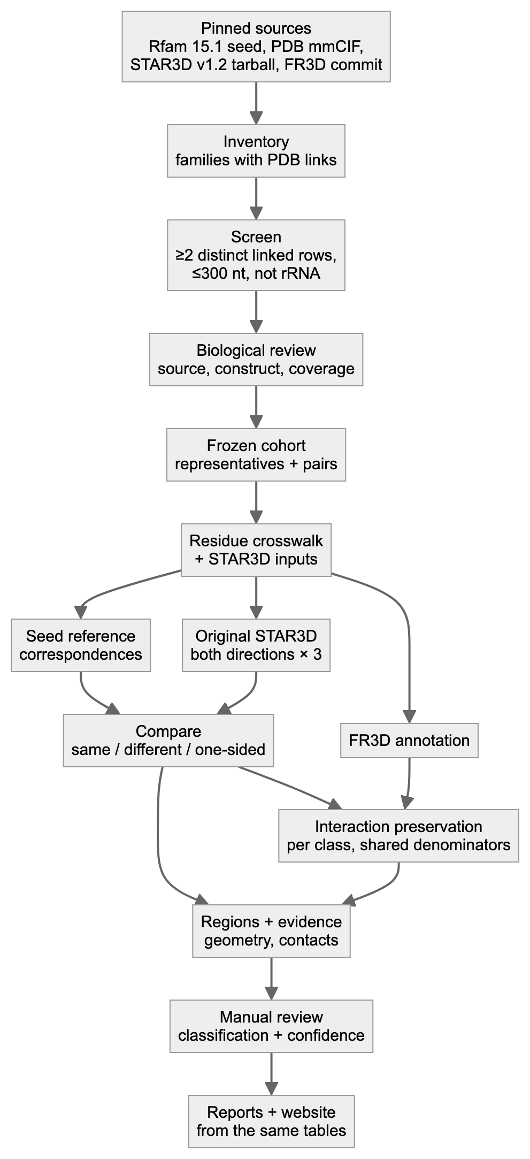
Figure 1. Complete research workflow.

B.1 Modules
Shared libraries used by many modules:
- scripts/stockholm.py — the Stockholm parser;
- scripts/fetch.py — downloads with a manifest;
- scripts/locate.py — maps residues to seed elements.
Module | Purpose | Inputs | Outputs | Actual script/path | Validation | Dependencies
Source pinning | Download and freeze sources | URLs in config.yaml | inputs/…; metadata/sources_manifest.tsv (URL, time, sha256) | scripts/fetch.py, scripts/inventory.py | Seed sha256 must equal config.yaml; never overwritten | network
Inventory and screen | Families with PDB links; ≥2 distinct linked rows; ≤300 nt; not rRNA | Rfam.seed.gz, Rfam.pdb.gz | results/family_inventory.tsv, metadata/chain_row_candidates.tsv | scripts/inventory.py | Parser gate on a real interleaved record (parser_gate.py) | stockholm.py
Structure evidence | Link each chain to a seed row; organism; coverage; modifications | mmCIF | mappings/structure_sequence_map.tsv, review/evidence/*.json | scripts/structures.py (build_link) | Exact sequence match at row coordinates; parent-mapped modifications | gemmi
Provenance and construct review | Source organism, engineering, papers | Papers, NCBI genomes | review/construct_review.tsv, review/exact_source_check.tsv, review/decisions.yaml | literature.py, exact_source_check.py, blast_*.py + manual review | Genome search on both strands; masks recorded | NCBI, Europe PMC
Cohort freeze | Representatives and pairs fixed before STAR3D | decisions.yaml | results/selected_representatives.tsv, results/selected_pairs.tsv, metadata/cohort_*_freeze.json | scripts/cohort.py --freeze | Refuses pending representatives; sha256 freeze | —
Crosswalk and STAR3D inputs | Residue identity across numbering systems; legacy PDB input | mmCIF, seed | results/residue_crosswalk.tsv, runs/_inputs/*.pdb, mappings/aligner_inputs.tsv | scripts/prepare_inputs.py | Re-reads the written file exactly as STAR3D does; identity check per residue | gemmi
Seed reference | Seed correspondences per pair | seed, crosswalk | results/reference_pairs.tsv, standard_seed_membership.tsv, standard_seed_rows.sto | scripts/reference.py | Raw-line trace + sha256 of every row; valid per-family Stockholm | —
Original STAR3D | Structural correspondences | PDB inputs, tarball | runs/<pair>/attemptN/…/*.aln, results/run_manifest.tsv | scripts/star3d.py run <PAIR> | Unique attempt dirs, in-container checksums, preprocessing-content gate | docker image star3d-runtime:1
Comparison | Same / different / one-sided partner per residue | .aln, reference | results/correspondence_comparison.tsv, pair_summary.tsv, replicate_consistency.tsv | scripts/compare.py | Re-validates stored outputs (counts, sha, injectivity); atomic writes | star3d.py
Interaction annotation | FR3D pairs and stacks; preservation per class | mmCIF, comparison | annotations/raw/*, results/interaction_comparison.tsv, interaction_summary.tsv | scripts/interactions.py | Installed FR3D commit verified; raw-hash cache; symmetry mates excluded; per-comparison denominators | fr3d-python 288f98cc
Regions | Group disagreements; eligibility | comparison, interactions | results/region_review.tsv | scripts/regions.py | Span and partner masks; history kept on change | locate.py
Region evidence | Geometry, contacts, interactions per region | all of the above | results/region_evidence/, results/anchor_fit/ | scripts/region_evidence.py, scripts/anchor_fit.py | Degenerate anchor sets refused | numpy, gemmi
Biological review | Classification + confidence | evidence tables, papers | review/region_review_v4.tsv → results/region_review.tsv | manual + scripts/apply_region_reviews.py | Dated; reviewer recorded | —
Method audit and sensitivity | STAR3D pair rule; S1/S2 | preprocessing products | results/sensitivity/, deliverables/2026-10-09_v4/star3d_sensitivity/ | star3d_preproc_audit.py, star3d_sensitivity*.py | Separate namespace; never replaces default | docker
Provenance surveys | Ordinary vs curated seed; release history | Rfam 14.0–15.1 files | results/seed_collection_comparison/, results/rfam_history/ | scripts/survey_b.py, scripts/rfam_history.py | Byte-level record comparison | —
Fresh reproduction | Re-download and rerun selected pairs | URLs | audit/fresh_repro*/ | scripts/fresh_repro.py --pairs … | Input gate stops on any mismatch | docker, FR3D
Prospective expansion | Pre-registered new pairs in an isolated workspace | screened candidates | expansion_v4/ | scripts/expansion_v4.py freeze / run | Freeze hashes re-checked before run | all stages
Reports and website | Human-readable outputs from the same tables | tables | reports/, deliverables/*/, deliverables/2026-10-09_v4/site/ | export_site_data.py, evidence_cards.py, render scripts | check_report_numbers.py; HTTP checks | pandoc, Chrome (docs)
Tests and manifests | Regression tests; checksums | code | tests/ (64), MANIFEST.tsv, repro package | pytest; mutation check | 16/16 re-introduced defects detected | pytest

B.2 Stage order and parallelism
The required order is:
- Inventory, then structures, then review, then cohort freeze.
- prepare_inputs.py (crosswalk), then reference.py. The reference stage needs the crosswalk; running it first gives zero assessable pairs, which happened once in v4 and was caught.
- star3d.py.
- compare.py, then interactions.py, then regions.py.
- Region evidence, then review, then reports.
What can run in parallel:
- Downloads, literature retrieval and genome checks for different structures.
- STAR3D runs for different pairs. Each uses its own attempt directory. On the emulated host we ran them one at a time.
- FR3D annotation of different structures.
- Report rendering, after the tables are final.
The global table stages (reference, compare, interactions) refuse subset runs. They always rewrite the complete table, so a partial rerun cannot silently replace complete results.

C. Step-by-step real example: 6VUI–7REX (RF00522, preQ1-I riboswitch)
All values below are copied from validated tables. The pair is Thermoanaerobacter tengcongensis (PDB 6VUI, chain A) versus Carnobacterium antarcticum (PDB 7REX, chain A).
Step 1: family and seed rows. Both chains carry explicit structure links in the pinned Rfam.seed.gz 15.1, as #=GR lines 6VUI_A_SS and 7REX_A_SS. The rows are:
- 6VUI → URS000080E32E_119072/1-33;
- 7REX → URS00023119CB_2126436/1-34.
Membership is proven by the raw decompressed line numbers and the sha256 of each aligned string (results/standard_seed_membership.tsv).
Step 2: structure and construct verification.
- Both are X-ray structures (2.68 Å and 2.6 Å).
- Each deposited sequence equals the row sequence over the family interval.
- There are no modified nucleotides.
- Each sequence was found exactly in its claimed source genome: AE008691.1 on the minus strand at 1523221 for 6VUI, and CP010796 on the plus strand at 2093557 for 7REX (review/exact_source_check.tsv). An exact genome match supports sequence provenance, but does not prove every step of how the experimental construct was prepared.
Step 3: a real crosswalk excerpt (results/residue_crosswalk.tsv):
rep | row index | nt | seed column | label_seq_id | auth ID | STAR3D index | STAR3D residue
6VUI_A | 1 | C | 6 | 1 | A:1 | 0 | A:1
6VUI_A | 16 | C | 27 | 16 | A:16 | 15 | A:16
7REX_A | 16 | U | 26 | 16 | A:16 | 15 | A:16
7REX_A | 17 | C | 27 | 17 | A:17 | 16 | A:17
7REX_A | 18 | C | 28 | 18 | A:18 | 17 | A:18
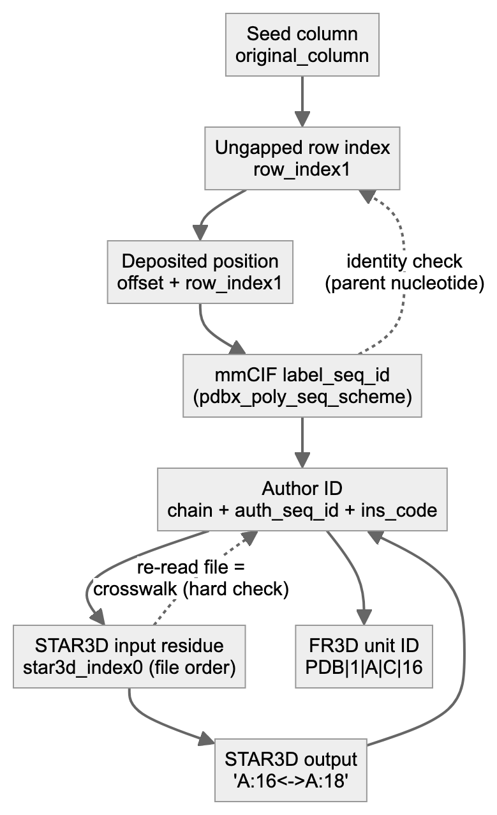
Figure 2. Residue identity mapping.
Step 4: the Rfam correspondence. 6VUI C16 sits in seed column 27. In the 7REX row, column 27 holds C17. So the seed says 6VUI C16 ↔ 7REX C17.
Step 5: STAR3D input and commands. prepare_inputs.py writes runs/_inputs/6vuia.pdb and runs/_inputs/7rexa.pdb (model 1, first altloc, author numbering). Inside a fresh attempt directory, in the container, the wrapper runs:
java -cp STAR3D.jar Preprocess 6vuia A
java -cp STAR3D.jar Preprocess 7rexa A
java -jar STAR3D.jar -o out/RF00522__6VUI_A__7REX_A__a1__forward__rep1.aln -p 6vuia A 7rexa A
The defaults recorded in the output are: RMSD cutoff 4.0 Å, minimum stack 3, gap open −5, gap extension −2, match 3, mismatch 0.
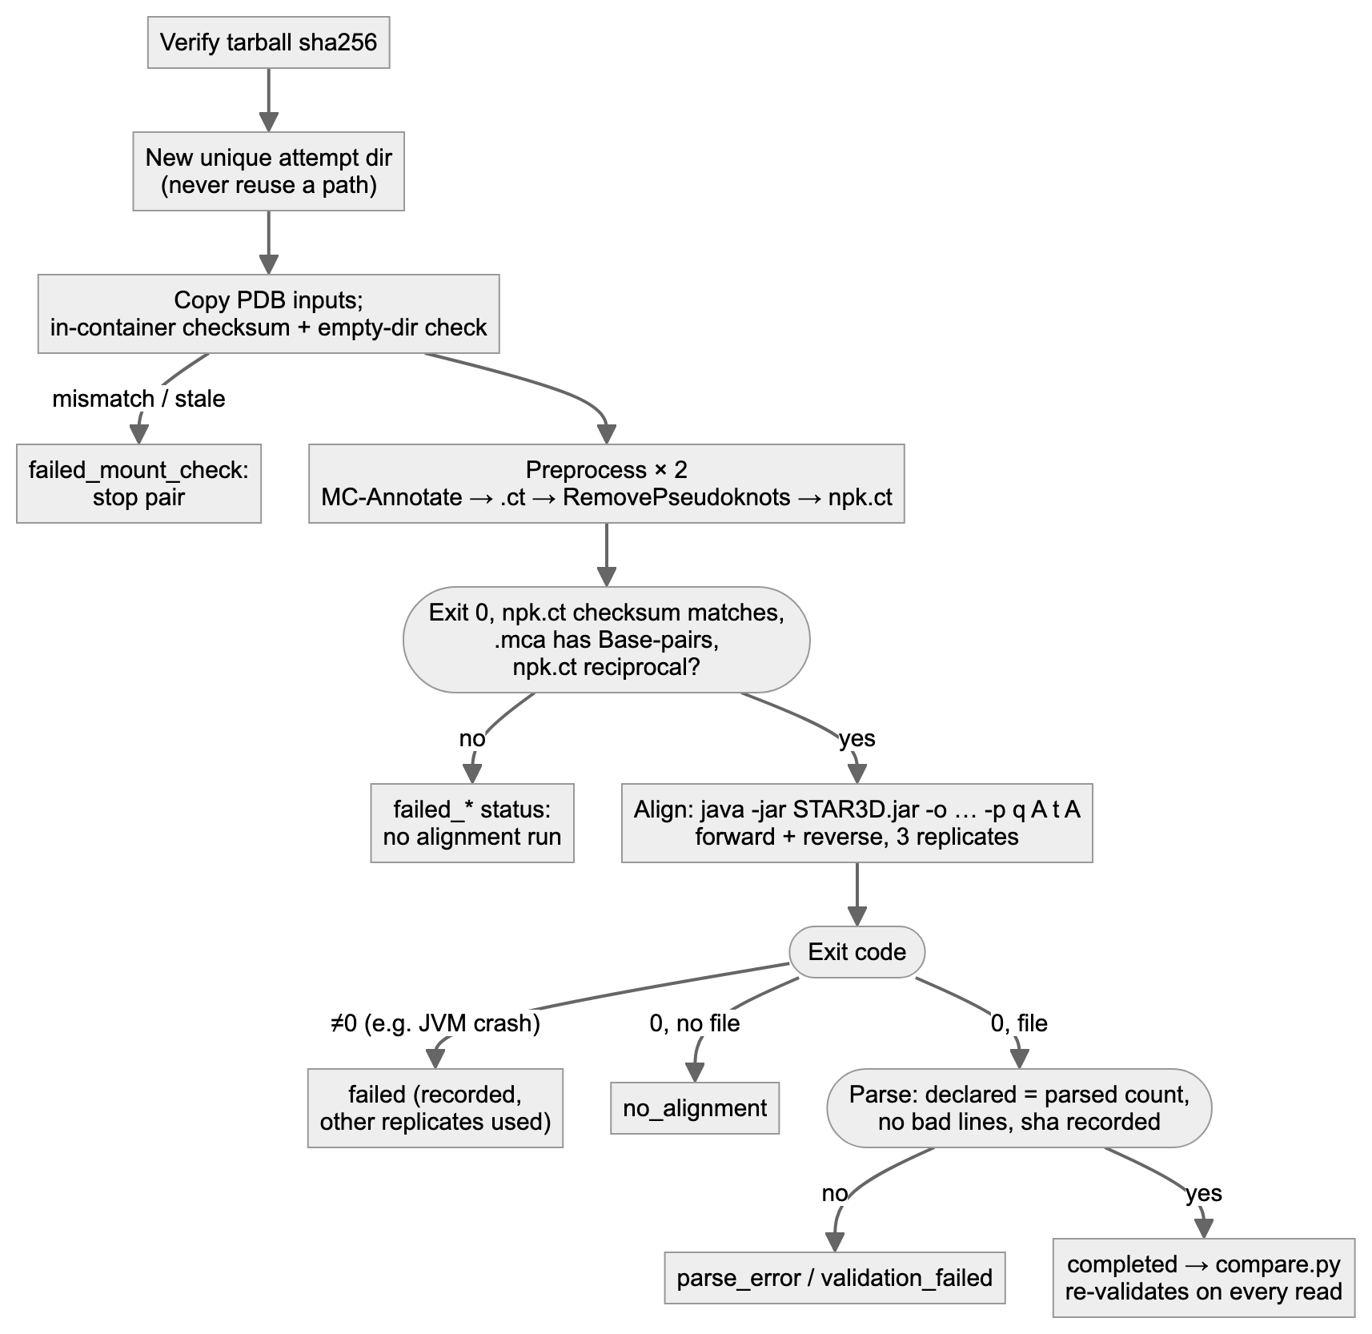
Figure 3. STAR3D execution and failure handling.
Step 6: parsed STAR3D correspondence. The .aln file reports #Aligned nucleotide: 32 and #Alignment RMSD: 2.34A, followed by mapping lines including:
A:5<->A:5
A:16<->A:18
A:24<->A:25
So STAR3D says 6VUI C16 ↔ 7REX C18. compare.py translates both sides through the crosswalk and labels each source residue (results/correspondence_comparison.tsv, forward rep1):
- Agreement example: 6VUI C1 → seed 1, STAR3D 1, labelled same_partner.
- Disagreement example: 6VUI C16 → seed 17, STAR3D 18, labelled different_partner.
- One-sided cases: 6VUI A13 is star3d_only (the seed leaves it opposite a gap); 6VUI A23 is rfam_only.
Pair totals: 16 same, 15 different, 1 seed-only and 1 STAR3D-only, out of 32 structurally assessable seed pairs.
Step 7: interaction annotation and eligibility.
- FR3D annotates 6VUI G5–C16 as cWW.
- Mapped through each method, it becomes 7REX G5–C17 under the seed, for which FR3D reports no annotation (no_annotated_target_pair), and G5–C18 under STAR3D, which is cWW (exact_class_preserved) (results/interaction_comparison.tsv).
- The interaction is eligible for the seed-vs-STAR3D comparison because:
  - both source residues are unmasked and observed;
  - both methods map both endpoints;
  - all targets are observed and unmasked.
Step 8: a worked interaction count. On the eligible set for 6VUI→7REX:
- the seed preserves 19 of 47 interactions and STAR3D 29 of 47 (results/interaction_summary.tsv);
- for canonical pairs alone, the seed preserves 0 of 7 and STAR3D 5 of 7.
Two caveats apply. First, the denominator is the same set for both methods; a method that maps fewer residues is not rewarded with a smaller denominator. Second, the reverse direction has its own denominator.
Step 9: interpreting the disagreement region. regions.py groups 6VUI 7–23 into one region. region_evidence.py then superposes the two structures on the residues where both methods agree. The anchor sets are all shared residues, shared residues minus the flanks, and local shared residues only. It then measures C1′ and base-centroid distances to each method’s partner.
- P1 3′ strand (14–21). The STAR3D partners are 0.5–3.3 Å away and the seed partners 3.6–8.8 Å, under every rule. The 7REX authors describe P1 with a G5–C18 pair.
- Loop L1 (7–12). The seed is better supported.
- Classification. P1 3′ strand: supported candidate (moderate). L1: possible STAR3D issue (low–moderate) (review/region_review_v4.tsv).
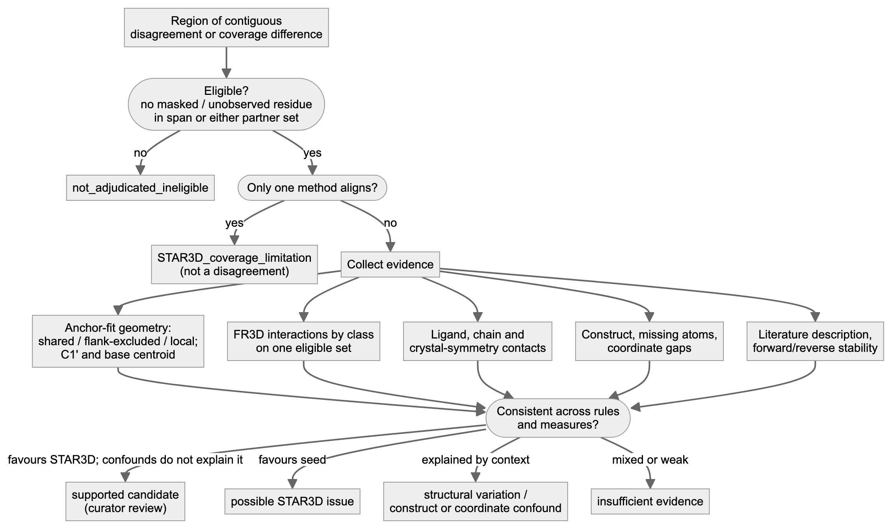
Figure 4. Scientific evidence assessment.
Step 10: from tables to report and website.
- The reports quote the tables. check_report_numbers_v4.py re-reads the tables and confirms the numbers.
- export_site_data.py copies the same tables into site/data/*.json, together with a manifest of source sha256 values.
- The website types no numbers of its own.
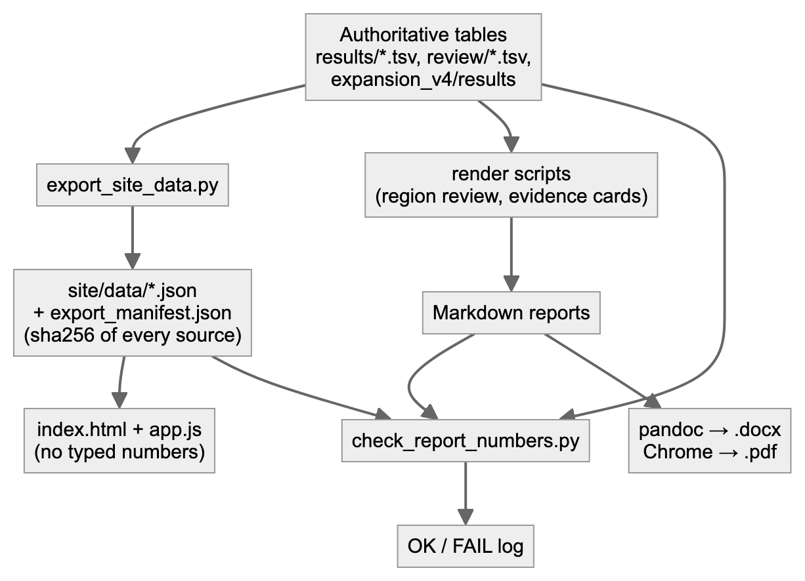
Figure 5. Report and website generation.

D. Data eligibility
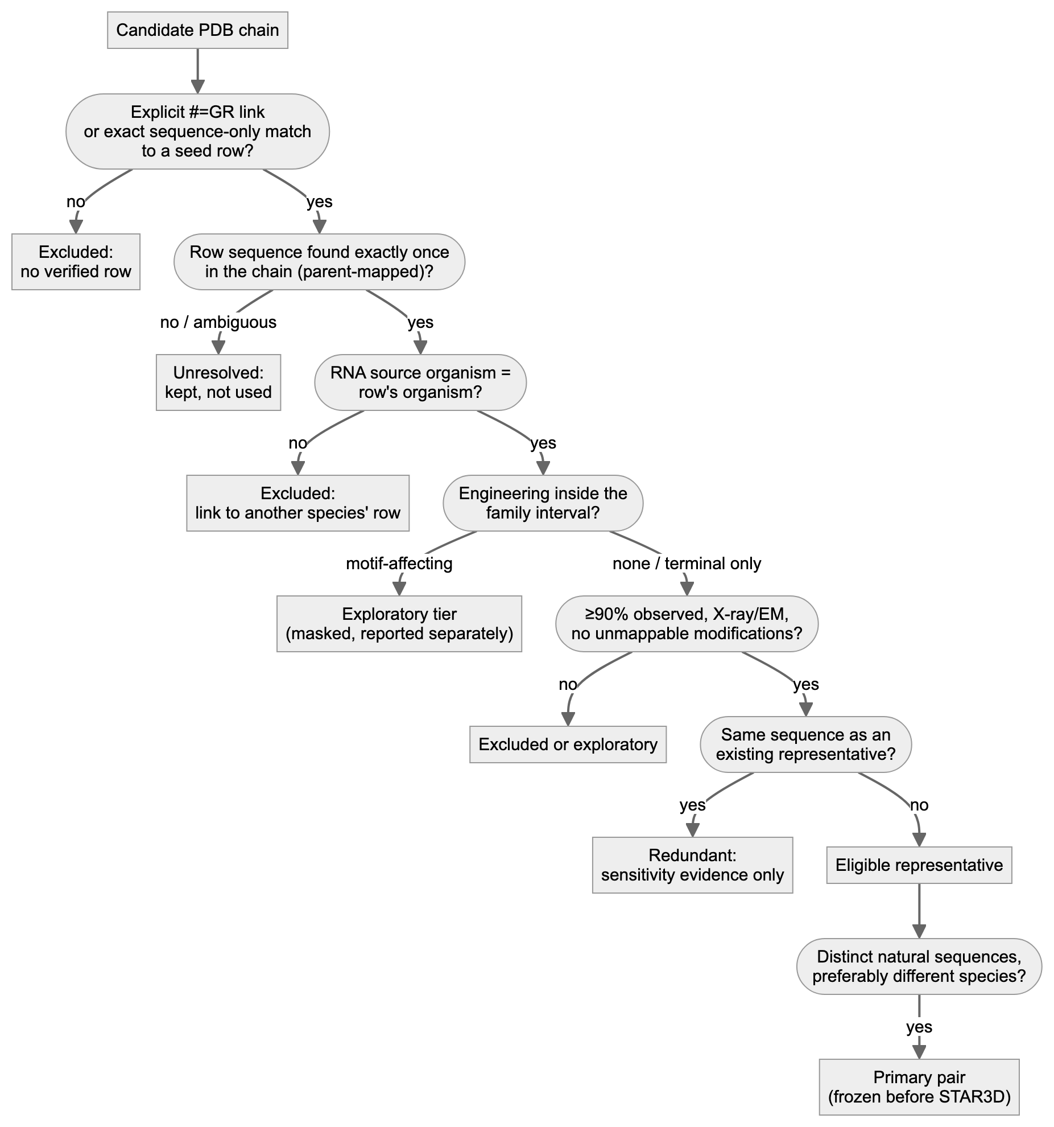
Figure 6. Data eligibility and exclusion decisions.
Examples from the actual screens:
- Organism mismatch. 9J4O (B. subtilis tRNA-Leu) was excluded because its exact sequence match is to a seed row from H. halodurans. An identical sequence does not make that row this RNA’s row.
- Modified nucleotides. 1EHZ (yeast tRNA-Phe) was excluded because original STAR3D reads modified nucleotides as “N”.
- Engineered constructs. SAM-I was kept as exploratory because both constructs are engineered inside the family interval.

E. Reproducibility and operation
All commands run from rfam_star3d_pilot_v2/.
Task | Command | Status
Environment | python3.13 -m venv .venv && .venv/bin/pip install -r requirements.lock.txt | used to build the current .venv; not re-run in v4
STAR3D runtime | docker build --platform linux/amd64 -t star3d-runtime:1 -f scripts/Dockerfile.star3d scripts/ | image sha256:e1602e60… in use; not rebuilt in v4
Tests | .venv/bin/python -m pytest -q tests | verified (64 passed)
Reproduce one pair from fresh downloads | .venv/bin/python scripts/fresh_repro.py --pairs RF00522__6VUI_A__7REX_A --out audit/fresh_repro_<new> | --pairs mode verified in v3 with 4 pairs
Reproduce the pilot | stages in README “Rerun by stage”: prepare_inputs.py → reference.py → star3d.py run <PAIR…> → compare.py → interactions.py → regions.py | individual stages verified across v2.1–v4
Add an eligible pair (isolated, prospective) | pre-register; add to REPS in a copy of scripts/expansion_v4.py; … freeze; … run | verified in v4 (tRNA pair)
Region evidence and review | .venv/bin/python scripts/region_evidence.py (set SQARMA_STUDY_ROOT for a workspace); edit review/region_review_v4.tsv; scripts/apply_region_reviews.py | verified
Regenerate reports | scripts/evidence_cards.py; deliverables/2026-10-09_v4/scripts/render_region_review.py; …/check_report_numbers_v4.py | verified
Website | .venv/bin/python scripts/export_site_data.py, then cd deliverables/2026-10-09_v4/site && ../../../.venv/bin/python -m http.server 8765 and open http://localhost:8765 | verified
Caching and checksums.
- Downloads are cached and never overwritten. Every file has a URL, retrieval time and sha256 in metadata/sources_manifest.tsv.
- Fresh reproduction compares re-downloads byte for byte. On any mismatch it quarantines the new bytes and blocks all dependent steps.
- FR3D outputs are reused only when their sidecar records the verified installed commit and matching raw-output hashes.
- STAR3D never reuses a directory: every attempt gets a new path, because the emulated file mount can serve stale views of a reused path.
Partial failures.
- Preprocessing. A failure here records a failed_* status and stops that pair.
- Alignment. A crash (for example a JVM signal) is recorded as failed; the other replicates are used.
- Corrupt or changed output. Validation failures from malformed or changed stored output are written only to results/*.INVALID.tsv, never over the complete tables.
Logs.
- logs/ holds pilot-stage logs.
- runs/<pair>/attemptN/logs/ holds each STAR3D run’s stdout and stderr.
- deliverables/<session>/logs/ holds session logs.
- audit/ holds reproduction records.

F. Limitations at large scale
Combinatorics. A family with k representatives has k(k−1)/2 pairs. Each pair needs:
- 2 directions × 3 replicates = 6 alignments;
- 2 preprocessing steps.
So 10 representatives give 45 pairs and 270 alignments. All-pairs analysis is neither necessary nor independent: pairs that share an RNA share its errors and its construct effects. Results should be reported per family and per distinct row, not per pair.
Other costs and limits:
- Downloads and annotation. mmCIF files are mostly small (median 120 kB over 166 files; largest 15 MB). Ribosome complexes are large, and annotating them takes longer.
- Biological curation is the bottleneck. Source organism, construct design, inaccessible papers and modified nucleotides each need judgement. More workers do not remove it.
- Execution. On this arm64 Mac, STAR3D runs under x86-64 emulation: 3 JVM crashes in 112 recorded alignment runs, including control runs (2.7%). A native x86-64 host is needed for scale. Memory was not limiting for RNAs up to 163 nt; longer RNAs were not tested.
- Missing rows and uncertain mappings. Most PDB chains have no seed row (10,520 of 12,818 candidate chains). Of the rest, 1,793 have only sequence-only matches, which need provenance review: two of the tRNA candidates pointed to another species’ row.
- Selection bias. Explicit structure links exist only in 3D-curated families, so the pilot cannot generalise to non-curated families without the sequence-only route.
- Automation is not interpretation. A region flagged by automatic disagreement detection can reflect coverage, an engineered construct, ligand context, refolding or coordinate gaps (section H). Each needs biological review.

G. Runtime and resources
Measured on the current host (emulated STAR3D; arm64 macOS):
Step | Measured | Source
STAR3D alignment (one direction, one replicate; RNAs 32–163 nt) | median 3.3 s; range 1.8–4.4 s; n = 118 | run manifests
STAR3D preprocessing (one RNA) | median 3.4 s; range 1.0–8.5 s; n = 57 | run manifests
FR3D annotation (11 small structures, sequentially) | 4.9 s total | interactions.py --verify-regenerate, v3 log
Comparison, interactions, regions (whole pilot) | seconds | logs
Website export | seconds | logs
Biological screening of 21 families by an AI agent (partly from existing tables) | about 25 min of agent time | v3 session
Downloads | not timed per file; network-bound | —
Human construct and paper review | not measured; the largest cost in the pilot | —
Projections (labelled assumptions, not measurements). Computational time for one emulated worker, assuming:
- 6 alignments and 2 preprocessing steps per pair;
- the medians above;
- RNAs ≤ 200 nt;
- crash retries ignored;
- caching of downloads but not of preprocessing (each attempt reprocesses both RNAs).
Scenario | Pairs | Alignments | Approx. compute (1 worker) | 4 workers (if memory allows)
5 families × 4 representatives | 30 | 180 | ≈ 13 min | ≈ 4 min
50 families × 6 representatives | 750 | 4,500 | ≈ 5.6 h | ≈ 1.5 h
200 families × 10 representatives | 9,000 | 54,000 | ≈ 67 h | ≈ 17 h
Caveats on these projections:
- Native hardware. A native x86-64 host would probably be faster; the factor was not measured.
- Length. Times for long RNAs (> 300 nt) are unknown.
- Annotation scales differently. FR3D cost grows with the number of structures, not pairs.
- Review time is outside these figures. Biological review scales with families and regions, at hours per family in the pilot. It cannot be parallelised away, because each decision needs evidence and judgement.
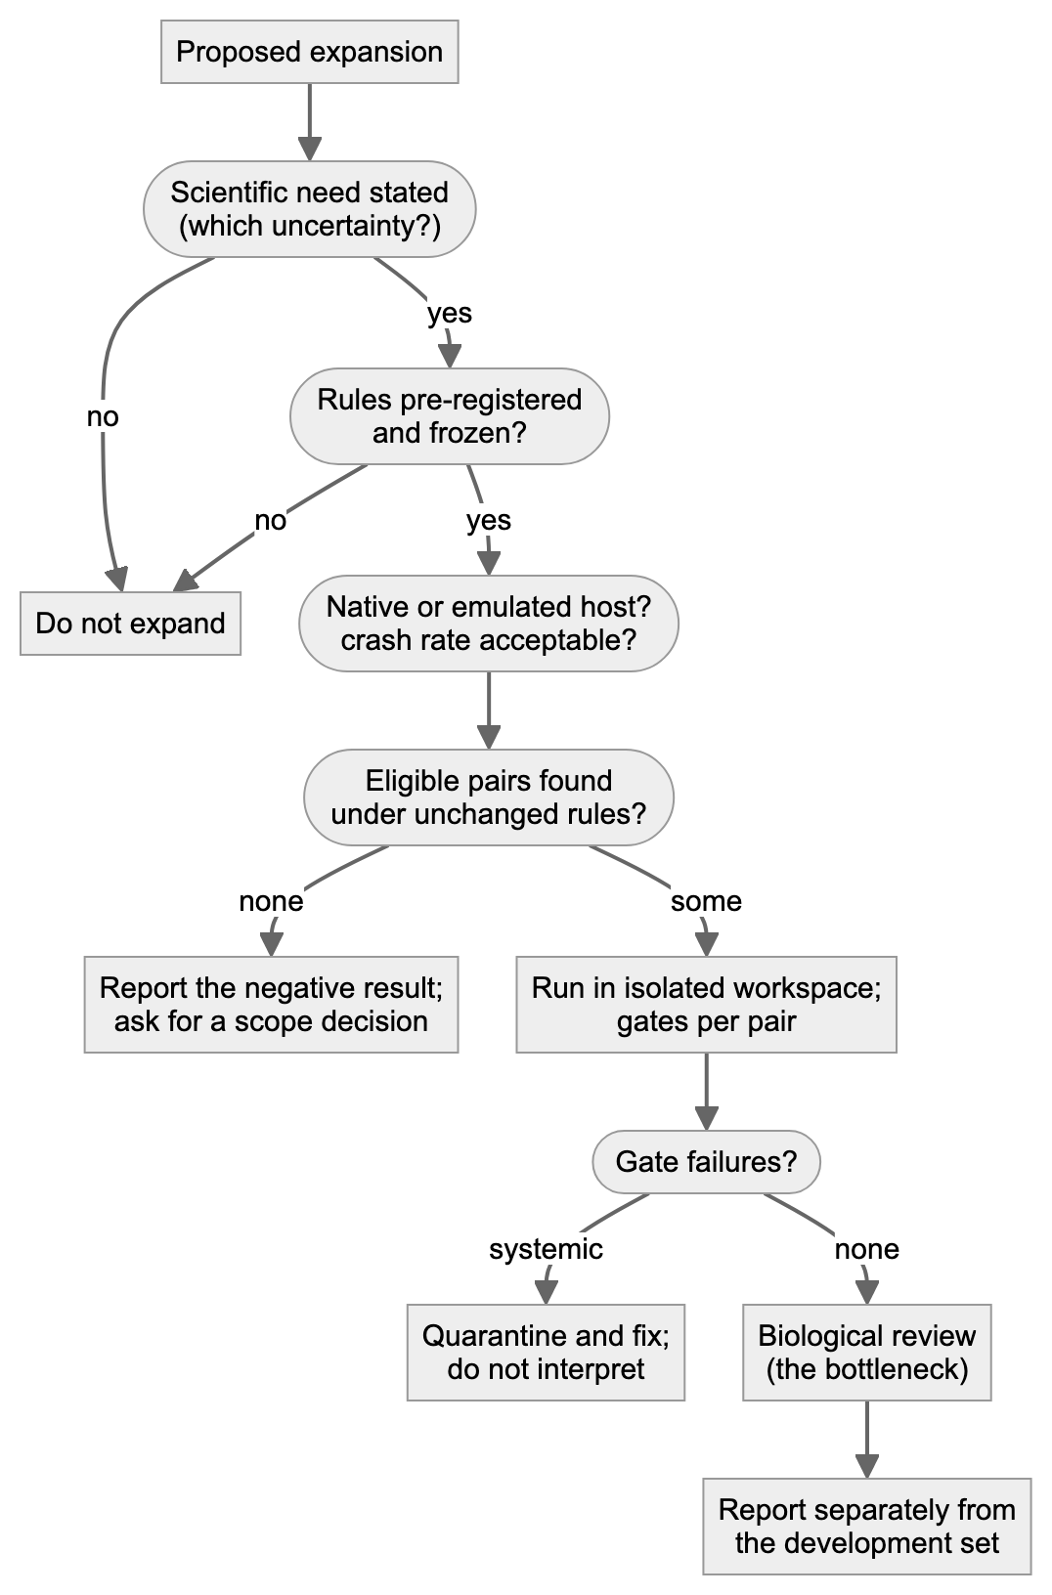
Figure 7. Scale-up readiness.

H. Current status and next decisions
Implemented and validated (v4; deliverables/2026-10-09_v4/validation_v4.md):
- The full pipeline, with 64 regression tests. Each of 16 historical defects was put back into the code and caught by the tests.
- Fresh reproduction of all 7 pilot pairs (the same agent, so not independent).
- Region review. All 19 pilot regions and 2 prospective regions have a dated review.
- STAR3D method audit with two labelled sensitivity analyses.
- Provenance surveys across Rfam 14.0–15.1.
Defensible scientific conclusions:
- One supported candidate (moderate). The P1 3′ strand of the 7REX row in RF00522 is one nucleotide out of register. It is backed by geometry, FR3D pairing, the authors’ own description and a sensitivity analysis. It is one observation.
- In loop L1 of the same RNA, the seed is better supported than STAR3D.
- Most other differences are not alignment disagreements. They are coverage limits, construct effects, coordinate gaps, or cases with insufficient evidence.
- The “ordinary” seed is the 3D-curated alignment for all studied families. Curated records are byte-identical to ordinary records in every release that ships a curated file.
- The released STAR3D code selects pairs differently from its paper. The preQ1 results are robust to this; the exploratory guanidine-I result is not.
Incomplete:
- 16 non-curated families with sequence-only links are unreviewed.
- No native host.
- No second structural aligner.
- No human review.
Conditions for scale-up. All are needed:
- a declared scope decision;
- a native x86-64 host;
- a pre-registered selection rule;
- explicit budget for biological review.
Questions for the professor:
- Should we accept modified natural tRNAs if we give STAR3D parent-mapped residue names? That is a method change and would be validated separately.
- Should engineered constructs form a separately reported tier?
- Should we now ask Smriti about predicted structures for the eligible-sequence list? That would be a separate study.
- Should the 7REX P1 candidate be sent to Rfam curators, and by whom?
Mermaid sources for all figures are in diagrams/*.mmd; diagrams/render.py renders them with headless Chrome.

