SQARMA Project Architecture and Pipeline Guide
Rfam seed alignments versus original STAR3D structural alignment — how the pilot actually works
2026-10-09 (v5: state of branch v5-single-run-natural-dataset)
Written for a PhD student joining the project. Prepared by an AI research agent (Claude) from the repository and its validated outputs; it has not yet been reviewed by the researcher or the professor. Every path below is relative to rfam_star3d_pilot_v2/ unless stated otherwise. Values quoted as results come from the tables named next to them. Anything not implemented is marked (planned), and commands that were not executed while preparing this guide are marked (untested).
Method. For each selected RNA pair, we use one forward alignment from original STAR3D v1.2 with default parameters, following the package’s preprocessing procedure.
Dataset policy. The active analysis includes only experimental structures of verified natural RNA sequences. Confirmed engineered constructs and unresolved cases are excluded from the accepted cohort. This is the researcher’s explicit requirement (v5); earlier versions analysed engineered constructs with masks and ran STAR3D in both directions with replicates. Those results are archived and are not used.

A. Project purpose and boundaries

A.1 The question
For distinct homologous RNA sequences with suitable experimental structures, where do ordinary Rfam seed correspondences and original STAR3D correspondences differ, and what evidence explains those differences?
Some terms used throughout:
- RNA family (Rfam). Rfam groups related RNAs into families such as RF00522 (the preQ1-I riboswitch). For each family it publishes a seed alignment: a hand-curated multiple sequence alignment in Stockholm format. Each row is one RNA sequence region (for example URS00023119CB_2126436/1-34), and each column says which nucleotides of the different rows correspond to each other.
- Correspondence. A statement that nucleotide i of RNA A plays the same role as nucleotide j of RNA B. A seed alignment implies correspondences: two residues in the same column correspond.
- STAR3D. A structural aligner (Ge & Zhang 2015, NAR 43:e137). From the 3D coordinates of two RNAs it finds conserved helical stacks, superimposes them and aligns the loops between them. Its output is a list of corresponding nucleotides. We use the original v1.2 release, not LocalSTAR3D or CircularSTAR3D.
- FR3D. A program that annotates base pairs (for example cWW, the canonical cis Watson–Crick pair) and base stacking in a 3D structure. We use it to ask whether a correspondence carries interactions over from one structure to the other.

A.2 Why compare Rfam with STAR3D
The long-term motivation is better identification of RNA interactions and motifs, especially non-canonical pairs. If sequence alignments place nucleotides in the wrong columns, interaction labels transferred through them will be wrong. Comparing a published sequence alignment with a structure-based one, on RNAs whose structures are known, shows where the two disagree and why.

A.3 What counts as an informative result
All of the following are valid results. A region can be classified as:
- a supported candidate for Rfam curator review;
- a STAR3D limitation, such as short alignments or coordinate-gap artefacts;
- genuine structural variation, for example from ligand binding or a bound protein;
- an experimental construct effect, for example engineered loops;
- a mapping or annotation problem;
- insufficient evidence.
Agreement is also informative, and so is a well-documented failure to find eligible data. Neither method is treated as ground truth.

A.4 What the project does not (yet) show
- No sequence-only predictor, and no general alignment-correction method.
- No accuracy estimate for Rfam. The active dataset has 1 family with 3 accepted pairs, so rates cannot be extrapolated.
- No structure-independent baseline. For every family studied, the “ordinary” seed is the 3D-curated alignment (section H).

A.5 Relation to the professor’s instructions
The meeting transcript is not in the repository. The professor’s requests are taken from the transcript-derived list in Phase 1/plans/RNA_Research_Plan_Fresh_Start_2026_10_08 (1).docx. Each one is traced to code and evidence in deliverables/2026-10-09_v4/tables/requirements_matrix.tsv, which also labels whether an item is a professor instruction, a later user decision or our own methodological choice. In summary, the professor asked us to:
- count families with ≥2 eligible distinct sequences;
- link each chain to its exact seed row;
- remove redundant and engineered constructs;
- compare the ordinary and structure-curated seeds;
- run original STAR3D and study disagreements;
- if experimental cases cannot be found, bring the search to Smriti and ask about predicted structures.

B. System architecture
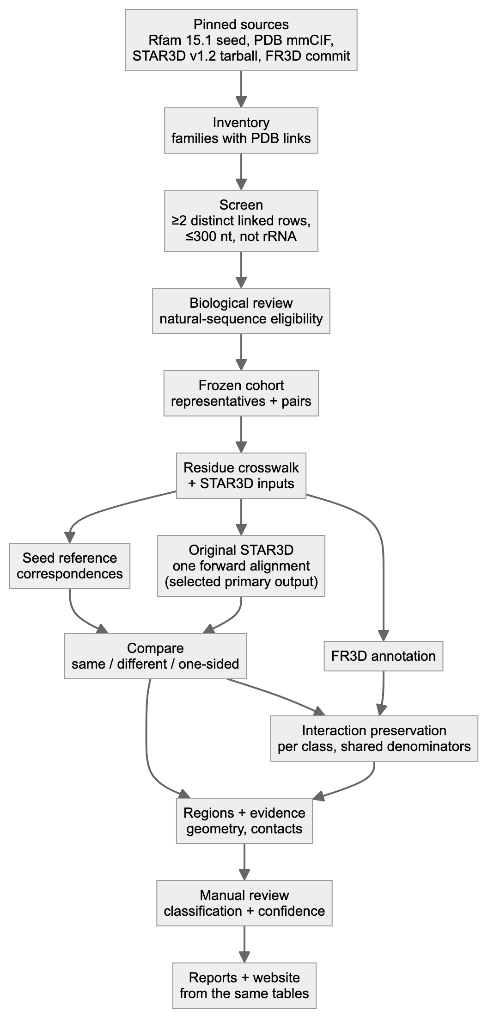
Figure 1. Complete research workflow.

B.1 Modules
Shared libraries used by many modules:
- scripts/stockholm.py — the Stockholm parser;
- scripts/fetch.py — downloads with a manifest;
- scripts/locate.py — maps residues to seed elements.
Module | Purpose | Inputs | Outputs | Actual script/path | Validation | Dependencies
Source pinning | Download and freeze sources | URLs in config.yaml | inputs/…; metadata/sources_manifest.tsv (URL, time, sha256) | scripts/fetch.py, scripts/inventory.py | Seed sha256 must equal config.yaml; never overwritten | network
Inventory and screen | Families with PDB links; ≥2 distinct linked rows; ≤300 nt; not rRNA | Rfam.seed.gz, Rfam.pdb.gz | results/family_inventory.tsv, metadata/chain_row_candidates.tsv | scripts/inventory.py | Parser gate on a real interleaved record (parser_gate.py) | stockholm.py
Structure evidence | Link each chain to a seed row; organism; coverage; modifications | mmCIF | mappings/structure_sequence_map.tsv, review/evidence/*.json | scripts/structures.py (build_link) | Exact sequence match at row coordinates; parent-mapped modifications | gemmi
Provenance and construct review | Source organism, engineering, papers | Papers, NCBI genomes | review/construct_review.tsv, review/exact_source_check.tsv | literature.py, exact_source_check.py, blast_*.py + manual review | Genome search on both strands | NCBI, Europe PMC
Natural-sequence eligibility (v5) | Decide verified_natural / confirmed_engineered / unresolved and accepted / excluded / pending for every chain | evidence above | review/natural_sequence_eligibility.tsv, results/dataset_chains.tsv | manual decisions + scripts/natural_policy.py | Engineered or unresolved can never be accepted; masking irrelevant; tests | —
Cohort freeze | Accepted representatives and pairs, fixed before any outcome is examined | eligibility table | results/selected_representatives.tsv, results/selected_pairs.tsv, metadata/cohort_v2.0_natural_freeze.json | scripts/natural_policy.py rebuild-cohort | A pair needs two accepted, distinct representatives; sha256 freeze | —
Crosswalk and STAR3D inputs | Residue identity across numbering systems; legacy PDB input | mmCIF, seed | results/residue_crosswalk.tsv, runs/_inputs/*.pdb, mappings/aligner_inputs.tsv | scripts/prepare_inputs.py | Re-reads the written file exactly as STAR3D does; identity check per residue | gemmi
Seed reference | Seed correspondences per pair | seed, crosswalk | results/reference_pairs.tsv, standard_seed_membership.tsv, standard_seed_rows.sto | scripts/reference.py | Raw-line trace + sha256 of every row; valid per-family Stockholm | —
Original STAR3D | ONE forward alignment per pair (Preprocess once per RNA) | PDB inputs, tarball | runs/<pair>/attemptN/…/*.aln, results/run_manifest.tsv | scripts/star3d.py run <PAIR> | Unique attempt dirs, in-container checksums, preprocessing-content gate; no retry | docker image star3d-runtime:1
Primary output selection | Choose the one original output per pair | run manifest, prepared inputs | results/primary_star3d_outputs.tsv | scripts/select_primary_outputs.py | Earliest valid forward record; input/preprocessing/output/crosswalk checks; never reverse or later replicate | star3d.py, compare.py
Comparison | Same / different / one-sided partner per residue | selected .aln, reference | results/correspondence_comparison.tsv, pair_summary.tsv | scripts/compare.py | Re-validates the stored output (counts, sha, injectivity); atomic writes | star3d.py
Interaction annotation | FR3D pairs and stacks; preservation per class | mmCIF, comparison | annotations/raw/*, results/interaction_comparison.tsv, interaction_summary.tsv | scripts/interactions.py | Installed FR3D commit verified; raw-hash cache; symmetry mates excluded; per-comparison denominators | fr3d-python 288f98cc
Regions | Group disagreements; eligibility | comparison, interactions | results/region_review.tsv | scripts/regions.py | Span and partner masks; history kept on change | locate.py
Region evidence | Geometry, contacts, interactions per region | all of the above | results/region_evidence/, results/anchor_fit/ | scripts/region_evidence.py, scripts/anchor_fit.py | Degenerate anchor sets refused | numpy, gemmi
Biological review | Classification + confidence | evidence tables, papers | review/region_review_v4.tsv → results/region_review.tsv | manual + scripts/apply_region_reviews.py | Dated; reviewer recorded | —
Method audit (historical) | STAR3D pair rule; S1/S2 sensitivity | preprocessing products | archive/v4_multi_run_history/results/sensitivity/ | star3d_preproc_audit.py (active); sensitivity runners archived | Separate namespace; never part of the primary analysis | docker
Provenance surveys | Ordinary vs curated seed; release history | Rfam 14.0–15.1 files | results/seed_collection_comparison/, results/rfam_history/ | scripts/survey_b.py, scripts/rfam_history.py | Byte-level record comparison | —
Fresh reproduction | Re-download and rerun selected pairs | URLs | audit/fresh_repro*/ | scripts/fresh_repro.py --pairs … | Input gate stops on any mismatch | docker, FR3D
Prospective expansion (pattern) | Pre-registered new pairs in an isolated workspace | screened candidates | expansion_v4/ (archived: tRNA pair excluded in v5) | scripts/expansion_v4.py freeze / run | Freeze hashes re-checked before run | all stages
Derived alignment view | Gapped display of seed and STAR3D correspondences (SQARMA visualisation, not STAR3D output) | comparison, crosswalk | results/derived_alignment_views.md/.tsv | scripts/derived_alignment_view.py | Self-check re-derives every correspondence; no invented matches | —
Reports and website | Human-readable outputs from the same tables | active tables | reports/, deliverables/2026-10-09_v5/, deliverables/2026-10-09_v5/site/ | export_site_data.py, evidence_cards.py, render scripts | check_report_numbers_v5.py; HTTP checks | pandoc, Chrome (docs)
Tests and manifests | Regression tests; checksums | code | tests/ (81), MANIFEST.tsv, repro package | pytest; mutation check | 18/18 re-introduced defects detected | pytest

B.2 Stage order and parallelism
The required order is:
- Inventory, then structures, then review, then cohort freeze.
- prepare_inputs.py (crosswalk), then reference.py. The reference stage needs the crosswalk; running it first gives zero assessable pairs, which happened once in v4 and was caught.
- star3d.py, only for pairs without a valid existing output, then select_primary_outputs.py.
- compare.py, then interactions.py, then regions.py.
- Region evidence, then review, then reports.
What can run in parallel:
- Downloads, literature retrieval and genome checks for different structures.
- STAR3D runs for different pairs. Each uses its own attempt directory. On the emulated host we ran them one at a time.
- FR3D annotation of different structures.
- Report rendering, after the tables are final.
The global table stages (reference, compare, interactions) refuse subset runs. They always rewrite the complete table, so a partial rerun cannot silently replace complete results.

C. Step-by-step real example: 6VUI–7REX (RF00522, preQ1-I riboswitch)
All values below are copied from validated tables. The pair is Thermoanaerobacter tengcongensis (PDB 6VUI, chain A) versus Carnobacterium antarcticum (PDB 7REX, chain A).
Step 1: family and seed rows. Both chains carry explicit structure links in the pinned Rfam.seed.gz 15.1, as #=GR lines 6VUI_A_SS and 7REX_A_SS. The rows are:
- 6VUI → URS000080E32E_119072/1-33;
- 7REX → URS00023119CB_2126436/1-34.
Membership is proven by the raw decompressed line numbers and the sha256 of each aligned string (results/standard_seed_membership.tsv).
Step 2: structure and construct verification.
- Both are X-ray structures (2.68 Å and 2.6 Å).
- Each deposited sequence equals the row sequence over the family interval.
- There are no modified nucleotides.
- Each sequence was found exactly in its claimed source genome: AE008691.1 on the minus strand at 1523221 for 6VUI, and CP010796 on the plus strand at 2093557 for 7REX (review/exact_source_check.tsv). An exact genome match supports sequence provenance, but does not prove every step of how the experimental construct was prepared.
Step 3: a real crosswalk excerpt (results/residue_crosswalk.tsv):
rep | row index | nt | seed column | label_seq_id | auth ID | STAR3D index | STAR3D residue
6VUI_A | 1 | C | 6 | 1 | A:1 | 0 | A:1
6VUI_A | 16 | C | 27 | 16 | A:16 | 15 | A:16
7REX_A | 16 | U | 26 | 16 | A:16 | 15 | A:16
7REX_A | 17 | C | 27 | 17 | A:17 | 16 | A:17
7REX_A | 18 | C | 28 | 18 | A:18 | 17 | A:18
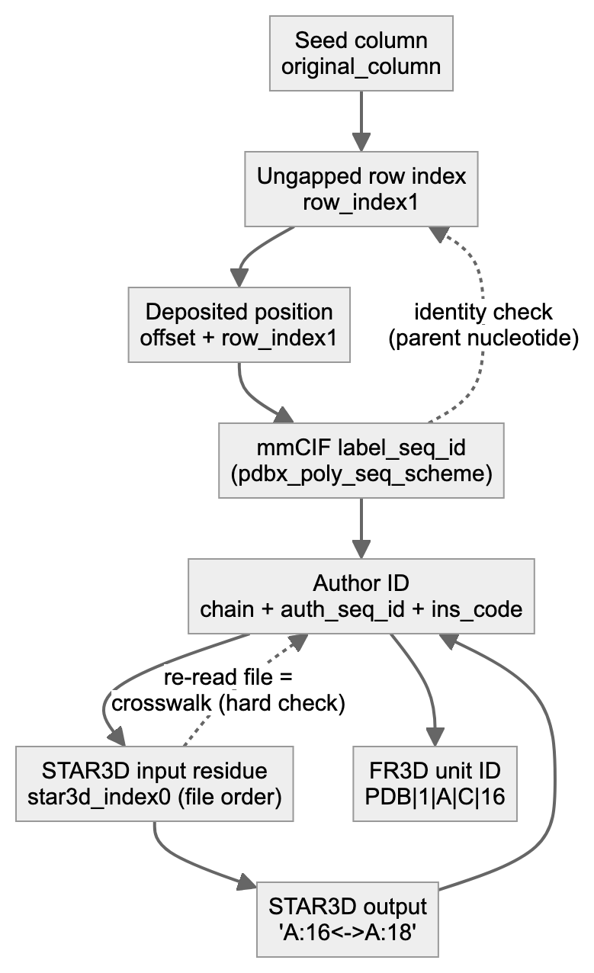
Figure 2. Residue identity mapping.
Step 4: the Rfam correspondence. 6VUI C16 sits in seed column 27. In the 7REX row, column 27 holds C17. So the seed says 6VUI C16 ↔ 7REX C17.
Step 5: STAR3D input and commands (the package README’s procedure; one forward alignment). prepare_inputs.py writes runs/_inputs/6vuia.pdb and runs/_inputs/7rexa.pdb (model 1, first altloc, author numbering). Inside a fresh attempt directory, in the container, the wrapper runs:
java -cp STAR3D.jar Preprocess 6vuia A
java -cp STAR3D.jar Preprocess 7rexa A
java -jar STAR3D.jar -o out/RF00522__6VUI_A__7REX_A__a1__forward__rep1.aln -p 6vuia A 7rexa A
This file, runs/RF00522__6VUI_A__7REX_A/attempt1/STAR3D_source/out/RF00522__6VUI_A__7REX_A__a1__forward__rep1.aln, is the pair’s selected primary output (results/primary_star3d_outputs.tsv). It is reused byte-for-byte. Its name still contains “rep1” because it was written before the single-run policy; it was not rerun just to rename it.
The defaults recorded in the output are: RMSD cutoff 4.0 Å, minimum stack 3, gap open −5, gap extension −2, match 3, mismatch 0.
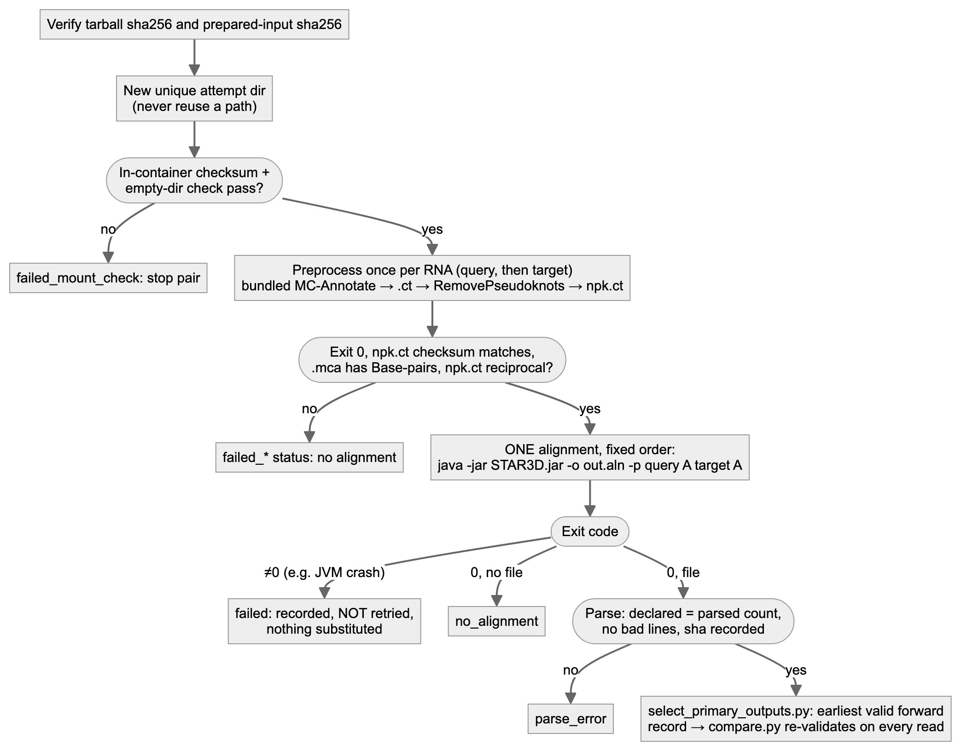
Figure 3. STAR3D execution and failure handling.
Step 6: parsed STAR3D correspondence. The .aln file reports #Aligned nucleotide: 32 and #Alignment RMSD: 2.34A, followed by mapping lines including:
A:5<->A:5
A:16<->A:18
A:24<->A:25
So STAR3D says 6VUI C16 ↔ 7REX C18. compare.py translates both sides through the crosswalk and labels each source residue (results/correspondence_comparison.tsv, the selected output):
- Agreement example: 6VUI C1 → seed 1, STAR3D 1, labelled same_partner.
- Disagreement example: 6VUI C16 → seed 17, STAR3D 18, labelled different_partner.
- One-sided cases: 6VUI A13 is star3d_only (the seed leaves it opposite a gap); 6VUI A23 is rfam_only.
Pair totals: 16 same, 15 different, 1 seed-only and 1 STAR3D-only, out of 32 structurally assessable seed pairs.
Step 7: interaction annotation and eligibility.
- FR3D annotates 6VUI G5–C16 as cWW.
- Mapped through each method, it becomes 7REX G5–C17 under the seed, for which FR3D reports no annotation (no_annotated_target_pair), and G5–C18 under STAR3D, which is cWW (exact_class_preserved) (results/interaction_comparison.tsv).
- The interaction is eligible for the seed-vs-STAR3D comparison because:
  - both source residues are unmasked and observed;
  - both methods map both endpoints;
  - all targets are observed and unmasked.
Step 8: a worked interaction count. On the eligible set for 6VUI→7REX:
- the seed preserves 19 of 47 interactions and STAR3D 29 of 47 (results/interaction_summary.tsv);
- for canonical pairs alone, the seed preserves 0 of 7 and STAR3D 5 of 7.
Two caveats apply. First, the denominator is the same set for both methods; a method that maps fewer residues is not rewarded with a smaller denominator. Second, target-RNA interactions are evaluated through the same mapping inverted, which is not another STAR3D run, and have their own denominator.
Step 9: interpreting the disagreement region. regions.py groups 6VUI 7–23 into one region. region_evidence.py then superposes the two structures on the residues where both methods agree. The anchor sets are all shared residues, shared residues minus the flanks, and local shared residues only. It then measures C1′ and base-centroid distances to each method’s partner.
- P1 3′ strand (14–21). The STAR3D partners are 0.5–3.3 Å away and the seed partners 3.6–8.8 Å, under every rule. The 7REX authors describe P1 with a G5–C18 pair.
- Loop L1 (7–12). The seed is better supported.
- Classification. P1 3′ strand: supported candidate (moderate). L1: possible STAR3D issue (low–moderate) (review/region_review_v4.tsv).
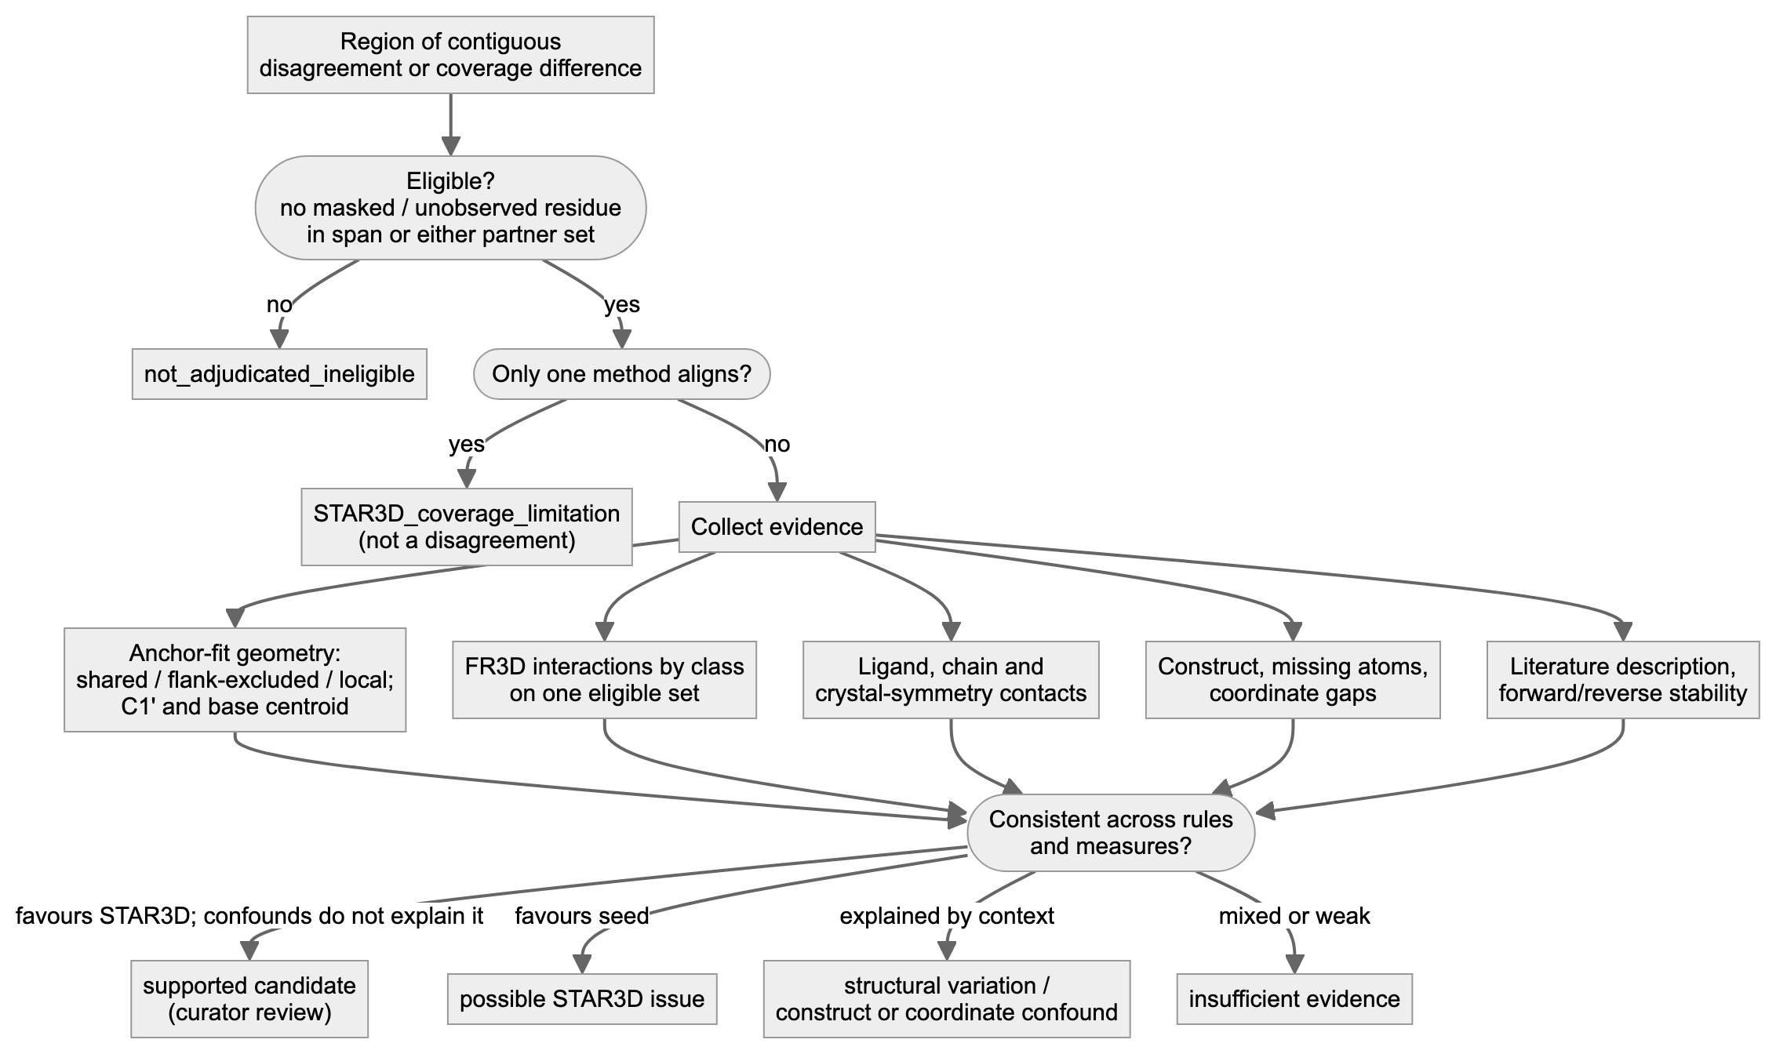
Figure 4. Scientific evidence assessment.
Step 10: from tables to report and website.
- The reports quote the tables. check_report_numbers_v5.py re-reads the tables and confirms the numbers.
- export_site_data.py copies the same tables into site/data/*.json, together with a manifest of source sha256 values.
- The website types no numbers of its own.
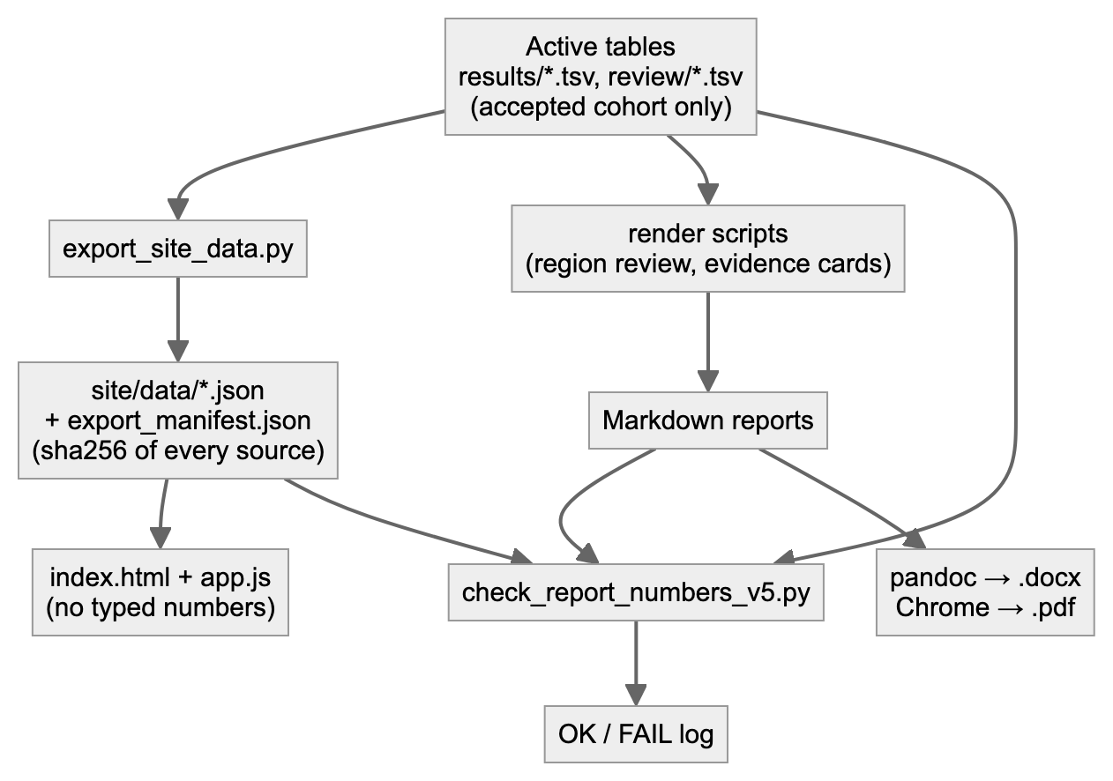
Figure 5. Report and website generation.

D. Data eligibility
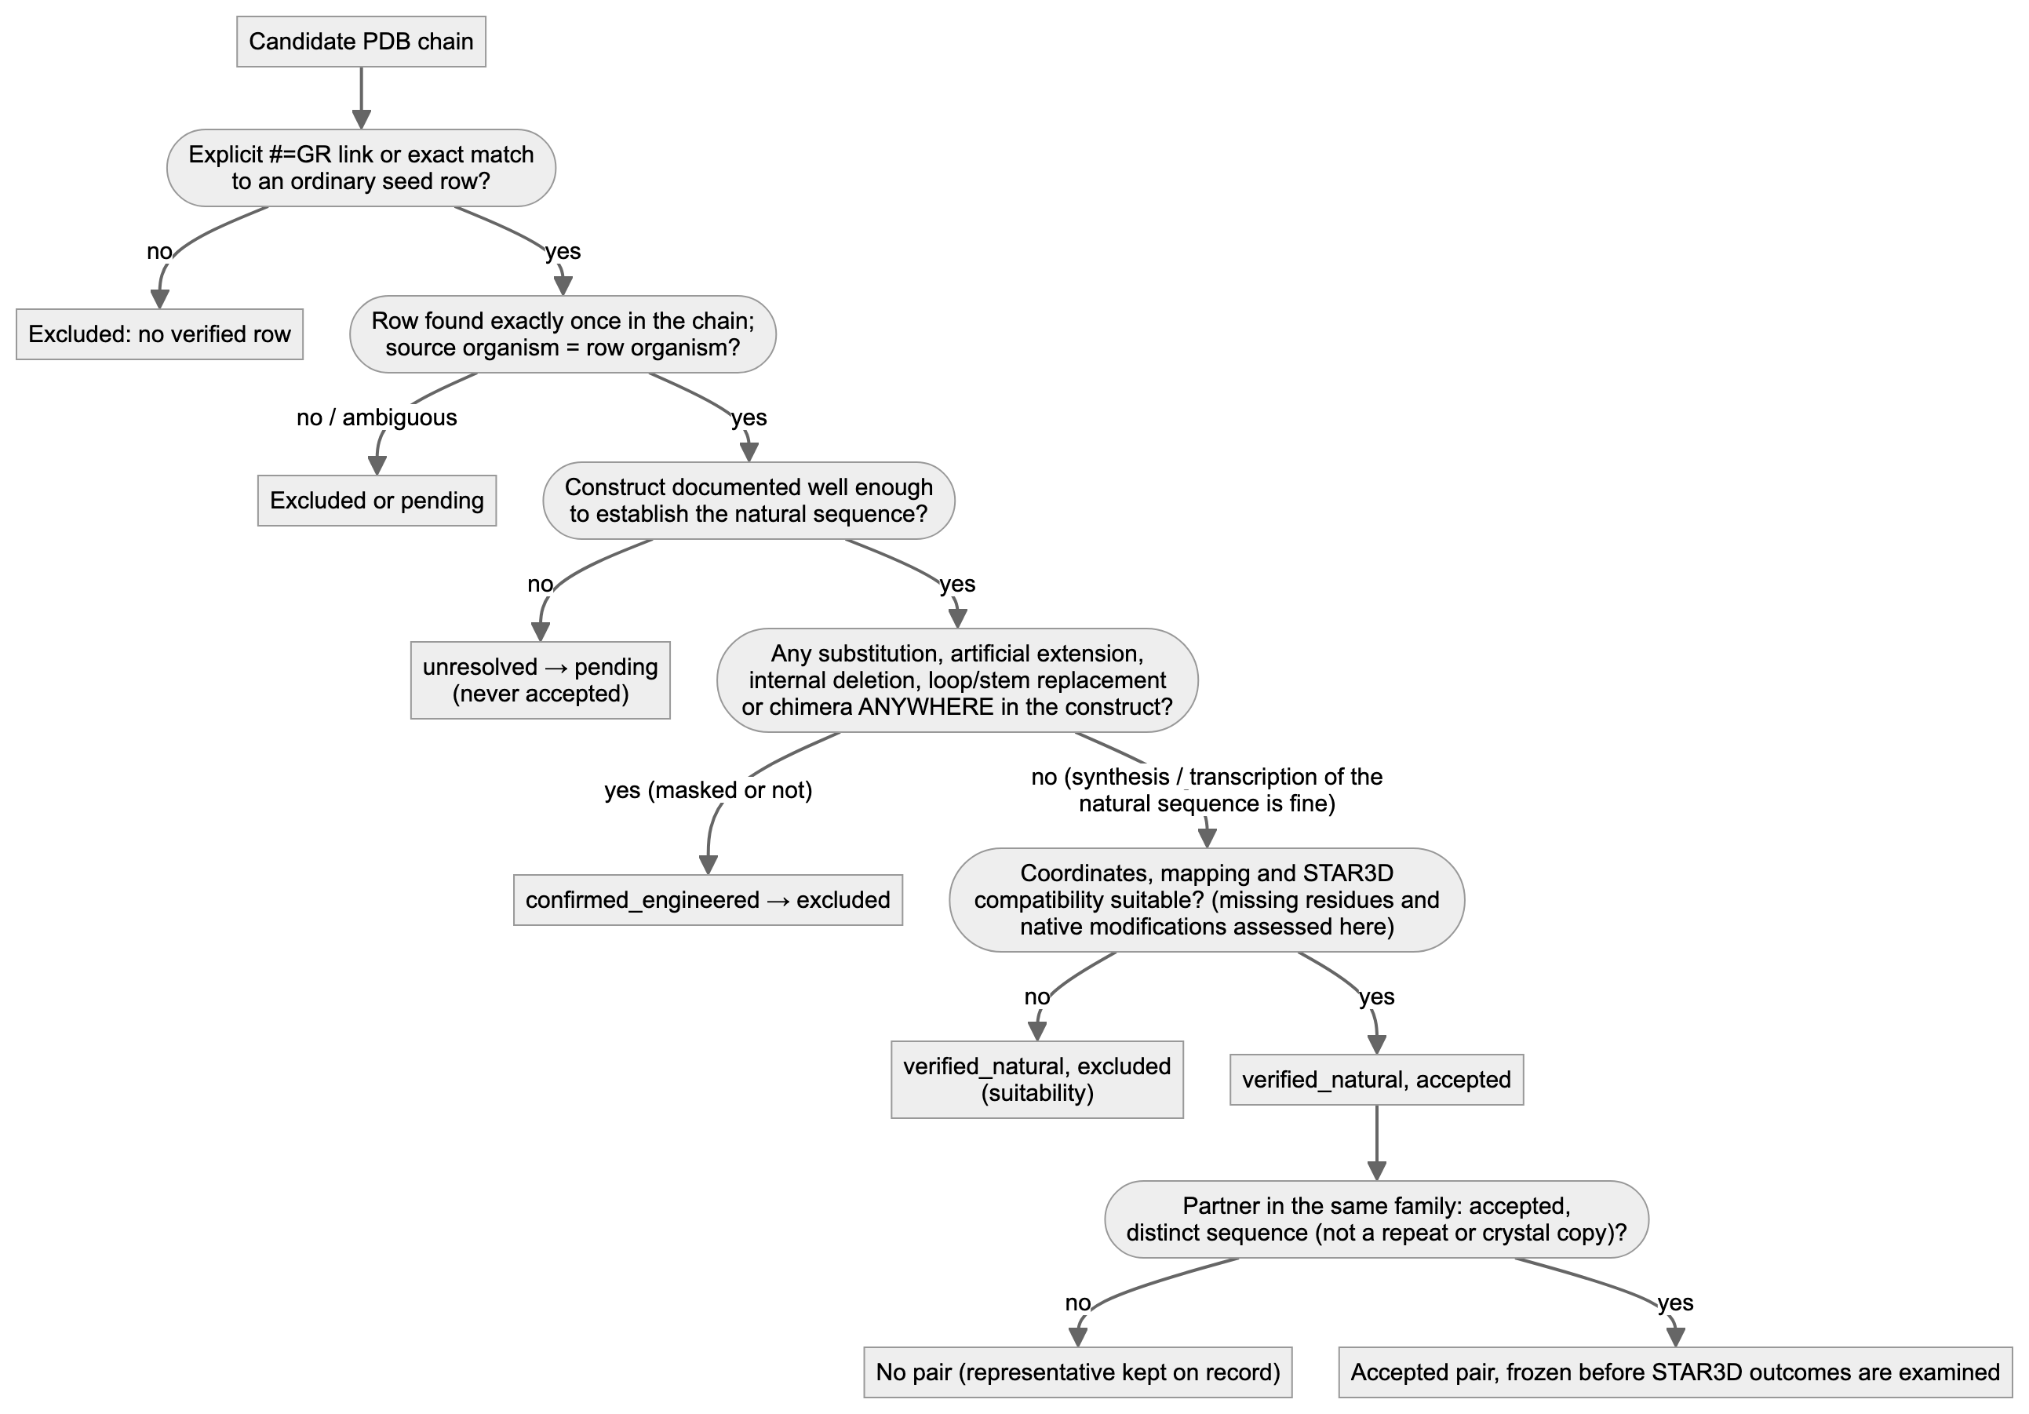
Figure 6. Data eligibility and exclusion decisions.
Examples from the actual screens:
- Organism mismatch. 9J4O (B. subtilis tRNA-Leu) was excluded because its exact sequence match is to a seed row from H. halodurans. An identical sequence does not make that row this RNA’s row.
- Modified nucleotides. 1EHZ (yeast tRNA-Phe) was excluded because original STAR3D reads modified nucleotides as “N”.
- Engineered constructs (v5 policy). Every construct with introduced substitutions, artificial extensions, internal deletions or loop and stem replacements is excluded, even when the altered residues were masked or lie outside the extracted interval. Examples: SAM-I 4KQY (GAAA tetraloop), cobalamin 6VMY (5′ “cloning artifact” G) and tRNA 5CCB (extra 5′ G).
- Not engineering. Chemical synthesis or transcription of the natural sequence (6VUI, 7REX, 7EQJ), missing coordinates (3FU2 13–14) and bound ligands are not engineering. They are assessed separately as suitability limitations.

E. Reproducibility and operation
All commands run from rfam_star3d_pilot_v2/.
Task | Command | Status
Environment | python3.13 -m venv .venv && .venv/bin/pip install -r requirements.lock.txt | used to build the current .venv; not re-run in v4 or v5
STAR3D runtime | docker build --platform linux/amd64 -t star3d-runtime:1 -f scripts/Dockerfile.star3d scripts/ | image sha256:e1602e60… in use; not rebuilt in v4 or v5
Tests | .venv/bin/python -m pytest -q tests | verified (81 passed)
Reproduce one pair from fresh downloads | .venv/bin/python scripts/fresh_repro.py --pairs RF00522__6VUI_A__7REX_A --out audit/fresh_repro_<new> | --pairs mode verified in v3 with 4 pairs; v5 compares the single fresh forward run with the selected primary output (untested in v5)
Reproduce the active analysis | prepare_inputs.py → reference.py → select_primary_outputs.py → compare.py → interactions.py → regions.py → region_evidence.py (no STAR3D run needed when inputs are unchanged) | verified in v5
Add an eligible pair | record the representatives in review/natural_sequence_eligibility.tsv (verified_natural + accepted); add the pair to the archived candidate list; scripts/natural_policy.py rebuild-cohort; prepare_inputs.py; reference.py; star3d.py run <PAIR> (one forward alignment); select_primary_outputs.py; downstream stages | rebuild-cohort and downstream stages verified in v5; a new STAR3D run of this kind is (untested) for v5 (the wrapper is unit-tested)
Region evidence and review | .venv/bin/python scripts/region_evidence.py (set SQARMA_STUDY_ROOT for a workspace); edit review/region_review_v4.tsv; scripts/apply_region_reviews.py | verified
Regenerate reports | scripts/evidence_cards.py; scripts/derived_alignment_view.py; deliverables/2026-10-09_v5/scripts/check_report_numbers_v5.py | verified
Website | .venv/bin/python scripts/export_site_data.py, then cd deliverables/2026-10-09_v5/site && ../../../.venv/bin/python -m http.server 8765 and open http://localhost:8765 | verified
Caching and checksums.
- Downloads are cached and never overwritten. Every file has a URL, retrieval time and sha256 in metadata/sources_manifest.tsv.
- Fresh reproduction compares re-downloads byte for byte. On any mismatch it quarantines the new bytes and blocks all dependent steps.
- FR3D outputs are reused only when their sidecar records the verified installed commit and matching raw-output hashes.
- STAR3D never reuses a directory: every attempt gets a new path, because the emulated file mount can serve stale views of a reused path.
Partial failures.
- Preprocessing. A failure here records a failed_* status and stops that pair.
- Alignment. A crash (for example a JVM signal) is recorded as failed and is not retried automatically. The pair has no primary output until a documented new attempt succeeds. No reverse run or replicate is substituted.
- Corrupt or changed output. Validation failures from malformed or changed stored output are written only to results/*.INVALID.tsv, never over the complete tables.
Logs.
- logs/ holds pilot-stage logs.
- runs/<pair>/attemptN/logs/ holds each STAR3D run’s stdout and stderr.
- deliverables/<session>/logs/ holds session logs.
- audit/ holds reproduction records.

F. Limitations at large scale
Combinatorics. A family with k representatives has k(k−1)/2 pairs. Each pair needs:
- 1 forward alignment (v5 single-run policy; earlier versions ran 2 directions × 3 replicates);
- 2 preprocessing steps.
So 10 representatives give 45 pairs and 45 alignments (plus 90 preprocessing steps). All-pairs analysis is neither necessary nor independent: pairs that share an RNA share its errors and its construct effects. Results should be reported per family and per distinct row, not per pair.
Other costs and limits:
- Downloads and annotation. mmCIF files are mostly small (median 120 kB over 166 files; largest 15 MB). Ribosome complexes are large, and annotating them takes longer.
- Biological curation is the bottleneck. Source organism, construct design, inaccessible papers and modified nucleotides each need judgement. More workers do not remove it.
- Execution. On this arm64 Mac, STAR3D runs under x86-64 emulation: 3 JVM crashes in 112 recorded alignment runs, including control runs (2.7%). A native x86-64 host is needed for scale. Memory was not limiting for RNAs up to 163 nt; longer RNAs were not tested.
- Missing rows and uncertain mappings. Most PDB chains have no seed row (10,520 of 12,818 candidate chains). Of the rest, 1,793 have only sequence-only matches, which need provenance review: two of the tRNA candidates pointed to another species’ row.
- Selection bias. Explicit structure links exist only in 3D-curated families, so the pilot cannot generalise to non-curated families without the sequence-only route.
- Automation is not interpretation. A region flagged by automatic disagreement detection can reflect coverage, an engineered construct, ligand context, refolding or coordinate gaps (section H). Each needs biological review.

G. Runtime and resources
Measured on the current host (emulated STAR3D; arm64 macOS):
Step | Measured | Source
STAR3D alignment (one forward alignment; RNAs 32–163 nt) | median 3.3 s; range 1.8–4.4 s; n = 118 historical runs | run manifests
STAR3D preprocessing (one RNA) | median 3.4 s; range 1.0–8.5 s; n = 57 | run manifests
FR3D annotation (11 small structures, sequentially) | 4.9 s total | interactions.py --verify-regenerate, v3 log
Comparison, interactions, regions (whole pilot) | seconds | logs
Website export | seconds | logs
Biological screening of 21 families by an AI agent (partly from existing tables) | about 25 min of agent time | v3 session
Downloads | not timed per file; network-bound | —
Human construct and paper review | not measured; the largest cost in the pilot | —
Projections (labelled assumptions, not measurements). Computational time for one emulated worker, assuming:
- 1 alignment and 2 preprocessing steps per pair;
- the medians above;
- RNAs ≤ 200 nt;
- crash retries ignored;
- caching of downloads but not of preprocessing (each attempt reprocesses both RNAs).
Scenario | Pairs | Alignments | Approx. compute (1 worker) | 4 workers (if memory allows)
5 families × 4 representatives | 30 | 30 | ≈ 5 min | ≈ 1.3 min
50 families × 6 representatives | 750 | 750 | ≈ 2.1 h | ≈ 32 min
200 families × 10 representatives | 9,000 | 9,000 | ≈ 25 h | ≈ 6.3 h
Caveats on these projections:
- Native hardware. A native x86-64 host would probably be faster; the factor was not measured.
- Length. Times for long RNAs (> 300 nt) are unknown.
- Annotation scales differently. FR3D cost grows with the number of structures, not pairs.
- Review time is outside these figures. Biological review scales with families and regions, at hours per family in the pilot. It cannot be parallelised away, because each decision needs evidence and judgement.
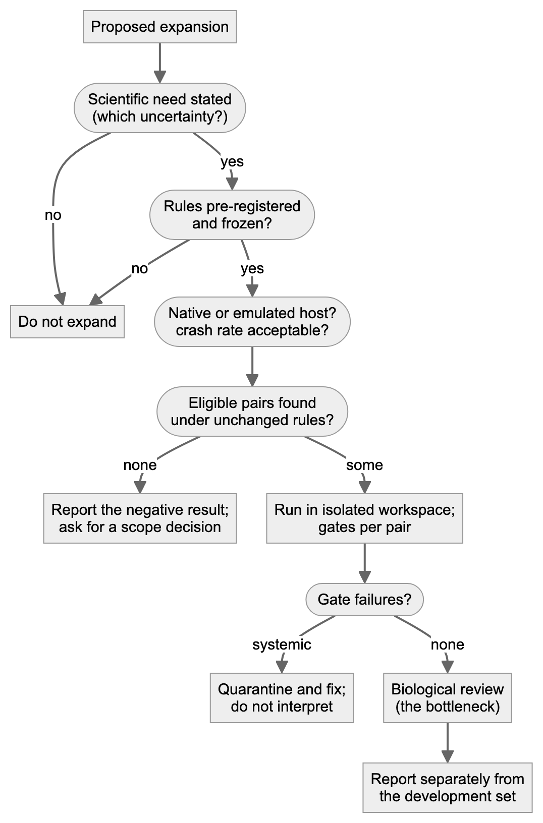
Figure 7. Scale-up readiness.

H. Current status and next decisions
Implemented and validated (v5; deliverables/2026-10-09_v5/validation_v5.md):
- Single-run policy. One forward original-STAR3D output per pair, selected by a fixed rule (results/primary_star3d_outputs.tsv). Refactoring to it changed 0 scientific values.
- Natural-sequence policy. All 13 previously analysed chains were re-reviewed: 4 verified natural, 9 confirmed engineered, 0 unresolved. The accepted cohort is frozen (metadata/cohort_v2.0_natural_freeze.json).
- Tests. 81 regression tests pass. 18 historical and policy defects were put back into the code one at a time, and the tests caught all 18.
- Region review. All 8 regions of the accepted pairs have a dated review.
Accepted dataset: 1 family (preQ1-I, RF00522), 3 structures (3FU2 A, 6VUI A, 7REX A), 3 pairs.
Defensible scientific conclusions:
- One supported candidate (moderate). The P1 3′ strand of the 7REX row is one nucleotide out of register in the seed. It is backed by geometry, FR3D pairing and the authors’ own description, and all supporting RNAs are verified natural. It is one observation.
- In loop L1 the seed is better supported than STAR3D.
- The remaining regions of the accepted pairs are coordinate confounds (3FU2 missing residues) or have insufficient evidence.
- The “ordinary” seed is the 3D-curated alignment for this family (identical records).
Withdrawn from active results: findings that relied on engineered constructs (TPP agreement control, cobalamin/SAM-I coverage examples, guanidine-I pairing-rule sensitivity, tRNA exploratory pair). They are kept in the archive as historical observations.
Incomplete:
- non-curated families reachable through sequence-only links have not been reviewed for natural constructs (16 families);
- no native host;
- no second aligner;
- no human review.
Questions for the professor:
- With natural constructs only, the explicitly linked inventory yields one family. Which route should we take to find more: sequence-only links in non-curated families, or predicted structures of natural sequences with Smriti (a separate study)?
- Should the 7REX P1 candidate be sent to Rfam curators, and by whom?
Mermaid sources for all figures are in diagrams/*.mmd; diagrams/render.py renders them with headless Chrome.

