Study and Verification of the operation of Half and Full Adder and Subtractor circuit.
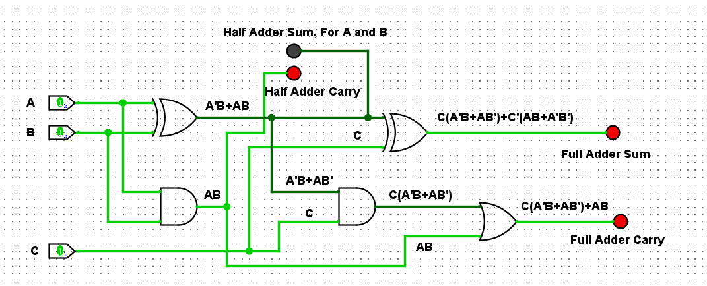
Figure 9: Half and Full Adder Circuit using Logic Gates
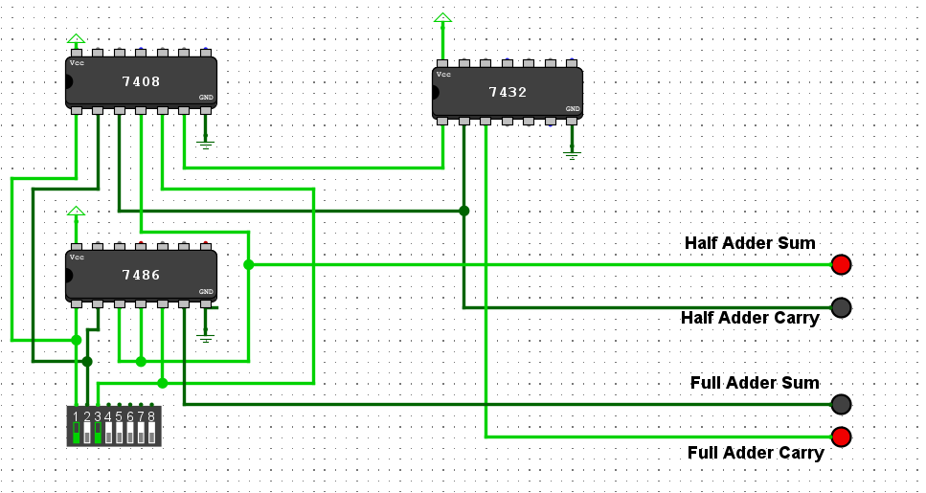
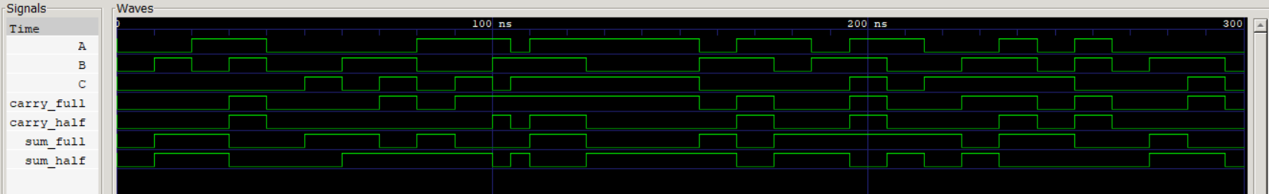
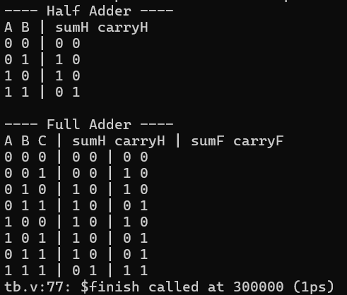
Figure 10: Half and Full Adder Circuit using Logic IC's
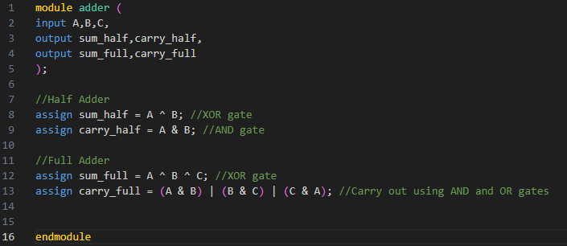
Figure 11: Verilog Code with corresponding Truth table and Signal Response for both Half Adder and Full Adder
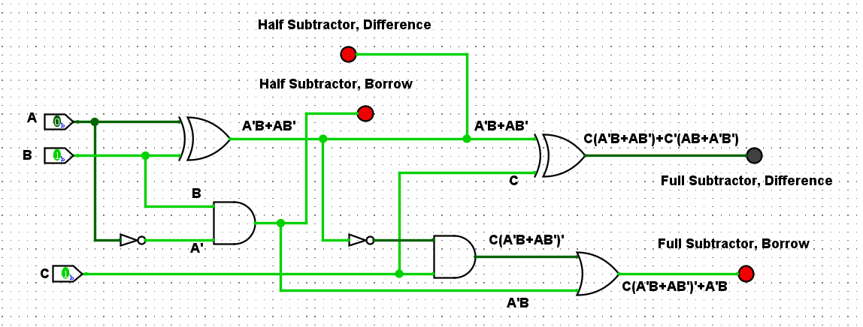
Figure 12: Half and Full Subtractor using Logic Gates
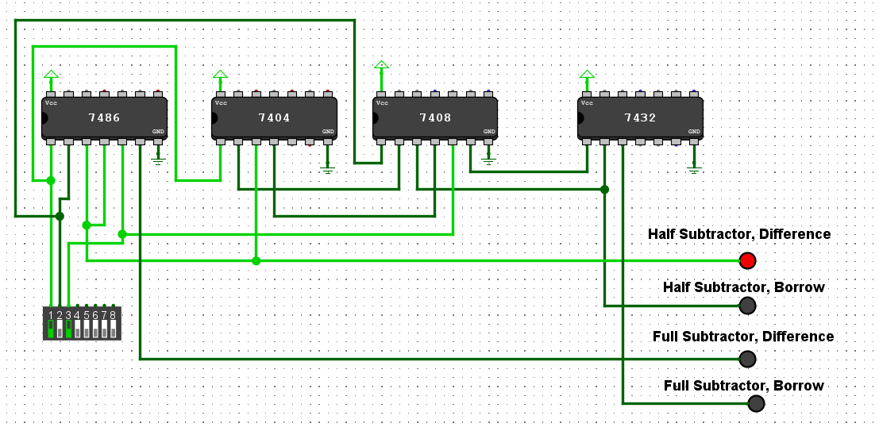
Figure 13: Half and Full Subtractor using IC's
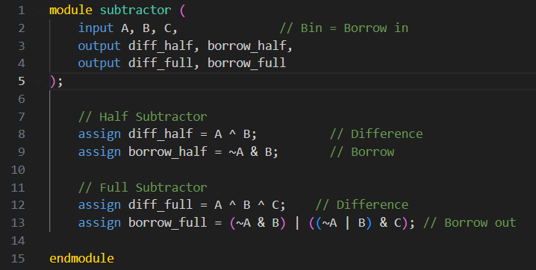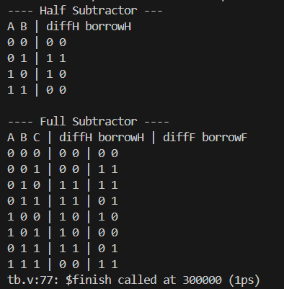
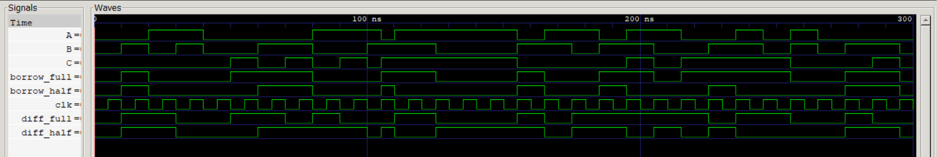
Figure 14: Verilog Code with corresponding Truth table and Signal Response for both Half Subtractor and Full Subtractor

