Implementing a Master-Slave J-K Flip Flop
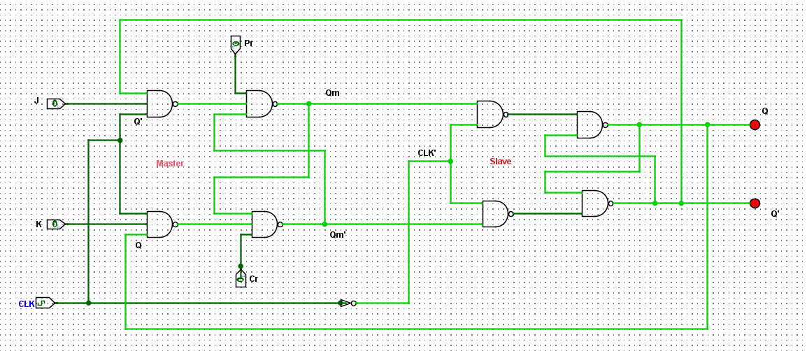
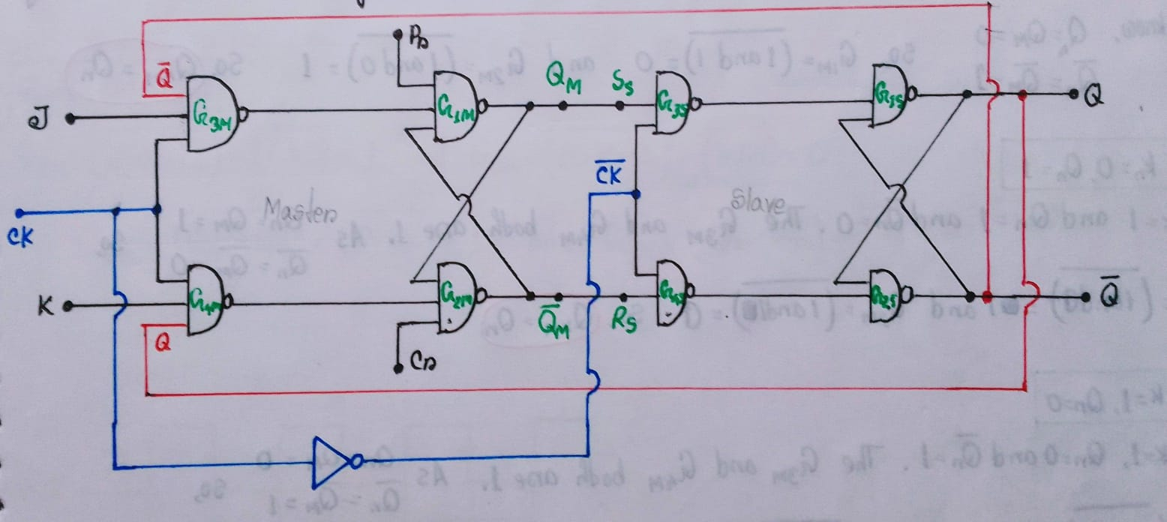
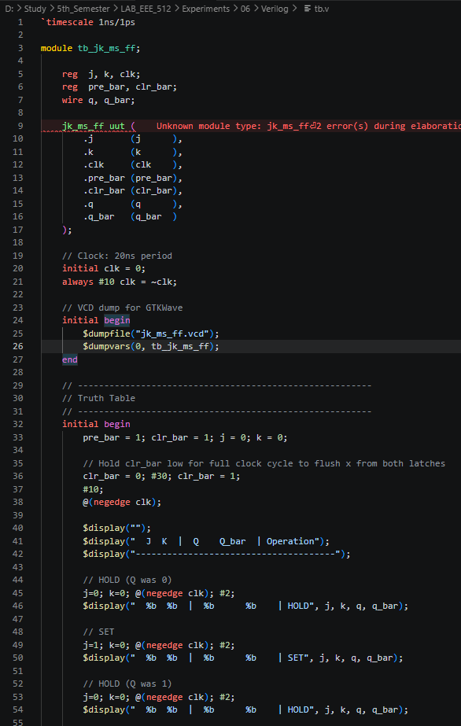
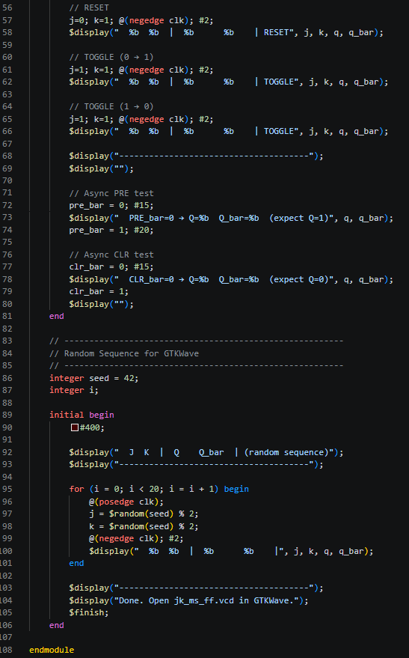
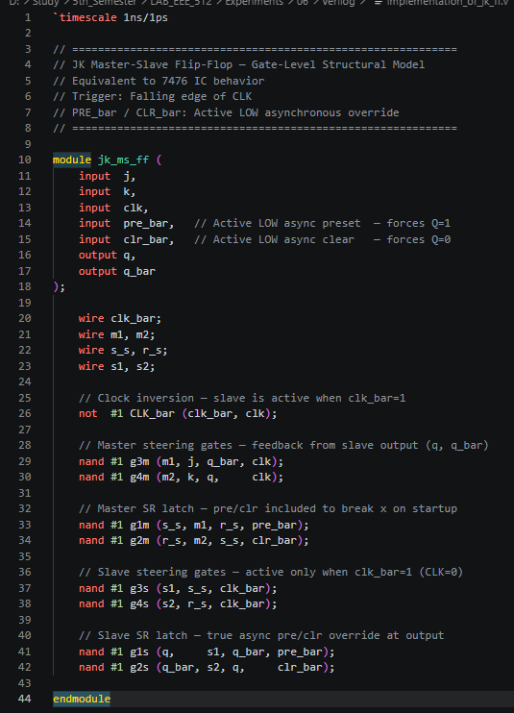
Figure 1: NAND Gate Implementation of a Master-Slave J-K Flip Flop
Figure 2: Verilog script for the Master slave JK Flip Flop
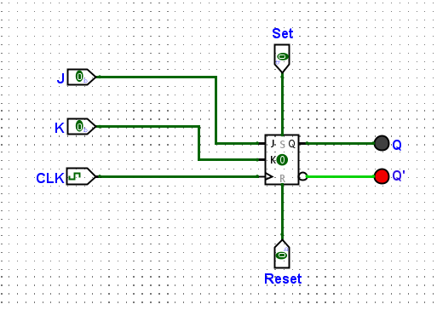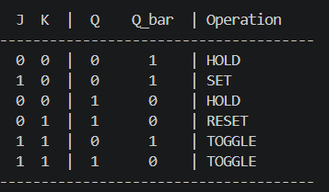
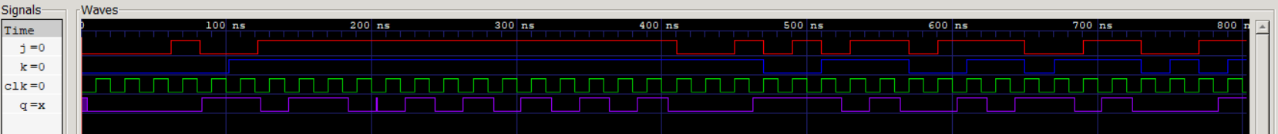
Figure 3: Block Diagram, Truth Table and Signal Response for the Master Slave J-K Flip Flop

