Assalamu Alaikum I am rowfun.

[eta bolei medical tour er page ta open korben]

This is a very important part for any hospital that doctors attend seminars and meet with the other doctors and this is just a glimpse of those activities

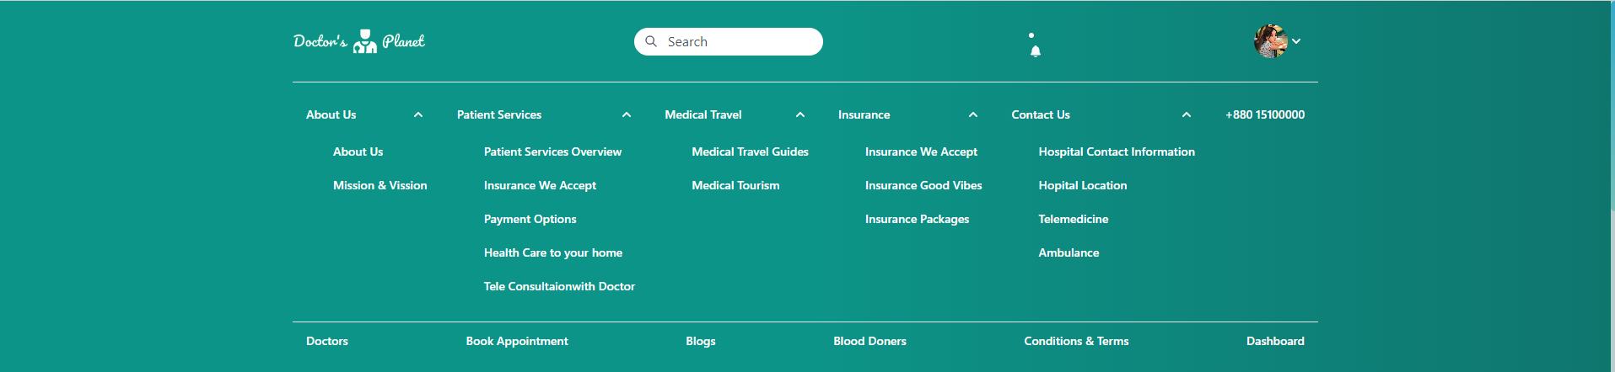

Ekhane joto gulo route ache sob open korben ,but jegulo open hoy r ki segulo open korben onno gulo na abar

Tarpor open korben insurance page er insurance we accept

We have insurance policy

Then open korben ambulance service sekhane emergency number ta click kore dekhaben and bolben

We have Ambulance sevice as well as contact form

Then open korben contact form

About us a jaben

And a little description about us bole about us open korben last a mission vision open kore rakhben then bola shuru korben

For the future implementation we have so many scops like we will add salary system, leaves counting system ,laboratories system and servies and many more.

For these system we will use technologies like typescripts , graphql,datavisualization.

Thank you all for giving us a such a moment to share our thoughts with all of you