Hi,

I want to make you aware about the new way to set up Real Eye.

Nothing has changed with the scripting in Decipher. The change relates to the Real Eye site, itself.

Moving forward, when you set up a job on the Real Eye site – **DO NOT ADD PARICIPANTS** to the job.

In the past, to finish the Real Eye set up, you clicked “Select Participants” (red circle below):

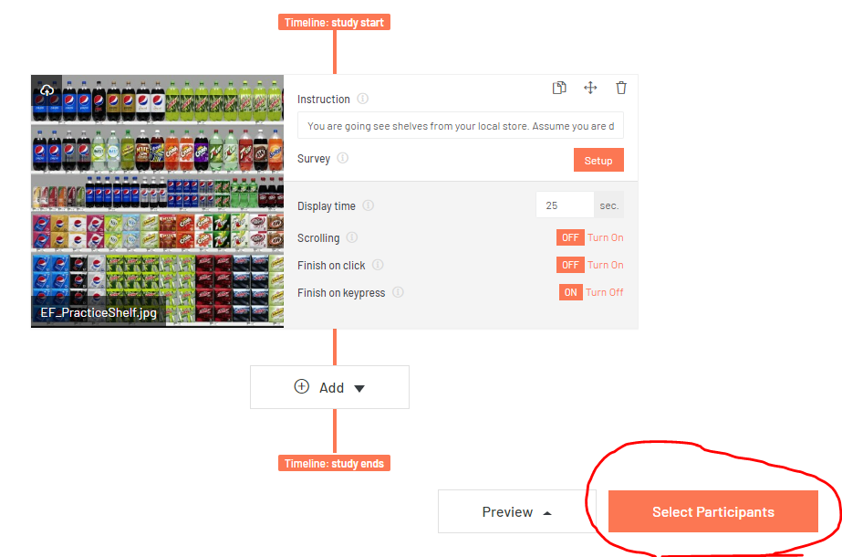

Then you entered a count limit (usually 9999), then clicked “Run The Study”:

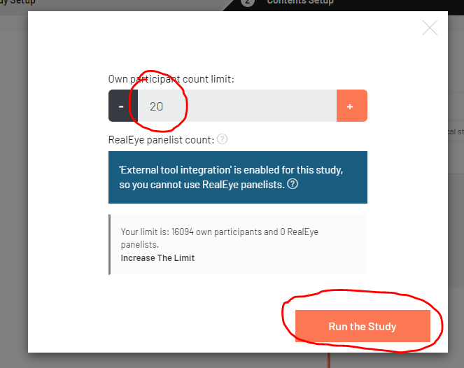

Please do not add a participant count any longer.  Leaving the participant count empty, will keep the Real Eye job in “Draft Mode” during the testing period.  We have learned that Real Eye is billing Behaviorally for every completed Real Eye, including test interviews.

Once all testing is completed, and the job is ready to launch, it is the responsibility of the **Field Manager** to add the participant count and to Run The Study.  Once the field manager adds the participant count (9999) and clicks on “Run the Study”,  all the test interviews are deleted, and we are then only billed for valid respondent Real Eye data.

To obtain the ProjectID needed for the xml, you can click on “Preview”, then “Share Preview Link”:

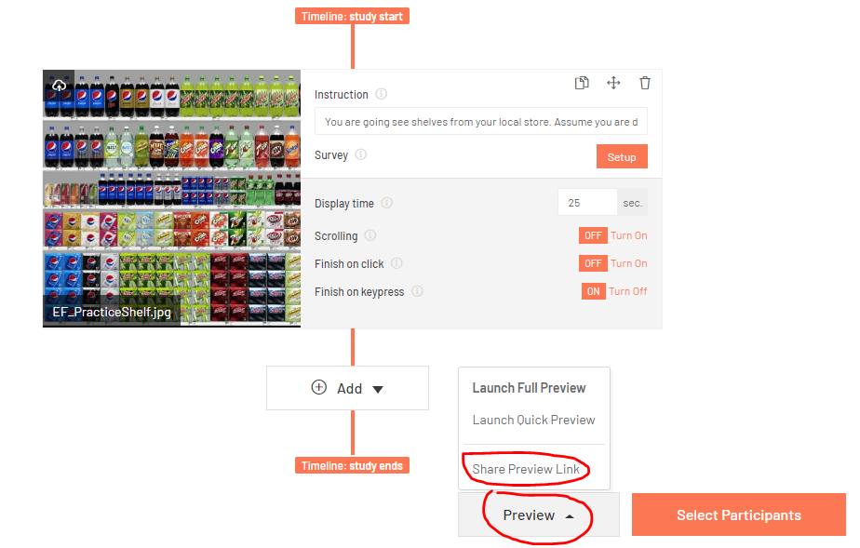

And the ProjectID appears in a pop-up window, where you can copy it, then paste it into the xml (make sure to copy the entire ProjectID. The snip below displayed only a portion of the entire ProjectID:

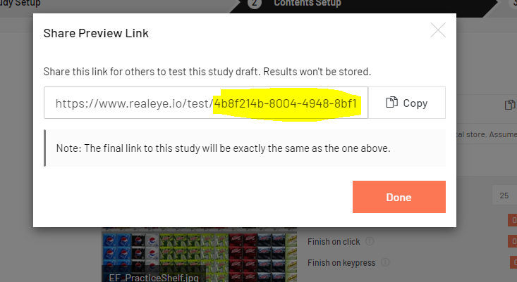

This “change” to the Real Eye set up, is essentially asking you to take fewer steps.

When setting up Real Eye, please set the Display Time for ALL the images to 10 seconds (see example below).  Note:  in the Real Eye template job, the practice soda shelf is already set for 10 seconds.

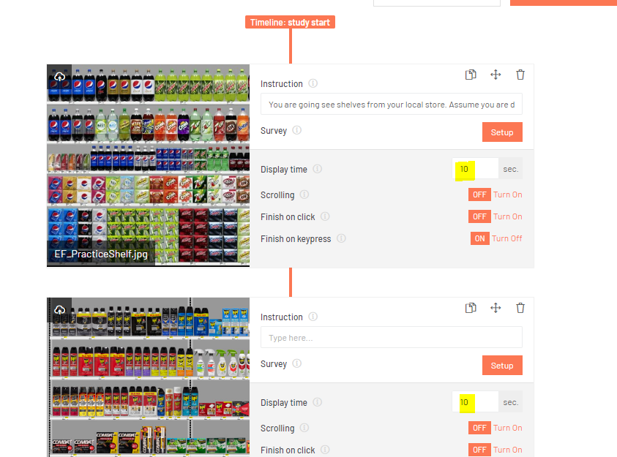

Previously, the shelf images were set for 25 seconds and the pack images for 15 seconds.  Moving forward, both shelf and pack images should now be set at 10 seconds.

Please feel free to reach out with any questions.

Thanks,