

**CSE370 : Database Systems**

**Project Report**

**Project Title : Travel Management System**

| **Group No :04 , CSE370 Lab Section : 15, Summer 2025** | | |
| --- | --- | --- |
| **ID** | **Name** | **Contribution** |
| 22201938 | Md. Nahian Alam |  |
| 23101250 | Md. Nashid Mahim |  |
| 23101310 | Rakibul Islam |  |

**Table of Contents**

| **Section**  **No** | **Content** | **Page No** |
| --- | --- | --- |
| 1 | Introduction | 3 |
| 2 | Project Features | 3 |
| 3 | ER/EER Diagram | 4 |
| 4 | Schema Diagram | 5 |
| 5 | Normalization | 6 |
| 6 | Frontend Development | 7 |
| 7 | Backend Development | 8 |
| 8 | Source Code Repository | 9 |
| 9 | Conclusion | 9 |
| 10 | References | 9 |

**Introduction**

The Travel Management System is a database based web application designed to simplify and automate the process of planning, booking, managing groups, etc. The primary goal of this system is to provide travelers a platform where they can search and book hotels, bus tickets, manage groups. The system is built using PHP for server side logic, MySQL for database management, HTML for the user interface.

**Project Features**

| **ID,**  **Name** | **Features [3 per member]** | |
| --- | --- | --- |
| 22201938  Md. Nahian Alam | Ft 1 | User |
| Ft 2 | Payment |
| Ft 3 | Offer |
| 23101250  Md. Nashid Mahim | Ft 1 | Reward Point |
| Ft 2 | Booking |
| Ft 3 | Accomodation |
| 23101310  Rakibul Islam | Ft 1 | Group |
| Ft 2 | Trip |
| Ft 3 |  |

**ER/EER Diagram**

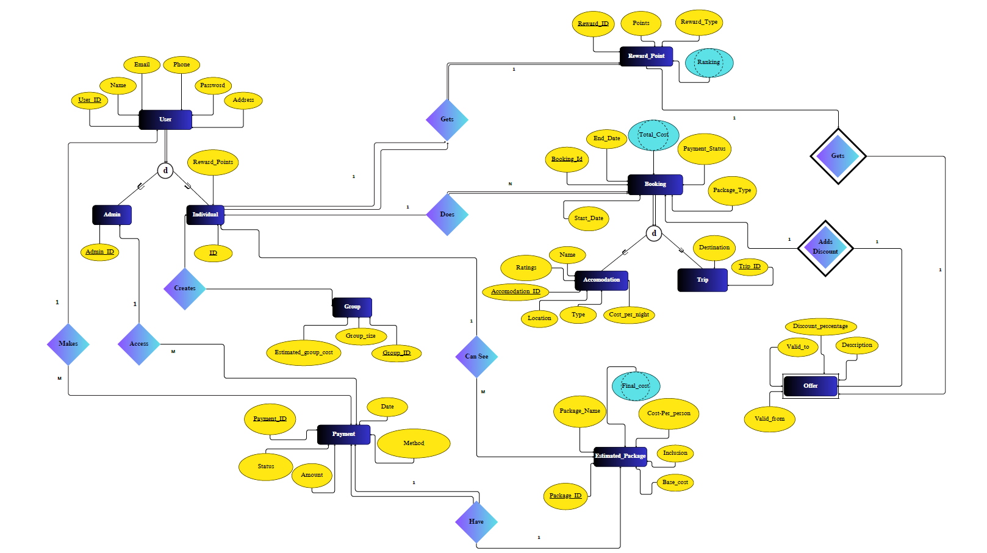

**Schema Diagram**

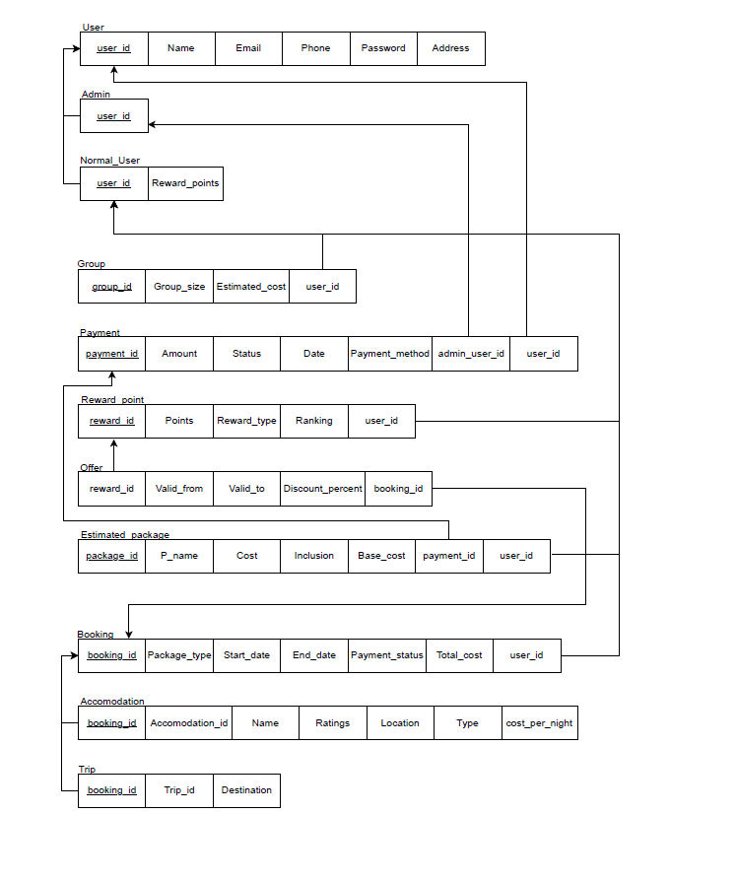

**Normalization**

1. Explain if your converted Schema is in 1NF or not. If not, decompose it to 1NF.
2. Explain if your converted Schema is in 2NF or not. If not, decompose it to 2NF. Can there be any partial functional dependencies in your relational schema?
3. Explain if your converted Schema is in 3NF or not. If not, decompose it to 3NF. Can there be any transitive dependencies in your relational schema?

**Ans:**

1. Schema is in 1NF as there is no nested table, multivalued or composite attribute.
2. Schema is in 2NF as there are no partial dependencies between the tables.
3. Schema is in 3NF as there are also no transitive dependencies and already in 2NF form.

**Frontend Development**

Frontend Development focuses on designing the user interface. It is the visible part of the application that interacts directly with the users, allowing them to search, book and manage their travel groups. In this project the frontend is developed using HTML. HTML is for structuring web page and displaying content such as booking form, payment details, offers and group information.

**Contribution of ID : 22201938, Name : Md. Nahian Alam**

**Contribution of ID : 23101250, Name : Md. Nashid Mahim**

**Contribution of ID : 23101310, Name : Rakibul Islam**

**Backend Development**

The backend development of this system is handling the core logic of the application, database interactions, asecure data processing. The backend ensures that all travel related operations are executed correctly. As the primary server side scripting language, it manages request from the frontend, process user input, communicates with database and generates dynamic response such as booking results, available offers and payment confirmations. Besides, MySQL as the relational database system, it stores all travel related data including user, booking, accommodations, trips, offer, payment, groups and reward points. SQL queries are used to insert, retrieve, update, delete information securely and efficiently.

**Contribution of ID : 22201938, Name : Md. Nahian Alam**

**Contribution of ID : 23101250, Name : Md. Nashid Mahim**

**Contribution of ID : 23101310, Name : Rakibul Islam**

**Source Code Repository**

<https://github.com/Rakib9534/CSE370-Database_Systems_Project>

**Conclusion**

The Travel Management System integrates multiple aspects of travel planning such as accommodation booking, trip management, offers, payments and group travel into a single platform. By combining all these things the system provides a reliable solution for both travelers and administrations. The project also demonstrates the effective use of PHP, MySQL, HTML etc in building a real world web application.