Lab 5.6.2: Challenge RIP Configuration

Topology Diagram
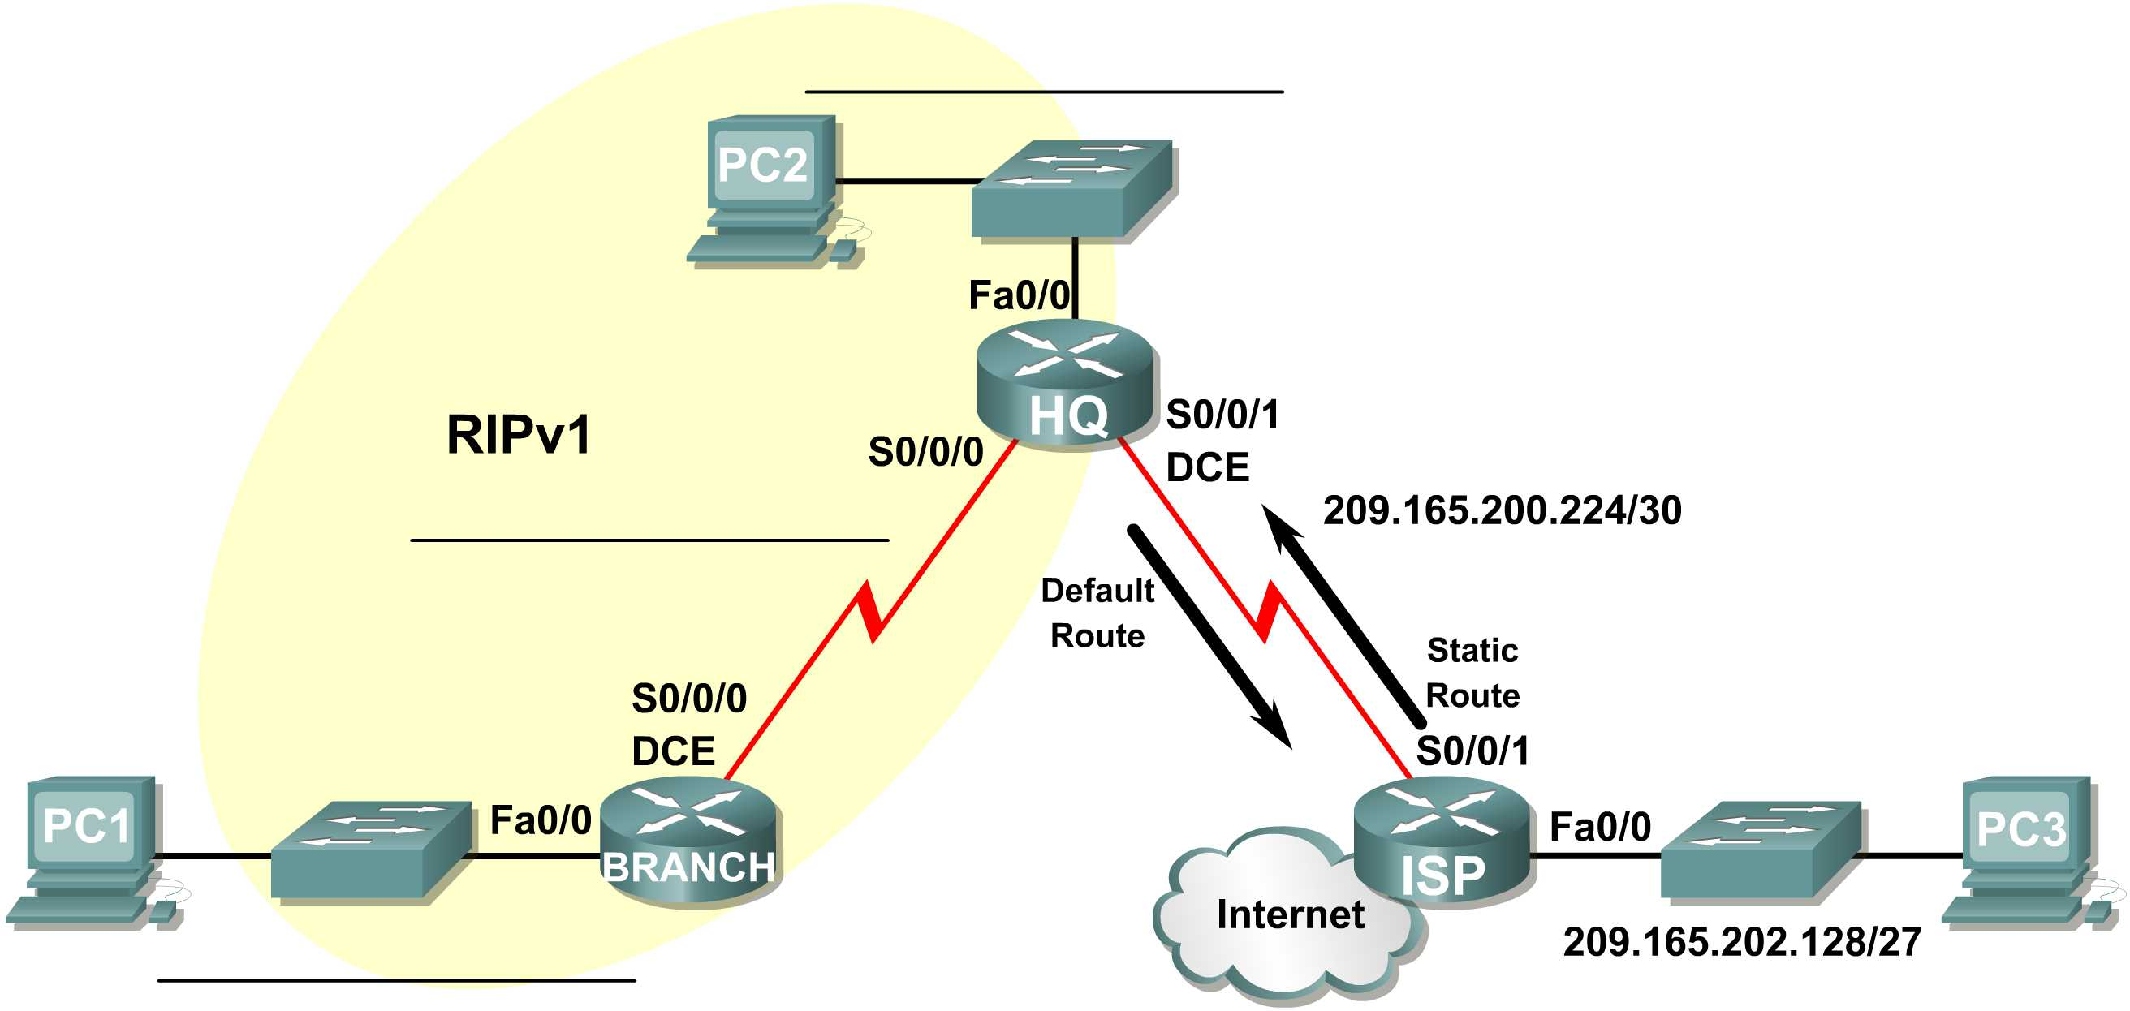

Addressing Table
Device | Interface | IP Address | Subnet Mask | Default Gateway
BRANCH | Fa0/0 | 10.10.2.1 | 255.255.254.0 | N/A
BRANCH | S0/0/0 | 192.168.1.126 | 255.255.255.128 | N/A
HQ | Fa0/0 | 192.168.1.129 | 255.255.255.128 | N/A
HQ | S0/0/0 | 192.168.1.1 | 255.255.255.128 | N/A
HQ | S0/0/1 | 209.165.200.226 | 255.255.255.252 | N/A
ISP | Fa0/0 | 209.165.202.129 | 255.255.255.224 | N/A
ISP | S0/0/1 | 209.165.200.225 | 255.255.255.252 | N/A
PC1 | NIC | 10.10.3.254 | 255.255.254.0 | 10.10.2.1
PC2 | NIC | 192.168.1.254 | 255.255.255.128 | 192.168.1.129
PC3 | NIC | 209.165.202.158 | 255.255.255.224 | 209.165.202.129

Learning Objectives
Upon completion of this lab, you will be able to:
- Subnet an address space given requirements.
- Assign appropriate addresses to interfaces and document them in the Addressing Table.
- Cable a network according to the Topology Diagram.
- Erase the startup configuration and reload a router to the default state.
- Configure RIPv1 routing on all routers.
- Configure and propagate a static default route.
- Verify RIPv1 operation.
- Test and verify full connectivity.
- Reflect upon and document the network implementation.

Scenario
In this lab activity, you will be given a network address that must be subnetted to complete the addressing of the network shown in the Topology Diagram. A combination of RIPv1 and static routing will be required so that hosts on networks that are not directly connected will be able to communicate with each other.
Task 1: Subnet the Address Space.
Step 1: Examine the network requirements.
The addressing for the network has the following requirements:
- The ISP LAN will use the 209.165.202.128/27 network.
- The link between the ISP router and the HQ router will use the 209.165.200.224/30 network.
- The 192.168.1.0/24 network must be subnetted for use in the HQ LAN and the link between the HQ and BRANCH routers. The HQ LAN will require 50 host IP addresses.
- The BRANCH LAN will use the 10.10.2.0/23 network.
(Note: Remember that the interfaces of network devices are also host IP addresses and are included in the above addressing requirements.)
Step 2: Consider the following questions when creating your network design:
How many subnets need to be created from the 192.168.1.0/24 network? ___2_______
What is the subnet mask for this network in dotted decimal format? _____255.255.255.128________
What is the subnet mask for the network in slash format? ____/25______
What are the network addresses of the subnets?
Subnet 0: ________192.168.1.0 /25__________________
Subnet 1: ________192.168.1.128 /25__________________
How many usable host IP addresses are there per subnet? ___128________
How many usable hosts IP addresses are available in the BRANCH LAN? ____512________
Step 3: Assign subnetwork addresses to the Topology Diagram.
  - Assign subnet 1 in the 192.168.1.0 network to the WAN link between the HQ and BRANCH routers.
  - Assign subnet 2 in the 192.168.1.0 network to the LAN attached to the HQ router.
Task 2: Determine Interface Addresses.
Step 1: Assign appropriate addresses to the device interfaces.
- Assign the first valid host address in the 209.165.202.128/27 network to the LAN interface on the ISP router.
- Assign the last valid host address in the 209.165.202.128/27 network to PC3.
- Assign the first valid host address in the 209.165.200.224/30 network to the WAN interface of the ISP router.
- Assign the last valid host address in the 209.165.200.224/30 network to the Serial 0/0/1 interface of the HQ router.
- Assign the first valid host address in the HQ LAN network to the LAN interface of the HQ router.
- Assign the last valid host address in the HQ LAN network to PC 2.
- Assign the first valid host address in the HQ/BRANCH WAN link to the Serial 0/0/0 interface of the HQ router.
- Assign the last valid host address in the HQ/BRANCH WAN link to the Serial 0/0/0 interface of the BRANCH router.
- Assign the first valid host address in the 10.10.2.0/23 network to the LAN interface on the BRANCH router.
- Assign the last valid host address in the 10.10.2.0/23 network to PC1.
Step 2: Document the addresses to be used in the table provided under the Topology Diagram.
Task 3: Prepare the Network.
Step 1: Cable a network that is similar to the one in the Topology Diagram.
You can use any current router in your lab as long as it has the required interfaces shown in the topology.
Note: If you use 1700, 2500, or 2600 routers, the router outputs and interface descriptions will appear different.
Step 2: Clear any existing configurations on the routers.
Task 4: Perform Basic Router Configurations.
Perform basic configuration in the BRANCH, HQ, and ISP routers according to the following guidelines:
- Configure the router hostname.
- Disable DNS lookup.
- Configure an EXEC mode password.
- Configure a message-of-the-day banner.
- Configure a password for console connections.
- Configure a password for VTY connections.
- Synchronize unsolicited messages and debug output with solicited output and prompts for the console and virtual terminal lines.
- Configure an EXEC timeout of 15 minutes.
Task 5: Configure and Activate Serial and Ethernet Addresses.
Step 1: Configure the BRANCH, HQ, and ISP routers.
Configure the interfaces on the BRANCH, HQ, and ISP routers with the IP addresses from the Addressing Table provided under the Topology Diagram.
When you have finished, be sure to save the running configuration to the NVRAM of the router.
Step 2: Configure the Ethernet interfaces of PC1, PC2, and PC3.
Configure the Ethernet interfaces of PC1, PC2, and PC3 with the IP addresses from the Addressing Table provided under the Topology Diagram.
Task 6: Verify Connectivity to Next-Hop Device.
You should not have connectivity between end devices yet. However, you can test connectivity between two routers and between an end device and its default gateway.
Step 1: Verify BRANCH connectivity.
Verify that BRANCH can ping across the WAN link to HQ and that HQ can ping across the WAN link it shares with ISP.
Step 2: Verify Ethernet interface connectivity.
Verify that PC1, PC2, and PC3 can ping their respective default gateways.
Task 7: Configure RIP Routing on the BRANCH Router.
Consider the networks that need to be included in the RIP updates that are sent out by the BRANCH router.
What networks are currently present in the BRANCH routing table before RIP is configured? List the networks with slash notation.
___________________________10.0.0.0/23 _____________________________________
____________________________192.168.1.0/25_________________________________
____________________________________________________________________________
What commands are required to enable RIP version 1 and include these networks in the routing updates?
______________________________ router rip _______________________________
___________________________ network 10.0.0.0_____________________________
____________________________ network 192.168.1.0_________________________
Are there any router interfaces that do not need to have RIP updates sent out? ___yes__________
What command is used to disable RIP updates on this interface?
______________________ passive-interface FastEthernet0/0_______________
Task 8: Configure RIP and Static Routing on the HQ Router
Consider the type of static routing that is needed on HQ.
What networks are present in the HQ routing table? List the networks with slash notation.
_________________________209.165.200.0/27___________________________
_____________________192.168.1.0/25________________________
_____________________________________________________________________________
A static default route will need to be configured to send all packets with destination addresses that are not in the routing table to the ISP router. What command is needed to accomplish this? Use the appropriate exit interface on the HQ router in the command.
_______________________ ip route 0.0.0.0 0.0.0.0 Serial0/0/1___________
What commands are required to enable RIPv1 and include the LAN network in the routing updates?
___________________________ router rip____________________________
____________________________ network 192.168.1.0___________________________
Are there any router interfaces that do not need to have RIP updates sent out? ___________
What command is used to disable RIP updates on this interface?
__________________________ passive-interface FastEthernet0/0 __________
The HQ router needs to send the default route information to the BRANCH router in the RIP updates. What command is used to configure this?
_________________________ default-information originate ___________
Task 9: Configure Static Routing on the ISP Router
Static routes will need to be configured on the ISP router for all traffic that is destined for the RFC 1918 addresses that are used on the BRANCH LAN, HQ LAN, and the link between the BRANCH and HQ routers.
What are the commands that will need to be configured on the ISP router to accomplish this?
ISP(config)# __________ ip route 10.10.2.0 255.255.254.0 Serial0/0/1___
ISP(config)#_______ ip route 192.168.1.0 255.255.255.0 Serial0/0/1___
Task 10: Verify the Configurations
Answer the following questions to verify that the network is operating as expected.
From PC2, is it possible to ping PC1? _____yes_____
From PC2, is it possible to ping PC3? _____yes_____
From PC1, is it possible to ping PC3? _____yes_____
The answer to the above questions should be yes. If any of the above pings failed, check your physical connections and configurations. Refer to the basic troubleshooting techniques used in the Chapter 1 labs.
What routes are present in the routing table of the BRANCH router?
______________________________10.0.0.0/23_____________________________________
______________________________192.168.1.0/25__________________________________
______________________________0.0.0.0/0_____________________________
_______________________________________________________________________
_____________________________________________________________________________
What is the gateway of last resort in the routing table of the BRANCH router?
______________________________192.168.1.1 to network 0.0.0.0____________________
What routes are present in the routing table of the HQ router?
______________________________10.0.0.0/8______________________________
______________________________192.168.1.0/25______________________________
______________________________209.165.200.0/27______________________________
______________________________0.0.0.0/0______________________________ ______________________________________________________________________
What networks are present in the routing table of the ISP router?
______________________________10.0.0.0/23______________________________
______________________________192.168.1.0/24______________________________
______________________________209.165.200.0/27______________________________
______________________________209.165.202.0/27______________________________
____________________________________________________________________
What networks, including the metric, are present in the RIP updates sent from the HQ router?
______________________________network 0.0.0.0 metric 1___________
____________________________network 192.168.1.128 metric 1_________
What networks, including the metric, are present in the RIP updates sent from the BRANCH router?
______________________________network 10.0.0.0 metric 1__________
____________________________________________________________________
Task 11: Reflection
If static routing were used instead of RIP on the BRANCH router, how many individual static routes would be needed for hosts on the BRANCH LAN to communicate with all of the networks in the Topology Diagram? _____Three_____
Task 12: Document the Router Configurations
On each router, capture the following command output to a text file and save for future reference:
- Running configuration
- Routing table
- Interface summarization
Task 13: Clean Up
Erase the configurations and reload the routers. Disconnect and store the cabling. For PC hosts that are normally connected to other networks (such as the school LAN or to the Internet), reconnect the appropriate cabling and restore the TCP/IP settings.

