

***Assignment Report***

Course name: Microprocessor Based Systems Design

Course code: CSC 471

Sec: A

***Traffic Light Control System with Pedestrian Crossing***

**Submitted To**

Md. Alomgir Hossain

Assistant professor, CSE Dept. IUBAT

**Submitted by**

Rakibul Hasan

21203070

Program: BCSE

Semester: Fall -2024

Submission Date: January 8, 2025

### ****1. Problem Statement****

Traffic light systems are a critical component of modern transportation infrastructure, ensuring smooth vehicle flow and pedestrian safety. This project aims to design and simulate a traffic light control system with an integrated pedestrian crossing feature. When a pedestrian button is pressed, the system halts normal traffic flow and allows safe pedestrian passage. The simulation is implemented using Arduino and Proteus software.

### ****2. Objective****

* To design and simulate a functional traffic light system with a pedestrian crossing.
* To prioritize pedestrian safety by halting traffic when a button is pressed.
* To utilize Arduino programming and Proteus simulation for implementing the system.

### ****3. Apparatus Required****

1. **Software**:
   * Proteus simulation software
   * Arduino IDE for programming
2. **Simulation Components**:
   * Arduino Uno R3 (Microcontroller)
   * LEDs (Red, Yellow, Green, Green LED (Pedestrian))
   * Push Button
   * Virtual Resistors (220 Ω)

### ****4. Description of Assignment****

This project involves the design of a traffic light control system with a pedestrian crossing feature. The traffic lights follow a standard sequence (Red ➔ Green ➔ Yellow). When a pedestrian button is pressed, the system halts the normal sequence, activates the pedestrian crossing light, and then resumes normal traffic flow after 5 seconds.

### ****5. Implementation of Assignment Circuit****

##### **Circuit Design**

The circuit is designed using Proteus, with the following connections:

* **Traffic Lights**:
  + Red LED connected to Pin 8.
  + Yellow LED connected to Pin 9.
  + Green LED connected to Pin 10.
* **Pedestrian Light**:
  + Pedestrian crossing LED connected to Pin 5.
* **Push Button**:
  + Connected to Pin 2 and GND, using the Arduino's internal pull-up resistor.

##### **Code Implementation**

The Arduino code controls the traffic lights and pedestrian crossing functionality. The button press triggers an interrupt in the traffic sequence to prioritize pedestrian safety. The system resumes normal operation after 5 seconds.

// Traffic Light Control with Pedestrian Crossing

const int RED_PIN = 8;       // Traffic Red LED

const int YELLOW_PIN = 9;    // Traffic Yellow LED

const int GREEN_PIN = 10;    // Traffic Green LED

const int PED_LED_PIN = 5;   // Pedestrian Walk LED

const int BUTTON_PIN = 2;    // Button Pin

bool pedestrianActive = false;  // Flag to track pedestrian crossing

void setup() {

    pinMode(RED_PIN, OUTPUT);

    pinMode(YELLOW_PIN, OUTPUT);

    pinMode(GREEN_PIN, OUTPUT);

    pinMode(PED_LED_PIN, OUTPUT);

    pinMode(BUTTON_PIN, INPUT_PULLUP); // Use internal pull-up resistor

}

void loop() {

    // Check if pedestrian button is pressed

    if (digitalRead(BUTTON_PIN) == LOW) { // Button pressed

        pedestrianActive = true;

        pedestrianCrossing();

        pedestrianActive = false;             // Set pedestrian crossing flag

    }

    digitalWrite(RED_PIN, HIGH);    // Traffic Red ON

    digitalWrite(YELLOW_PIN, LOW);  // Ensure Yellow is OFF

    digitalWrite(GREEN_PIN, LOW);   // Ensure Green is OFF

    delay(5000);

    // Check if pedestrian button is pressed

    if (digitalRead(BUTTON_PIN) == LOW) { // Button pressed

        pedestrianActive = true;

        pedestrianCrossing();

        pedestrianActive = false;             // Set pedestrian crossing flag

    }

    digitalWrite(RED_PIN, LOW);     // Traffic Red OFF

    digitalWrite(GREEN_PIN, HIGH);  // Traffic Green ON

    delay(5000);

    // Check if pedestrian button is pressed

    if (digitalRead(BUTTON_PIN) == LOW) { // Button pressed

        pedestrianActive = true;

        pedestrianCrossing();

        pedestrianActive = false;             // Set pedestrian crossing flag

    }

    digitalWrite(GREEN_PIN, LOW);   // Traffic Green OFF

    digitalWrite(YELLOW_PIN, HIGH); // Traffic Yellow ON

    delay(2000);                    // Wait 2 seconds

    digitalWrite(YELLOW_PIN, LOW);

}

// Pedestrian Crossing Sequence

void pedestrianCrossing() {

    // Turn on pedestrian crossing lights

    digitalWrite(RED_PIN, HIGH);       // Traffic Red ON

    digitalWrite(GREEN_PIN, LOW);      // Traffic Green OFF

    digitalWrite(YELLOW_PIN, LOW);     // Traffic Yellow OFF

    digitalWrite(PED_LED_PIN, HIGH);   // Pedestrian Walk Light ON

    delay(5000);                       // Wait 5 seconds for crossing

    // Turn off pedestrian lights and resume normal cycle

    digitalWrite(PED_LED_PIN, LOW);    // Pedestrian Walk Light OFF

}

### ****6. Result Analysis****

The simulation was run in Proteus. The LEDs successfully followed the programmed sequence:

1. Normal traffic light sequence operates as expected (Red ➔ Green ➔ Yellow).
2. Pedestrian button interrupts the sequence, activating the pedestrian crossing light and stopping traffic.
3. After 5 seconds, the system smoothly resumes the traffic light sequence.

This validated the proper functioning of the traffic light control system.

**Simulation Screenshots:**

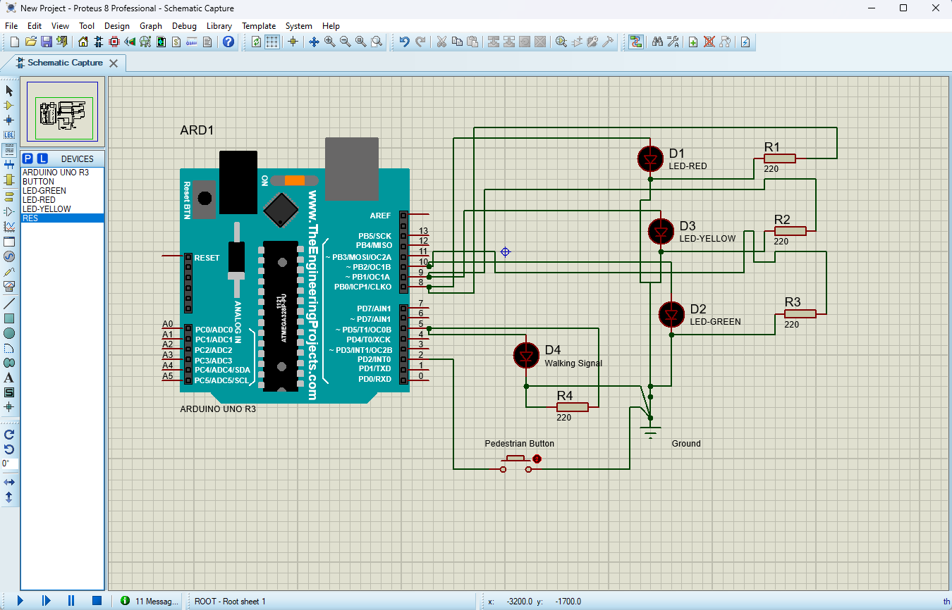

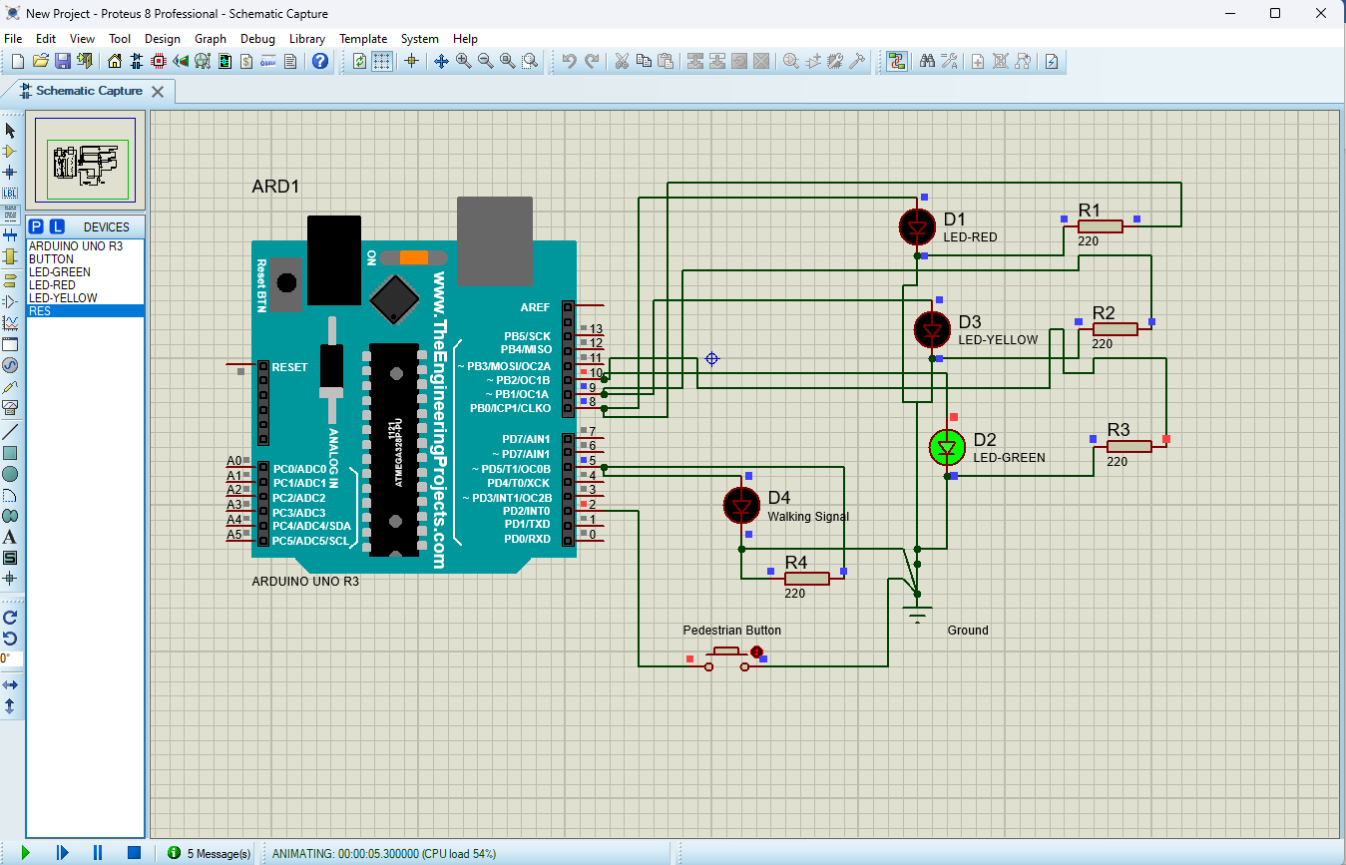

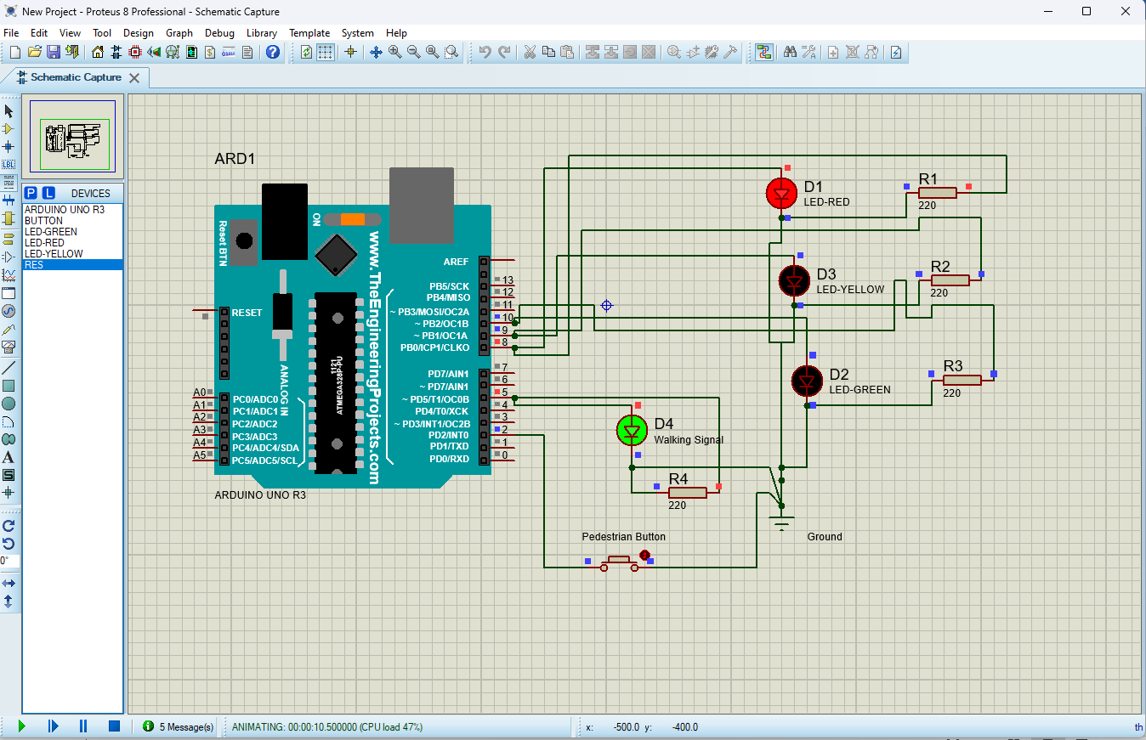

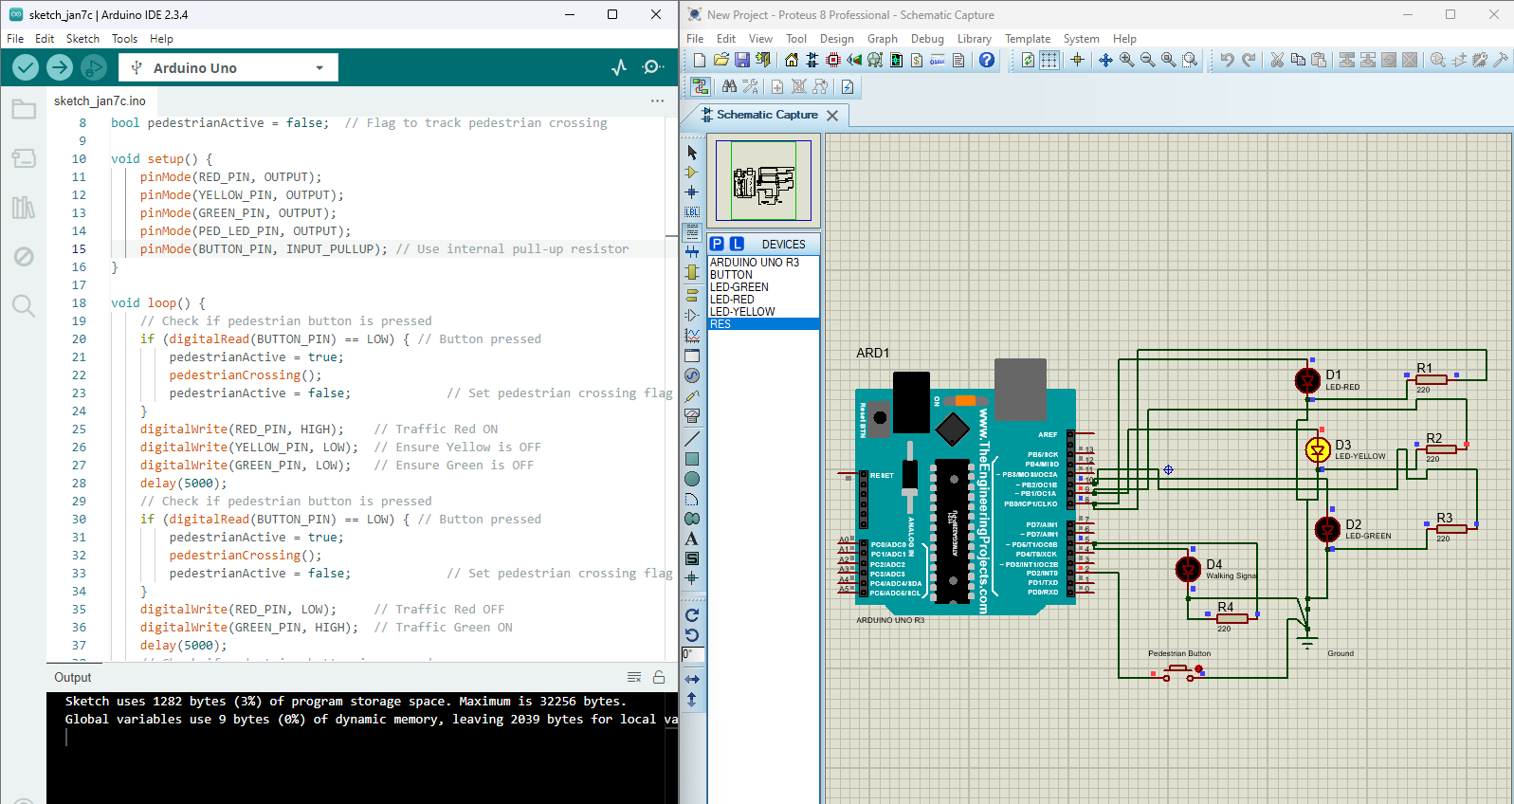

### ****7. Procedure to Perform****

1. Open Proteus and create a new project.
2. Add the Arduino Uno microcontroller and connect the LEDs (Red, Yellow, Green, PED Green Light) to digital pins 8, 9, 10 and 5 through virtual resistors which is 220 ohms.
3. Load the provided C++ code into the Arduino in Proteus.
4. Start the simulation and observe the traffic light sequence.
5. Verify that the lights follow the correct timing and order.

### ****8. Conclusion****

This project successfully demonstrates a traffic light system integrated with a pedestrian crossing feature. It prioritizes pedestrian safety by halting traffic on demand and resuming normal operation afterward. The system is efficient, modular, and can be scaled for real-world implementation.