Paper Preparation Instructions for ICPACE 2021 International Conference on Planning, Architecture and Civil Engineering

**M. A. Sobhan1, M. A. Alim2, M. M. Sazzad3**

*1Professor, Department of Civil Engineering, RUET, Bangladesh (sobhan@ruet.ac.bd)*

*2Professor, Department of Civil Engineering, RUET, Bangladesh (*[*alim23@ruet.ac.bd*](mailto:alim23@ruet.ac.bd)*)*

*3Assistant Engineer, LGED, Bangladesh (mms123@gmail.com)*

**Abstract**

This document template is designed to guide authors in formatting their papers by directly entering and editing the text. Alternatively, authors can use this document and follow the guidelines to adjust the format of their paper to the required form. This “abstract” section is limited to a maximum of 200 words. Authors are required to present a short summary of their study including their findings, conclusions and outcomes.

***Keywords:*** *This section should be written in italic and include maximum of 5 keywords related to the study separated by semi-colon.*

**1. Introduction**

Submission of full papers, maximum 6 pages, will be due on April 15, 2021. Paper submissions must be in electronic copy, in both Microsoft Word Document (docx) and pdf formats.

**2. Guidelines**

Authors should follow these guidelines in writing their papers. Paper must be customized to A4 size. Then the page setup must be adjusted so that all margins are 2.5 cm (top, bottom, left and right). The body text should be aligned in single column to “justified” style and line spacing must be single.

Font type Times New Roman, size 12 pt. should be used throughout the text (**also for the line spaces**). There should not be any underlined words. Spacing on the first page must be adjusted as follows: starting from the first line, enter 3 spaces and write the title of the paper (16 pt, Bold), enter 3 spaces and write name and surname of the authors as shown above (12 pt., Bold), enter 1 space and write the affiliation of each author on a separate line (12 pt.), enter 3 spaces and write the title “Abstract” (12 pt., Bold). At the end of the abstract, enter 1 space and write the title “*Keywords*” (12 pt., Bold, Italic, include maximum 5 keywords), enter 2 spaces and write the first section heading “Introduction”. Information on numbering and format for headings are given in the next section.

SI (international system) units must be used throughout the whole text.

**3. Section Headings**

Type each section heading in 12 pt., Bold and number sequentially except for the References section. Enter 1 line space after section titles. Enter 2 line spaces between section titles and preceding paragraphs.

***3.1 Format for Subsection Headings***

Subsection headings should be formatted in 12 pt. font size, Italic and bold style. There should be 1 line space after the subsection headings and 1 line space between subsection headings and the preceding paragraphs.

**4. Tables and Figures**

Use the same format for plain text in table and figure captions. Table and figure captions must be centered and separated from the plain text by 1 line space. Tables and figures must also be separated by 1 line space from both the plain text and the caption. Both tables and figures should be adjusted to “in-line text” format and must be formatted to sit horizontally centered (please see Table 1 and Figure 1).

Table 1. Undisturbed sample properties

|  |  |  |
| --- | --- | --- |
| **Sample ID** | **Depth**  **(m)** | **Bulk density, ρb (g/cm3)** |
| S2-1 | 6.00-6.30 | 1.80 |
| S2-2 | 6.00-6.30 | 1.85 |
| S2-3 | 9.40-9.70 | 1.93 |
| S2-4 | 9.40-9.70 | 1.90 |



Figure 1. SPT blow counts for the profile investigated

Adjust the resolution of pictures, if any, to between a maximum of 600 dpi and a minimum of 300 dpi, with a grey-scale color quality as shown in Figure 2. The paper size should not exceed 10 MB.

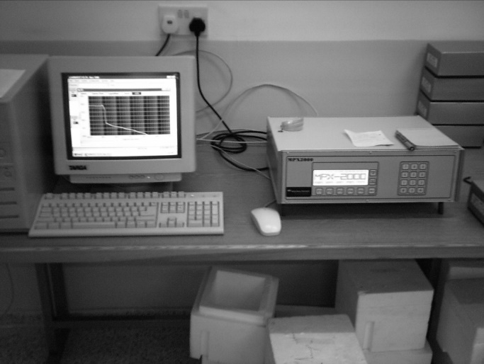

Figure 2. Data acquisition unit

**5. Equations**

Equations should be written using “Microsoft Word Equation Editor”. All Greek and Latin symbols in the equations must be typed in “Times New Roman” style.

$G_{i}=\left[1+\frac{ρK_{d}}{n}\right]λ_{i}c_{i}+\frac{ρK_{d}}{n}\frac{δc_{i}}{δt}$ (1)

Equations must be formatted to be “in-line-text” using default indentation of 1.27 cm, with the equation number aligned to the far right of the page width. As in the format of tables and figures, there should be 1 line space between equations and both preceding and following paragraphs.

The definition of each symbol or parameter in the equation can be given below the equation, after entering 1 line space.

**References**

References should be sorted by the surname of the first author. Numbering should not be used for references, and there should be no line space between subsequent references. References should be hanging indented (i.e. after the first line of each reference subsequent lines should be indented) 1 tab stop (use 0.5 cm for tab stop) from the left margin (see the examples below). References must be cited in the text with the author(s) last name and the date in parentheses—e.g.: (Fredlund and Rahardjo, 1993), (Fredlund and Rahardjo, 1993; Garrett, 2003; Ng, 2004; Kuhn, 2006). In the case of more than two authors, “et al.” should be used after the first author’s surname, e. g. (Aung et al., 1998).

Aung, K. K., Rahardjo, H., Leong, E. C. and Toll, D. G. (2001). Relationship between porosimetry measurement and soil-water characteristic curve for an unsaturated residual soil. *Geotechnical and Geological Engineering*, 19, 401-416.

Ng, T. T. (2004). Shear strength of assemblies of ellipsoidal particles. *Geotechnique*, 54(10), 659–669.

Kuhn, M. R. (2006). OVAL and OVALPLOT: Programs for analyzing dense particle assemblies with the discrete element method. Retrieved from*, http://faculty.up.edu/kuhn/oval/doc/oval 0618.pdf*

Garrett, D. L. (2003). Coupled analysis of floating production systems. *In Proceedings of International Symposium on Deep Mooring Systems*, ASCE, Reston, pp. 152-167.

Fredlund, D. G. and Rahardjo, H. (1993). *Soil Mechanics for Unsaturated Soils*. 2nd ed., New York, John Wiley and Sons Inc.