**Improvement of Strength of Unpaved Road by Using Jute Geotextile**

**Md. Humayun Kabir1, Laboni Gupta2**

*1Associate Professor, Department of Civil Engineering, KUET, Bangladesh (mhkabir@ce.kuet.ac.bd)*

*2Lecturer, Department of Civil Engineering, EUB, Bangladesh (*[*labonigupta20@gmail.com*](mailto:alim23@ruet.ac.bd)*)*

**Abstract**

This study illustrates the analysis of improving the strength of unpaved road by using jute geotextile of different thickness. To complete the task, 4 sets of CBR test had been conducted for the combination of soil only, soil-jute(type-1)-soil, aggregate-soil, aggregate-jute (type-2)-soil. At first organic soils were collected from Shiromoni and specific gravity, Atterberg limit, optimum moisture content, maximum dry density test of soil had been performed. Moreover, the values of mass per unit area, grab tensile strength, puncture resistance of jute geotextile were measured. From results it was found that there was an increase in the strength of soil due to the use of jute geotextile. While conducting the CBR tests well graded aggregate had been used as top layer because a finished road is only as good as the materials that form the riding surface and reduces soil loss from the surface of the road. The CBR value of soil was found 8.1% which was increased about 11% due to the use of jute(type-1) at the 4th layer of soil. Again, the CBR value of soil having aggregate on its top surface was 8.6% that was increased to 17% for using jute(type-2) at the interface of soil and aggregate.

***Keywords:*** *Unpaved road; Jute Geotextile; CBR test; Subgrade strength Improvement.*

**1. Introduction**

Many unpaved roads possess an even, wide, preserved surface with wide shoulders while others have cramped or no shoulders and rutted, loose, or washboard surfaces where vehicles may slide out of control due to a severely raveled surface. Unfortunately, these problems are often the worst where vehicles turn and brake, such as bends and crossing points where vehicle control is most calumniator.

The unpaved roads are the key to deal with the low volume traffic. Large deformations can take place in this type of road due to weak subgrade. To overcome these deformations, the soil of weak subgrade can be reinforced by using jute geotextile. JGT provides an effective and technically precise alternative to the rearranged granular filters. It restricts the relocation of soil grains and helps in developing natural graded filters by interaction with soil bed. Exchanging conventional inverted filters with JGT will preserve an ample amount of materials, time and money. Aggregates are allotted over JGT to prevent unswerving exposure to sunlight and water as well as to disseminate the thrust of wave actions. An unexpected alter from a paved to an unpaved surface creates a risk of skidding and losing control of the vehicle. So, the unpaved roads are reinforced by using jute geotextile.

**2. Methodology**

Organic soil was used in this regard and soil was collected from Shiromoni, Khulna at a depth of 5 feet from the existing ground. Samples were taken in large polythene bags and transported to the Geotechnical Engineering Laboratory of the department of Civil Engineering, Khulna University of Engineering and Technology, Khulna. The collected soil was dried in the sun for 7 days. Then it was pulverized manually by hammer. Later the soils were screened through the sieve of 4.75 mm aperture before preparing the specimen for testing.

**Flow diagram of the whole task is shown below:**

Collection of Disturbed soil samples

Drying the soil for 7 days and then crushed into powder form

Determination of physical Properties of soil samples

.

Sieved analysis of soil samples through sieve #4

Completion of compaction tests to obtain optimum moisture content and maximum dry density.

Preparation of samples for California bearing ratio(CBR) test and conducted the test for the combination of soil only, soil-jute-soil, aggregate-soil, aggregate-jute-soil.

Sieve analysis of aggregate

Testing the properties of jute geotextile

Figure-1. Flow diagram of the task

**Sample set up for soil:**

1. Sample set-up for soil only

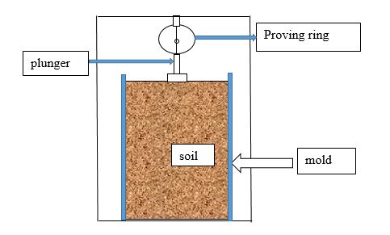

Figure-2. Sample setup for soil

1. Sample set-up for (soil-jute(type-1)-soil)

* During CBR test the jute was placed at 4th layer of each mold at a height of 24 mm from the top of the sample.

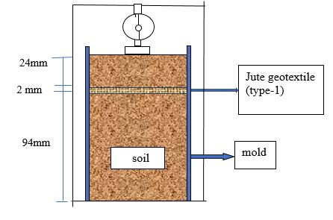

Figure-3. Sample setup for soil-jute(type-1)-soil

1. Sample set up for(aggregate-soil)

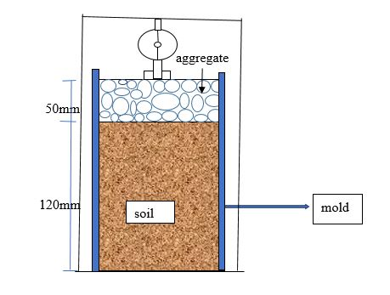

Figure 4. Sample setup for aggregate-soil

###### Sample set up for aggregate-jute(type-2)-soil

* before filling the free space of the mold by aggregate the jute was placed at the top level of soaked sample.

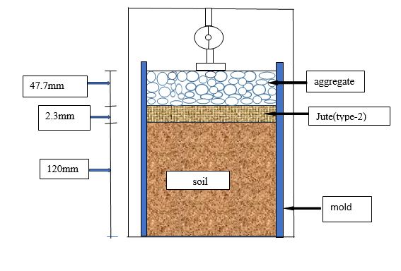

Figure 5. Sample setup for aggregate-jute(type-2)-soil

**3. Results & discussion**

Table 1. Determination of CBR values

|  |  |
| --- | --- |
| Combination | CBR values |
| Soil | 8.1 |
| Soil-jute (1)-soil | 11 |
| Aggregate-soil | 8.6 |
| Aggregate-jute (2)-soil | 17 |

From table 1. it can be visualized that, due to the use of jute geotextile the strength of subgrade soil has been improved significantly. The presence of jute layer imposes the development of an alternate failure surface thereby increasing the bearing capacity. Reduction in the transmission of shear stresses to the subgrade and by providing the vertical confinement outside the loaded area helps in improving the bearing capacity. Further, for quantifying the amount of increase in the penetration resistance, the reinforcement ratio is taken into remuneration. The reinforcement ratio (Koerner, 2005) at a particular penetration is,

Reinforcement ratio=load with geotextile/load without geotextile.

Based on the reinforcement ratio obtained for both soil-jute(1)-soil and aggregate-jute(2)-soil, the reinforcement ratio versus penetration curve is plotted-

Figure 6. variation of reinforcement ratio with penetration

Figure-6 shows that the reinforcement ratio for jute-2 is more jute-1, which indicates that the introduction of jute geotextile offers good resistance even to lower penetration. Further, the reinforcement ratio increases with an increase in the thickness of the jute. Hence the use of geotextile is the most advantageous in an unpaved road with soft subgrade at higher penetration.

**Refferences:**

Ayyar, T. S. R., and Dipu, V. S. (1997) Coir geotextiles as reinforcement in foundation, Proceedings of Coir Board Seminar on Coir geotextiles, Coimbatore.

Ayyar, T. S., and Girish, M. S. (2000) Improvement of durability of coir geotextiles, Proceedings of Indian Geotechnical Conference, Bombay.

Babu, K. (2007). Utilisation of Coir Geotextiles for unpaved roads and embankments. PhD Thesis, Cochin University of Science and Technology.

Baruah, U., Saikia, B., and Bora, P. (2010). Road Construction in Assam by Using Coir Mat., Indian

Datye, K., and Gore, V. (1994). Application of natural geotextiles and related products.

David Jones, “UNDERSTANDING UNPAVED ROAD MATERIAL PERFORMANCE-INTERPRETATION” PhD University of California Pavement Research Center.

Dey, A., and Meena, S. (2013). Gesoynthetic reinforced unpaved road resting on c- subgrade. Indian Geotechnical Conference, Roorkee.

Dr. P. Senthill Kumar, R. Rajkumar “EFFECT OF GEOTEXTILE ON CBR STRENGTH OF UNPAVED ROAD WITH SOFT SUBGRADE” Vol.17[2012],Bund,J

Dutta, R., and Rao, G. V. (2008). Potential of Coir Based Products as Soil Reinforcement. International Journal of Earth Sciences and Engineering, pp 71–79.

Fannin, R., and Sigurdsson, O. (1996). Field observations on stabilization of unpaved roads with geosynthetics. Journal of Geotechnical Engineering, American Society of Civil Engineers, Vol: 122, No. 7, pp 544–553.

G. Huntington and K. Ksaibati, Gravel Roads Management, Volume 1 (University of Wyoming: October 2010).

G. Huntington and K. Ksaibati, Gravel Roads Management: Implementation Guide, Volume 2 (University of Wyoming: October 2010).

G. Huntington, “Road Geometry, Surface Materials Are Key to Safety on Gravel Roads,” Safety Compass Newsletter, 6:2 (6) Fall 2012.

Geomembranes, Elsevier, Vol: 13, No. 6, pp 371–388.

Geotechnical Conference, Geotrendz, IIT Bombay.

Kabir, M. H., Zakaria, M., Abedin, M. Z., and Saha, G. P. (1989). Jute fabric reinforced unpaved road design. Construction and Building Materials, Elsevier, Vol: 3, No. 3, pp 140–144.

Kumar, P. S., and Rajkumar, R. (2012). Effect of Geotextile on CBR Strength of Unpaved Road with Soft Subgrade. EJGE, Vol. 17, pp 1355-1363.