Final Examination
Program: Enhancing Digital Government Economy (EDGE) Course: Applied Penetration Testing Engineer: Hands-on Batch: CADS003
Name: Md Joynal Abedin Rakin

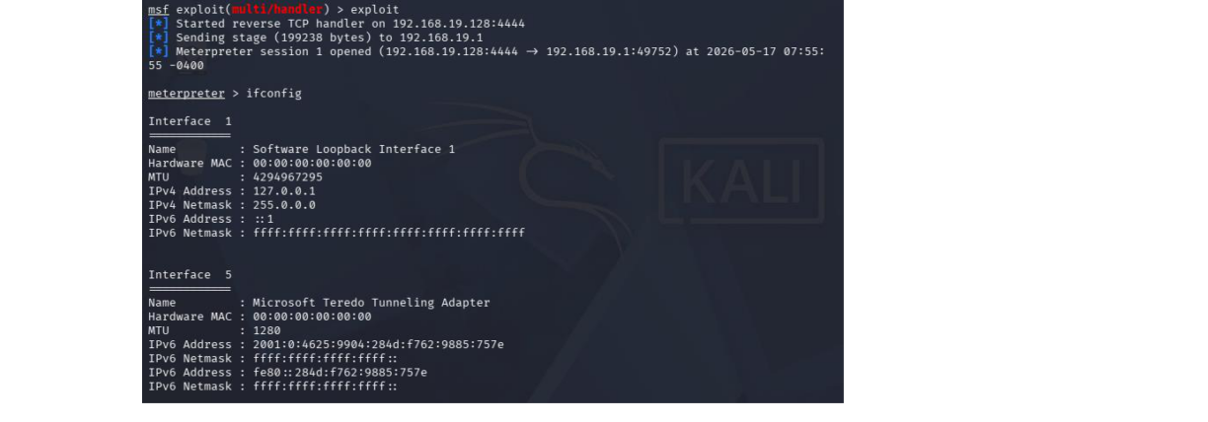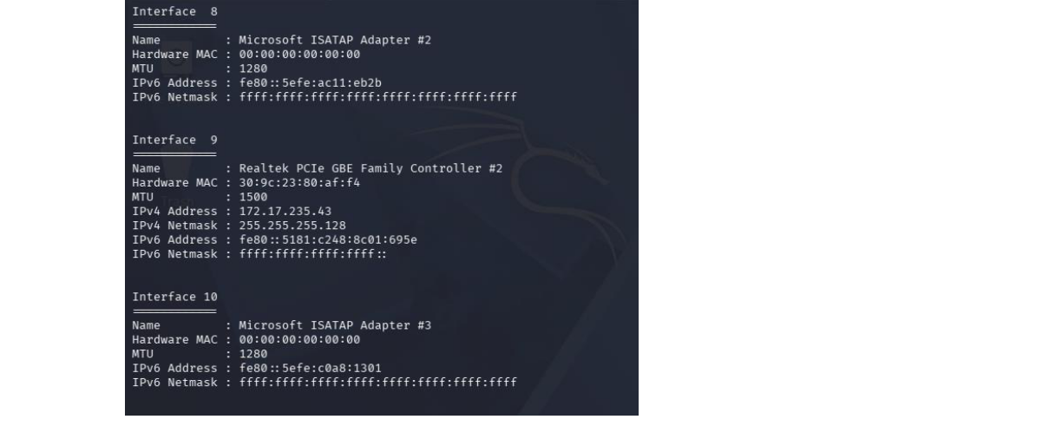
Scenario No.1

Phase-1:
After Gaining Access of Windows 10, To Know all Hidden internal IP Address We can use :
>ipconfig Result:

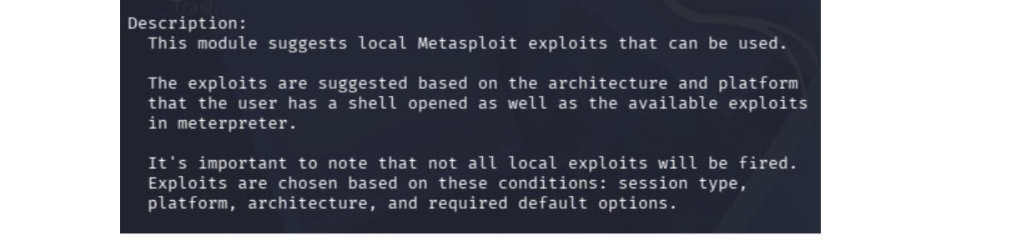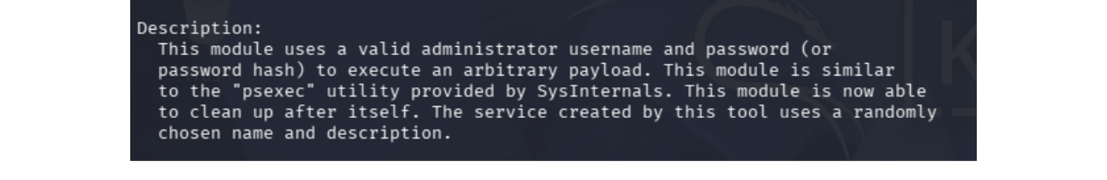
Phase-2:
Metasploit post-module can you use to suggest potential exploits for escalating is:
local_exploit_suggester

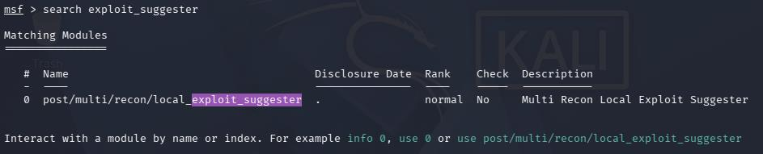

Phase-3:
Metasploit module allows you to use the hash itself to authenticate to other machines is:
exploit/windows/smb/psexec
This Module can be used to use Hash itself to authenticate Other Machine.

Phase-4:
which auxiliary module can you run to perform a TCP port scan on Target 2 is:
scanner/portscan/tcp

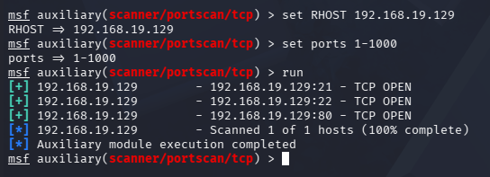

Scenario No.2 Phase-1:
$1$ prefix indicate MD5-Crypt Hashing Algorithm and the command that will show the cracked
password if the session already over will be:
john --show export.txt
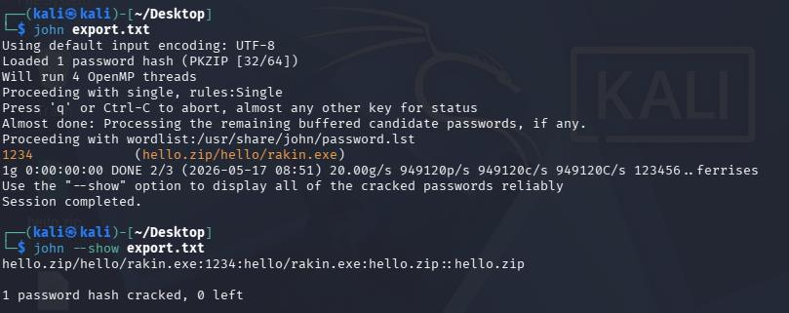

Phase-2:
Hydra command to target the SSH service for user custom username list using custom password list, ensuring you use 4 parallel tasks WOULD BE:
hydra -L user.txt -P pass.txt -T 4 ssh://192.168.19.129

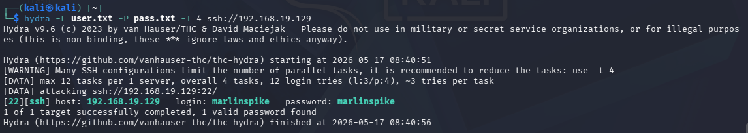

Phase-3:
salt is just a random data that is added to a password before hashing to make sure each hash is unique which makes rainbow table attacks ineffective.

Scenario No.3 Answers:-> Question-1:
Wireshark filter that is most effective for isolating the username and password sent via an unencrypted web form would be:
http.request.method == "POST"
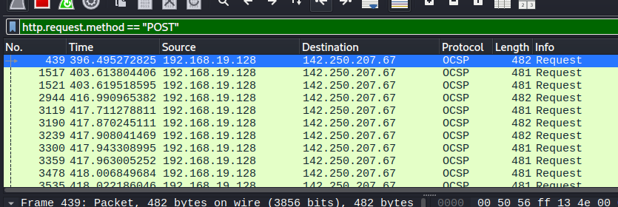

Question-2:
Encoding method that we view the plaintext within wireshark :
Follow→HTTP Stream (right-click the packet→Follow→HTTP Stream)

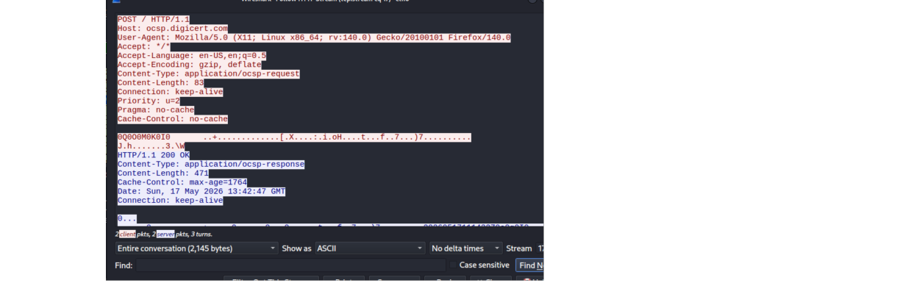

Question-3:
The packet type is called a Gratuitous ARP. It indicates that a host is broadcasting ARP information without being requested.
Question-4:
Wireshark feature that shows an entire FTP session in one window would be:
Follow→HTTP Stream (right-click the packet→Follow→HTTP Stream)

