ASSIGNMENT 1

CSA0593-DBMS

-192324289

RAKINA S

QUESTION:

Banking System Database with Transaction Management

Create a relational database to manage banking operations, including accounts, transactions, loans, and customer details.

Requirements:

* Design tables for customers, accounts, transactions, and loan processing, with appropriate primary and foreign keys.
* Implement stored procedures for deposit, withdrawal, and loan processing with transaction rollback in case of errors.
* Develop SQL queries for reporting monthly transactions, loan approvals, and account balances.
* Implement ACID properties to ensure reliable transaction management, and test using various failure scenarios.

1. **Customers Table**

**This table stores information about each customer.**

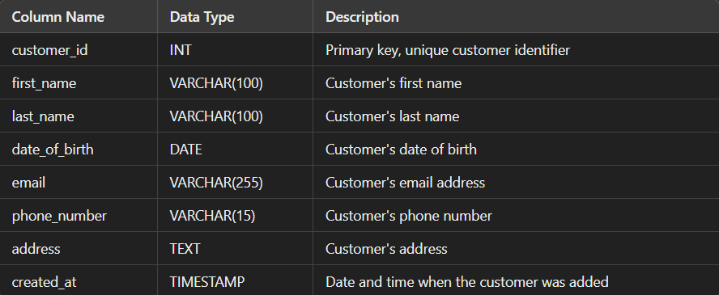

2.Account Table

This table stores information about each account held by a customer.

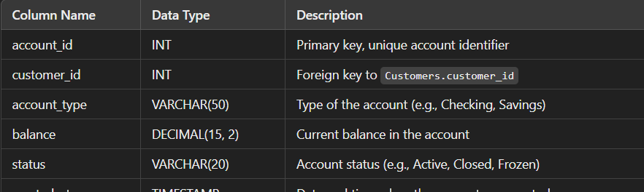

**Relationships:**

* Accounts.customer_id references Customers.customer_id (one-to-many: one customer can have many accounts).

3.Transaction Table

This table stores information about all transactions made on accounts.

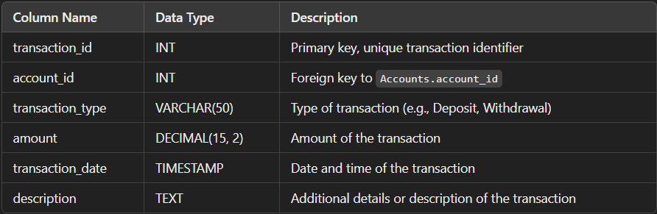

**Relationships:**

* Transactions.account_id references Accounts.account_id (one-to-many: one account can have many transactions).
* 4.Loan Table

This table stores details about loans given to customers.

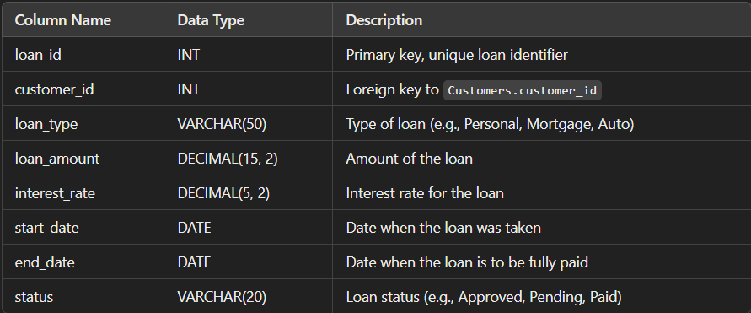

**Relationships:**

* Loans.customer_id references Customers.customer_id (one-to-many: one customer can have many loans).

5.Loan Payments Table

This table stores information about payments made towards loans.

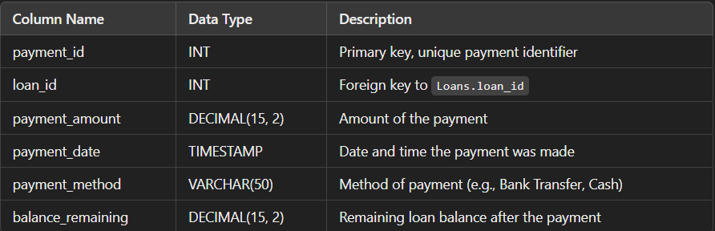

**Relationships:**

* Loan Payments.loan_id references Loans.loan_id (one-to-many: one loan can have many payments).

6.Account Managers Table

This table stores information about bank employees who manage accounts and customer relationships.

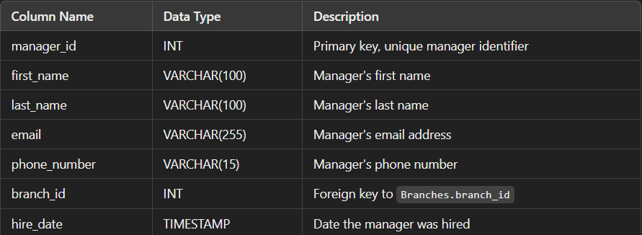

**Relationships:**

* Account Managers.branch_id references Branches.branch_id (one-to-many: one branch can have many account managers).

SQL QUERIES:

1. **Monthly Transactions Report**

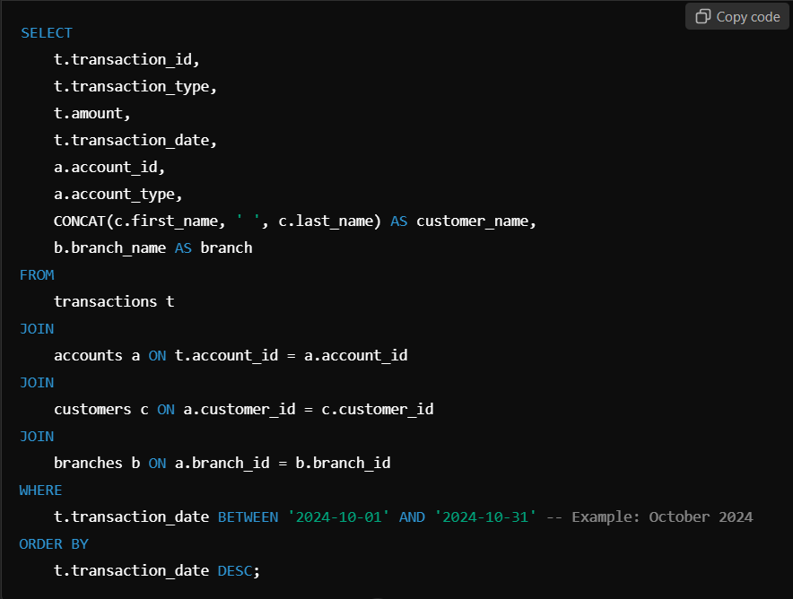

1. **Loan Approvals Report**

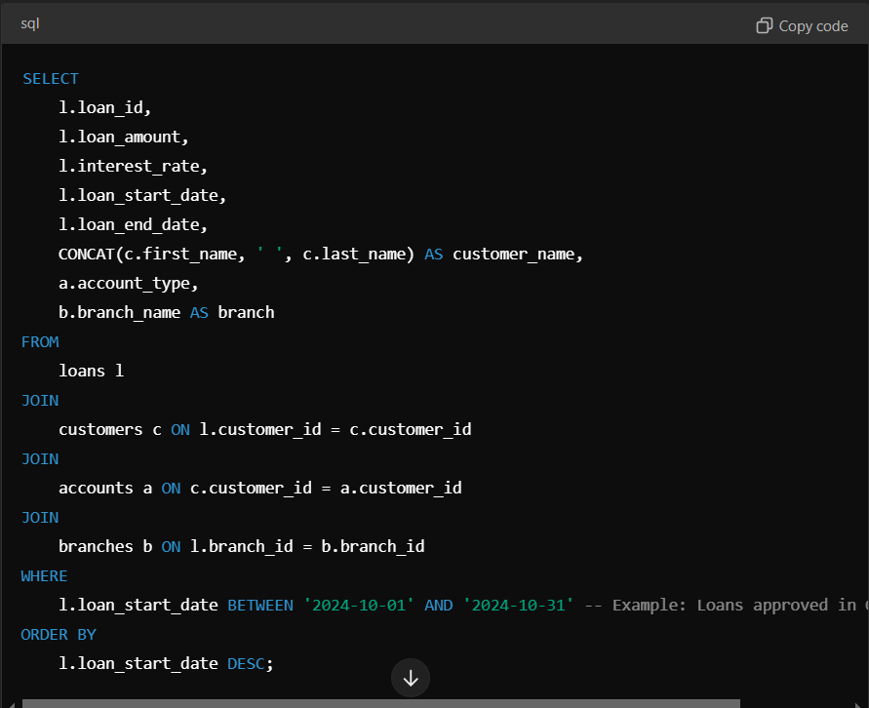

1. **Account Balances Report**

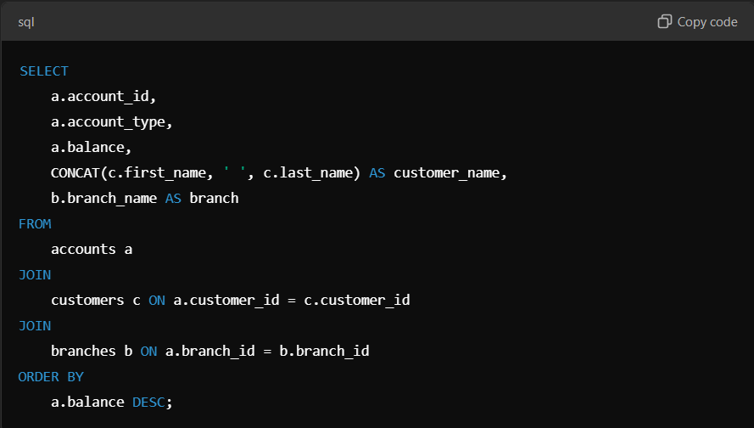

Implementing ACID Properties in SQL:

* 1. **Atomicity**

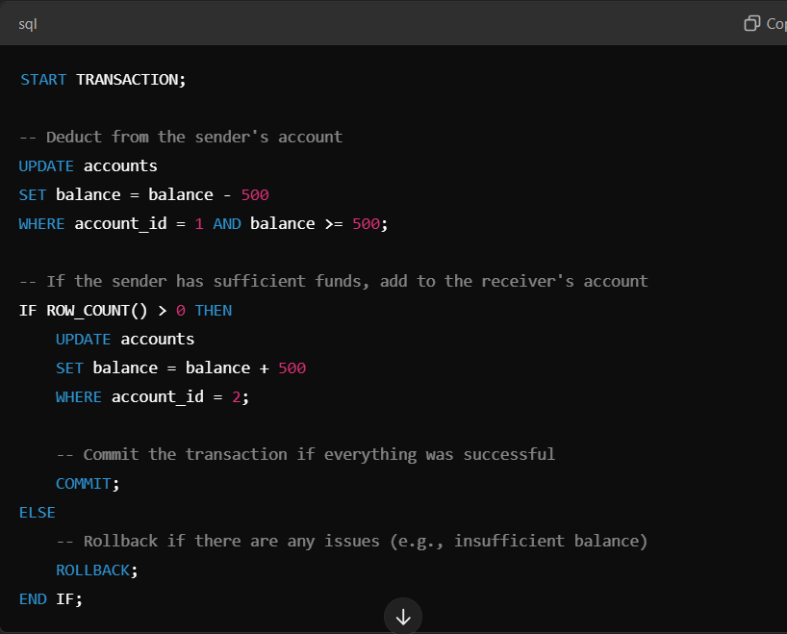

**2.Consistency**

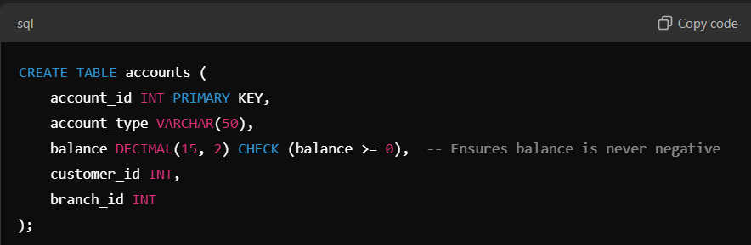

**3.Isolation**

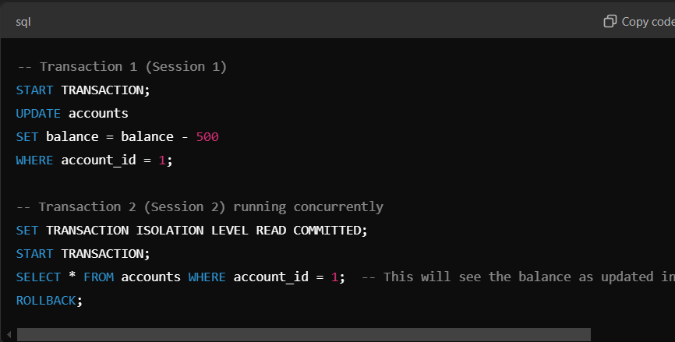

Testing ACID Properties Using Failure Scenarios:

