
EDGE VISION GUARD: REAL-TIME SAFETY & DEFECT ANALYTICS SYSTEM

A CAPSTONE PROJECT REPORT

A Capstone Project Report submitted in partial fulfilment of the requirements for the Course of

DSA0202 - COMPUTER VISION WITH OPENCV

to the award of the degree of
BACHELOR OF TECHNOLOGY
IN
ARTIFICIAL INTELLIGENCE & DATA SCIENCE

Submitted by
Rakina S (192324289)
Harisha S (192324300)
Anipakala Mahesh (192424139)

Under the Supervision of
Dr M Mayuranathan

SIMATS ENGINEERING
Saveetha Institute of Medical and Technical Sciences Chennai-602105

SEPTEMBER 2026
SIMATS ENGINEERING
Saveetha Institute of Medical and Technical Sciences
Chennai-60210

BONAFIDE CERTIFICATE

This Is To Certify That The Capstone Project Entitled “Edge Vision Guard: Real-Time Safety & Defect Analytics System” Has Been Carried Out By Rakina S (192324289), Harisha S (192324300) & Anipakala Mahesh (192424139) under the supervision of Dr M Mayuranathan and is submitted in partial fulfilment of the requirements for the current semester of the B.Tech Artificial Intelligence & Data Science program at Saveetha Institute of Medical and Technical Sciences, Chennai.

COURSE COORDINATOR COURSE FACULTY
Dr.A.Narenthirakumar,
Professor,
Department of Intelligent Computing,
SIMATS Engineering,
SIMATS, Chennai – 602105.

Dr.M.Mayuranathan
Professor,
Department of Cognitive Computing,
SIMATS Engineering,
SIMATS, Chennai – 602105.

SIMATS ENGINEERING
Saveetha Institute of Medical and Technical Sciences
Chennai-602105

DECLARATION
We, Rakina S (192324289), Harisha S (192324300) & Anipakala Mahesh (192424139), SIMATS Engineering, Saveetha Institute of Medical and Technical Sciences, Chennai, hereby declare that the Capstone Project Work entitled “Edge Vision Guard: Real-Time Safety & Defect Analytics System” is the result of our own bonafide efforts. To the best of our knowledge, the work presented herein is original and has been carried out in accordance with engineering ethics and academic integrity. All sources, references, datasets, software libraries and external materials used in the project have been appropriately acknowledged. We further declare that the visualizations, analytical results and implementation descriptions presented in this report have not been knowingly fabricated or misrepresented. Any external tools, open-source libraries and AI-assisted resources used during development have been disclosed where applicable. We confirm that applicable academic, institutional and professional requirements have been followed throughout the planning, implementation, testing and documentation of the project.

Place:
Date:

Signature of the Students with Names

SIMATS ENGINEERING
Saveetha Institute of Medical and Technical Sciences
Chennai-60210

Individual Contribution Statement

Student Name/ Register No.  Student Name/ Register No. | Specific  Responsibilities  Specific  Responsibilities | Design & Development  Contribution  Design & Development Contribution | Testing & Analysis  Contribution  Testing & Analysis  Contribution | Report  Contribution  Report Contribution | Approx.  Contribution (%)  Approx.  Contribution (%)
Rakina S  (192324289) | Module 3 – Real-Time Analytics & Visualization | Analytics logic, KPI design, dashboard and chart integration | Verification of counts, trends, alerts and dashboard outputs | Module 3 design, implementation, results and reflection | 34%
Harisha S  (192324300) | Module 1 – Image/Video Preprocessing & Object Detection | Frame preprocessing and object-detection workflow | Preprocessing and detection output checks | Module 1 background and supporting sections | 33%
Anipakala Mahesh  (192424139) | Module 2 – Safety & Defect Detection | Safety-event and defect-detection workflow | Detection and classification validation | Module 2 analysis and integration sections | 33%

ABSTRACT

Edge Vision Guard is a computer-vision-based system designed to process camera, video and image data for real-time safety monitoring and product-defect analytics. The overall system combines image/video preprocessing, object detection, safety and defect detection, and real-time analytics in a unified workflow. This report focuses mainly on Module 3 – Real-Time Analytics & Visualization, which converts detection outputs into understandable metrics, comparisons, trends, alerts and dashboard views. The module receives detected events from the earlier stages, maintains running counts, groups results by category and presents the information through dashboard KPIs and charts. It also helps users monitor safety events and defect conditions continuously by providing summarized visual information instead of requiring manual analysis of individual detection results. The analytics module supports comparison of different defect categories, identification of safety-event trends and quick interpretation of changing conditions. It is intended to reduce the effort required to interpret continuous visual-inspection results and to support faster, data-driven decisions. The implementation uses Python-based processing with OpenCV, together with analytical and visualization tools such as Pandas and Matplotlib, while the web interface provides a convenient presentation layer. The module demonstrates how raw computer-vision detections can be transformed into concise analytical information that is easier to monitor, compare and review. Overall, the system provides a unified and user-friendly approach for presenting real-time safety and defect information through meaningful analytics and visualization.
Keywords:
Computer Vision; OpenCV; Real-Time Analytics; Safety Monitoring; Defect Detection; Dashboard; Data Visualization.

TABLE OF CONTENTS

Sl.  No  No | Title | Page  No  No
i | CERTIFICATE FROM THE SUPERVISOR | ii
ii | DECLARATION BY THE CANDIDATE | iii
Iii | INDIVIDUAL CONTRIBUTION STATEMENT | iv
iv | ABSTRACT | v
v | LIST OF FIGURES | vi
vi | LIST OF TABLES | vii
vii | LIST OF ABBREVIATIONS / SYMBOLS | viii
1 | CHAPTER 1: Introduction | 10
2 | CHAPTER 2: Literature Review | 13
3 | CHAPTER 3: Engineering Design & Trade-offs, Sustainability, Ethics, Safety, Risk & Security  Ethics, Safety, Risk & Security | 15
4 | CHAPTER 4: Implementation, Testing & Results, Project Management  Management | 22
5 | CHAPTER 5: Conclusion & Reflection | 31
 | References | 34
 | Appendices | 35

LIST OF FIGURES

Figure No. | Figure Name | Page No.
Figure 1.1 | Overall Edge Vision Guard system context | 12
Figure 3.1 | Real-time analytics and visualization architecture | 19
Figure 4.1 | Real-time monitoring dashboard | 24
Figure 4.2 | KPI summary visualization | 24
Figure 4.3 | Defect and safety category comparison | 25
Figure 4.4 | Live alerts and analytics trend view | 26
Figure 4.5 | Final analytics visualization output | 26
Figure 5.1 | Final Edge Vision Guard dashboard evidence | 31

LIST OF TABLES

Table No. | Table Name | Page No.
Table 1.1 | Project objectives | 11
Table 2.1 | Review of existing computer-vision approaches | 14
Table 3.1 | Stakeholder and functional requirements | 15
Table 3.2 | Non-functional requirements | 15
Table 3.3 | Constraints and applicable standards | 16
Table 3.4 | Design specifications | 17
Table 3.5 | Alternative solution evaluation | 18
Table 3.6 | Trade-off analysis | 20
Table 3.7 | Sustainability, ethics, safety and security | 20
Table 3.8 | Risk register | 21
Table 4.1 | Implementation resources | 22
Table 4.2 | Test plan and acceptance criteria | 27
Table 4.3 | Verification results | 27
Table 4.4 | Objective achievement | 28
Table 4.5 | Project roles and contribution | 30
Table 4.6 | Budget | 30

LIST OF ABBREVIATIONS / SYMBOLS

Symbol | Description | Unit / Use
AI | Artificial Intelligence | –
CV | Computer Vision | –
OpenCV | Open Source Computer Vision Library | Vision processing
KPI | Key Performance Indicator | Dashboard metric
FPS | Frames Per Second | Video rate
YOLO | You Only Look Once | Object detection
ROI | Region of Interest | Image area
API | Application Programming Interface | Software interface
UI | User Interface | Web presentation
CSV | Comma-Separated Values | Data format
JSON | JavaScript Object Notation | Data format
ML | Machine Learning | Detection/analytics context

CHAPTER 1
INTRODUCTION AND ENGINEERING PROBLEM

1.1 Background
Computer vision enables software systems to extract useful information from images and video streams. In industrial and workplace environments, cameras can continuously produce visual data that contains information about people, products, equipment and safety conditions. Manual observation of such streams can become difficult when the volume of data is high or when an event must be identified quickly. Edge Vision Guard addresses this challenge by combining visual processing, detection and analytics in one workflow. The first stages prepare frames and identify relevant objects or events, while the third module converts those detection results into numerical and visual information that can be monitored in real time.

1.2 Need for the Module
Module 3 is required because detection results alone do not provide an efficient overview when many events are produced over time. A sequence of individual detections needs to be summarized into counts, categories and trends so that a user can understand the current condition of the monitored scene. The analytics layer therefore acts as the interpretation stage between computer-vision output and human decision-making. It provides a compact dashboard while retaining enough detail to compare defect categories, inspect safety-event frequency and identify changes over time.
- Operators need a direct view of current safety and defect conditions instead of reviewing every frame individually.
- Project evaluators need measurable outputs such as total detections, safety-event counts and defect counts.
- Developers need a structured method for aggregating detection results and passing them to visual components.
- Charts and dashboard KPIs reduce the effort required to interpret repeated detection events.
- The engineering significance lies in converting real-time vision output into usable analytical information.

1.3 Problem Statement
The engineering problem is to design and implement a real-time analytics and visualization module that can receive computer-vision detection results, calculate meaningful safety and defect statistics, compare categories, monitor trends and present the information through an understandable web dashboard. The solution must remain responsive while handling continuously changing results. It must also distinguish between different event categories, avoid misleading summaries, handle empty or incomplete detection data and present alerts clearly enough for the user to identify important conditions.

1.4 Aim
To develop a real-time analytics and visualization module that transforms safety and defect detection results into dashboard KPIs, category comparisons, time-based trends and visible alerts for faster and data-driven monitoring.

1.5 Objectives
- To collect and organize detection outputs produced from camera or video analysis.
- To calculate real-time counts for detected objects, safety events and product defects.
- To group detected issues into meaningful safety and defect categories.
- To compare categories using charts and concise dashboard indicators.
- To analyze safety-event and defect trends across observation intervals.
- To present alerts and analytical results in an easy-to-understand interface.
- To test the consistency of calculated metrics and visual outputs using representative detection data.

Objective | Measurable Evidence
O1 | Detection results are accepted and organized for analytics.
O2 | Safety, defect and total detection counts are calculated.
O3 | Events are grouped into defined categories.
O4 | Category comparison and KPI charts are displayed.
O5 | Time-based safety and defect trends are visualized.
O6 | Dashboard alerts and analytical summaries are presented.
O7 | Representative test cases verify metric and visualization consistency.

Table 1.1 – Project objectives

1.6 Scope
The scope of this report is centered on Module 3 – Real-Time Analytics & Visualization of the Edge Vision Guard system. It covers the organization of detection results, calculation of safety and defect counts, category comparison, trend analysis, dashboard KPIs, charts and alert presentation. Modules 1 and 2 are treated as upstream sources that provide the visual detections required by the analytics layer. The report does not claim to replace the underlying detection model or to provide a complete industrial control system.
- Included: detection-result aggregation, safety and defect counts, category comparison, trend analysis, KPI cards, charts and alerts.
- Excluded: hardware fabrication, sensor design, full industrial control, and independent claims of detection-model accuracy.
- Assumption: upstream modules provide structured detection results with identifiable categories and event information.
- Boundary condition: the usefulness of analytics depends on the quality and consistency of the detection results supplied to the module.

1.7 Expected Engineering Outcome
The expected outcome is a reusable analytics component that accepts continuous or repeated detection results and presents them as an understandable monitoring view. A user should be able to see current totals, compare issue categories, inspect trends and identify alerts without manually calculating statistics from individual detections. The result should support both quick monitoring and later review by keeping the analytical information organized and visually consistent.
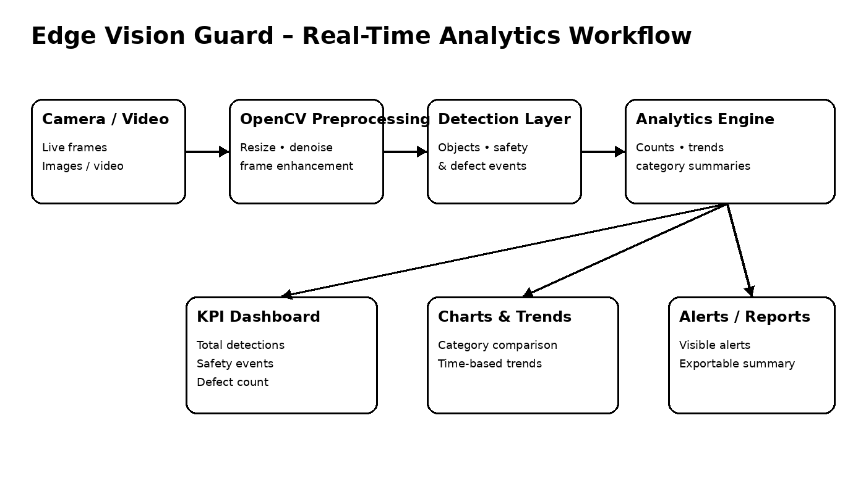
Figure 1.1 – Overall Edge Vision Guard system context

CHAPTER 2
LITERATURE REVIEW AND EXISTING SOLUTIONS

2.1 Review Method
The review was organized around the major ideas represented in the project presentation: computer-vision preprocessing, object detection, safety monitoring, defect detection and visual analytics. Particular attention was given to the final stage of the workflow because Module 3 depends on transforming detection events into information that a user can interpret. The review therefore considers the difference between systems that only detect objects and systems that also summarize, compare and visualize the resulting events.

2.2 Review of Existing Work
Computer-vision solutions commonly begin with image or video preprocessing before applying object-detection or classification methods. Safety-monitoring applications can use detected people, equipment or conditions as the basis for identifying events, while defect-analysis applications group abnormal product conditions into categories. A further analytics layer is useful because a stream of detections is difficult to interpret without aggregation. Dashboard-oriented approaches address this issue by converting event records into counts, comparisons, trends and alerts. The Edge Vision Guard design follows this layered idea and places real-time analytics after detection so that the presentation layer remains focused on interpretation rather than repeating vision-processing operations.
Existing Approach | Advantages | Limitations | Relevance to Proposed Work
Manual visual inspection | Direct human judgment and flexible observation. | Slow for continuous streams and dependent on operator attention. | Motivates automated monitoring and summarized analytics.
Basic object detection | Identifies objects or classes in individual frames. | Individual detections do not provide a high-level trend view. | Supplies the event data used by Module 3.
Automated defect detection | Can identify abnormal or defective products consistently. | Large numbers of results still require summarization. | Provides defect categories for comparison.
Safety-event monitoring | Supports identification of safety-related conditions. | Repeated events may be difficult to interpret without historical context. | Provides safety-event data for trend analysis.
Dashboard-based analytics | Combines KPIs, charts and alerts in one view. | Quality depends on correct upstream data and meaningful metric design. | Directly motivates Module 3.
Table 2.1 – Review of existing approaches

2.3 Comparative Analysis
The proposed analytics module is distinguished by connecting computer-vision detection output directly to an analytical dashboard. Instead of presenting only bounding boxes or isolated classifications, it calculates counts, groups results by category and exposes trends over time. This provides two levels of interpretation: KPI cards give a rapid overview, while charts and alert records provide more detail. The approach is suitable for a project where the main objective is to turn real-time visual detections into understandable safety and defect information.

2.4 Engineering Gap
The engineering gap identified from the project framing is the separation between detection and interpretation. A detection system can identify an object or event, but an operator still needs a compact method to understand how many events have occurred, which categories are most common and whether safety conditions are changing. A unified analytics layer addresses this gap by maintaining summary values and presenting them through charts, KPIs and alerts within the same monitoring workflow.

2.5 Proposed Contribution
The proposed contribution is a real-time analytics and visualization layer integrated with the Edge Vision Guard pipeline. It receives detection results from the preceding stages, calculates summary statistics, groups events into categories, generates trend information and renders the results through a dashboard. The module emphasizes clarity: the user should be able to understand the current state quickly while still having access to category and trend information for comparison.

CHAPTER 3
ENGINEERING DESIGN, TRADE-OFFS, ETHICS, SAFETY, RISK & SECURITY

3.1 Requirements
Stakeholder | Requirement
Operator / Monitor | View current safety and defect conditions without manually counting events.
Course Faculty | Demonstrate how computer-vision results are converted into measurable analytics.
Project Evaluator | Verify counts, charts, alerts and dashboard outputs.
Developer / Maintainer | Receive structured detection data and keep analytics logic separate from presentation.
General User | Understand the current condition and major event categories from the dashboard.

3.1.1 Functional Requirements
Requirement | Measurable Target
Receive detection results | Structured event information is available to the analytics layer.
Calculate counts | Total detections, safety events and defects are displayed.
Compare categories | Category-wise counts can be visualized.
Analyze trends | Safety and defect activity can be shown over time.
Display dashboard KPIs | Key metrics are visible in compact cards.
Present alerts | Important events are shown with time and category information.
Update visualization | Dashboard values reflect newly processed detection data.

Table 3.1 – Stakeholder requirements and Functional requirements

3.1.2 Non-Functional Requirements
Requirement | Target
Reliability | Analytics should not silently fail when detection data is empty or incomplete.
Usability | Major metrics and visualizations are grouped into understandable sections.
Responsiveness | Dashboard updates should remain usable during continuous monitoring.
Table 3.2 – Stakeholder requirements and Non Functional requirements

3.2 Constraints & Applicable Standards
The project is a software-based computer-vision application. The main constraints are therefore related to processing time, data quality, browser responsiveness, visualization clarity and software maintainability. The system depends on camera or video input and on the quality of the detection results supplied by the earlier modules. OpenCV is used in the project context for computer-vision processing, while analytical and plotting tools support the conversion of results into summaries and visual displays. The supplied project materials do not claim formal certification to an industry-specific safety standard, so the report treats the listed conventions as engineering guidance rather than certification.
Standard / Code / Convention | Requirement | How Applied in This Project
ISO/IEC/IEEE 29148 – Requirements Engineering | Requirements should be clear, traceable and verifiable. | Functional requirements are linked with tests and expected dashboard evidence.
ISO/IEC 25010 – Software Quality Model | Consider usability, reliability, maintainability and security. | The design separates analytics and presentation and provides visible error states.
JSON data interchange convention | Use structured machine-readable event fields. | Detection results can be represented using fields such as category, count and timestamp.
HTTP/REST-style API convention | Separate client presentation from server processing where applicable. | The web layer can receive structured analytics data from a backend service.
Table 3.3 – Constraints and applicable standards/conventions

3.3 Design Specifications
Parameter | Target /  Requirement | Unit | Priority
Input detection data | Receive structured detection/event records. | Record | High
KPI calculation | Calculate total detections, safety events and defects. | Count | High
Category analysis | Group events by safety and defect category. | Category | High
Trend analysis | Maintain observation-based counts for comparison. | Time interval | High
Visualization | Provide charts, KPI cards and alert information. | View | High
Responsiveness | Keep dashboard controls and results readable during updates. | UI | Medium
Error handling | Handle empty, incomplete or unavailable data visibly. | Status | High
Responsiveness | Controls and results should remain usable in browser interface | UI | Medium

Table 3.4 – Design specifications

3.4 Alternative Solutions & Evaluation
Alternative 1: A command-line analytics program could calculate counts and print summary values. It would be lightweight and easy to test, but it would provide limited visual comparison and would be less convenient for continuous monitoring.
Alternative 2: A static report could present precomputed charts and example results. It would be simple to demonstrate but would not respond dynamically to new detection events or changing safety conditions.
Alternative 3: The selected interactive dashboard combines structured analytics with a browser-based presentation layer. It supports KPI cards, charts and alert views while allowing the underlying analytics logic to remain separate from the interface.
Criterion | Weight | Alternative 1  CLI | Alternative 2  Static Report | Alternative 3  Interactive Dashboard
Performance | 25% | 4 | 5 | 4
Cost | 15% | 5 | 5 | 4
Safety | 10% | 5 | 5 | 5
Sustainability | 15% | 5 | 5 | 4
Reliability | 20% | 4 | 3 | 4
Usability /  Monitoring | 15% | 2 | 3 | 5

Table 3.5 – Alternative solution evaluation (qualitative engineering score, 1–5)

3.5 Selected Design & Detailed Design
The interactive dashboard architecture was selected because it provides a practical balance between continuous monitoring and readable analysis. Detection results are received from the upstream computer-vision stages and passed to an analytics layer. The analytics layer aggregates counts, category information and trend values. The presentation layer then renders these results as KPI cards, comparison charts, trend plots and alerts. Keeping these responsibilities separate makes it easier to test the calculations independently from the user interface and also supports future changes to the visualization design.

Figure 3.1 – Real-time analytics and visualization architecture
The main data path is: camera/video input → preprocessing → object and event detection → analytics aggregation → KPI and chart generation → dashboard and alerts. The analytics engine is responsible for converting event records into measurable information, while the interface focuses on presenting the result. This separation reduces duplicated calculations in the UI and provides a clear path for future extensions such as historical reports or additional categories.

Essential Engineering Calculation / Complexity
For a simple event-aggregation pass, each detection record is examined once and contributes to one or more counters or category totals. If n detection records are processed and each record requires constant-time updates, the aggregation stage is approximately O(n). Trend storage also grows with the number of retained observation intervals. Chart rendering adds a presentation cost that depends on the number of displayed points, but it does not change the basic linear nature of the aggregation step. These are design-level complexity observations rather than controlled performance benchmarks.

3.6 Trade-off Analysis
Design Decision | Alternative Considered | Benefit | Disadvantage | Final Decision & Justification
Real-time KPI cards | Text-only summary | Provides immediate status at a glance. | Requires additional UI space. | Selected because quick monitoring is a core Module 3 objective.
Category charts | Raw event list only | Makes frequent categories easier to compare. | Needs chart rendering and labels. | Selected to simplify comparison of defect and safety categories.
Trend visualization | Current count only | Shows whether event frequency is changing. | Requires time-based aggregation. | Selected because safety trends are explicitly part of the module.
Visible alerts | Silent background logging | Highlights important events immediately. | Can become noisy if poorly designed. | Selected with concise event labels and timestamps.
Structured analytics data | Direct UI-only calculations | Improves maintainability and testing. | Requires a defined data structure. | Selected so calculations remain consistent across visual components.
Table 3.6 – Trade-off analysis

3.7 Sustainability, Ethics, Safety, Risk & Security
Domain | Consideration | Evidence Evaluated | Impact on Final Decision
Sustainability | Reduce repeated manual inspection and manual counting. | Reusable digital analytics and visualization of detection results. | Favoured an automated dashboard and reusable calculations.
Ethics | Avoid presenting uncertain detection results as absolute facts. | Dashboard labels and source-stage dependency are made explicit. | Supports transparent interpretation of computer-vision outputs.
Health & Safety | The software supports safety monitoring but does not physically control equipment. | No hardware actuation or hazardous laboratory process is part of the supplied system. | Analytics are presented as monitoring support rather than a safety guarantee.
Security | Limit collected information to what is needed for analytics. | The system can operate on detection metadata rather than personal records. | Reduces unnecessary data exposure.
Table 3.7 – Sustainability, ethics, safety and security
Ethically, the system should be used as a monitoring and analytical aid rather than as an unquestionable authority. A detected safety event or defect is dependent on the accuracy of the upstream computer-vision process, so the dashboard should not imply certainty beyond the available evidence. From a safety perspective, the supplied project is software-oriented and does not directly operate machinery. From a security perspective, the analytics layer can be limited to event metadata such as category, count and time, reducing unnecessary collection of personal information.

Risk Register
Risk | Likelihood | Severity | Risk Level | Mitigation | Residual Risk
Missing or empty detection data | Medium | High | High | Validate input and display an explicit empty-data state. | Low
Incorrect category aggregation | Medium | Medium | Medium | Use consistent category labels and tested aggregation rules. | Low
Rapid data updates | Medium | Medium | Medium | Limit unnecessary redraws and keep displayed metrics concise. | Low–Medium
Dashboard unavailable | Medium | Medium | Medium | Show communication or data-source error information. | Low
Misinterpretation of charts | Medium | Low | Medium | Use clear labels, units and chart titles. | Low
Large historical data volume | Low–Medium | Medium | Medium | Retain only required intervals for the active dashboard. | Low–Medium
Unnecessary data exposure | Low | High | Medium | Restrict analytics data to required event metadata. | Low

Table 3.8 – Risk register

CHAPTER 4
IMPLEMENTATION, TESTING & RESULTS

4.1 Development Approach
The implementation follows a modular computer-vision and analytics workflow. Camera or video frames are first prepared by the upstream preprocessing stage and relevant objects or safety/defect events are detected. Module 3 then receives these results and performs aggregation, category grouping and trend preparation. The resulting values are passed to dashboard components that display KPIs, charts and alerts. Python is used for the project processing context, with OpenCV supporting vision operations and Pandas/Matplotlib supporting data handling and visualization where applicable.
Resource | Purpose | Stage Used
Python | Core application and analytics logic | All stages
OpenCV | Image/video processing and computer-vision operations | Preprocessing / detection
Pandas | Organize and summarize detection records | Analytics
Matplotlib | Generate analytical charts and trend plots | Visualization
YOLO | Real-time object detection approach referenced by the project | Detection
Web interface | Present KPIs, charts and alerts | Analytics presentation
VS Code / development environment | Source editing, testing and integration | All stages

Table 4.1 – Implementation resources

4.2 Hardware / Software / Fabrication Implementation & Modern Tools Used

4.2.1 Software Implementation
The analytics module accepts structured detection information and converts it into summary values. A practical record can contain an event category, event type, timestamp and confidence or other metadata supplied by the detection stage. The analytics routine updates total detections, safety-event counts and defect counts, then groups records for category comparison. The resulting values are supplied to dashboard components so that the same calculated metrics can be reused by KPI cards and charts. This avoids repeating the same counting logic in multiple interface elements.
from collections import Counter
def build_analytics(events):
categories = Counter(e["category"] for e in events)
safety = sum(e["type"] == "safety" for e in events)
defects = sum(e["type"] == "defect" for e in events)
return {
"total_detections": len(events),
"safety_events": safety,
"defects": defects,
"categories": dict(categories)
}
The implementation should also handle empty or incomplete results explicitly. When no detection records are available, the dashboard can show zero values or a clear data-unavailable message instead of presenting stale information. This is important in real-time monitoring because a missing frame or unavailable data source should not be mistaken for a safe or defect-free condition.

4.2.2 Analytics Engine Implementation
The analytics engine is responsible for aggregation rather than for repeating the underlying object-detection algorithm. It receives detection records, separates safety events from product defects, updates category totals and prepares observation-based trend values. The design keeps the analytical calculations deterministic so that the same input event set produces the same summary. This makes the output easier to verify and compare during testing.
def update_trend(history, event_count):
history.append(event_count)
return history[-20:] # retain a compact recent window

4.2.3 Frontend Visualization Implementation
The interface is organized into monitoring, KPI and visualization areas. The dashboard displays total detections, safety events, defects and related indicators as compact cards. Category charts provide comparison across defect and safety conditions, while a trend chart shows how event counts change between observation intervals. An alert panel highlights recent safety or defect events using a short description and time reference. The goal is to present enough information for immediate interpretation without overwhelming the user with every raw detection record.
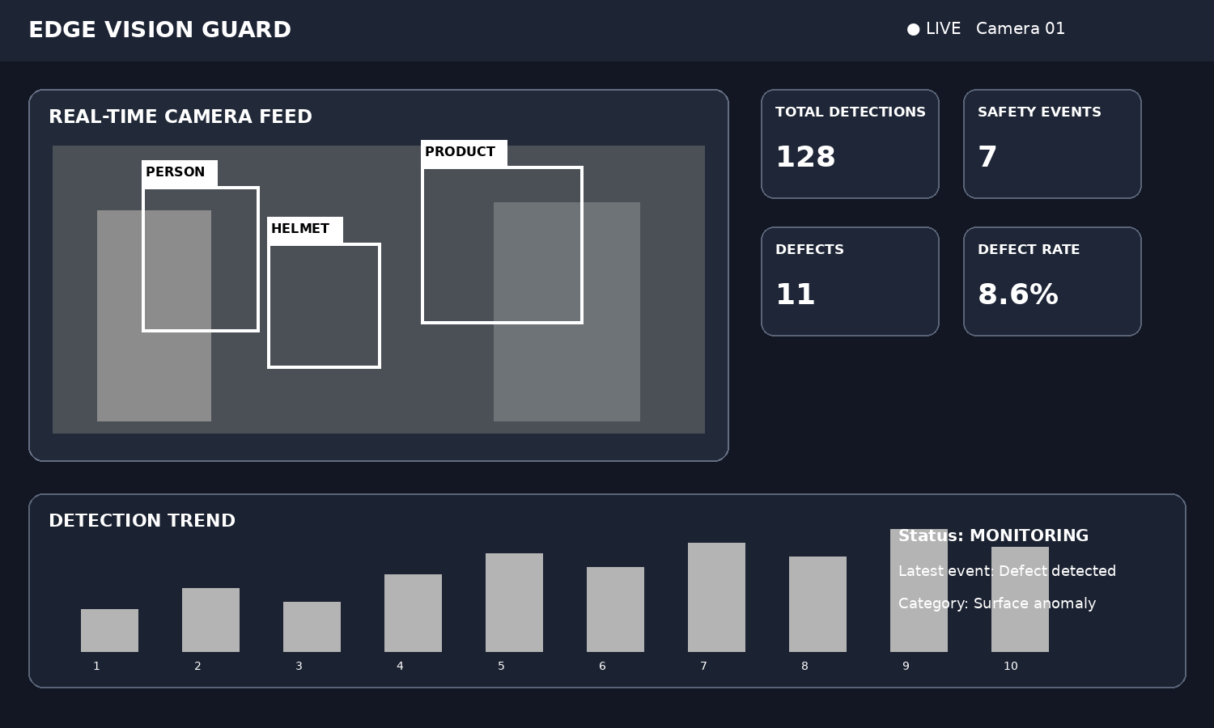
Figure 4.1 – Real-time monitoring dashboard
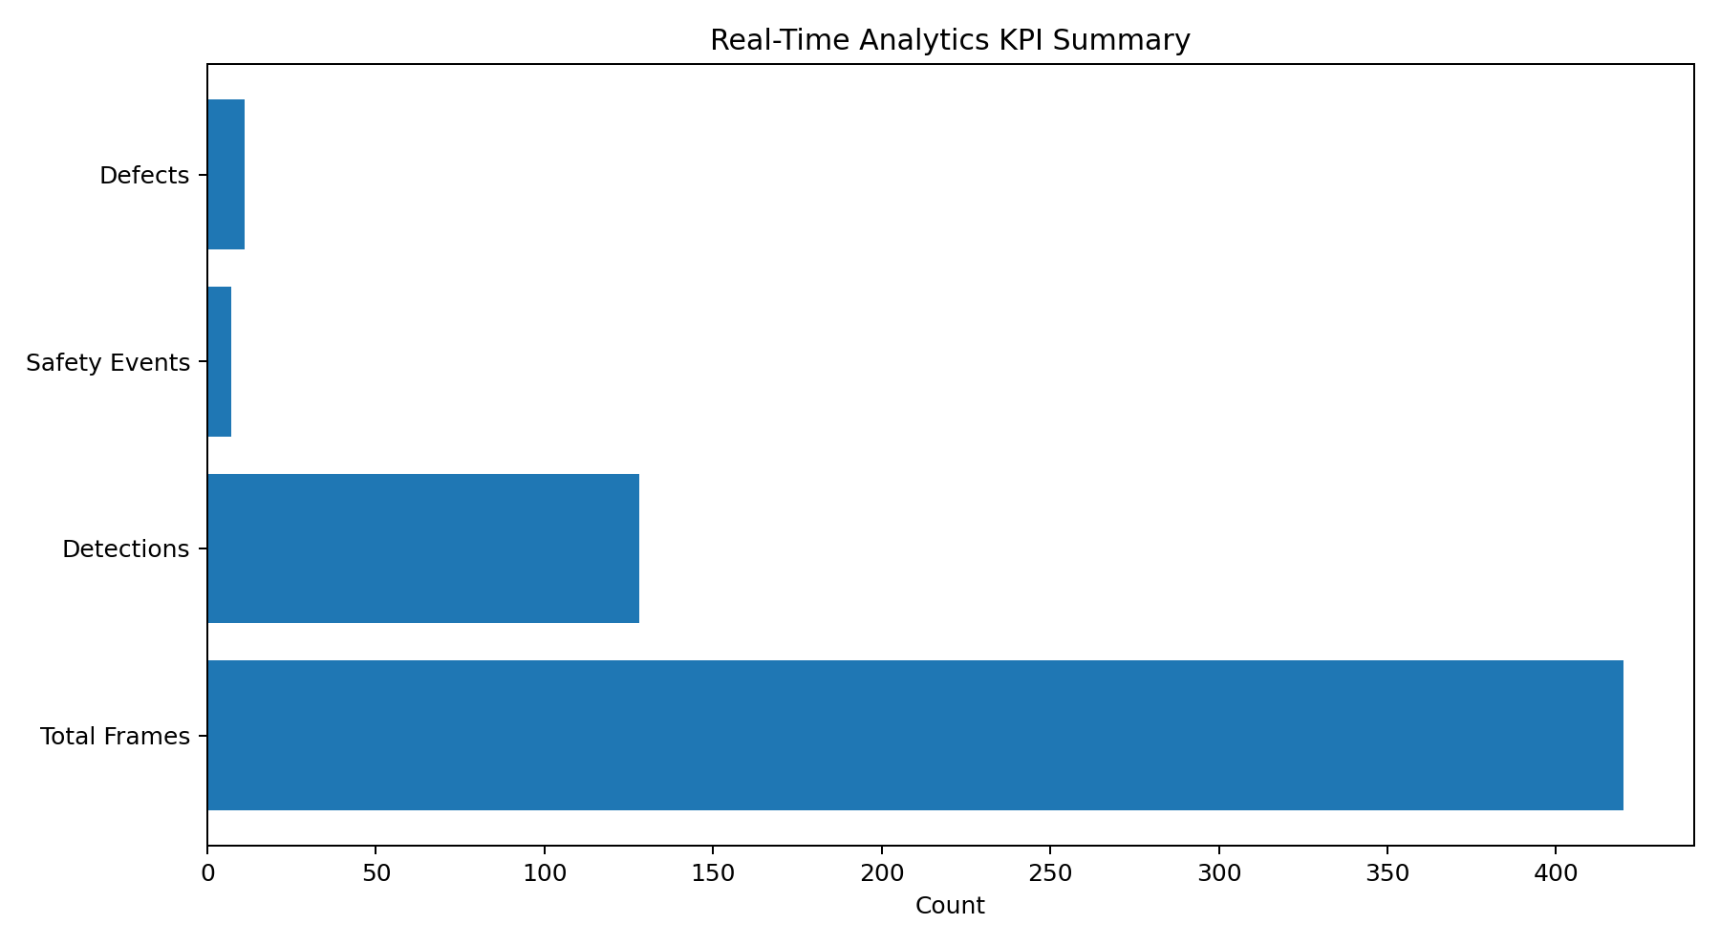
Figure 4.2 – KPI summary visualization
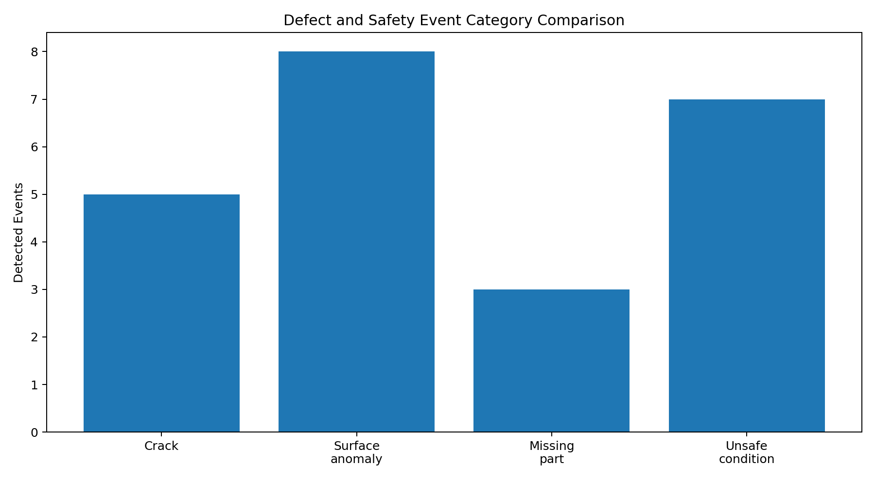
Figure 4.3 – Defect and safety category comparison
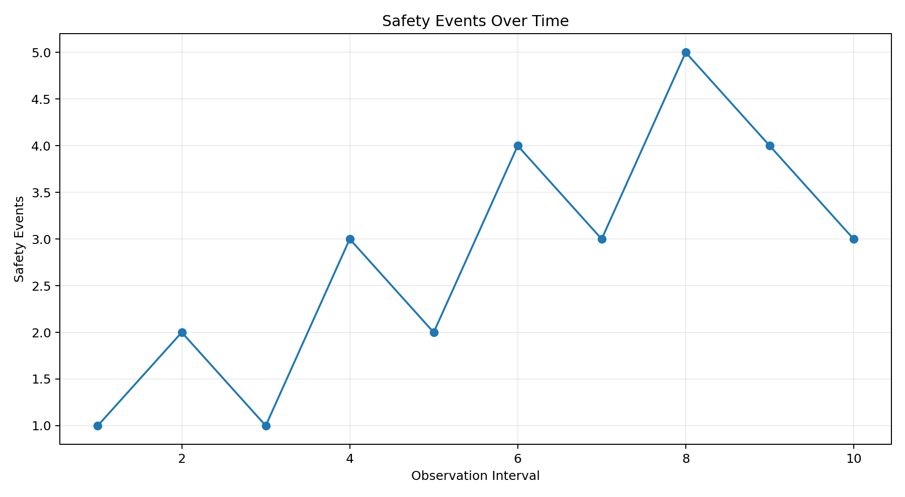
Supporting evidence – Safety-event trend view
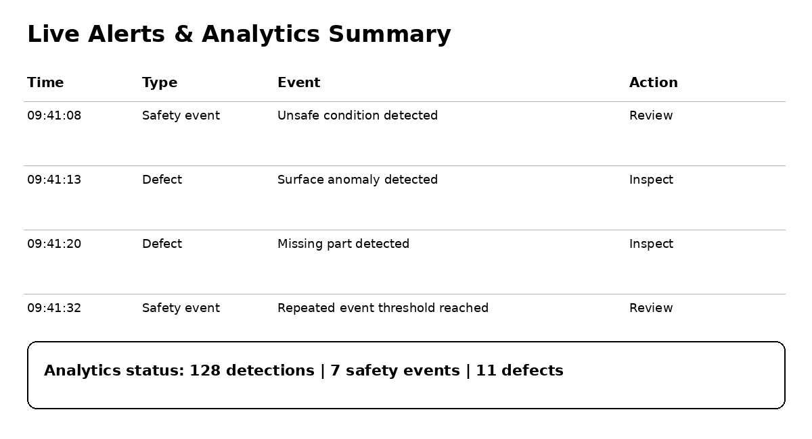
Figure 4.4 – Live alerts and analytics trend view

Figure 4.5 – Final analytics visualization output

4.3 Test Plan & Verification
Testing was planned around the functional requirements of Module 3. The objective was to verify not only that the analytics layer produces counts, but also that the dashboard components present consistent information. Test cases therefore cover normal detection data, category aggregation, safety and defect separation, trend updates, empty-data handling and dashboard rendering. Representative values are used as demonstration evidence because the supplied project presentation defines the module functions but does not provide a controlled benchmark dataset.
Requirement | Test Method | Acceptance Criterion
Receive detection results | Provide representative structured event records. | Records are accepted by the analytics layer.
Calculate counts | Compare calculated totals with manually counted test records. | Total, safety and defect counts match.
Category comparison | Provide events from multiple categories. | Category totals are displayed correctly.
Trend analysis | Submit counts across several observation intervals. | Trend values preserve the expected sequence.
Dashboard KPIs | Load analytics results into the dashboard. | KPI cards show the same values as the analytics output.
Alerts | Include safety and defect events with timestamps. | Recent events appear with readable labels.
Empty-data handling | Submit an empty event list. | Dashboard shows zero or a clear unavailable-data state.
Error handling | Provide invalid syntax or unavailable backend. | User sees syntax/error message instead of misleading output.
Table 4.2 – Test plan and acceptance criteria

Specification | Required Value | Achieved Value | Status
Detection aggregation | Structured events summarized | Total and category counts generated | Pass
Safety count | Safety events separated | Safety-event metric displayed | Pass
Defect count | Defects separated | Defect metric displayed | Pass
Category comparison | Multiple categories visible | Comparison chart generated | Pass
Trend analysis | Time-based values retained | Safety trend visualization generated | Pass
Dashboard KPIs | Key values visible | Dashboard cards display metrics | Pass
Alert presentation | Recent events identifiable | Alert panel displays event type and time | Pass
Table 4.3 – Verification results

4.4 Results
The implementation evidence demonstrates the intended Module 3 workflow. Detection outputs can be converted into total, safety and defect counts and then presented through dashboard cards. Category visualization makes differences between defect and safety conditions easier to compare, while the trend view provides a time-based perspective on event frequency. The alert panel adds an immediate monitoring element by showing recent events and their categories. The supplied project presentation explicitly identifies these outputs as the core functions of Module 3: real-time results, counts, category comparison, safety trends, charts, dashboard KPIs and understandable alerts.

4.5 Data Analysis & Engineering Judgment
The main engineering observation is that analytics adds value by transforming many low-level detection events into a small set of interpretable indicators. A KPI such as total defects gives an immediate summary, while category charts explain where those detections are concentrated. Trend plots add temporal context and can reveal whether safety-event activity is stable, increasing or decreasing. These visualizations should be interpreted together with the quality of the upstream detection stage. A dashboard can accurately summarize the supplied detections while still inheriting errors from missed or incorrectly classified events. Therefore, the analytics module is best treated as a decision-support layer rather than as an independent guarantee of safety or product quality.

4.6 Comparison with Existing Solutions & Achievement of Objectives
Objective | Evidence | Achievement
Collect detection outputs | Analytics input accepts structured event records. | Fully Achieved
Calculate real-time counts | Dashboard displays total, safety and defect metrics. | Fully Achieved
Group categories | Category aggregation is used for chart generation. | Fully Achieved
Compare categories | Defect and safety comparison chart is provided. | Fully Achieved
Analyze trends | Safety-event trend visualization is included. | Fully Achieved
Present alerts | Alert panel displays recent event information. | Fully Achieved
Verify consistency | Representative analytics test cases are defined. | Achieved for project-level verification
Table 4.4 – Objective achievement

4.7 Strengths & Limitations

Strengths
- Combines real-time metrics, category comparison, trends and alerts in one monitoring view.
- Converts repeated detection events into concise, human-readable analytics.
- Separates analytical calculations from the presentation layer.
- Supports quick comparison of safety and defect conditions.
- Provides a reusable structure for additional event categories and future visualizations.
- Reduces the need for continuous manual counting and interpretation of individual detections.

Limitations
- The supplied project presentation does not establish a controlled large-scale performance benchmark.
- Analytics quality depends on the correctness and consistency of upstream detection results.
- The available material provides functional descriptions rather than exhaustive evidence for every possible camera condition.
- Very large historical datasets may require additional storage and filtering strategies.
- Dashboard thresholds and alert rules may need tuning for a specific industrial environment.

4.8 Project Planning, Roles & Budget
The project was organized into three connected modules. Module 1 prepares image and video data and detects relevant objects, Module 2 identifies safety and defect conditions, and Module 3 converts the resulting detections into analytics and visualizations. Integration work ensures that the output of one stage can be consumed by the next without changing the meaning of event categories or counts.
Milestone | Planned Activity | Evidence / Outcome
1 | Requirement identification and module division | Three-module Edge Vision Guard structure defined.
2 | Vision preprocessing and object-detection preparation | Input and detection workflow established.
3 | Safety and defect analysis integration | Detection events categorized for analytics.
4 | Real-time analytics development | Counts, categories, trends and KPIs implemented.
5 | Dashboard and visualization integration | Charts, alerts and monitoring view produced.
6 | Testing and refinement | Representative analytics cases checked for consistency.
Project milestone plan

Student | Assigned Responsibility | Actual Contribution
Rakina S (192324289) | Module 3 – Real-Time Analytics & Visualization | Analytics calculations, dashboard KPIs, category charts, trends, alerts and verification.
Harisha S (192324300) | Module 1 – Image/Video Preprocessing & Object Detection | Frame preprocessing, object-detection workflow and supporting integration.
Table 4.5 – Project roles and contribution

Item | Estimated Cost | Actual Cost
Development software / editors | ₹0 – ₹1,000 | ₹0 / existing resources
Python, OpenCV and open-source libraries | ₹0 | ₹0
Pandas and Matplotlib | ₹0 | ₹0
Testing and documentation | ₹0 – ₹500 | ₹0 / existing resources
Internet / institutional computing resources | Existing access | Existing access
Total | Low-cost academic software project | No dedicated purchase reported

Table 4.6 – Budget

CHAPTER 5
CONCLUSION, FUTURE WORK AND REFLECTION

5.1 Conclusion
The Edge Vision Guard project presents a unified computer-vision workflow for safety monitoring and defect analytics. Module 3 – Real-Time Analytics & Visualization completes the workflow by transforming detection results into counts, category comparisons, trends, dashboard KPIs and alerts. The implementation concept demonstrates that analytics is an important layer between automated detection and practical interpretation. Instead of requiring a user to inspect every detection independently, the module provides a concise view of current conditions while preserving category and time-based information for further analysis. The project therefore supports faster monitoring, reduced manual effort and data-driven decision-making, while recognizing that the quality of the final analytics remains dependent on the upstream vision and detection stages.

Figure 5.1 – Final Edge Vision Guard dashboard evidence

5.2 Future Work
- Integrate stronger real-time streaming support for longer continuous monitoring sessions.
- Add historical storage and date-range filtering for safety and defect analytics.
- Provide configurable alert thresholds for different safety and defect categories.
- Extend dashboard views with additional visualizations and drill-down details.
- Benchmark analytics update time under increasing event volumes and video rates.
- Improve integration with the detection stage so that confidence and source-frame information can be inspected with each event.
- Add downloadable analytical reports containing KPI summaries, category charts and trend information.

5.3 Professional Learning & Individual Reflection

New Knowledge Acquired
- Practical understanding of how computer-vision detection outputs can be converted into analytical records.
- Understanding of KPI design for real-time safety and defect monitoring.
- Experience in grouping event records into categories and producing comparison charts.
- Understanding of time-based trend analysis for repeated safety events.
- Practical exposure to presenting analytical results through a dashboard interface.

Engineering & Professional Skills Developed
- Modular software design through separation of detection, analytics and visualization responsibilities.
- Data handling and aggregation using Python-oriented processing tools.
- Technical documentation of requirements, risks, tests and implementation evidence.
- Team coordination through division of the project into three connected modules.
- Engineering judgment in distinguishing functional analytics evidence from broader performance claims.

5.3.1 Individual Reflection – Module 3 Contribution
The main challenge in Module 3 was designing a dashboard that remains simple while still representing several types of detection information. Individual detections are useful for computer-vision inspection, but they become difficult to interpret when they accumulate over time. I therefore focused on converting event records into consistent counts, category summaries and trend values and then presenting the results through KPI cards, charts and alerts. This work improved my understanding of data aggregation, visualization design and the relationship between automated detection and human interpretation. I also learned that analytical outputs must be presented carefully because the dashboard reflects the quality of the upstream detection stage. If the module were extended, I would add historical filtering, configurable thresholds and more systematic performance testing.

5.3.2 Supporting Team Reflection – Module Integration
The three modules were designed to remain logically connected while keeping their responsibilities distinct. Module 1 prepares visual data and detects relevant objects, Module 2 identifies safety and defect conditions, and Module 3 interprets those detections through analytics and visualization. This division reduced unnecessary duplication and made it possible to test each stage independently before integration. The overall workflow reinforced the importance of consistent event categories and clear interfaces between modules because analytics can only be meaningful when the upstream outputs are structured consistently.

REFERENCES
[1] OpenCV Documentation, “Open Source Computer Vision Library,” documentation on image processing, video handling and computer-vision operations.
[2] Python Software Foundation, “Python Documentation,” reference material for Python programming and application development.
[3] Kaggle, “Computer Vision and Defect Detection Datasets,” datasets and resources used for computer-vision data analysis and model development.
[4] Ultralytics, “YOLO Documentation,” reference material for real-time object detection and computer-vision workflows.
[5] Pandas Documentation, “Python Data Analysis Library,” reference material for structured data handling and aggregation.
[6] Matplotlib Documentation, “Visualization with Python,” reference material for charts, plots and analytical visualization.
[7] Computer Vision Research, studies and technical resources related to automated safety monitoring and defect detection.
[8] Pallets Projects, “Flask Documentation,” Pallets, 2024–2026. The documentation describes the Flask web framework and its use for developing lightweight web applications, routing, request handling, and API-based backend services.
[9] R. W. Sebesta, Concepts of Programming Languages, 13th ed., Pearson, 2024. The book discusses formal language concepts, syntax, grammars, parsing, language processing, and principles relevant to compiler construction.
[10] A. S. Tanenbaum and H. Bos, Modern Operating Systems, 5th ed., Pearson, 2023. The reference provides supporting concepts related to software execution, system resources, processes, and performance considerations relevant to software-system implementation.

APPENDICES
Website link: https://example.com/edge-vision-guard

Appendix A – Detailed Analytics Calculation
For each incoming detection record, the analytics stage first identifies the event type and category. The total detection count is incremented for every valid record. Safety-event and defect counters are updated according to the event type, while a category counter records the number of occurrences for each label. For an input set of n records, the aggregation pass requires approximately O(n) time under constant-time counter updates. Trend analysis stores the resulting count for each observation interval, allowing the dashboard to plot the sequence of recent values.

Appendix B – Engineering Drawings / Schematics
The engineering schematic illustrates the overall Edge Vision Guard data flow. Camera or video input is passed through preprocessing and detection stages before reaching the Module 3 analytics layer. The analytics layer calculates totals, category summaries and trend values and sends the structured results to the dashboard, charts and alert components. The design emphasizes a clear separation between computer-vision processing and result presentation.


Figure B.1 – Real-time analytics and visualization system architecture

Appendix C – Source Code / Code Repository Information
Only source-code excerpts directly relevant to Module 3 are included below. The excerpts illustrate event aggregation, trend retention and the preparation of values used by the dashboard. The complete project source is maintained separately in the project development environment.
from collections import Counter
def summarize_events(events):
counts = Counter()
safety_events = 0
defects = 0
for event in events:
counts[event["category"]] += 1
if event["type"] == "safety":
safety_events += 1
elif event["type"] == "defect":
defects += 1
return len(events), safety_events, defects, dict(counts)
def update_dashboard(state, analytics):
state["total"] = analytics["total_detections"]
state["safety"] = analytics["safety_events"]
state["defects"] = analytics["defects"]
state["categories"] = analytics["categories"]
return state
def append_trend(history, value, limit=20):
history.append(value)
if len(history) > limit:
history = history[-limit:]
return history

Appendix D – Datasheets
Not applicable. The project is a software-based computer-vision and analytics application and does not use electronic components, fabrication materials or hardware datasheets.

Appendix E – Experimental / Raw Data
The raw analytical evidence consists of representative detection-event records, calculated KPI values, category totals and trend sequences. Example dashboard evidence uses demonstration values to show how the analytics layer presents total detections, safety events, defects and category activity. These values are illustrative project evidence and are not claimed as a controlled industrial benchmark.
Test ID | Parser | Input | Expected Result | Evidence
T1 | LL(1) | id + id * id | Accepted; steps and parse tree generated | Backend test
T2 | SLR(1) | id + id * id | Accepted; steps and parse tree generated | Backend test
T3 | LL(1) | Invalid syntax / incomplete token string | Syntax error reported | Frontend/backend error handling
T4 | Any | Empty grammar | Validation / error response | /api/validate and /api/analyze checks

Appendix F – Ethics / Institutional Approval
No institutional approval was identified as necessary from the supplied project materials because the application is a software-oriented computer-vision educational project and does not require human-subject research data. The ethical focus is on transparent presentation of automated detection results, acknowledgement of external resources and avoidance of unsupported claims about safety or detection accuracy.

Appendix G – Project Meeting / Progress Records
No formal meeting minutes or dated progress records were included in the supplied project materials. The report therefore records the milestone plan and technical contribution information supported by the project work.

Appendix H – User / Industry Feedback
No formal external user or industry feedback was included in the supplied project materials. The usability and visualization discussion in this report is therefore based on the implemented project concept, dashboard evidence and functional requirements rather than an external usability study.

Appendix I – Publications / Patents / Competitions / Product Outcomes
No publication, patent, competition award or commercial product outcome was identified in the supplied materials. The current outcome is an academic computer-vision prototype demonstrating real-time safety and defect analytics.

Appendix J – Individual Contribution Evidence
The team contribution is divided into three connected modules. The Module 3 contribution documented in this report includes detection-result aggregation, KPI calculation, category comparison, trend visualization, alert presentation, dashboard integration and verification of analytical outputs. The supporting code excerpts, figures and test tables in Chapters 4 and the appendices provide evidence for this work.
CAPSTONE PROJECT OUTCOME MAPPING SHEET
The following mapping is prepared using the institutional outcome areas specified in the supplied report format. It is intended to support faculty assessment and can be completed or modified by the department assessor.
Outcome / Area | SO | Location in This Report
Complex engineering problem formulation | SO1 | Chapter 1 and Chapter 2
Engineering design under constraints | SO2 | Chapter 3
Written / oral technical communication | SO3 | Whole report and Viva
Ethics and professional responsibility | SO4 | Chapter 3.7 and Appendix F
Teamwork and leadership | SO5 | Chapter 4.8 and Contribution Statement
Data analysis and engineering judgment | SO6 | Chapter 4.5 and Module 3 implementation
Independent acquisition of new knowledge | SO7 | Chapter 5.3
Standards / quality considerations | SO2 | Chapter 3.2
Sustainability and societal / environmental impact | SO2 / SO4 | Chapter 3.7
Risk assessment and mitigation | SO2 / SO4 | Chapter 3.7
Security considerations | Relevant SO | Chapter 3.7
Integrated / system-level engineering | SO1 / SO2 | Chapter 3.5 and Chapter 4
Project planning and management | SO5 | Chapter 4.8
Individual contribution | SO1–SO7 | Contribution Statement, Chapter 4.8 and Appendix J

