Question 1: Mapping Data onto Aesthetics
1. Write an R program to create a scatter plot with Sales on the x-axis and Profit on the
y-axis.

# Load library
library(ggplot2)
# Create dataset
data <- data.frame(
Product = c("P1", "P2", "P3", "P4", "P5", "P6"),
Sales = c(120, 90, 150, 80, 135, 100),
Profit = c(18, 12, 25, 8, 22, 16),
Category = c("Electronics", "Clothing", "Electronics", "Furniture", "Furniture", "Clothing")
)

# Create scatter plot
ggplot(data, aes(x = Sales,
y = Profit,
color = Category,
size = Sales)) +
geom_point(alpha = 0.8) +
labs(
title = "Sales vs Profit by Product Category",
x = "Sales (₹ Lakhs)",
y = "Profit (%)",
color = "Category",
size = "Sales"
) +
theme_minimal()
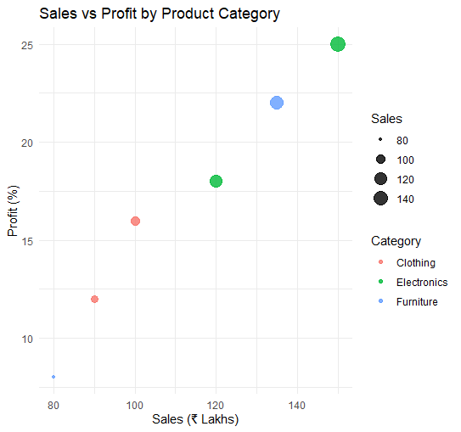

2. Map Category using an appropriate aesthetic and Sales using another suitable
aesthetic.
- Color → Category (Electronics, Clothing, Furniture)
- Size → Sales (₹ Lakhs)
- X-axis → Sales
- Y-axis → Profit

3. Interpret the relationship between Sales and Profit.

- There is a positive relationship between Sales and Profit.
- Products with higher sales generally have higher profit percentages.
- Electronics products show relatively high sales and high profits.
- Furniture and Clothing products have comparatively lower sales and profits.

4. Identify the type of scale used for each variable.

Variable | Scale Type
Sales | Continuous (Quantitative)
Profit | Continuous (Quantitative)
Category | Discrete (Categorical)

5. Suggest one alternative visualization that better represents the same data.
A Bubble Chart can better represent the same data by:
- X-axis → Sales
- Y-axis → Profit
- Color → Category
- Bubble Size → Sales (or Profit)
This makes it easier to compare product performance while highlighting differences between categories.

Question 2: Coordinate Systems (Cartesian and Polar)
1. Write an R program to visualize the dataset using a Cartesian coordinate system.
# Load library
library(ggplot2)
# Create dataset
data <- data.frame(
Direction = c("N", "NE", "E", "SE", "S", "SW", "W", "NW"),
Frequency = c(18, 12, 20, 15, 22, 11, 16, 14)
)
# Bar chart (Cartesian Coordinate System)
ggplot(data, aes(x = Direction, y = Frequency, fill = Direction)) +
geom_bar(stat = "identity") +
labs(
title = "Direction Frequency (Cartesian Coordinate System)",
x = "Direction",
y = "Frequency"
) +
theme_minimal()
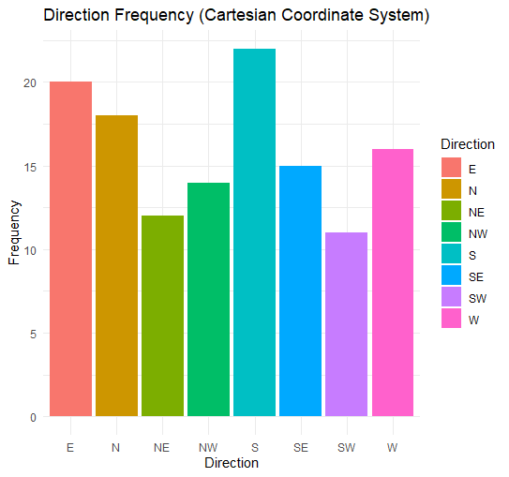

2. Write another R program to visualize the same data using a Polar coordinate system.
# Load library
library(ggplot2)
# Create dataset
data <- data.frame(
Direction = c("N", "NE", "E", "SE", "S", "SW", "W", "NW"),
Frequency = c(18, 12, 20, 15, 22, 11, 16, 14)
)
# Polar chart
ggplot(data, aes(x = Direction, y = Frequency, fill = Direction)) +
geom_bar(stat = "identity", width = 1) +
coord_polar() +
labs(
title = "Direction Frequency (Polar Coordinate System)"
) +
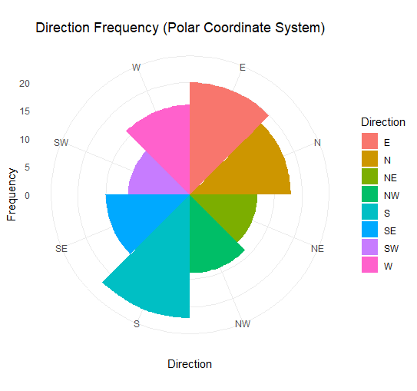
theme_minimal()

3. Compare the effectiveness of both visualizations.
Cartesian Coordinate System | Polar Coordinate System
Easy to compare frequencies accurately. | Highlights the circular nature of directional data.
Suitable for comparing bar heights. | Better for showing compass directions.
Simple and easy to interpret. | More visually attractive but less precise for comparing values.

4. Explain which coordinate system is more appropriate for directional data.
The Polar Coordinate System is more appropriate for directional data because the directions (N, NE, E, SE, S, SW, W, NW) naturally represent angles around a circle, similar to a compass or wind rose.
5. Justify your answer based on data interpretation.
- Directional data is circular, not linear.
- A polar chart preserves the true spatial relationship between directions.
- It makes it easier to understand the distribution of frequencies around the compass.
- Although a Cartesian bar chart is better for comparing exact values, the polar coordinate system provides a more meaningful representation of directional data.
Question 3: Color Scales for Data Representation
1. Write an R program to create a bar chart using a sequential color scale based on
Marks.
# Load library
library(ggplot2)
# Create dataset
data <- data.frame(
Student = c("A", "B", "C", "D", "E", "F"),
Marks = c(45, 58, 72, 81, 67, 90)
)
# Bar chart with sequential color scale
ggplot(data, aes(x = Student, y = Marks, fill = Marks)) +
geom_bar(stat = "identity") +
scale_fill_gradient(low = "lightblue", high = "darkblue") +
labs(
title = "Student Marks",
x = "Student",
y = "Marks",
fill = "Marks"
) +
theme_minimal()
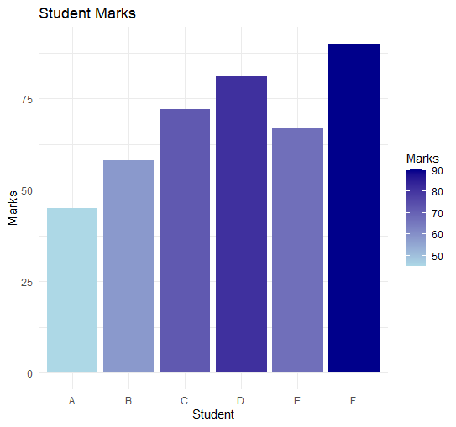

2. Identify the students with the highest and lowest marks from the visualization.
- Highest Marks: Student F – 90
- Lowest Marks: Student A – 45

3. Explain why a sequential color scale is appropriate.
A sequential color scale is suitable because:
- Marks are continuous numerical data.
- It uses light colors for lower values and dark colors for higher values.
- This helps viewers easily identify low and high marks.

4. Suggest a color palette suitable for color-blind users.
A good color-blind-friendly palette is:
- Viridis
Example in R:
scale_fill_viridis_c()
Other color-blind-friendly palettes include:
- Cividis
- Plasma
- Inferno

5. Explain the difference between sequential and categorical color scales.
Sequential Color Scale | Categorical Color Scale
Used for continuous numerical data. | Used for categorical (group) data.
Colors change gradually from light to dark. | Uses different distinct colors for each category.
Example: Marks, Temperature, Sales. | Example: Gender, Department, Product Category.
Shows the magnitude of values. | Differentiates between categories only.

Question 4: Highlighting with Color
1. Write an R program to create a bar chart highlighting the region with the highest
revenue.
# Load library
library(ggplot2)
# Create dataset
data <- data.frame(
Region = c("North", "South", "East", "West", "Central"),
Revenue = c(820, 760, 790, 1010, 770)
)
# Create a new column for highlighting
data$Highlight <- ifelse(data$Revenue == max(data$Revenue),
"Highest", "Others")

# Bar chart with highlighted highest revenue
ggplot(data, aes(x = Region, y = Revenue, fill = Highlight)) +
geom_bar(stat = "identity") +
scale_fill_manual(values = c("Highest" = "red",
"Others" = "skyblue")) +
labs(
title = "Regional Revenue",
x = "Region",
y = "Revenue (₹ Crores)",
fill = "Legend"
) +
theme_minimal()
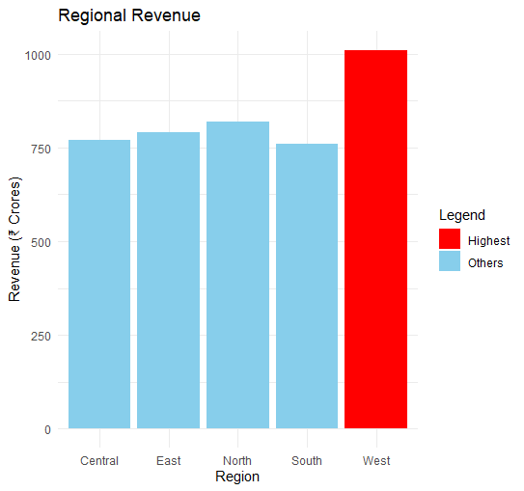

2. Explain how highlighting improves data interpretation.
- Draws immediate attention to the most important data.
- Helps viewers quickly identify key values.
- Makes comparisons easier.
- Improves the overall readability of the chart.

3. Identify the highest-performing region.

West has the highest revenue of ₹1010 Crores.

4. Discuss how excessive use of colors can affect interpretation.
- Too many colors can make the chart confusing.
- It distracts viewers from the important information.
- Similar colors may be difficult to distinguish.
- Overuse of colors reduces the effectiveness of highlighting.

5. Suggest one alternative highlighting technique other than color.
One alternative to color highlighting is adding data labels (showing the exact revenue value on each bar).
Other alternatives include:
- Using a different bar pattern (e.g., stripes).
- Increasing the bar size or border thickness.
- Adding an annotation or arrow pointing to the highest value.

Question 5: Integrated Visualization
1. Write an R program to create a bubble chart using appropriate aesthetic mappings.
# Load library
library(ggplot2)
# Create dataset
data <- data.frame(
City = c("A", "B", "C", "D", "E"),
Population = c(8.2, 5.6, 9.4, 6.8, 4.9),
AQI = c(110, 180, 90, 240, 150),
Rainfall = c(850, 430, 1200, 520, 680),
Region = c("North", "South", "North", "East", "West")
)
# Bubble chart
ggplot(data, aes(x = Population,
y = AQI,
size = Rainfall,
color = Region,
label = City)) +
geom_point(alpha = 0.7) +
geom_text(vjust = -1) +
labs(
title = "Population vs AQI",
x = "Population (Million)",
y = "AQI",
size = "Rainfall (mm)",
color = "Region"
) +
theme_minimal()

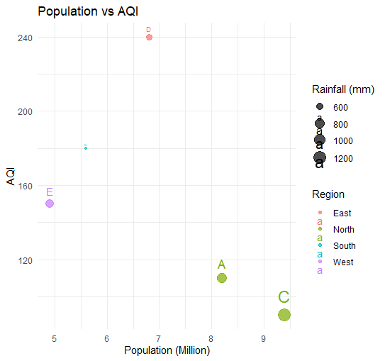

2. Select suitable aesthetics for Population, AQI, Rainfall, and Region.

Variable | Aesthetic
Population | X-axis
AQI | Y-axis
Rainfall | Bubble Size
Region | Color
City | Label

3. Interpret the relationship between Population and AQI.

- There is no strong positive relationship between Population and AQI.
- City D has a moderate population (6.8 million) but the highest AQI (240).
- City C has the highest population (9.4 million) but a relatively low AQI (90).
- This suggests that factors other than population also influence air quality.

4. Identify the continuous and categorical variables.
Continuous Variables | Categorical Variables
Population | City
AQI | Region
Rainfall

5. Recommend one improvement to enhance the visualization's readability.
One improvement is to add labels for each city (as done with geom_text()), making it easier to identify individual data points. Other improvements include:
- Using a color-blind-friendly palette (e.g., scale_color_viridis_d()).
- Increasing font size for axis labels and title.
- Adding light grid lines for easier comparison.

