Set 11 – Product Category Analysis
1. Create a pie chart to represent the distribution of sales across product categories.Include labels.
# Product Category data
category <- c("Electronics", "Clothing", "Appliances")
sales <- c(50000, 35000, 40000)
# Calculate percentage
percentage <- round(sales / sum(sales) * 100, 1)
# Create labels
labels <- paste(category, "\n$", sales, "\n", percentage, "%")
# Create pie chart
pie(sales,
labels = labels,
main = "Product Category Sales Distribution")
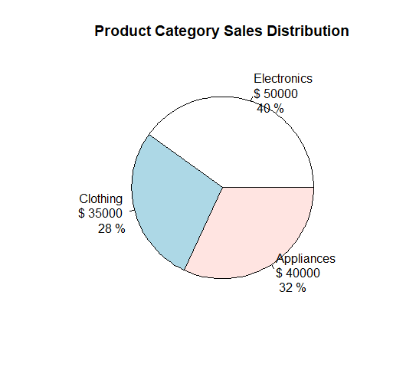

2. Generate a funnel chart to analyze the sales conversion process for each product category.Label the stages and title the chart.
# Product Category data
category <- c("Electronics", "Clothing", "Appliances")
sales <- c(50000, 35000, 40000)

# Arrange from highest to lowest
order_data <- order(sales, decreasing = TRUE)
category <- category[order_data]
sales <- sales[order_data]
# Create funnel-style chart
barplot(sales,
names.arg = category,
horiz = TRUE,
main = "Sales Funnel by Product Category",
xlab = "Sales ($)",
col = "skyblue",
las = 1)
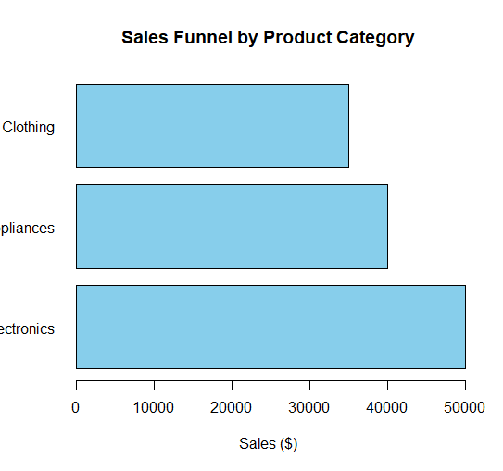

3. Build a table to display the sales data for each product category. Label the table elements.
# Create data
product_data <- data.frame(
Category = c("Electronics", "Clothing", "Appliances"),
Sales = c(50000, 35000, 40000)
)

# Display the table
print(product_data)
OUTPUT
Category Sales
1 Electronics 50000
2 Clothing 35000
3 Appliances 40000

Set 12 – Website Traffic Analysis
1. Create a line chart to visualize the trend in daily page views over time. Label the axes
and title the chart.
# Create the data
date <- as.Date(c("2023-01-01",
"2023-01-02",
"2023-01-03"))
page_views <- c(1500, 1600, 1400)
# Create line chart
plot(date,
page_views,
type = "o",
main = "Daily Website Page Views",
xlab = "Date",
ylab = "Page Views")
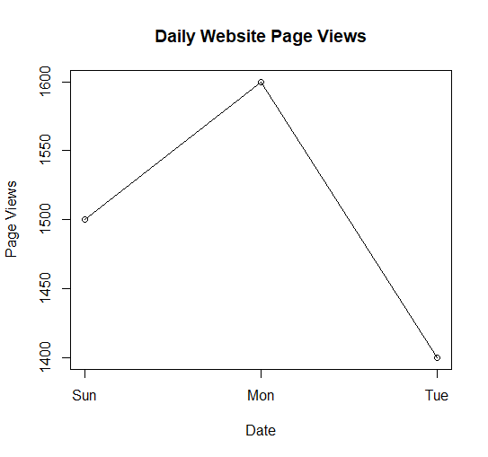

2. Generate a bar chart showing the top N days with the highest click-through rates. Label the chart elements.
# Create the data
date <- c("2023-01-01",
"2023-01-02",
"2023-01-03")
ctr <- c(2.3, 2.7, 2.0)
# Number of top days
N <- 3
# Sort CTR from highest to lowest
order_data <- order(ctr, decreasing = TRUE)

top_dates <- date[order_data][1:N]
top_ctr <- ctr[order_data][1:N]
# Create bar chart
barplot(top_ctr,
names.arg = top_dates,
main = "Top Days by Click-through Rate",
xlab = "Date",
ylab = "Click-through Rate (%)",
col = "skyblue")
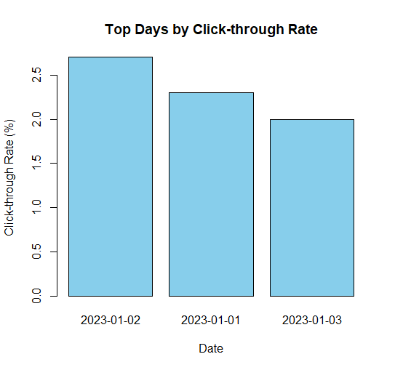

3. Build a table to show the website traffic data for each day. Label the table elements.
# Create website traffic data
website_data <- data.frame(
Date = c("2023-01-01",
"2023-01-02",
"2023-01-03"),
Page_Views = c(1500, 1600, 1400),
Click_Through_Rate = c("2.3%", "2.7%", "2.0%")
)
# Display the table
print(website_data)
OUTPUT
Date Page_Views Click_Through_Rate
1 2023-01-01 1500 2.3%
2 2023-01-02 1600 2.7%
3 2023-01-03 1400 2.0%

Set 13 – Geographic Data

1. Create a map chart to visualize the distribution of cities on a geographic map. Label

the map elements.
# Create geographic data
city <- c("City A", "City B", "City C")
population <- c(500000, 700000, 600000)
temperature <- c(75, 68, 80)
elevation <- c(1000, 800, 1200)
# Example latitude and longitude
latitude <- c(13.08, 13.12, 13.05)
longitude <- c(80.27, 80.30, 80.25)

# Create data frame
geo_data <- data.frame(
City = city,
Population = population,
Temperature = temperature,
Elevation = elevation,
Latitude = latitude,
Longitude = longitude
)
# Create map-style plot
plot(longitude, latitude,
pch = 19,
cex = population / 200000,
xlab = "Longitude",
ylab = "Latitude",
main = "Geographic Distribution of Cities")
# Add city labels
text(longitude, latitude,
labels = city,
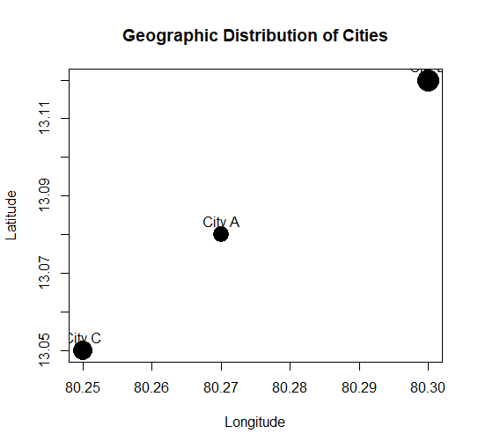
pos = 3)

2. Generate a scatter plot to explore the relationship between average temperature and
population size. Explain any insights.
# Data
city <- c("City A", "City B", "City C")
population <- c(500000, 700000, 600000)
temperature <- c(75, 68, 80)
# Scatter plot
plot(temperature,
population,
pch = 19,
main = "Average Temperature vs Population",
xlab = "Average Temperature",
ylab = "Population")
# Add city labels
text(temperature,
population,
labels = city,
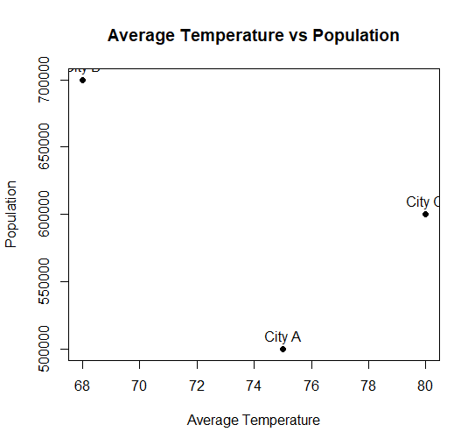
pos = 3)

3. Build a table to display the geographic data for each city. Label the table elements.
# Create geographic data
geo_data <- data.frame(
City = c("City A", "City B", "City C"),
Population = c(500000, 700000, 600000),
Avg_Temperature = c(75, 68, 80),
Elevation = c(1000, 800, 1200)
)
# Display table
print(geo_data)
OUTPUT
City Population Avg_Temperature Elevation
1 City A 500000 75 1000
2 City B 700000 68 800
3 City C 600000 80 1200

Set 14 – Survey Results
1. Create a stacked bar chart to display the distribution of answers for Question 1. Label the chart elements.
# Create the data
q1 <- c("A", "B", "C")
# Count responses
counts <- table(q1)
# Create stacked bar chart
barplot(counts,
main = "Distribution of Answers for Question 1",
xlab = "Question 1",
ylab = "Number of Respondents",
col = c("skyblue", "orange", "lightgreen"),
legend.text = names(counts))
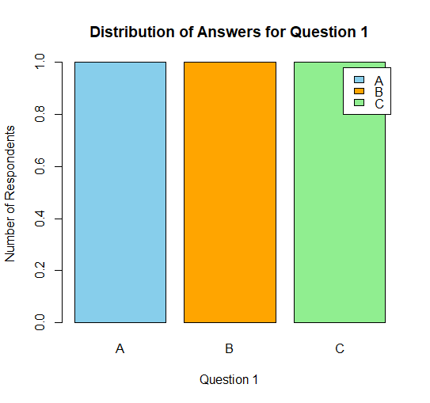

2. Generate a radar chart to visualize the overall pattern of responses across all three questions.
# Create survey data
survey <- data.frame(
Respondent = c(1, 2, 3),
Q1 = c("A", "B", "C"),
Q2 = c("B", "A", "A"),
Q3 = c("C", "D", "B")
)
# Convert answers to numbers
answer_value <- c(A = 1, B = 2, C = 3, D = 4)
q1_values <- answer_value[survey$Q1]
q2_values <- answer_value[survey$Q2]
q3_values <- answer_value[survey$Q3]
# Calculate average response
averages <- c(
Q1 = mean(q1_values),
Q2 = mean(q2_values),
Q3 = mean(q3_values)
)
print(averages)
# Radar chart using base R
angles <- seq(0, 2 * pi, length.out = length(averages) + 1)
values <- c(averages, averages[1])
plot(angles,
values,
type = "n",
axes = FALSE,
xlab = "",
ylab = "",
main = "Overall Pattern of Survey Responses")
# Draw radar grid
for (r in 1:4) {
lines(
angles,
rep(r, length(angles)),
lty = 2
)
}
# Draw radar shape
lines(angles,
values,
type = "o",
pch = 16)
# Add question labels
text(
angles[1:3],
rep(0.5, 3),
labels = names(averages)
)
# Add axis
axis(2, at = 1:4, labels = 1:4)
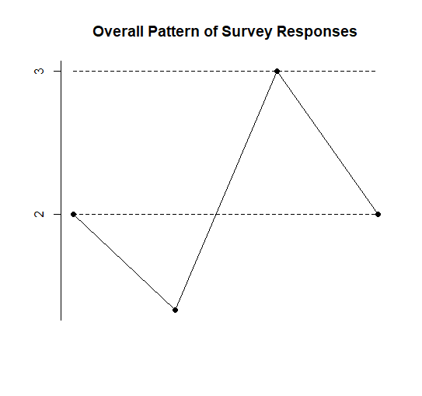

3. Build a table to show the survey response data for each respondent. Label the table elements.
# Create survey data
survey_data <- data.frame(
Respondent = c(1, 2, 3),
Question_1 = c("A", "B", "C"),
Question_2 = c("B", "A", "A"),
Question_3 = c("C", "D", "B")
)
# Display table
print(survey_data)
OUTPUT
Respondent Question_1 Question_2 Question_3
1 1 A B C
2 2 B A D
3 3 C A B

Set 15 – Survey Responses Analysis
1. Create a line chart to visualize the stock prices of three companies (Stock A, Stock B, and Stock C) over a specific time period. Label the axes and title the chart.
# Question 1 responses
q1 <- c("A", "B", "C")
# Count each answer
counts <- table(q1)
# Grouped bar chart
barplot(counts,
main = "Distribution of Answers for Question 1",
xlab = "Answer",
ylab = "Number of Responses",
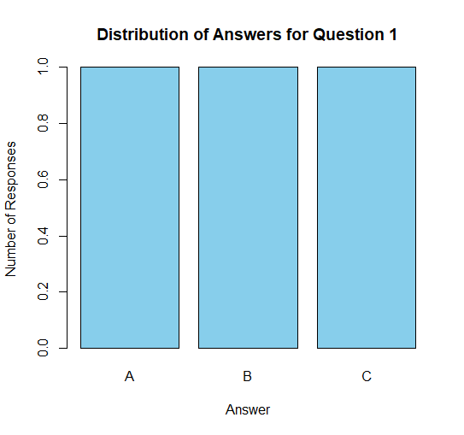
col = "skyblue")

2. Generate a stacked bar chart to represent the overall distribution of responses for all three questions.
# Create survey data
survey <- data.frame(
Q1 = c("A", "B", "C"),
Q2 = c("B", "A", "A"),
Q3 = c("C", "D", "B")
)
# Create response counts
responses <- rbind(
table(factor(survey$Q1, levels = c("A", "B", "C", "D"))),
table(factor(survey$Q2, levels = c("A", "B", "C", "D"))),
table(factor(survey$Q3, levels = c("A", "B", "C", "D")))
)
# Give row names
rownames(responses) <- c("Question 1",
"Question 2",
"Question 3")
# Stacked bar chart
barplot(t(responses),
beside = FALSE,
main = "Overall Distribution of Survey Responses",
xlab = "Questions",
ylab = "Number of Responses",
col = c("skyblue", "orange", "lightgreen", "pink"),
legend.text = c("A", "B", "C", "D"))
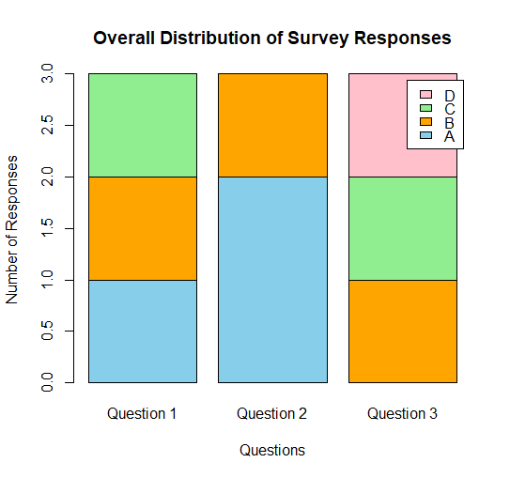

3. Build a table to show the survey response data for each survey. Label the table elements.
# Create survey data
survey_data <- data.frame(
Survey_ID = c(1, 2, 3),
Question_1 = c("A", "B", "C"),
Question_2 = c("B", "A", "A"),
Question_3 = c("C", "D", "B")
)
# Display table
print(survey_data)
OUTPUT
Survey_ID Question_1 Question_2 Question_3
1 1 A B C
2 2 B A D
3 3 C A B

Set 16 – Stock Analysis
1. Create a line chart to visualize the stock prices of three companies (Stock A, Stock B, and Stock C) over a specific time period. Label the axes and title the chart.
# Create the data
date <- as.Date(c("2023-01-01",
"2023-01-02",
"2023-01-03"))
stock_A <- c(100, 105, 110)
stock_B <- c(150, 152, 148)
stock_C <- c(120, 118, 122)
plot(date, stock_A,
type = "o",
pch = 16,
ylim = c(90, 160),
main = "Stock Prices Over Time",
xlab = "Date",
ylab = "Stock Price")
lines(date, stock_B,
type = "o",
pch = 16)
# Add Stock C
lines(date, stock_C,
type = "o",
pch = 16)
# Add legend
legend("topleft",
legend = c("Stock A", "Stock B", "Stock C"),
lty = 1,
pch = 16)
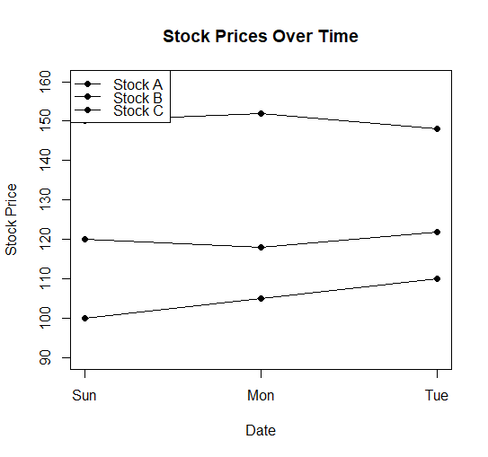

2. Generate a bar chart showing the daily percentage change in stock prices for Stock A. Label the chart elements.
stock_A <- c(100, 105, 110)
# Calculate daily percentage change
percentage_change <- c(
NA,
diff(stock_A) / stock_A[-length(stock_A)] * 100
)
date <- c("2023-01-01",
"2023-01-02",
"2023-01-03")
because there is no previous price
change_date <- date[-1]
change_value <- percentage_change[-1]
barplot(change_value,
names.arg = change_date,
main = "Daily Percentage Change - Stock A",
xlab = "Date",
ylab = "Percentage Change (%)",
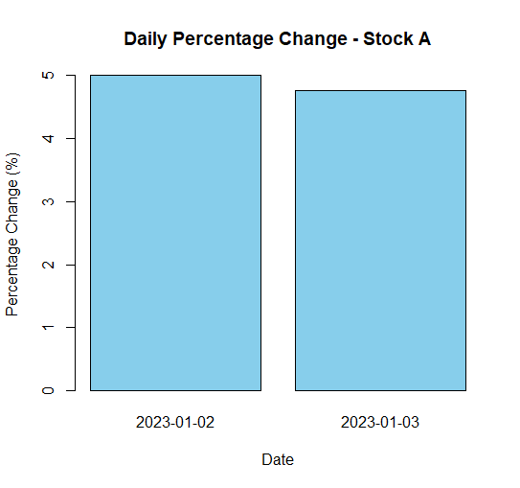
col = "skyblue")

3. Build a table to display the stock price data for each company over the given period. Label the table elements.
# Create stock data
stock_data <- data.frame(
Date = c("2023-01-01",
"2023-01-02",
"2023-01-03"),
Stock_A = c(100, 105, 110),
Stock_B = c(150, 152, 148),
Stock_C = c(120, 118, 122)
)
# Display table
print(stock_data)
OUTPUT
Date Stock_A Stock_B Stock_C
1 2023-01-01 100 150 120
2 2023-01-02 105 152 118
3 2023-01-03 110 148 122

Set 17 – Customer Satisfaction Analysis
1. In Python, create a histogram to visualize the distribution of customer ages. Label the axes and title the chart.
import matplotlib.pyplot as plt
# Customer age data
ages = [28, 35, 42, 30, 45]

# Create histogram
plt.hist(ages, bins=5, edgecolor='black')
# Add labels and title
plt.xlabel("Age")
plt.ylabel("Number of Customers")
plt.title("Distribution of Customer Ages")
# Display chart
plt.show()
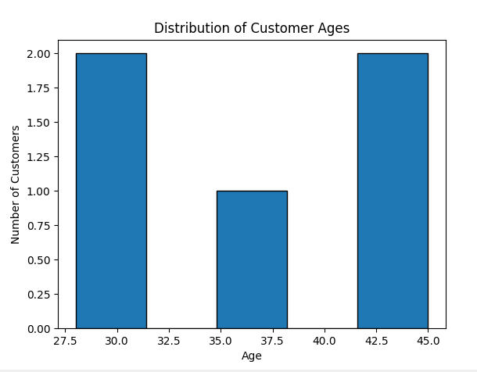

2. In R, generate a pie chart to represent the distribution of overall customer satisfaction scores.Include labels.
# Satisfaction scores
scores <- c(4, 5, 3, 4, 5)
# Count each score
score_count <- table(scores)
# Create labels
labels <- paste(
"Score", names(score_count),
"\n", score_count, "customers"
)
# Create pie chart
pie(score_count,
labels = labels,
main = "Customer Satisfaction Score Distribution")
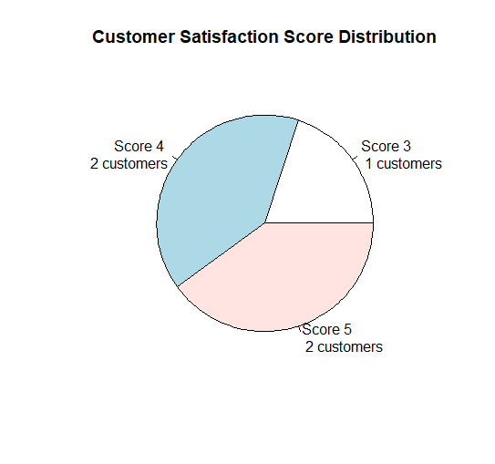

4. In Python, perform sentiment analysis on open-ended customer feedback and create a word cloud visualization.
import nltk
from nltk.sentiment import SentimentIntensityAnalyzer
from wordcloud import WordCloud
import matplotlib.pyplot as plt
# Download sentiment analyzer
nltk.download('vader_lexicon')
# Customer feedback
feedback = [
"The service was excellent and very helpful",
"I am happy with the product",
"The service was slow and disappointing",
"Good experience and friendly staff",
"Excellent product and great service"
]
# Combine all feedback
text = " ".join(feedback)
# Sentiment analysis
sia = SentimentIntensityAnalyzer()
sentiment_score = sia.polarity_scores(text)
print("Sentiment Scores:")
print(sentiment_score)
# Create word cloud
wordcloud = WordCloud(
width=800,
height=400,
background_color="white"
).generate(text)
# Display word cloud
plt.imshow(wordcloud, interpolation="bilinear")
plt.axis("off")
plt.title("Customer Feedback Word Cloud")

plt.show()

