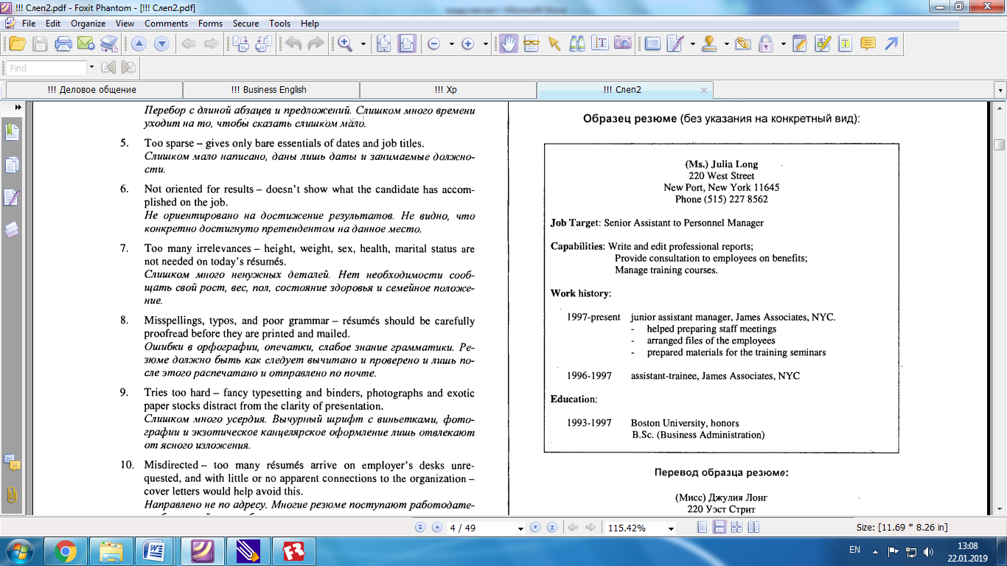

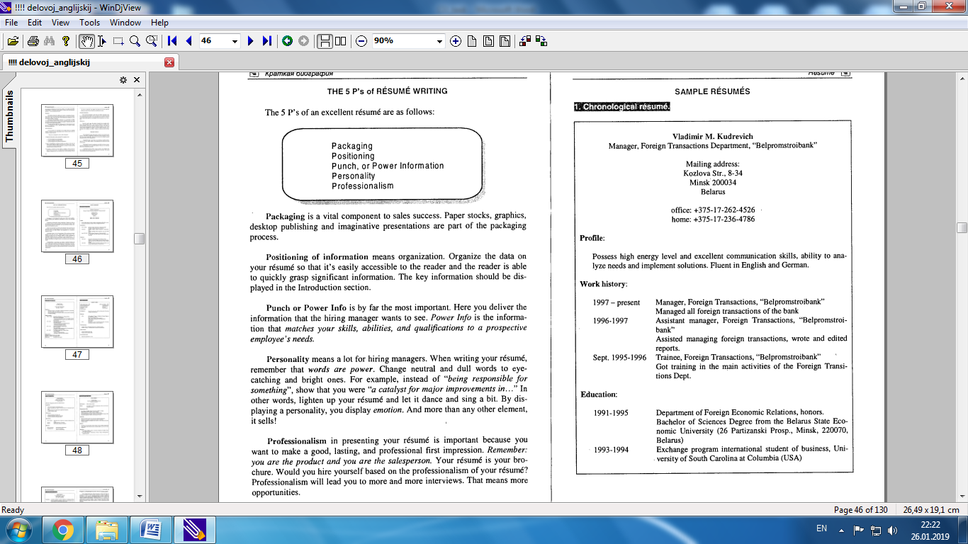

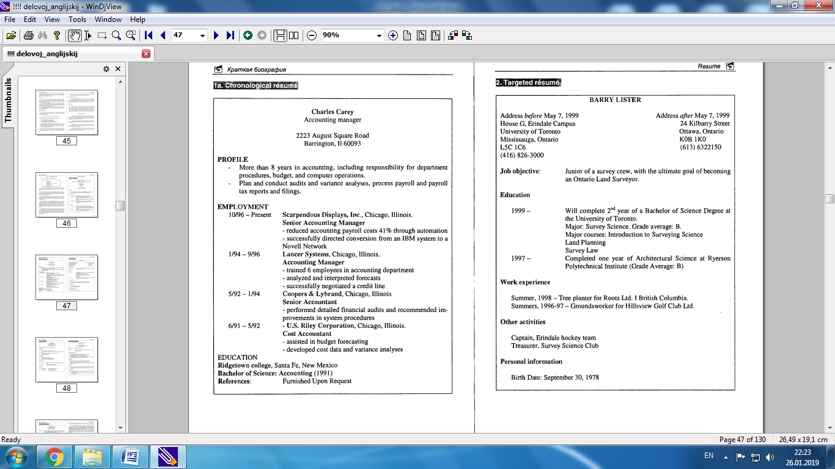

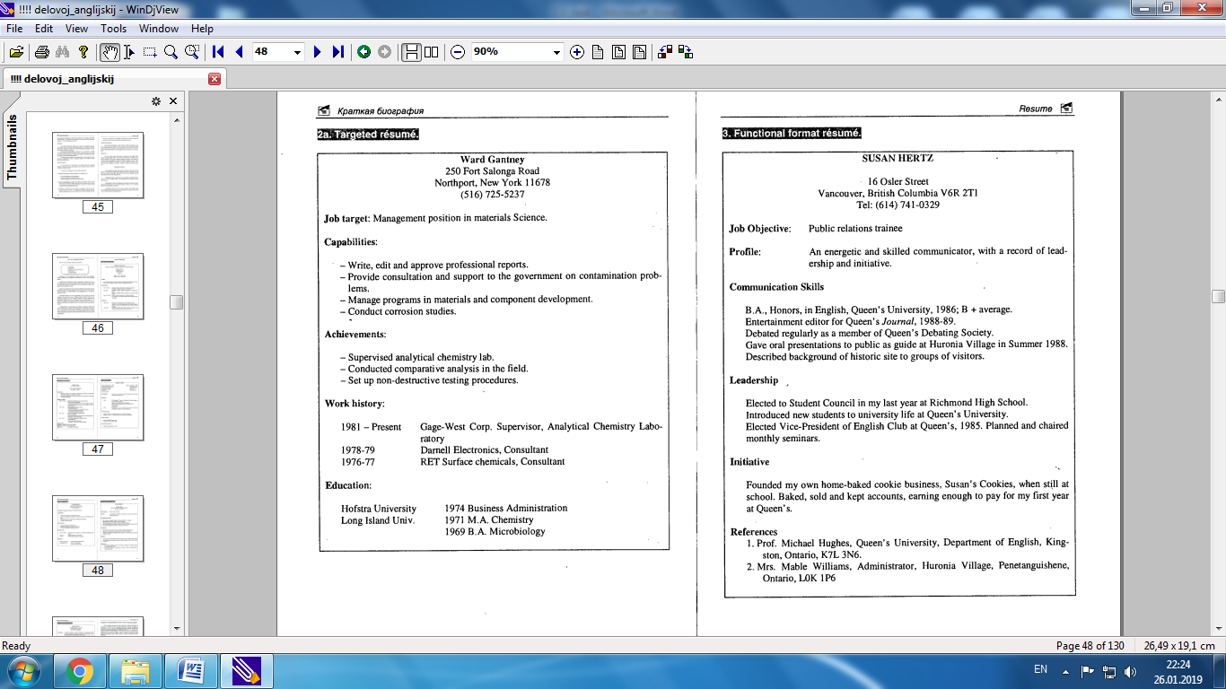

Сопроводительное письмо (Cover Letter)

Dear Mr. N:

I would like to apply for the position of senior assistant to personnel man­ager advertised in the "Daily News" on 9lh October.

A copy of my resume is enclosed. From this you will see that I am at pre­sent working as a junior assistant in the personnel department at James As­sociates. Although I enjoy my work, I feel I would now like to take on a position with more responsibility and in a larger organization.

I can be available for interview at any time, and I look forward to hearing from you.

Sincerely yours, Julia Long (Miss)

Или

