Sideways Stories from Wayside School

Joy

QUESTIONS:

- Joy had a real problem. What was it?
- What else didn’t she have? What could she have done if she had had one?
- How bad were Miss Mush’s meals?
- What had Dameon brought for lunch? What was he lacking? Why didn’t he have to worry about getting that from Miss Mush? So, where did he go?
- At this moment, Joy saw an opportunity – what was it? Did she hesitate?
- What did she do first? And then? And then again? And then? Why did she do all of this? Why did she have second thoughts in the end?
- Have you ever had second thoughts about choosing to study English?
- What was left of the sandwich, the piece of cake and the apple after she had eaten them? What did she do with these things? Why?
- What did Joy start doing once Dameon had returned to his desk and noticed that his lunch was missing?
- Why did Calvin, Jason, Allison and Deedee seem to be guilty?
- What did Mrs. Jewls do each time Joy told on them?
- How did Allison react to being accused of eating Dameon’s cake?
- Why did Mrs. Jewls think that Dameon ought to thank Joy?
- What did Louis bring Joy at this point? How had he gotten it? What had Joy done with it?
- What was in Joy’s lunch? Did it match what he had had in his?
- What did Joy do with her lunch? How did Mrs. Jewls reward her? Why?
- What did Joy help herself to when Mrs. Jewls wasn’t looking?
- What happened at two o’clock to the names that Mrs. Jewls had written on the board? Why? Did they remember anything about what had happened?
- What kind of a lunch had Dameon had? What kind should he have had? Did it matter to him? What happened five minutes after he finished it?
- How about Joy? How did she feel five minutes after she had finished eating? And how did she feel at dinnertime?
- But then what horrible thing happened? Was it worse than what would have happened if she had gone without lunch?
- What is the moral of this story?

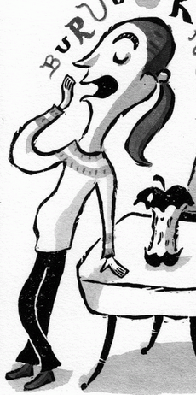
meal ticket –
a ticket or card that allows someone to eat a meal or meals, for example in a hall of residence at a university

mush –
1 [SINGULAR/UNCOUNTABLE] a thick soft substance
The potatoes will turn to mush if they are overcooked.
2 AMERICAN a thick food made
by boiling maize flour with water or milk, eaten at breakfast

have second thoughts–
to consider changing a decision you have already made; if you have second thoughts about something, you change your opinion or start to have doubts about it (often + about)
You're not having second thoughts about coming to Brighton with me, are you?

Baggie–
a brand of plastic bag, manufactured in various sizes, as for preserving food or holding trash; a variety of thin, strong, sealable plastic bag, used primarily for storing food

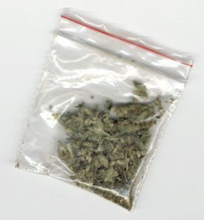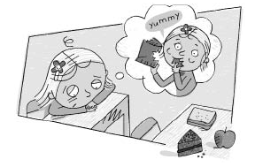

Dick Goodwin
- I remember five-six years ago my uncle Harold told my aunt about this affair he had. It was a sort of mildly upsetting event in my family... The affair was over, something like eight years. So I remember asking him, "Why did you tell her? You got away with it." And I'll never forget what he said. It was the getting away with it part that he couldn't live with.

