Sideways Stories from Wayside School

Nancy

QUESTIONS:

- What was special about Nancy’s hands and feet? How was he different from Ron?
- How did he feel about his name? Did it bother any of the other students in the class?
- What kind of a person was he? Did this affect his social life?
- Who was his one friend? Why were they friends? What did they call each other? Why was he afraid to ask her what her name was? What puzzled him about her? What was he happy to do?
- What happened one morning when the two of them were late for school?
- What did her teacher call her? How did she react? What did this teacher tell her to do (in two different ways)?
- What did she do after Mac repeated her name?
- What did she look like? What did she have on her face?
- Why had Nancy’s mother given him such a name? Who was he named after? How about Mac?
- What did the two of them decide to do? How did they do it?
- What did Mac do once he entered Mrs. Jewls’s classroom? How did he explain what had happened? What did some of the students say to him?
- How did things turn out after this? What did everybody else in the class want to do? What did they do to make this happen? What was the result?
- How long did the confusion last? How did they finally start working out exactly who was who? How did they figure out who was Rondi? Allison? Mrs. Jewls?
- What problem did they have with the Erics?
- What did they all decide to do in the end? Why?
- Did Mac and Nancy keep their new names? What did they call each other?
- Do you like your name? If you wanted to change it, what other name would you choose?

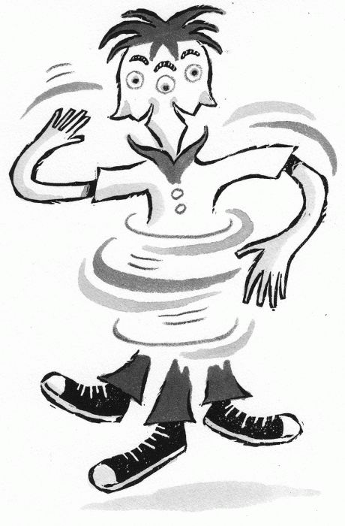

Nancy
- Nancy doesn't like his name. He thinks it's a girl's name. None of the other kids think Nancy's name is strange, but Nancy is really self-conscious about it—so he's quiet and shy and never says anything. His only friend is a girl who goes to class on the twenty-third story of Wayside School.
- Nancy and his friend are happy not knowing each other's names. They call each other "'Hey, You' or just plain 'You'" (28.4).
- One day, Nancy's friend is late to class and he overhears her teacher call his friend "Mac." Mac is mortified that Nancy has found out, but Nancy calls after her and tells her his name: "I was ashamed to tell you my name" (28.13), she says.
- They bond over their mutual hatred of their own names—Nancy was named for a favorite aunt, and Mac a beloved dog—and decide to trade names. Apparently the best way to do this is to spin around "one hundred times in opposite directions" (28.24) until they fall over.
- When Nancy—now Mac—goes back to class, he doesn't feel shy anymore. He introduces himself as Mac, and everyone in the class starts to think that this trading names idea sounds pretty cool. They all decide to trade names with each other, spin around, and fall over, but… "when they stood up again, no one knew who anybody was" (28.43). Oops.
- They argue over whose names are whose for over an hour, until someone finally figures out who Rondi is because she's missing two teeth. From there they start to figure out the other students, and also Mrs. Jewls, who's the oldest.
- To avoid further confusion, everyone decides to keep his own name.
- Mac and Nancy are the only ones who keep their new names, but since old habits die hard, whenever they get together they still call each other "Hey, You" or just plain "you."

I'd love to see Nancy more popularised as a male name - a good friend of mine is a lovely man named Nancy, and he's never teased or anything for it. I mean ...

