MATHEMATICS
PRACTICE TEST

PRACTICE QUESTIONS
Here are some practice examples to show you what the questions on the real test are like.

Practice Example 1

5 + 2 =

A: 5 B: 6 C: 7 D: 8 E: None of these

Practice Example 2

Which is the largest number?

A: 403 B: 4600 C: 406 D: 4060 E: None of these

Practice Example 3
4879

What value does the circled number in the number above represent?

A: 4879 B: 700 C: 70 D: 7 E: None of these

You will have 30 minutes to do as many questions as you can.

NO CALCULATORS PERMITTED FOR THIS TEST.

PLEASE DO NOT TURN THIS PAGE UNTIL YOU ARE ASKED TO DO SO.

Question 1

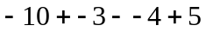

A: 2 B: – 12 C: – 4 D: 16 E: None of these

Question 2

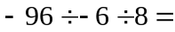

A: 2 B: 12 C: – 12 D: – 2 E: None of these

Question 3

Jo bought a used car for $6000 and paid 15% deposit. How much did he still have to pay?

A: $900 B: $5000 C: $4500 D: $5100 E: None of these

Question 4

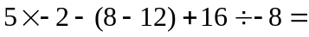

A: 6 B: – 8 C: – 16 D: – 6 E: None of these

Question 5

What is 8% of $600?

A: $580 B: $480 C: $48 D: $58 E: None of these

Question 6

Which is the longest distance?

A: 3500cm B: 65.5m C: 75000mm D: 15.5m E: 0.1km

Question 7

The perimeter of the shape is

12cm
10cm
25cm

A: 47cm B: 72cm C: 69cm D: 94cm E: Not enough
information to find perimeter

Question 8

If the length of the shorter arc is 22cm and C is the centre of the circle then the circumference of the circle is:

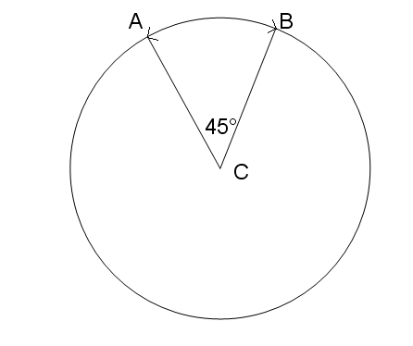

A: 990cm B: 67cm C: 176cm D: 88cm E: None of these

Question 9

If 2 fligs make a flog and 3 flogs make a flug, how many fligs in 12 flugs?

A: 72 B: 17 C: 36 D: 34 E: None of these

Question 10

If 2 ¹/₃ : 4 ¹/₃ then 7: =

A: 12 B: 13 C: 8 ²/₃ D: 6 ¹/₃ E: None of these

Question 11

Concrete is made by mixing screenings cement and sand in the ratio 3:1:15. How much sand would be needed to make 125 tonnes of concrete?

A: 27 tonnes B: 33.75 tonnes C: 45 tonnes D: 75 tonnes E: None of these

Question 12
a°
87°
127°

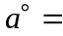

A: 53 B: 40 C: 93 D: 146 E: None of these

Question 13

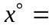

56°

A: 124 B: 304 C: 54 D: 66 E: None of these

Use the following graph to answer questions 14 and 15

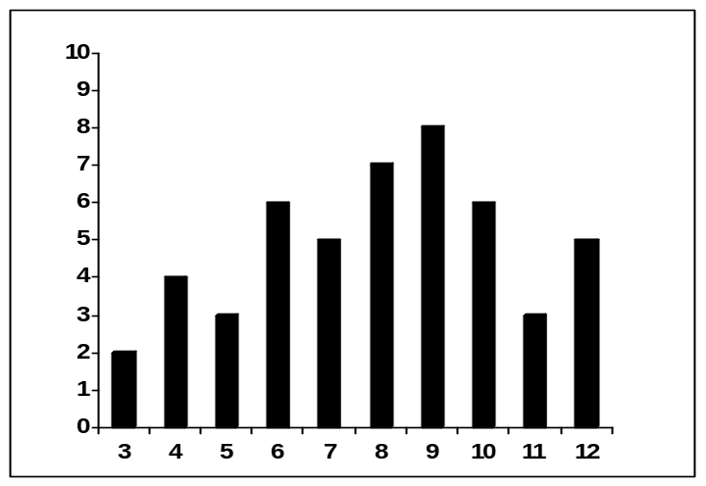
Frequency
Hours of Study
The graph shows the number of hours a year 8 group spent doing homework for one week.

Question 14

How many students studied for more than 8 hours in the week?

A: 22 B: 29 C: 42 D: 50 E: None of these

Question 15

How many students studied for 6 hours or less per week?

A: 9 B: 18 C: 15 D: 12 E: None of these

Question 16

Two six sided dice are thrown together. What is the probability that a total of 10 is thrown?

A: ¹/₆ B: ¹/₁₂ C: ¹/₂ D: ⁵/₆ E: None of these

Question 17

The gradient of the line is

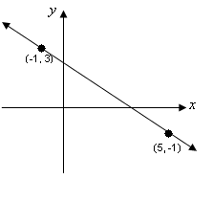
A:  B:  C: 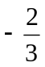 D: 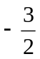 E: None of these

Question 18

The y intercept of the graph could only be:

A: 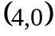 B: 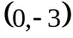 C: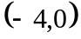 D: 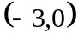 E: 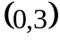

Question 19

Which inequation shows the following statement?

x is 6 or less and more than – 5

A: – 5 < ≤ 6 B: – 5 > ≤ 6 C: – 5 ≤ ≤ 6 D: – 5 < < 6 E: – 5 ≤ < 6

Question 20

Expand and simplify
– 6 (2x – 3) – 11

A: 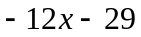 B: 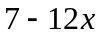 C: 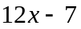 D: 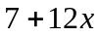 E: None of these

Question 21

Which option would make this solid?

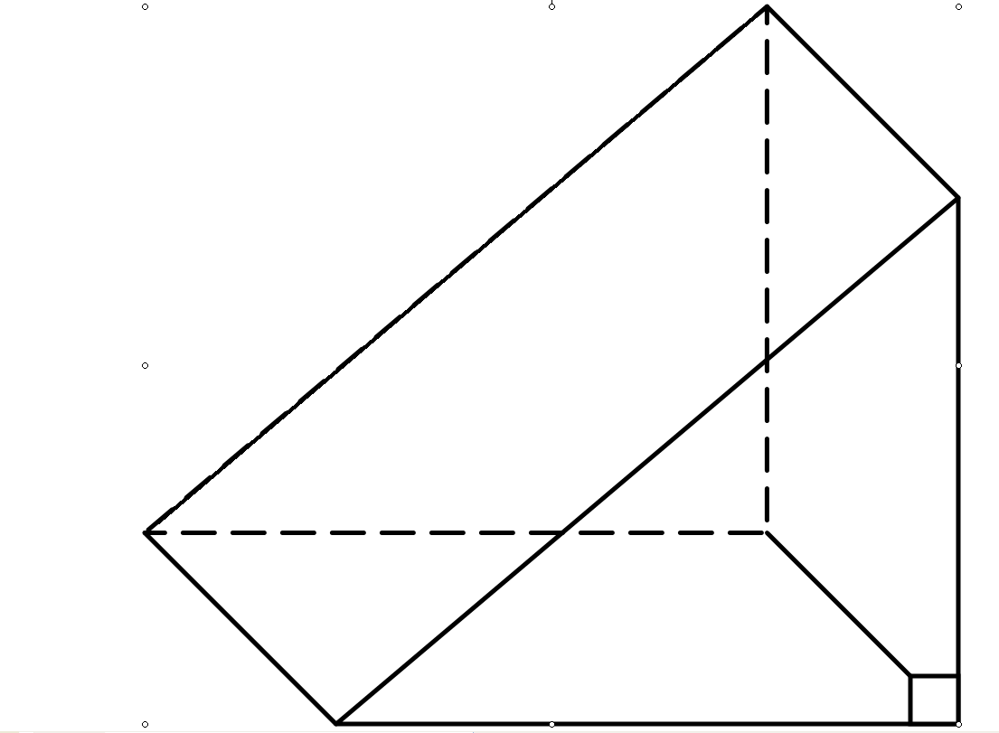

A: B:
C: D:

E: None of the nets would make the solid

Question 22

The diagram shows a small rectangular field. If Linda runs from A to B to D to C to A, how far does she run?
40m
C
B

A
D
30m

A: 120m B: 160m C: 140m D: 150m E: None of these

Question 23
Simplify the surd 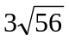 completely

A: 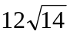 B: 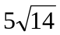 C: 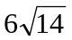 D: 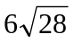 E: None of these

Question 24

The length of equals
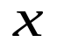
A: 6cm
5cm
4cm
3cm

B: 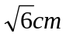

C: 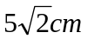

D: 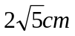
E: None of these

Question 25

The rectangle box has dimensions as shown. What is the length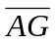?
D
E
B
F
C
G
H
A
6cm
2cm
8cm
A: 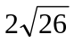

B: 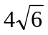

C: 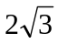

D: 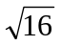

E: None of these

Question 26

Sam bought a car valued at $7700. One year later the car’s value had decreased by ²/_{7.} What is the new value of the car?

A: $2200 B: $5500 C: $9900 D: $4400 E: None of these

Question 27

If Density = Mass ÷ Volume, what is the Mass of the solid in the diagram if its Density is 1.2gm / cm^{3?}
2cm

5cm
6cm
A: 50gm

B: 60gm

C: 72gm

D: 38.4gm

E: None of these

Question 28

What is the speed in m/s of a car that travels 30km in 20 minutes?

A: 1500 m/s B: 150 m/s C: 90 m/s D: 540 m/s E: None of these

Question 29

If R = 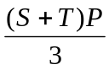 then equals

A: 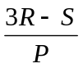 B: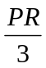 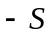 C: 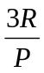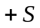 D: 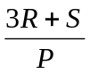 E:

Question 30

Solve the inequation for

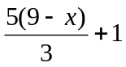< 11
A: < 3 B: > 3 C: > – 3 D: > 1⁴/₅ E: None of these

Question 31

Solve for

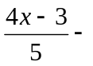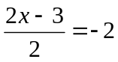

A: 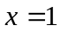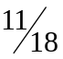 B: 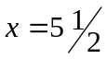 C: 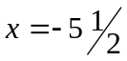 D: 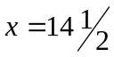 E: 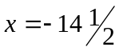

Question 32

Which equation could only be the equation of the graph?

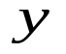
A: 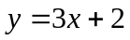

B: 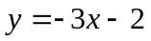

C: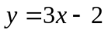

D: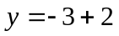

E: 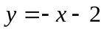

Question 33

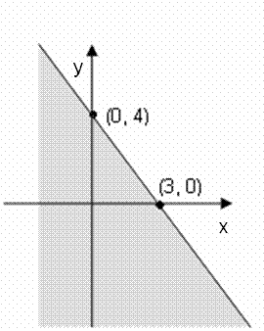
Which set of coordinates lie outside the shaded area?
A: 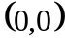

B: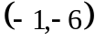

C: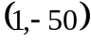

D: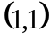

E: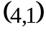
Question 34

The equation of this graph is:
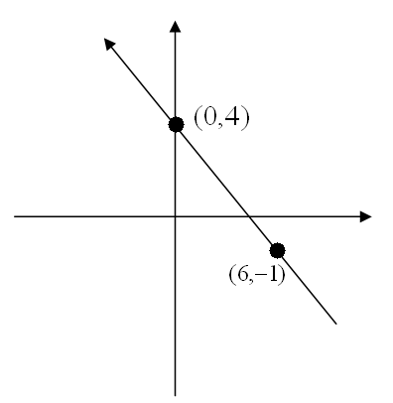
A: 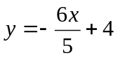

B: 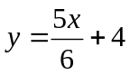

C: 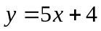
D: 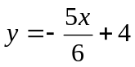
E: 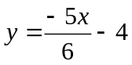

Question 35

The coordinates of the point of intersection for the two graphs could only be:
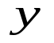
A: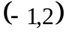

B: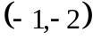

C: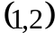

D: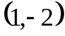

E: 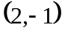

Question 36
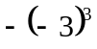 =

A: - 9 B: 27 C: 9 D: -27 E: None of these

Question 37
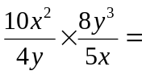
A: 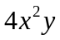 B: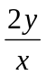 C: 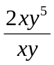 D: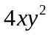 E: None of these

Question 38
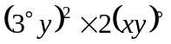

A: 18y² B: 36xy³ C: 2y² D: 6xy² E: None of these

Question 39

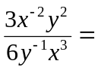
A: 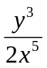 B: 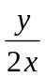 C: 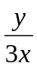 D: 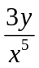 E 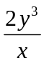

Question 40
Which is not the same as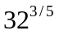?

A: 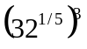 B: 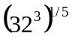 C: 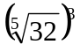 D: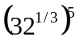 E: 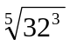

Use the Venn diagram to answer questions 41, 42 and 43
5
F
S
7
10
6

The diagram shows a class of music students and
instruments they learn.

S = Saxophone
F = Flute

Question 41

What is the total number of students in the class?

A: 33 B: 22 C: 17 D: 23 E: 28

Question 42

How many students learnt neither saxophone nor flute?

A: 5 B: 6 C: 7 D: 10 E: None of these

Question 43

How many students learnt just the saxophone or the flute?

A: 12 B: 22 C: 17 D: 15 E: None of these

Question 44

Which is the best cumulative frequency graph for the histogram?
Score
Frequency

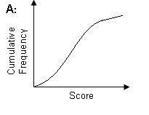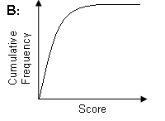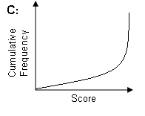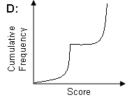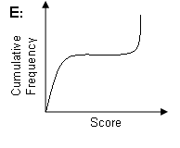

Question 45

Jack’s Dad invested some money and for every $12 he invested he got a total of $15 back. If Jack’s Dad invested $300, how much in total did he get back?

A: $225 B: $525 C: $480 D: $375 E: None of these

Question 46

Expand the brackets and simplify

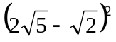

A: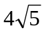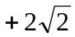 B: 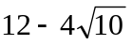 C: 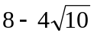 D: 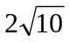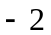 E: None of these

Question 47

Rationalise and simplify 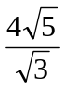
A:  B: 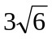 C: 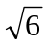 D: 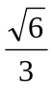 E: None of these

Question 48

If 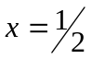 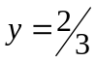 and 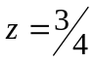 evaluate

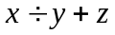

A: 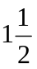 B: 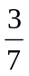 C: 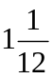 D: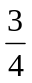 E: None of these

Question 49

Expand and simplify

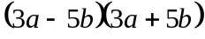

A: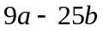 B: 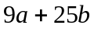 C: 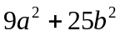 D: 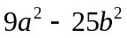 E: None of these

Question 50

Factorise and simplify

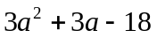

A: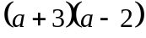 B: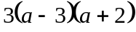 C: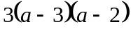 D: 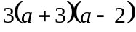 E: None of these

Question 51

Simplify 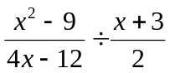

A: 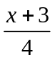 B:  C: 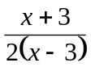 D: 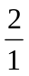 E: None of these

Question 52

The correct ratio to find is:
6
15
72°

A: 6 Cos 72° B: 6 Tan 72° C: 15 Sin 18° D: 15 Sin 72° E: 15 Cos 18°
72°

Question 53

The turning point of the graph could only be:

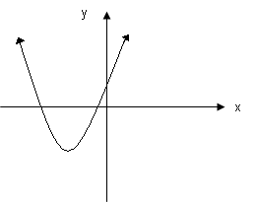

A: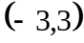 B: 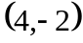 C: 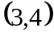 D: 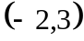 E: 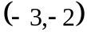

Question 54

A number is subtracted from two times its square and the result is 45. An equation to find the value of would be:

A: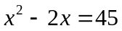 B: 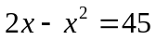 C: 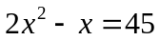 D: 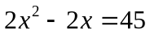 E: 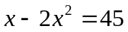

Question 55

Find the points of intersection of the graphs of y = x² and y = 3x – 2.

A: 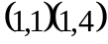 B: 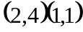 C: 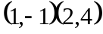 D: 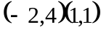 E: None of these

Use the graph to answer questions 56, 57 & 58

The graph shows the price paid and weight for bags of sugar bought at different shops.

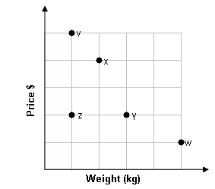

Question 56

Which shop gave the worst value for money?

A: Shop z B: Shop y C: Shop x D: Shop w E: Shop v

Question 57

Which two shops charged the same price per kilogram?

A: Shops z & x B: Shops z & v C: Shops y & z D: Shops v & w E: Shops x & y

Question 58

At which shop would you get three times the amount of sugar for the same price as shop z?

A: Shop v B: Shop x C: Shop w D: Shop y E: None of these

Question 59

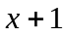
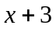
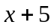

A: 4 B: 5 C: 6 D: 3 E: None of these

Question 60

Factorise 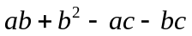

A: 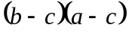 B: 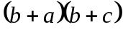 C: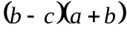 D: 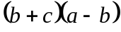 E: 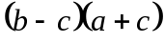

WELL DONE. THIS IS THE END OF THE TEST.

IF YOU STILL HAVE TIME LEFT, PLEASE CHECK OVER YOUR ANSWERS.

