1. Creating “Hello world” Application.
   1. Click **Start** →**Android Studio**, a **Welcome to Android Studio** dialog box will appear. Click **New Project**, the **New Project Dialog box** appears.
   2. Choose **Empty Views Activity** then click **Next**.
   3. Specify the **Name** of your project, Select the **Language** as **Java**, and Select the

**Minimum SDK** as **API 16 (“Jelly Bean”, Android 4.1)**. Click **Finish** Button.

* 1. Create a **Button** resource in **activity_main.xml** and update the following code

*<?*xml version="1.0" encoding="utf-8"*?>*

<androidx.constraintlayout.widget.ConstraintLayout xmlns:andr[oid="htt](http://schemas.android.com/apk/res/android)p:/[/sc](http://schemas.android.com/apk/res/android)he[mas.android.com/apk/res/android"](http://schemas.android.com/apk/res/android)

xmlns:app=["http://sc](http://schemas.android.com/apk/res-auto)h[emas.android.com/apk/res-auto"](http://schemas.android.com/apk/res-auto) xmlns:t[ools="ht](http://schemas.android.com/tools)tp:/[/sc](http://schemas.android.com/tools)he[mas.android.com/tools"](http://schemas.android.com/tools) android:layout_width="match_parent" android:layout_height="match_parent" tools:context=".MainActivity">

<Button

**android:id="@+id/hello"** android:layout_width="wrap_content" android:layout_height="wrap_content" **android:background="#535538" android:text="Click Me!"** app:layout_constraintBottom_toBottomOf="parent" app:layout_constraintEnd_toEndOf="parent" app:layout_constraintStart_toStartOf="parent" app:layout_constraintTop_toTopOf="parent" />

</androidx.constraintlayout.widget.ConstraintLayout>

The following figure illustrates the design view of the application.

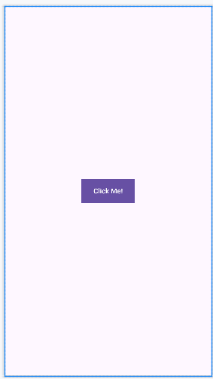

* 1. Create a **Button** object, create **clickListener**, **onClick** event and update the following code in **MainActivity.java**

package com.example.hello_world;

import androidx.appcompat.app.AppCompatActivity; import android.os.Bundle;

import android.view.View; import android.widget.Button; import android.widget.Toast;

public class MainActivity extends AppCompatActivity { @Override

protected void onCreate(Bundle savedInstanceState) { super.onCreate(savedInstanceState); setContentView(R.layout.*activity_main*);

# Button b; b=findViewById(R.id.*hello*);

**b.setOnClickListener(new View.OnClickListener() { @Override**

# public void onClick(View v) {

**Toast.*makeText*(MainActivity.this, "Hey! We are using Android Application", Toast.*LENGTH_SHORT*).show();**

}

});

}

}

* 1. Click **Run app** or **shift+F10** to execute the application.

**Output:**

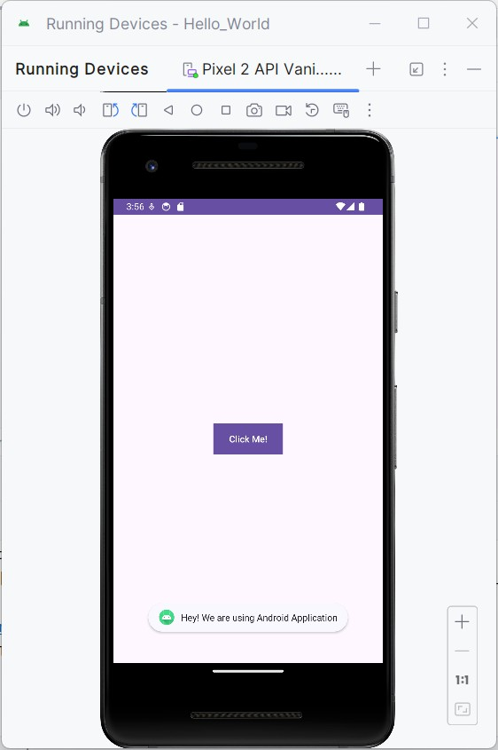

1. Creating an application that displays message based on the screen orientation.
2. Click **Start** →**Android Studio**, a **Welcome to Android Studio** dialog box will appear. Click **New Project**, the **New Project Dialog box** appears.
3. Choose **Empty Views Activity** then click **Next**.
4. Specify the **Name** of your project, Select the **Language** as **Java**, and Select the

**Minimum SDK** as **API 16 (“Jelly Bean”, Android 4.1)**. Click **Finish** Button.

1. Create two **Button** resources in **activity_main.xml** and update the following code.

<?xml version="1.0" encoding="utf-8"?>

<RelativeLayout xmlns:android=["http://schemas.android.com/](http://schemas.android.com/apk/res/android)a[pk/res/android"](http://schemas.android.com/apk/res/android) xmlns:app=["http://sc](http://schemas.android.com/apk/res-auto)h[emas.android.com/apk/res-auto"](http://schemas.android.com/apk/res-auto) xmlns:tools=["http://schemas.android.com/tool](http://schemas.android.com/tools)s"

android:id="@+id/main" android:layout_width="match_parent" android:layout_height="match_parent" tools:context=".MainActivity">

<Button

android:id="@+id/por" android:layout_width="wrap_content" android:layout_height="wrap_content" android:text="Portrait" android:layout_centerInParent="true"/>

<Button

android:id="@+id/lan" android:layout_width="wrap_content" android:layout_height="wrap_content" android:text="Landscape" android:layout_below="@id/por" android:layout_centerInParent="true"/>

</RelativeLayout>

The following figure illustrates the design view of the application.

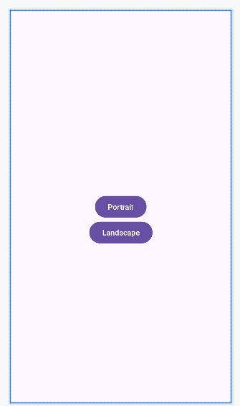

1. Create two **Button** object, create **clickListener**, **onClick** event and update the following code in **MainActivity.java**

package com.example.screen;

import android.content.pm.ActivityInfo; import android.os.Bundle;

import android.view.View; import android.widget.Button; import android.widget.Toast;

import androidx.activity.EdgeToEdge;

import androidx.appcompat.app.AppCompatActivity; import androidx.core.graphics.Insets;

import androidx.core.view.ViewCompat;

import androidx.core.view.WindowInsetsCompat; public class MainActivity extends AppCompatActivity {

@Override

protected void onCreate(Bundle savedInstanceState) { super.onCreate(savedInstanceState); EdgeToEdge.enable(this); setContentView(R.layout.activity_main);

Button l,p; l=findViewById(R.id.*lan*); p=findViewById(R.id.*por*);

l.setOnClickListener(new View.OnClickListener() { @Override

public void onClick(View v) {

setRequestedOrientation(ActivityInfo.*SCREEN_ORIENTATION_LANDSCAPE*);

Toast.*makeText*(MainActivity.this, "Hey! We are in Landscape orientation", Toast.*LENGTH_SHORT*).show();

}

});

p.setOnClickListener(new View.OnClickListener() { @Override

public void onClick(View v) {

setRequestedOrientation(ActivityInfo.*SCREEN_ORIENTATION_PORTRAIT*); Toast.*makeText*(MainActivity.this, "Hey! We are in Portrait orientation",

Toast.*LENGTH_SHORT*).show();

}

});

}

}

1. Click **Run app** or **shift+F10** to execute the application.

**Output**

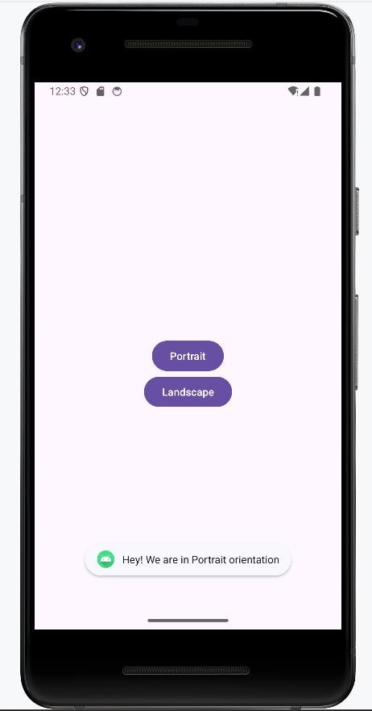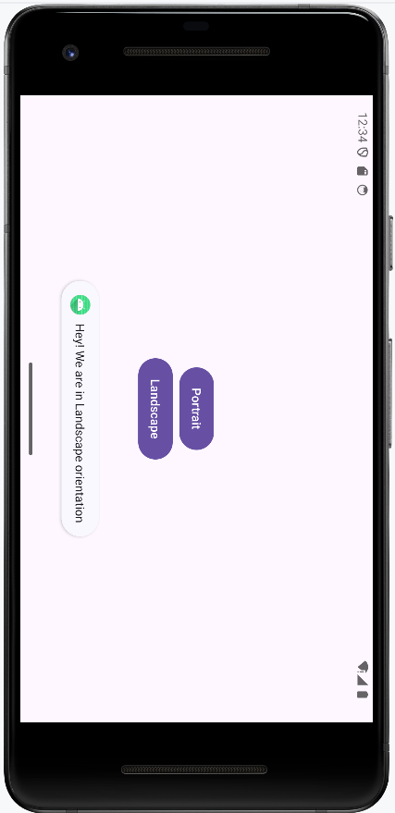

3. Create an application to develop Login window using UI controls.

1. Click **New Project**, the **New Project Dialog box** appears.
2. Choose **Empty Views Activity** then click **Next**.
3. Specify the **Name** of your project, Select the **Language** as **Java**, and Select the

**Minimum SDK** as **API 16 (“Jelly Bean”, Android 4.1)**. Click **Finish** Button.

1. Create **background** resources(**bg_outer.xml**, **bg_inner.xml**)
   1. To create resource file click **app**→**res**→**drawable.** Right click **drawable**→**New**→ **Drawable Resource File.** The **New Resource File** dialog box appears.
   2. Set **filename** as **bg_outer.xml**, **root element** as **shape** and then click **ok.**

Modify the bg_outer.xml file

<?xml version="1.0" encoding="utf-8"?>

<shape xmlns:android="[http://schemas.android.com/apk/res/android"](http://schemas.android.com/apk/res/android)>

<corners android:radius="12dp" />

<gradient android:startColor="#B388FF" android:endColor="#397C9A" android:angle="100"/>

</shape>

* 1. Likewise, create another background resource for inner layout. Set **filename** as **bg_inner.xml**, **root element** as **shape** and then click **ok.** Modify the bg_outer.xml file

<?xml version="1.0" encoding="utf-8"?>

<shape xmlns:android="[http://schemas.android.com/apk/res/android"](http://schemas.android.com/apk/res/android)>

<gradient android:startColor="#84FFFF" android:endColor="#f08" android:angle="100"/>

<corners android:radius="20dp"/>

</shape>

1. Create **two EditText box** and **a Button** resource in **activity_main.xml** and update the following code.

<?xml version="1.0" encoding="utf-8"?>

<RelativeLayout xmlns:android=["http://schemas.android.com/](http://schemas.android.com/apk/res/android)a[pk/res/android"](http://schemas.android.com/apk/res/android) xmlns:app=["http://sc](http://schemas.android.com/apk/res-auto)h[emas.android.com/apk/res-auto"](http://schemas.android.com/apk/res-auto) xmlns:tools=["http://schemas.android.com/tool](http://schemas.android.com/tools)s"

android:id="@+id/main" android:layout_width="match_parent" android:layout_height="match_parent" tools:context=".MainActivity" android:background="@drawable/bg_outer">

<LinearLayout android:layout_width="match_parent" android:layout_height="wrap_content" android:gravity="center" android:layout_centerInParent="true" android:orientation="vertical" android:background="@drawable/bg_inner" android:padding="30dp"

>

<TextView android:layout_width="wrap_content" android:layout_height="wrap_content" android:text="LOGIN PAGE" android:textSize="32sp" android:textStyle="bold"

android:fontFamily="sans-serif-condensed-medium" android:textColor="@color/black" android:paddingBottom="20dp"

/>

<EditText android:id="@+id/editTextUsername" android:layout_width="match_parent" android:layout_height="wrap_content"

android:hint="Username" android:layout_marginBottom="16dp"/>

<EditText android:id="@+id/editTextPassword" android:layout_width="match_parent" android:layout_height="wrap_content" android:hint="Password"

android:layout_below="@id/editTextUsername" android:layout_marginBottom="16dp" android:inputType="textPassword"/>

<Button

android:id="@+id/buttonLogin" android:layout_width="wrap_content" android:layout_height="wrap_content" android:text="Login" android:layout_below="@id/editTextPassword"/>

</LinearLayout>

</RelativeLayout>

The following figure illustrates the design view of the application.

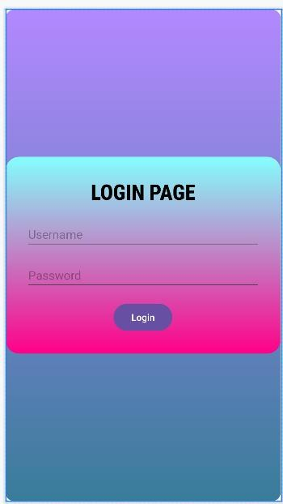

1. Create two **EditText** and a **Button** object, create **clickListener**, **onClick** event for button object and update the following code in **MainActivity.java**

package com.example.controls;

import android.os.Bundle; import android.view.View; import android.widget.Button; import android.widget.EditText; import android.widget.Toast;

import androidx.activity.EdgeToEdge;

import androidx.appcompat.app.AppCompatActivity; import androidx.core.graphics.Insets;

import androidx.core.view.ViewCompat;

import androidx.core.view.WindowInsetsCompat;

public class MainActivity extends AppCompatActivity { private EditText editTextUsername,editTextPassword; private Button buttonLogin;

@Override

protected void onCreate(Bundle savedInstanceState) { super.onCreate(savedInstanceState); EdgeToEdge.enable(this); setContentView(R.layout.activity_main);

editTextUsername = findViewById(R.id.*editTextUsername*); editTextPassword = findViewById(R.id.*editTextPassword*); buttonLogin = findViewById(R.id.*buttonLogin*); buttonLogin.setOnClickListener(new View.OnClickListener() {

@Override

public void onClick(View v) {

String username = editTextUsername.getText().toString().trim(); String password = editTextPassword.getText().toString().trim();

if(username.equals("admin") && password.equals("pass")){ Toast.*makeText*(MainActivity.this, "Login successful",

Toast.*LENGTH_SHORT*).show();

} else {

Toast.*makeText*(MainActivity.this, "Invalid username or password", Toast.*LENGTH_SHORT*).show();

}

}

});

}

}

1. Click **Run app** or **shift+F10** to execute the application.

**Output**

St. Claret College, MES Ring Road, Jalahalli, Bangalore-13

