**Web Programming Lab Manual**

**5th Semester NEP Syllabus**

**Labcycle 1:** Create a form with the elements of Textboxes, Radio buttons, Checkboxes, and so on. Write JavaScript code to validate the format in email, and mobile number in 10 characters, If a textbox has been left empty, popup an alert indicating when email, mobile number and textbox has been left empty.

<!xml version="1.0" encoding="utf-8" ?>

<!DOCTYPE html>

<head>

<title> Validate Text Boxes </title>

<script type="text/javascript">

function check()

{

var myArray=new Array();

for(var i=0;i<document.myForm.length;i++)

{

if(document.myForm.elements[i].value.length ==0)

{

myArray.push(document.myForm.elements[i].name);

}

}

if(myArray.length !=0)

{

alert("The following Text Boxes are Empty: \n" +myArray);

return false;

}

else

{

validateEmail();

validatePhoneNumber();

return false;

}

}

function validateEmail() {

var email = document.getElementById("email").value;

var pattern1 = /^[^\s@]+@[^\s@]+\.[^\s@]+$/;

var isValid = pattern1.test(email);

if (isValid) {

document.getElementById("result1").innerHTML += "Email is valid.";

} else {

document.getElementById("result1").innerHTML += "Email is invalid.";

}

}

function validatePhoneNumber() {

var Ph_number = document.getElementById("ph_no").value;

if (Ph_number.length ==10)

{

document.getElementById("result2").innerHTML += "Phone number is valid.";

}

else

{

document.getElementById("result2").innerHTML += "Phone number is invalid.";

}

}

</script>

</head>

<body>

<form name="myForm" onsubmit="return check()">

Email: <input type="text" id="email" name="Email"/>

Phone_Number:<input type="text" id="ph_no" name="Phone_Number"/>

Age: <input type="text" name="Age"/> <br/><br/>

<input type="submit" value="Send message"/> <br/><br/>

</form>

<p id="result1"></p>

<p id="result2"></p>

</body>

</html>

**Output:**

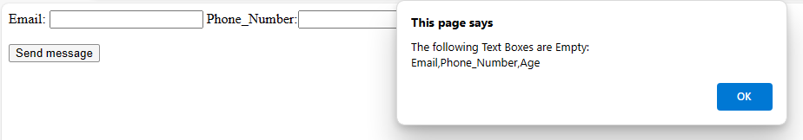

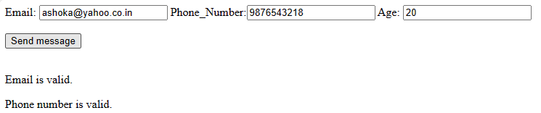

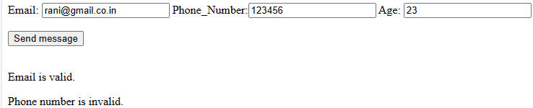

**Labcycle 2**: Develop a HTML Form, which accepts any Mathematical expression. Write JavaScript code to Evaluates the expression and Displays the result.

<!xml version="1.0" encoding="utf-8" ?>

<!DOCTYPE html>

<html xmlns="http://www.w3.org/1999/xhtml">

<head>

<meta charset="utf-8" />

<title>Expression Evaluation</title>

<script type="text/javascript">

function Evaluate()

{

var enteredExpr = document.getElementById("expr").value;

document.getElementById("result").value = eval(enteredExpr);

}

</script>

</head>

<body>

<form name="myForm">

Enter any valid expression: <input type="text" id="expr" /> <br /> <br />

<input type="button" value="Evaluate" onClick="Evaluate()" /> <br /> <br />

Result of expression: <input type="text" id="result" /> <br /> <br />

</form>

</body>

</html>

**Output:**

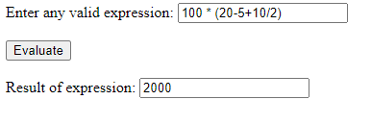

**Labcycle 3:** Create a page with dynamic effects. Write the code to include layers and basic animation.

<!xml version="1.0" encoding="utf-8" ?>

<!DOCTYPE html>

<html xmlns="http://www.w3.org/1999/xhtml">

<head>

<title> Basic Animation </title>

<style>

#layer1{position:absolute; top:50px;left:50px;}

#layer2{position:absolute; top:50px;left:400px;}

#layer3{position:absolute; top:50px;left:800px;}

</style>

<script type="text/javascript">

function moveImage(layer)

{

var top = window.prompt("Enter top value");

var left = window.prompt("Enter left value");

document.getElementById(layer).style.top =top+'px';

document.getElementById(layer).style.left =left+'px';

}

</script>

</head>

<body>

<div id="layer1"><img src="ball.jpg" onclick="moveImage('layer1')" alt="My Image."/></div>

<div id="layer2"><img src="ball.jpg" onclick="moveImage('layer2')" alt="My Image."/></div>

<div id="layer3"><img src="ball.jpg" onclick="moveImage('layer3')" alt="My Image."/></div>

</body>

</html>

**Output:**



**Labcycle 4:** Write a JavaScript code to find the sum of N natural Numbers. (Use userdefined function)

<html>  
<head>  
<title>JavaScript program to find the Sum of n natural numbers</title>  
</head>  
<body>  
<table>  
<tr>  
<td> <input type="text" name="a" id="first" placeholder="Enter a number"/> </td>  
</tr>  
<tr>  
<td> <button onclick="sum ()">Submit</button></td>  
</tr>  
</table>  
<div id="num"></div>  
</body>  
  
<script type="text/javascript">  
function sum()  
{  
var n,i, sum = 0;  
n = parseInt(document.getElementById ("first").value);  
for (i = 1; i <= n; i++)  
{  
sum = sum+i;  
}  
document.getElementById ("num").innerHTML="Sum of "+n+ " natural numbers is :"+sum;  
}  
</script>  
</html>

**Output:**

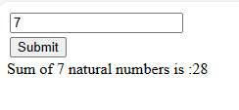

**Labcycle 5:** Write a JavaScript code block using arrays and generate the current date in words, this should include the day, month and year.

<!xml version="1.0" encoding="utf-8" ?>

<!DOCTYPE html>

<html xmlns="http://www.w3.org/1999/xhtml">

<head>

<title>Date Display</title>

<script type="text/javascript">

var days = [ "First" , "Second" , "Third" , "Fourth" , "Fifth" , "Sixth" , "Seventh" , "Eighth" , "Ninth" , "Tenth" , "Eleventh" , "Twelfth" , "Thirteenth" , "Fourteenth" , "Fifteenth" , "Sixteenth" , "Seventeenth" , "Eighteenth" , "Ninteenth" , "Twentyeth" , "TwentyFirst" , "TwentySecond" , "TwentyThird" , "TwentyFourth" , "TwentyFifth" , "TwentySixth" , "TwentySeventh" , "TwentyEighth" , "TwentyNinth" , "Thirtyeth" , "ThirtyFirst"];

var months = [ "January" , "February" , "March" , "April" , "May" , "June" , "July" , "August" , "September" , "October" , "November" , "December" ];

var year = "Two Thousand Twenty Three";

var dateObj = new Date();

var currMonth = dateObj.getMonth();

var currDate = dateObj.getDate();

var currYear = dateObj.getFullYear();

if (currYear == 2023)

alert ("Today's Date is : " + days [ currDate - 1 ] + " " + months [ currMonth ] + " " + year );

else

alert ("Today's Date is : " + days [ currDate - 1 ] + " " + months [ currMonth ] + " " + currYear );

</script>

</head>

<body>

</body>

</html>

**Output:**



**Labcycle 6:** Create a form for Student information. Write JavaScript code to find Total, Average, Result and Grade.

<!xml version="1.0" encoding="utf-8" ?>

<!DOCTYPE html>

<html xmlns="http://www.w3.org/1999/xhtml">

<head>

<title>Student Data Example</title>

<script type="text/javascript">

function showResult()

{

var name = document.getElementById ( "name" ) .value;

var cls = document.getElementById ( "class" ) .value;

var marks1 = parseInt ( document.getElementById ("sub1").value );

var marks2 = parseInt ( document.getElementById ("sub2").value );

var marks3 = parseInt ( document.getElementById ("sub3").value );

var total = marks1 + marks2 + marks3;

var avg = total / 3;

var grade, result;

if ( avg >= 60 )

{

grade = "A";

result = "First Class";

}

else if ( avg < 60 && avg >= 50 )

{

grade = "B";

result = "Second Class";

}

else if ( avg < 50 && avg >= 40 )

{

grade = "C";

result = "Third Class";

}

else

{

grade = "D";

result = "Fail";

}

document.write( "<h2> Results </h2>" );

document.write( "<b> Name: " + name + " </b> <br />" );

document.write( "<b> Class: " + cls + " </b> <br />" );

document.write( "<b> Total Marks: " + total + " </b> <br />" );

document.write( "<b> Average: " + avg + " </b> <br />" );

document.write( "<b> Grade: " + grade + " </b> <br />" );

document.write( "<b> Result: " + result + " </b> <br />" );

}

</script>

</head>

<body>

<form>

<table border="5">

<tr>

<th align="center" colspan="2">Student Details</th>

</tr>

<tr>

<td>Student Name: </td>

<td><input type="text" id="name" /></td>

</tr>

<tr>

<td>Student Class: </td>

<td><input type="text" id="class" /></td>

</tr>

<tr>

<td>Student Marks1: </td>

<td><input type="number" id="sub1" /></td>

</tr>

<tr>

<td>Student Marks2: </td>

<td><input type="number" id="sub2" /></td>

</tr>

<tr>

<td>Student Marks3: </td>

<td><input type="number" id="sub3" /></td>

</tr>

</table>

<input type="button" value="View Results" onClick="showResult()" />

</form>

</body>

</html>

**Output:**

 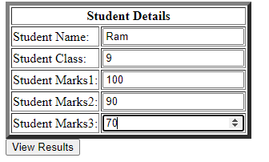

**Labcycle 7:** Create a form for Employee information. Write JavaScript code to find DA, HRA, PF, TAX, Gross pay, Deduction and Net pay.

<!xml version="1.0" encoding="utf-8" ?>

<!DOCTYPE html>

<html xmlns="http://www.w3.org/1999/xhtml">

<head>

<title>Employee Salary Details</title>

<script type="text/javascript">

function showSalary()

{

var empname = document.getElementById ( "empname" ) .value;

var empno = document.getElementById ( "empno" ) .value;

var basic = parseInt ( document.getElementById ( "basic" ) .value );

var hra = basic * 0.4;

var da = basic * 0.6;

var gross = basic + hra + da;

var pf = gross * 0.13;

var tax = gross * 0.2;

var deductions = pf + tax;

var netsalary = gross - deductions;

document.writeln ( " <table border='5'> ");

document.writeln ( " <tr> <th> Employee Salary Details </th> </tr> ");

document.writeln ( " <tr> <td> Emp Name: </td> <td> " + empname + " </td> </tr> ");

document.writeln ( " <tr> <td> Emp No: </td> <td> " + empno + " </td> </tr> " );

document.writeln ( " <tr> <td> Basic Salary: </td> <td> " + basic + " </td> </tr> " );

document.writeln ( " <tr> <td> HRA: </td> <td> " + hra + " </td> </tr> " );

document.writeln ( " <tr> <td> DA: </td> <td> " + da + " </td> </tr> " );

document.writeln ( " <tr> <td> Gross Salary: </td> <td> " + gross + " </td> </tr> " );

document.writeln ( " <tr> <td> PF: </td> <td> " + pf + " </td> </tr> " );

document.writeln ( " <tr> <td> Tax: </td> <td> " + tax + " </td> </tr> " );

document.writeln ( " <tr> <td> Deductions: </td> <td> " + deductions + " </td> </tr> " );

document.writeln ( " <tr> <td> Net Salary: </td> <td> " + netsalary + " </td> </tr> " );

}

</script>

</head>

<body>

<form>

<table border="5">

<tr>

<th> Employee Details </th>

</tr>

<tr>

<th> Employee Name: </th>

<td> <input type="text" id="empname" /> </td>

</tr>

<tr>

<th> Employee No: </th>

<td> <input type="text" id="empno" /> </td>

</tr>

<tr>

<th> Basic Pay: </th>

<td> <input type="number" id="basic" /> </td>

</tr>

</table>

<br /><input type="button" value="Show Salary Details" onClick="showSalary()" />

</form>

</body>

</html>

**Output:**

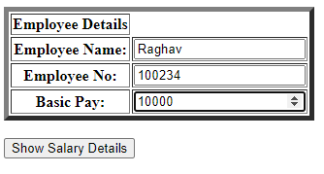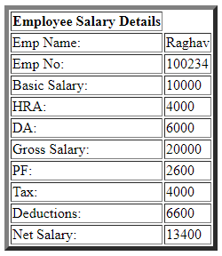

**Labcycle 8:** Write a program in PHP to change background color based on day of the week using if else if statements and using arrays .

**Labcycle8.html**

<html>

<head>

<title> Background color </title>

</head>

<body>

<form action="http://localhost/bgcolor2.php" method="post">

<p>

<input type="submit" value="Click here" />

</p>

</form>

</body>

</html>

**Labcycle8.php**

<?php

$today = date("l");

print("$today");

if($today == "Sunday")

{

$bgcolor = "#ffffff";

}

elseif($today == "Monday")

{

$bgcolor = "#ffff00";

}

elseif($today == "Tuesday")

{

$bgcolor = "#ff00ff";

}

elseif($today == "Wednesday")

{

$bgcolor = "#00ffff";

}

elseif($today == "Thursday")

{

$bgcolor = "#ff0000";

}

elseif($today == "Friday")

{

$bgcolor = "#00ff00";

}

else

{ // Only Saturday remains

$bgcolor = "#0000ff";

}

print("<body bgcolor=\"$bgcolor\">\n");

?>

**Labcycle 9:** Write a simple program in PHP for i) generating Prime number ii) generate Fibonacci series.

**Labcycle9a.html**

<html>

<head>

<title> Background color </title>

</head>

<body>

<form action="http://localhost/labcycle9a.php" method="post">

<p>

<input type="submit" value="Click to generate prime numbers from 1 to 100" />

</p>

</form>

</body>

</html>

**Labcycle9a.php**

<?php

$count = 0 ;

$number = 2 ;

while ($count < 20 )

{

$div_count=0;

for ( $i=1;$i<=$number;$i++)

{

if (($number%$i)==0)

{

$div_count++;

}

}

if ($div_count<3)

{

echo $number." , ";

$count=$count+1;

}

$number=$number+1;

}

?>

**Output**:



**Labcycle9b**: generate Fibonacci series.

**Labcycle9b.html**

<html>

<head>

<title> Background color </title>

</head>

<body>

<form action="http://localhost/labcycle9b.php" method="post">

<p>

<input type="submit" value="Generating Fibonacci numbers" />

</p>

</form>

</body>

</html>

**Labcycle9b.php:**

<?php

// PHP code to get the Fibonacci series

// Recursive function for fibonacci series.

function Fibonacci($number){

// if and else if to generate first two numbers

if ($number == 0)

return 0;

else if ($number == 1)

return 1;

// Recursive Call to get the upcoming numbers

else

return (Fibonacci($number-1) +

Fibonacci($number-2));

}

// Driver Code

$number = 10;

for ($counter = 0; $counter < $number; $counter++){

echo Fibonacci($counter),' ';

}

?>

**Labcycle 10:** Write a PHP program to remove duplicates from a sorted list

**Labcycle10.html:**

<html>

<head>

<title> Background color </title>

</head>

<body>

<form action="http://localhost/labcycle10.php" method="post">

<p>

<input type="submit" value="Click here" />

</p>

</form>

</body>

</html>

**Labcycle10.php:**

<?php

function remove_duplicates_list($list1) {

$nums_unique = array_values(array_unique($list1));

return $nums_unique ;

}

$nums = array(1,1,2,2,3,4,5,5);

print_r($nums);

echo "After removing duplicates";

print_r(remove_duplicates_list($nums));

?>

**Labcycle 11:** Write a PHP Script to print the following pattern on the Screen:

*****

****

***

**

*

**Labcycle11.php**

<?php

//Star Pyramid Size

$size = 5;

for ($i=0; $i<$size; $i++) //loop to terminate line

{

for ($j=0; $j<$i;$j++) //loop to print spaces

echo "&nbsp;&nbsp;";

for ($k=0;$k<$size-$i;$k++) //loop to print *

echo "*&nbsp;&nbsp;";

echo "<br />";

}

?>

**Labcycle11.html**

<html>

<head>

<title> Background color </title>

</head>

<body>

<form action="http://localhost/labcycle11.php" method="post">

<p>

<input type="submit" value="Click here" />

</p>

</form>

</body>

</html>

**Labcycle 12:** Write a simple program in PHP for Searching of data by different criteria.