**Phase 3: Development Part 1**

**Introduction**

In this phase 3 project the dataset of website visitors can be visualized using IBM Cognos. IBM Cognos is a business intelligence and performance management software suite developed by IBM. It is designed to help organizations make informed business decisions by providing capabilities for reporting, analytics, dashboards, scorecards, and data visualization. IBM Cognos is used by businesses and enterprises to transform data from various sources into valuable insights and actionable information.

**Visualization of data using IBM Cognos**

**Unique website visits using Pie chart**

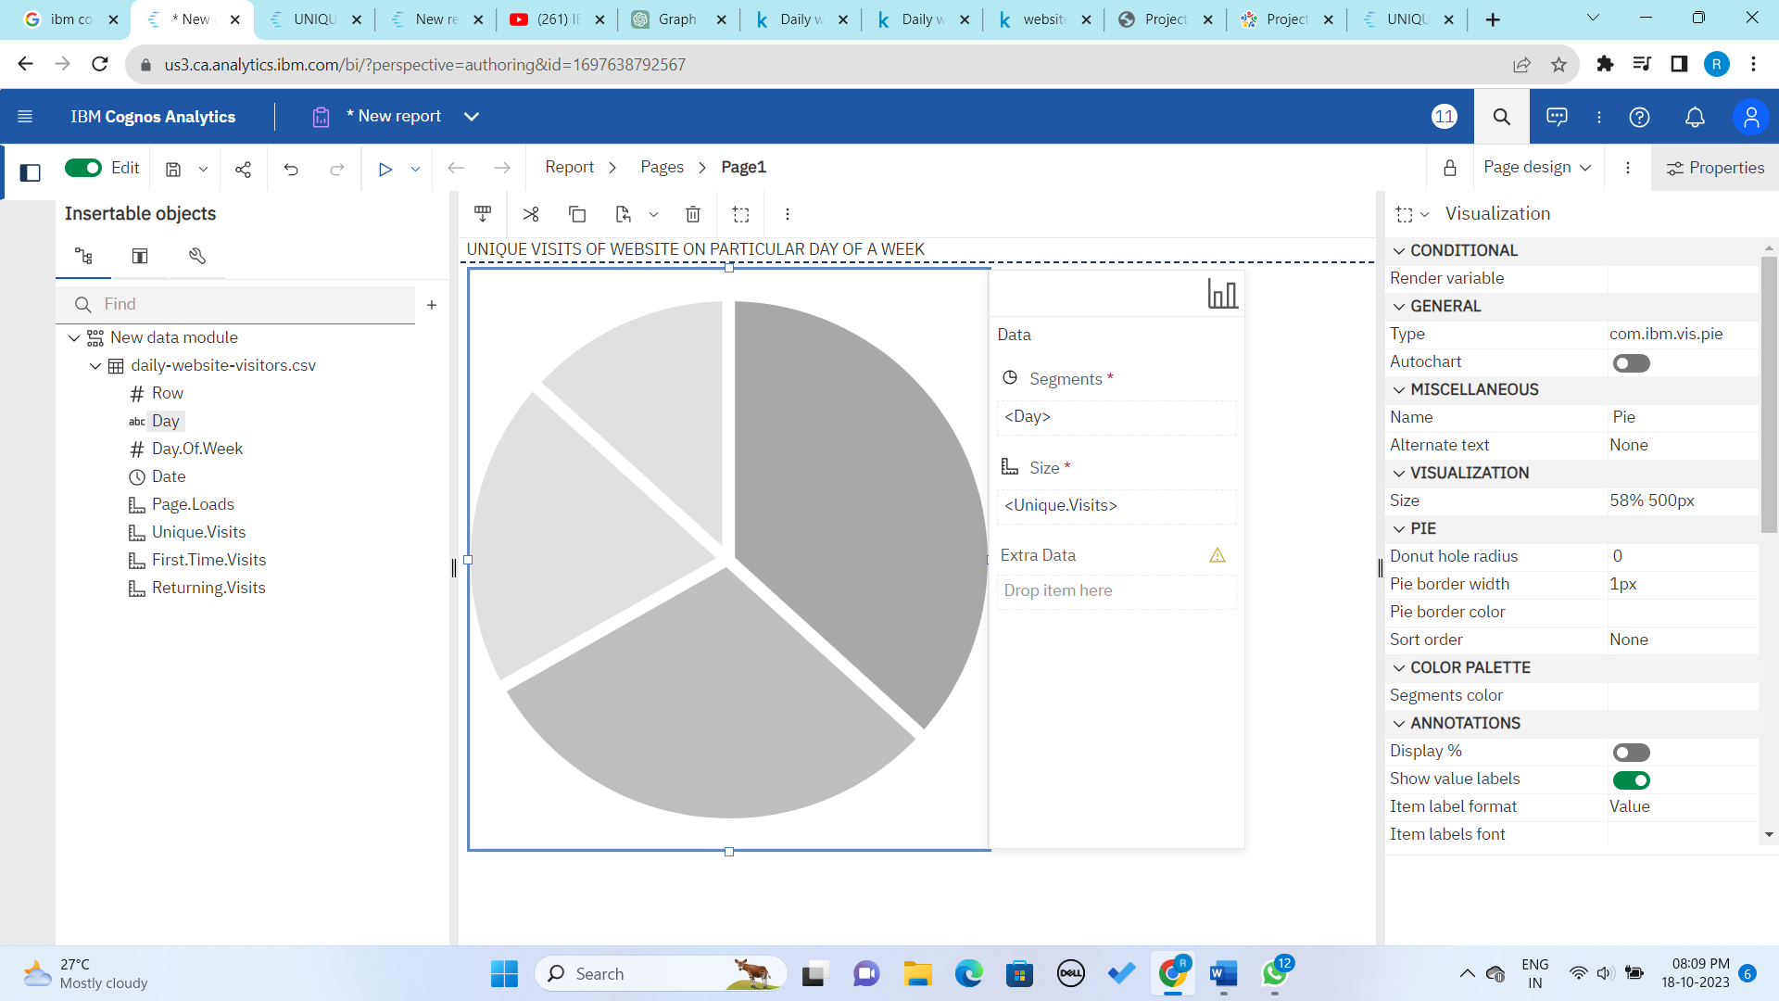

**Output:**

**Link**[**:** https://us3.ca.analytics.ibm.com/bi/?pathRef=.my_folders%2FUNIQUE%2BVISITS%2BOF%2BWEBSITE%2BON%2BPARTICULAR%2BDAY%2BOF%2BA%2BWEEK&action=run&format=HTML&prompt=false](:%20https:/us3.ca.analytics.ibm.com/bi/?pathRef=.my_folders%2FUNIQUE%2BVISITS%2BOF%2BWEBSITE%2BON%2BPARTICULAR%2BDAY%2BOF%2BA%2BWEEK&action=run&format=HTML&prompt=false)

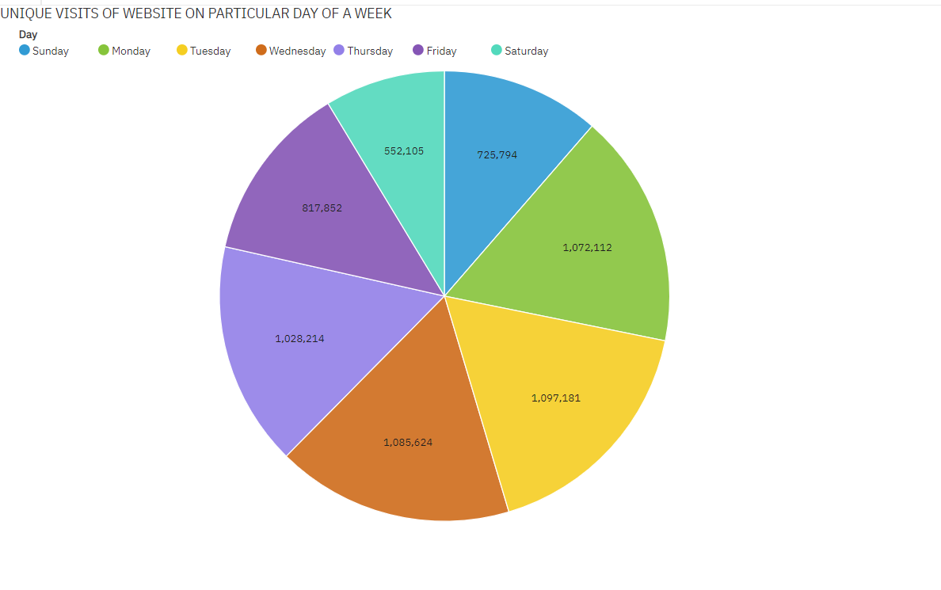

Pie charts are useful when you want to show the composition of your website traffic. From the above pie chart, we can observe that

1. Saturday has low number of unique visits
2. Tuesday has more number of unique visits

**Data preprocessing using python libraries**

The preprocessing of dataset uses libraries such as pandas, numpy etc. The basic preprocessing code of python

1. **Display the dataset**

*import pandas as pd*

*website_data=pd.read_csv("D:\Data Analytics\daily-website-visitors.csv")*

*print(website_data)*

**Output:**

Row Day Day.Of.Week Date Page.Loads Unique.Visits \

0 1 Sunday 1 9/14/2014 2,146 1,582

1 2 Monday 2 9/15/2014 3,621 2,528

2 3 Tuesday 3 9/16/2014 3,698 2,630

3 4 Wednesday 4 9/17/2014 3,667 2,614

4 5 Thursday 5 9/18/2014 3,316 2,366

... ... ... ... ... ... ...

2162 2163 Saturday 7 8/15/2020 2,221 1,696

2163 2164 Sunday 1 8/16/2020 2,724 2,037

2164 2165 Monday 2 8/17/2020 3,456 2,638

2165 2166 Tuesday 3 8/18/2020 3,581 2,683

2166 2167 Wednesday 4 8/19/2020 2,064 1,564

First.Time.Visits Returning.Visits

0 1,430 152

1 2,297 231

2 2,352 278

3 2,327 287

4 2,130 236

... ... ...

2162 1,373 323

2163 1,686 351

2164 2,181 457

2165 2,184 499

2166 1,297 267

1. **Display specified number of rows**

*import matplotlib.pyplot as plt*

*import pandas as pd*

*import seaborn as sns*

*import numpy as np*

*data=pd.read_csv("D:\Data Analytics\daily-website-visitors.csv")*

*data.head(7)*

**Output**

Row Day Day.Of.Week Date Page.Loads Unique.Visits First.Time.Visits Returning.Visits

0 1 Sunday 1 9/14/2014 2,146 1,582 1,430 152

1 2 Monday 2 9/15/2014 3,621 2,528 2,297 231

2 3 Tuesday 3 9/16/2014 3,698 2,630 2,352 278

3 4 Wednesday 4 9/17/2014 3,667 2,614 2,327 287

4 5 Thursday 5 9/18/2014 3,316 2,366 2,130 236

5 6 Friday 6 9/19/2014 2,815 1,863 1,622 241

6 7 Saturday 7 9/20/2014 1,658 1,118 985 133

1. **Remove null values**

*data=data.dropna()*

*data.isnull().sum()*

**Output**

Row 0

Day 0

Day.Of.Week 0

Date 0

Page.Loads 0

Unique.Visits 0

First.Time.Visits 0

Returning.Visits 0

dtype: int64

**Conclusion**

Thus, dataset is visualized using Cognos and preprocessing is done using python libraries.