NAME: RAKSHA R POOJARY
CLASS : AIML-C
SRN: PES2UG24AM214

Terminal1: 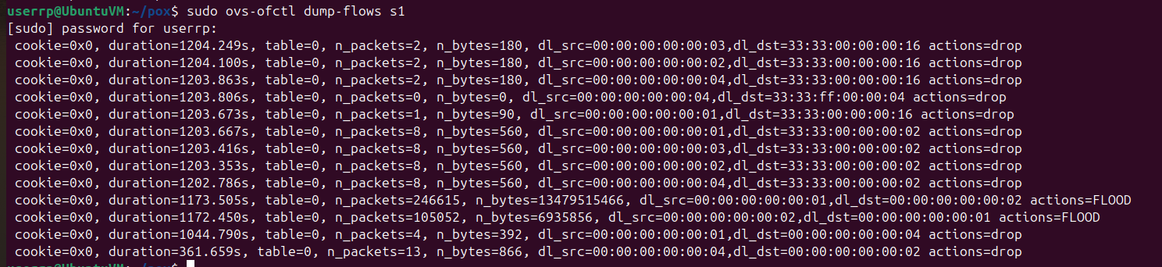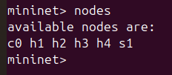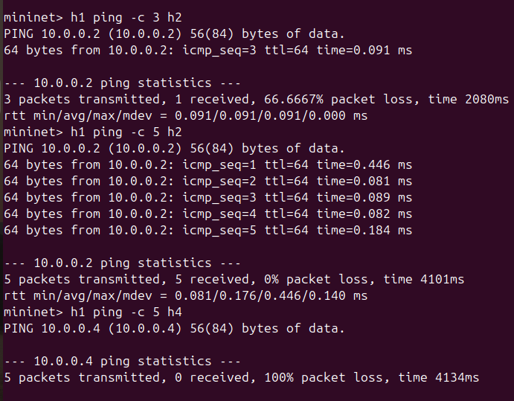
Terminal 2: ( run the pox controller)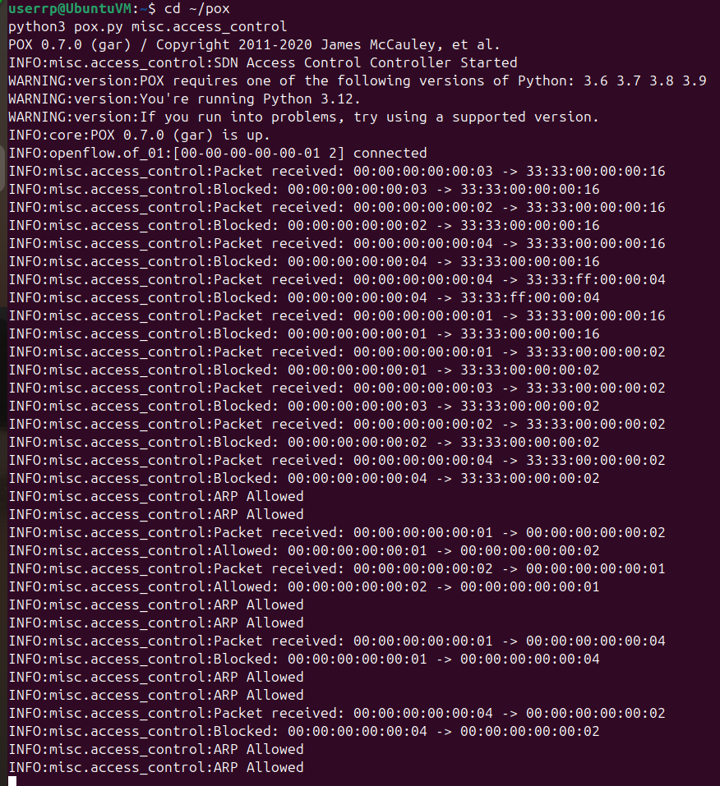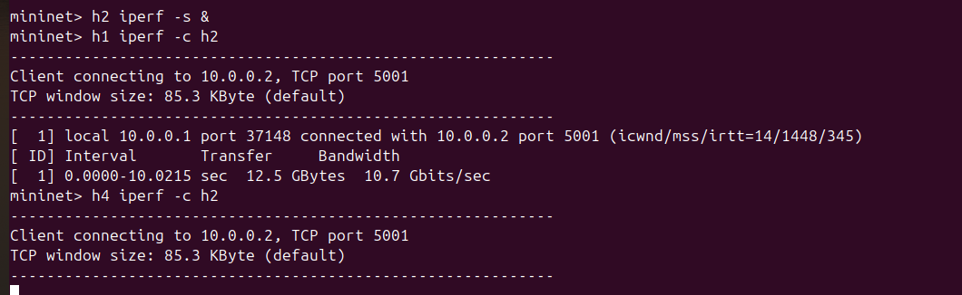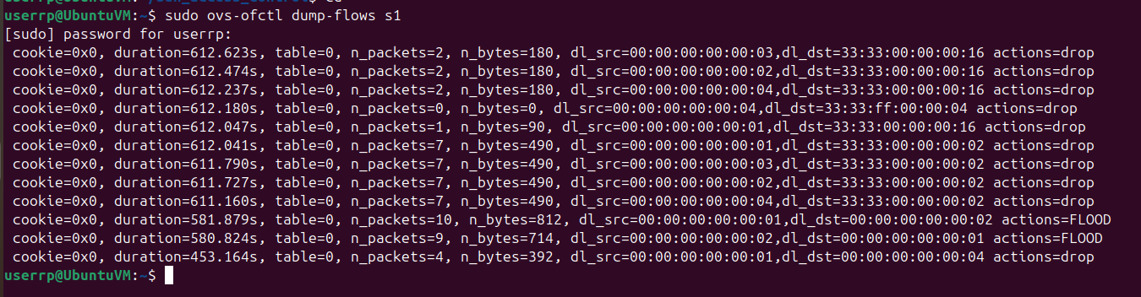
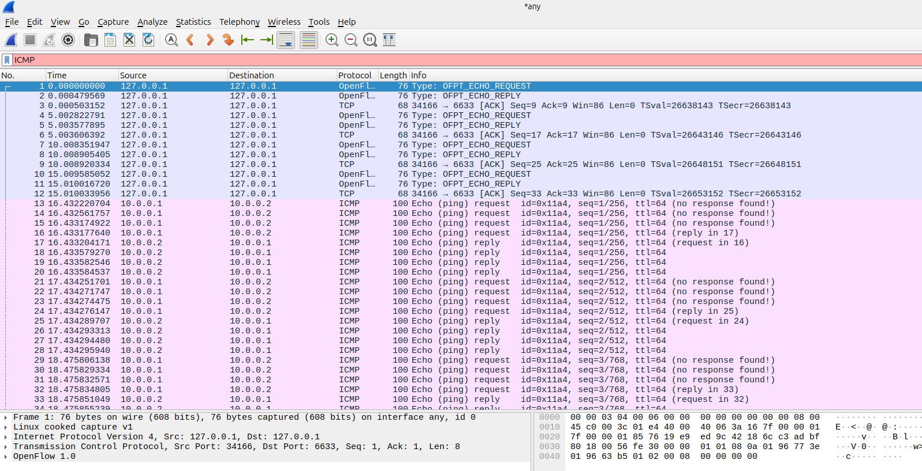
Whitelist.txt file:
10.0.0.1 , 10.0.0.2
10.0.0.2 , 10.0.0.1
10.0.0.2 , 10.0.0.3
10.0.0.3 , 10.0.0.2

