SOFTWARE TEST PLAN
Event Management System
Test Plan with Software Architecture and Design Specification

Project | Event Management System
Version | 1.2
Status | Ready for Review
Prepared by | Team 7
Date | 17 September 2026

Rahul B - PES2UG24CS393
Rajath N Gonda - PES2UG24CS394
Rajgopal Deshpande - PES2UG24CS395
Raksha V - PES2UG24CS396

Document Control

Revision History
Version | Date | Author | Change Summary | Approval
1.2 | 17-09-2026 | Team 7 | Completed rubric-alignment updates, NFR validation, bidirectional traceability and API examples | Pending

Approvals
Role | Name | Signature | Date
Faculty Reviewer
Team Representative

Table of Contents
Part I Software Test Plan
1 Introduction
2 Test Items and References
3 Features to Be Tested
4 Test Approach
5 Test Execution and Validation
5.1 Security Validation
5.2 Test Environment
5.3 Test Data
5.4 Detailed Test Cases
6 Entry and Exit Criteria
7 Suspension and Resumption Criteria
8 Test Deliverables
9 Roles and Responsibilities
10 Schedule and Risks
11 Requirements Traceability Matrix
Part II Software Architecture and Design Specification
12 Architecture and Design Introduction
13 Software Architecture
14 Detailed Design

Part I Software Test Plan

1 Introduction

1.1 Purpose
This Software Test Plan defines the scope, strategy, environment, responsibilities, detailed test cases, security validation, acceptance criteria, and traceability for the Event Management System. It provides a controlled basis for verifying that the implementation satisfies the approved Software Requirements Specification.

1.2 Scope
Testing covers account registration and authentication, role-based authorization, event creation and publication, discovery, attendee registration, capacity control, payment processing, e-ticket generation, notifications, reporting, performance, usability, audit retention, and security controls. Third-party payment and email services will be tested through sandbox accounts or controlled mocks. Physical on-site hardware is outside scope.

1.3 Objectives
- Verify all high-priority functional requirements and representative medium-priority requirements.
- Validate measurable non-functional targets for response time, concurrency, responsiveness, availability evidence, and audit retention.
- Confirm security controls for transport encryption, password protection, payment-data handling, role enforcement, and suspicious-activity alerting.
- Maintain bidirectional traceability from SRS requirement IDs to test cases and outcomes.

1.4 Intended Audience
This plan is intended for developers, testers, the project guide, security reviewers, and stakeholders responsible for accepting the Event Management System.

1.5 Definitions and Abbreviations
Term | Meaning
EMS | Event Management System
SRS | Software Requirements Specification
RTM | Requirements Traceability Matrix
RBAC | Role-Based Access Control
PII | Personally Identifiable Information
TLS | Transport Layer Security
API | Application Programming Interface
PAN | Primary Account Number

2 Test Items and References

2.1 Test Items
- Web user interface for attendees, organizers, and administrators
- Django application and REST endpoints
- PostgreSQL data layer and concurrency controls
- Payment-gateway sandbox integration
- Email service and background notification jobs
- Authentication, authorization, monitoring, and audit modules

2.2 Reference Documents
Reference | Description
SRS-EMS-1.0 | Event Management System Software Requirements Specification, Version 1.0
IEEE 829 | IEEE-style software test documentation structure
OWASP ASVS | Security verification guidance for web applications
WCAG 2.1 AA | Accessibility target stated in the SRS

3 Features to Be Tested
Area | Included Features | SRS References | Priority
Authentication | Registration, verification, login, lockout, roles | EMS-F-001 to EMS-F-005 | High
Event Management | Create, edit, publish, ticket types, capacity | EMS-F-010 to EMS-F-014 | High
Discovery and Registration | Search, details, registration, cancellation, dashboard | EMS-F-020 to EMS-F-024 | High/Medium
Payment and Ticketing | Payment, QR e-ticket, refunds | EMS-F-030 to EMS-F-032 | High/Medium
Notifications | Confirmation and reminder emails | EMS-F-040 to EMS-F-041 | High/Medium
Reporting and Administration | CSV report and account management | EMS-F-050 to EMS-F-051 | Medium
Non-functional | Performance, availability, scalability, usability, retention | EMS-NF-001 to EMS-NF-005 | High/Medium
Security | TLS, tokenization, password hashing, RBAC, alerts | EMS-SR-001 to EMS-SR-005 | High/Medium

3.1 Features Not Tested
Production payment settlement, production email deliverability, physical access-control devices, and failure modes inside third-party providers are excluded. Their interfaces will be validated through sandbox responses, signed webhooks, mocks, and retry behavior.

4 Test Approach

4.1 Test Levels
- Unit testing for validation rules, models, services, and permission checks.
- Integration testing across web, database, email, payment, and background-job boundaries.
- System testing through complete user workflows in a production-like environment.
- Acceptance testing against the measurable criteria stated in the SRS.

4.2 Test Types and Techniques
Test Type | Technique | Primary Evidence
Functional | Positive, negative, boundary-value, and state-transition testing | Test execution record and screenshots
Integration | API and database verification; webhook signature tests | Logs, request/response records
Performance | Load test with percentile response-time analysis | Load-test report
Security | Authorization, TLS, storage inspection, lockout and alert tests | Security checklist and logs
Usability | Responsive layouts at 360, 768, and 1440 pixels | Browser screenshots
Regression | Automated suite after each approved change | CI test report

4.3 Defect Management
Each defect shall record a unique ID, affected requirement and test case, severity, reproduction steps, expected result, actual result, evidence, owner, and status. Critical and High defects block release until corrected and successfully retested.

4.4 Pass and Fail Rules
A test passes only when every expected result is observed and no unapproved defect remains. A failed step causes the test case to fail. Blocked cases shall identify the external dependency and shall not be counted as passed.

5 Test Execution and Validation

5.1 Security Validation
Security validation is mandatory for release. The following checks cover the security objectives and requirements defined in the SRS.
Security Objective | Validation Method | Mapped Requirements | Evidence
Protect PII and payment information | TLS scan, database inspection, gateway-token verification | EMS-SR-001, EMS-SR-002 | TLS report and database schema/query results
Enforce authenticated and authorized access | Cross-role negative API tests and session tests | EMS-F-003 to EMS-F-005, EMS-SR-004 | HTTP status records and authorization logs
Maintain integrity and availability | Concurrency tests, audit review, alert simulation | EMS-F-014, EMS-NF-003, EMS-SR-005 | Load report, audit entries and alert screenshots
Protect credentials | Password-storage inspection and lockout test | EMS-F-004, EMS-SR-003 | Hash configuration and TC-02 results

Security exit condition: no open Critical or High security defect; all High-priority security requirements pass; Medium findings have an approved mitigation and owner.

5.2 Test Environment
Layer | Configuration
Client | Current and previous major versions of Chrome, Firefox, Edge, and Safari; desktop and mobile viewports
Application | Python 3.x, Django, Django REST Framework, Celery workers
Database and Queue | PostgreSQL test database; Redis cache and task queue
External Services | Payment gateway sandbox; transactional email sandbox or mock inbox
Infrastructure | Linux test server behind HTTPS reverse proxy
Tools | pytest/Django TestCase, API client, browser developer tools, load-test tool, TLS scanner

5.3 Test Data
Use synthetic attendee, organizer, and administrator accounts. Do not use real payment-card or personal data. Payment tests shall use gateway-provided sandbox tokens. Test events shall include free, paid, sold-out, cancelled, and capacity-one boundary cases.

5.4 Detailed Test Cases

TC-01 Register and verify user
Field | Details
Requirement IDs | EMS-F-001, EMS-F-002
Priority | High
Preconditions | No account exists for the test email.
Test Steps | 1. Open registration.  2. Enter valid name, email and strong password.  3. Submit.  4. Open verification link.  5. Log in.
Expected Result | Account is created; verification email is sent; link works within 24 hours; verified user can log in.
Actual Result | To be completed during execution
Status | Not Executed

TC-02 Login failure and lockout
Field | Details
Requirement IDs | EMS-F-003, EMS-F-004, EMS-SR-005
Priority | High
Preconditions | Verified account exists.
Test Steps | 1. Enter an incorrect password five times.  2. Attempt a sixth login within 15 minutes.  3. Check audit log and alert.  4. Retry after lockout expires.
Expected Result | Sixth attempt is rejected; generic message is shown; audit event and alert are recorded; login works after the lockout interval with valid credentials.
Actual Result | To be completed during execution
Status | Not Executed

TC-03 Role-based access control
Field | Details
Requirement IDs | EMS-F-005, EMS-F-051, EMS-SR-004
Priority | High
Preconditions | Attendee, Organizer and Administrator accounts exist.
Test Steps | 1. Attempt organizer/admin endpoints as Attendee.  2. Attempt admin endpoint as Organizer.  3. Repeat using correct roles.
Expected Result | Out-of-role requests return HTTP 403 and disclose no restricted data; permitted roles succeed.
Actual Result | To be completed during execution
Status | Not Executed

TC-04 Create and publish event
Field | Details
Requirement IDs | EMS-F-010 to EMS-F-013
Priority | High
Preconditions | Organizer is authenticated.
Test Steps | 1. Create an event with title, venue, schedule, capacity and ticket types.  2. Save as Draft.  3. Confirm it is absent from public search.  4. Publish it.  5. Edit a field.
Expected Result | Draft appears in organizer dashboard only; published event becomes searchable; ticket types are offered; edits appear within one minute.
Actual Result | To be completed during execution
Status | Not Executed

TC-05 Capacity and concurrent registration
Field | Details
Requirement IDs | EMS-F-014, EMS-F-022, EMS-NF-003
Priority | High
Preconditions | Published event with one remaining ticket.
Test Steps | 1. Start multiple registration requests for the final ticket.  2. Submit requests concurrently.  3. Inspect registrations and remaining capacity.
Expected Result | Exactly one registration is confirmed; later requests receive Sold Out; capacity never becomes negative; no duplicate registration or data loss occurs.
Actual Result | To be completed during execution
Status | Not Executed

TC-06 Search performance and responsive UI
Field | Details
Requirement IDs | EMS-F-020, EMS-F-021, EMS-NF-001, EMS-NF-004
Priority | High
Preconditions | Published events exist across categories, dates and locations.
Test Steps | 1. Search by keyword, category, date and location.  2. Run normal-load test up to 500 concurrent users.  3. Check pages at 360, 768 and 1440 pixels.
Expected Result | Only matching published events appear; 95th-percentile response time is at most 2 seconds; content remains usable without clipping or horizontal overflow.
Actual Result | To be completed during execution
Status | Not Executed

TC-07 Payment and e-ticket workflow
Field | Details
Requirement IDs | EMS-F-030, EMS-F-031, EMS-F-040, EMS-SR-002
Priority | High
Preconditions | Authenticated attendee and paid event exist; sandbox gateway is available.
Test Steps | 1. Register and pay with an approved sandbox token.  2. Verify signed webhook processing.  3. Inspect registration, database and inbox.
Expected Result | Payment is confirmed once; registration becomes Confirmed; QR e-ticket and email arrive within 2 minutes; database stores gateway token/reference only and no raw PAN.
Actual Result | To be completed during execution
Status | Not Executed

TC-08 Cancel registration and refund
Field | Details
Requirement IDs | EMS-F-023, EMS-F-032
Priority | Medium
Preconditions | Confirmed paid registration exists within cancellation cutoff.
Test Steps | 1. Cancel registration.  2. Request refund according to policy.  3. Check gateway, registration and capacity.
Expected Result | Registration becomes Cancelled; correct full or partial refund is recorded; capacity is released; repeated refund request does not duplicate the refund.
Actual Result | To be completed during execution
Status | Not Executed

TC-09 Notifications and reporting
Field | Details
Requirement IDs | EMS-F-041, EMS-F-050, EMS-NF-005
Priority | Medium
Preconditions | Confirmed attendees exist; reminder scheduler and audit archive are enabled.
Test Steps | 1. Trigger 48-hour and 2-hour reminder jobs using controlled time.  2. Generate attendee and revenue CSV and compare it with stored data.  3. Create auditable user, event, payment and administrative actions.  4. Advance controlled time to the stated retention boundary and verify archive, retrieval and protected deletion behaviour.
Expected Result | Each attendee receives one reminder at each configured offset; CSV values match the database and on-screen totals; audit records remain complete, retrievable and access-controlled for the SRS retention period, and disposal occurs only according to policy.
Actual Result | To be completed during execution
Status | Not Executed

TC-10 Security transport, passwords and monitoring
Field | Details
Requirement IDs | EMS-NF-002, EMS-SR-001, EMS-SR-003, EMS-SR-005
Priority | High
Preconditions | HTTPS environment, health monitoring, backups, test accounts and security scanner are available.
Test Steps | 1. Scan supported TLS versions and inspect stored password representation.  2. Simulate repeated login and abnormal registration activity.  3. Review uptime measurements against the monthly availability target.  4. Stop one application worker and simulate a transient dependency failure.  5. Verify health alerts, bounded retry, recovery and successful restoration from backup evidence.
Expected Result | Protocols below TLS 1.2 are rejected; passwords are salted Argon2/PBKDF2 hashes and never plaintext; suspicious patterns create administrator-visible alerts; availability meets the SRS target, failures are detected, service recovers without data corruption, and restoration evidence is recorded.
Actual Result | To be completed during execution
Status | Not Executed

6 Entry and Exit Criteria

6.1 Entry Criteria
- Approved SRS and stable testable build are available.
- Test environment, accounts, sandbox integrations, and synthetic data are ready.
- Unit tests pass and deployment smoke test succeeds.
- Requirement-to-test mappings have been reviewed.

6.2 Exit Criteria
- All ten planned test cases have been executed.
- All High-priority functional, non-functional, and security tests pass.
- No Critical or High defect remains open.
- At least 95 percent of all planned tests pass; any remaining Medium or Low failure has documented acceptance.
- RTM, execution evidence, and final summary report are complete.

7 Suspension and Resumption Criteria
Testing shall be suspended when the build cannot start, the database is corrupt, essential sandbox services are unavailable, or a Critical defect prevents further meaningful execution. Testing resumes after the blocking condition is corrected, the environment passes a smoke test, and affected cases are reset for retesting.

8 Test Deliverables
- Approved Software Test Plan
- Test data and environment configuration record
- Automated and manual execution results
- Defect reports with evidence
- Performance and security validation reports
- Completed Requirements Traceability Matrix
- Final test summary report

9 Roles and Responsibilities
Role | Responsibility
Test Lead | Maintain plan, assign tests, monitor progress and approve summary.
Testers | Prepare data, execute cases, capture evidence and report defects.
Developers | Provide builds, unit-test results and defect corrections.
Security Reviewer | Review authorization, transport, credential and monitoring evidence.
Project Guide or Stakeholder | Review exit evidence and accept or reject the release.

10 Schedule and Risks

10.1 Indicative Schedule
Activity | Duration | Output
Planning and environment setup | 1 day | Approved plan and ready environment
Functional and integration testing | 2 days | Execution results and defects
Performance and security validation | 1 day | Specialized reports
Regression and closure | 1 day | Final RTM and summary

10.2 Risks and Mitigations
Risk | Impact | Mitigation
Payment or email sandbox unavailable | Integration cases blocked | Use controlled mocks; rerun against sandbox before closure.
Insufficient concurrent-test resources | NFR evidence incomplete | Use scripted load generation and document environment limits.
Changing requirements | Coverage gaps | Version the SRS and update RTM before execution.
Test data leaks | Privacy breach | Use synthetic identities and gateway sandbox tokens only.

11 Requirements Traceability Matrix
The matrix provides bidirectional traceability: each SRS requirement is mapped to its verification test, and every detailed test case identifies the SRS requirement IDs it verifies. One test case may validate several closely related requirements.
Requirement ID | Requirement Summary | Verification
EMS-F-001 | User registration | TC-01
EMS-F-002 | Email verification | TC-01
EMS-F-003 | User login | TC-02
EMS-F-004 | Account lockout | TC-02
EMS-F-005 | Role-based access | TC-03
EMS-F-010 to F-013 | Create, edit, publish and ticket types | TC-04
EMS-F-014 | Capacity enforcement | TC-05
EMS-F-020 to F-021 | Search and event details | TC-06
EMS-F-022 | Register for event | TC-05
EMS-F-023 | Cancel registration | TC-08
EMS-F-024 | View registrations | TC-05
EMS-F-030 to F-031 | Payment and e-ticket | TC-07
EMS-F-032 | Refund | TC-08
EMS-F-040 | Confirmation email | TC-07
EMS-F-041 | Reminders | TC-09
EMS-F-050 | CSV reporting | TC-09
EMS-F-051 | Account administration | TC-03
EMS-NF-001 | Search response time | TC-06
EMS-NF-002 | Monthly availability | TC-10
EMS-NF-003 | Peak registration scalability | TC-05
EMS-NF-004 | Responsive interface | TC-06
EMS-NF-005 | Audit-log retention | TC-09
EMS-SR-001 | TLS 1.2 or higher | TC-10
EMS-SR-002 | No raw card storage | TC-07
EMS-SR-003 | Secure password hashing | TC-10
EMS-SR-004 | RBAC on APIs | TC-03
EMS-SR-005 | Suspicious-activity alerts | TC-02, TC-10

Part II Software Architecture and Design Specification

12 Architecture and Design Introduction

12.1 Purpose
This part defines the architecture and detailed design of the Event Management System. It translates the approved SRS into components, interfaces, data responsibilities, security controls, interaction sequences, API contracts, and error-handling rules that developers and testers can implement and verify.

12.2 Scope and Design Goals
- Separate presentation, business, integration, and persistence responsibilities.
- Support secure attendee, organizer, and administrator workflows.
- Prevent overselling and duplicate payment or notification processing.
- Provide measurable performance, availability, auditability, and maintainability.
- Preserve traceability from SRS requirements through architecture components, APIs, and tests.

12.3 Assumptions and Constraints
The implementation uses Python and Django with PostgreSQL, Redis, and Celery. Payment-card processing is delegated to a PCI-DSS-compliant gateway. Email delivery depends on a transactional email provider. The browser interface is responsive and all production traffic is protected by TLS 1.2 or higher.

13 Software Architecture

13.1 Architectural Pattern
The system uses a layered modular-monolith pattern with a client-server deployment. The browser is the presentation client. Django provides the web and REST interface, while domain modules implement authentication, events, registrations, payments, tickets, notifications, reporting, and administration. PostgreSQL stores transactional data. Redis and Celery support caching and asynchronous work. External payment and email services are reached through isolated adapters. This pattern keeps the initial deployment manageable while maintaining clear module boundaries that can later be separated into services if scale requires it.

13.2 Component Diagram
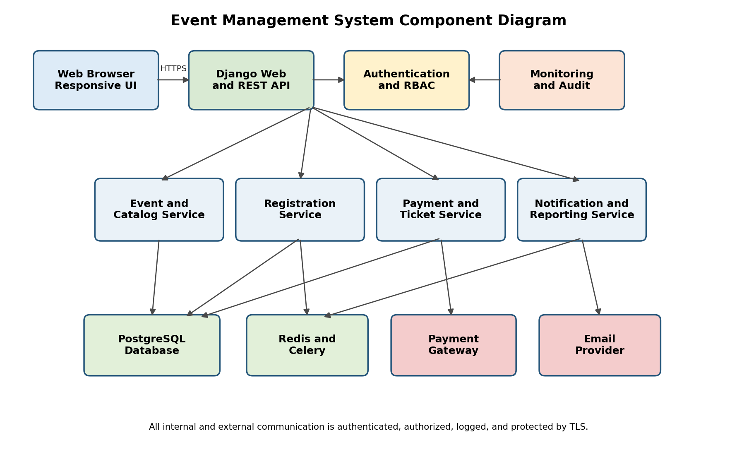
Figure 1 Event Management System component diagram

13.3 Component Descriptions
Component | Primary Responsibility | Key Requirements
Web Browser UI | Responsive discovery, registration, organizer dashboard, administration and accessible form interaction. | EMS-F-001, F-010, F-020 to F-024, F-050 to F-051, EMS-NF-004
Django Web and REST API | Request routing, validation, orchestration, consistent responses, CSRF protection and API versioning. | All functional requirements
Authentication and RBAC | Registration, verification, sessions, lockout, password hashing and role enforcement. | EMS-F-001 to F-005, EMS-SR-003 to SR-005
Event and Catalog Service | Create, edit, publish and search events; maintain ticket types and public visibility. | EMS-F-010 to F-014, F-020 to F-021
Registration Service | Create, cancel and list registrations using transactions and row-level locks. | EMS-F-022 to F-024, EMS-NF-003
Payment and Ticket Service | Gateway orders, signed webhooks, refunds, QR ticket generation and idempotency. | EMS-F-030 to F-032, EMS-SR-002
Notification and Reporting | Confirmation and reminder jobs, attendee CSV and revenue reporting. | EMS-F-040 to F-041, EMS-F-050
PostgreSQL | Transactional persistence, constraints, indexes, audit records and retention. | EMS-NF-003, EMS-NF-005
Redis and Celery | Caching, rate limiting, background jobs, retries and scheduled reminders. | EMS-F-004, EMS-F-040 to F-041
Monitoring and Audit | Operational metrics, security alerts and administrator-visible audit events. | EMS-NF-002, EMS-SR-005

13.4 Security Architecture
Control Area | Design Control | Requirements
Identity | Verified email, secure session cookies, CSRF protection, configurable session expiry and lockout after five failed attempts. | EMS-F-002 to F-004
Authorization | Deny-by-default RBAC at UI, view, service, and API levels; object ownership checked for organizer and attendee records. | EMS-F-005, EMS-SR-004
Data Protection | TLS 1.2+, salted Argon2 or PBKDF2 hashes, encrypted secrets, least-privilege database account, no raw card storage. | EMS-SR-001 to SR-003
Payment Integrity | Signed webhook verification, idempotency keys, amount and event validation before confirmation or refund. | EMS-F-030, EMS-F-032
Monitoring | Structured audit records for login, role, publication, payment, refund and administrative actions; abnormal-rate alerts. | EMS-F-004, EMS-SR-005
Availability | Health checks, database backups, retry with bounded exponential backoff and independently monitored workers. | EMS-NF-002

13.5 Architecture Traceability
SRS Area | Architecture Elements | Verification
Authentication and authorization | Web API, Authentication and RBAC, PostgreSQL, Redis | TC-01 to TC-03, TC-10
Event management and discovery | Web UI, Event and Catalog Service, PostgreSQL, cache | TC-04, TC-06
Registration and capacity | Registration Service, PostgreSQL transactions and locks | TC-05, TC-08
Payment and ticketing | Payment and Ticket Service, gateway adapter, notification jobs | TC-07, TC-08
Notifications and reports | Celery scheduler, Email Provider, Reporting module | TC-09
Performance and availability | Indexes, cache, worker queue, health and monitoring components | TC-05, TC-06, operational review
Security | TLS boundary, RBAC, secure storage, audit and monitoring | TC-02, TC-03, TC-07, TC-10

13.6 Deployment View
The browser communicates over HTTPS with a reverse proxy and Django application server. The application server accesses PostgreSQL through a least-privilege service account and Redis over a private network. Celery workers consume background tasks and call the email provider. The payment gateway calls a dedicated signed-webhook endpoint. Production secrets are supplied through protected environment configuration and are not committed to GitHub.

14 Detailed Design

14.1 Sequence Diagram for Registration and Payment
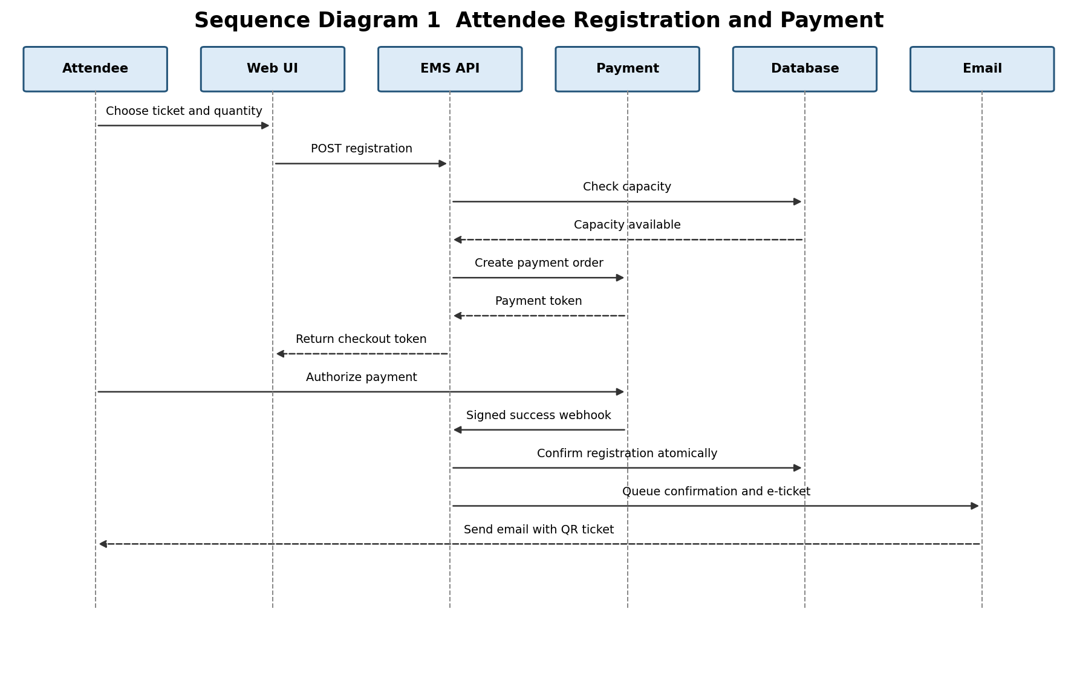
Figure 2 Attendee registration, payment confirmation and e-ticket delivery
The final capacity update and registration confirmation run in one database transaction. The webhook handler verifies the signature and uses an idempotency key so duplicate gateway callbacks cannot create duplicate registrations or tickets.

14.2 Sequence Diagram for Event Publication
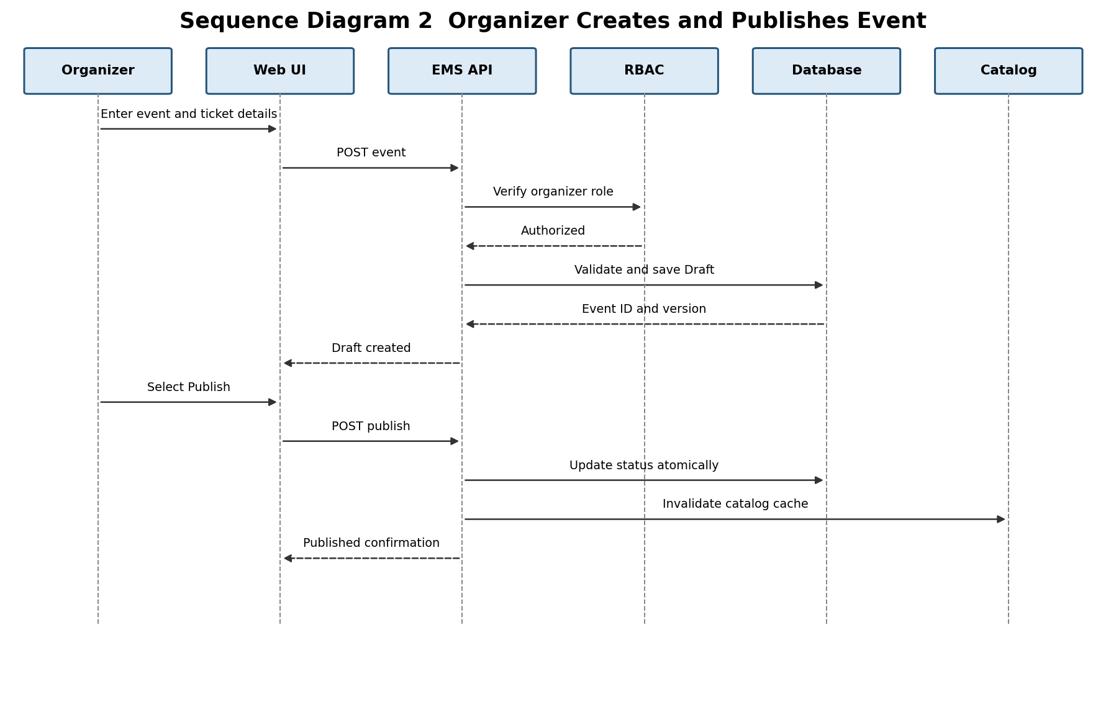
Figure 3 Organizer creates and publishes an event
The service verifies the Organizer role, validates required fields and date rules, stores the event as Draft, and publishes only after a separate authorized request. Publication invalidates relevant catalog caches so the event becomes visible within the SRS limit.

14.3 API Design
The REST API uses JSON, HTTPS, UTF-8, ISO 8601 timestamps, resource-oriented URLs, and consistent HTTP status codes. Protected endpoints require an authenticated session or bearer token. State-changing browser requests require CSRF protection. List endpoints support pagination and bounded filtering.
Method and Endpoint | Role | Purpose | Successful Response
POST /api/v1/auth/register | Public | Create account and send verification message. | 201 account identifier and verification status
POST /api/v1/auth/login | Verified user | Authenticate and establish session. | 200 user profile and permitted role
GET /api/v1/events | Public | Search published events by query, category, date and location. | 200 paginated event list
POST /api/v1/events | Organizer | Create an event in Draft status. | 201 event resource
PATCH /api/v1/events/{id} | Owning Organizer | Edit permitted event fields. | 200 updated event resource
POST /api/v1/events/{id}/publish | Owning Organizer | Publish a valid event. | 200 event with Published status
POST /api/v1/events/{id}/registrations | Attendee | Reserve ticket quantity and begin payment when required. | 201 registration and checkout reference
POST /api/v1/payments/webhook | Gateway | Verify and process payment event idempotently. | 200 acknowledgement
POST /api/v1/registrations/{id}/cancel | Owning Attendee | Cancel within cutoff and initiate eligible refund. | 200 cancellation and refund status
GET /api/v1/events/{id}/reports/attendees.csv | Owning Organizer | Download attendee and revenue CSV. | 200 text/csv attachment
PATCH /api/v1/admin/users/{id} | Administrator | Activate, deactivate or change role. | 200 updated user status

14.3.1 API Request and Response Examples
The following examples define the expected JSON structure for a successful registration request and a validation failure.
Example | JSON Payload
Registration request | {  "event_id": 104,  "ticket_type_id": 7,  "quantity": 2  }
Successful response 201 | {  "registration_id": 8801,  "status": "PendingPayment",  "checkout_reference": "chk_72A1"  }
Validation error 400 | {  "code": "VALIDATION_ERROR",  "message": "Request validation failed",  "request_id": "req_01HZX",  "field_errors": {"quantity": ["Must be between 1 and 10"]}  }

14.4 Request and Response Conventions
Concern | Design Rule
Validation | Reject missing, malformed, out-of-range or inconsistent input before domain processing.
Authentication | Return 401 when credentials are absent or invalid; do not expose account existence.
Authorization | Return 403 for an authenticated user lacking the required role or ownership.
Concurrency | Use database transactions, unique constraints, row-level locks and idempotency keys.
Pagination | Use page and page_size with a server-defined maximum; return count and navigation links.
Versioning | Expose stable routes under /api/v1; incompatible changes require a new version.
Correlation | Accept or generate a request ID and include it in logs and error responses.

14.5 Data Design
Entity | Important Fields and Relationships
User | id, name, unique email, password hash, role, verified_at, active flag; has many registrations and owned events.
Event | id, organizer_id, title, category, venue, starts_at, capacity, status, cancellation and refund rules.
TicketType | id, event_id, name, price, quantity_limit and sold_count; unique name per event.
Registration | id, attendee_id, event_id, ticket_type_id, quantity, status, total_amount and timestamps; unique business key prevents duplicates.
Payment | id, registration_id, provider reference, token/reference, amount, status, idempotency key; never stores a raw PAN.
Ticket | id, registration_id, signed QR token, issued_at and revoked_at.
AuditEvent | id, actor_id, action, target type and ID, outcome, request ID, IP metadata and timestamp.

14.6 Error Handling
The system returns a stable error object containing code, message, request_id, and optional field_errors. Messages are safe for users and do not reveal stack traces, database details, credentials, or whether an email address exists. Server logs retain diagnostic context under the matching request ID.
Condition | HTTP Status | System Behavior
Invalid input | 400 | Return field-level errors; make no state change.
Unauthenticated request | 401 | Reject and record security-relevant failures.
Unauthorized role or ownership | 403 | Reject without exposing restricted resource data.
Resource not found | 404 | Return a generic not-found response.
Capacity conflict or duplicate request | 409 | Rollback transaction and return Sold Out or duplicate-operation result.
Rate limit exceeded | 429 | Return retry guidance and log abnormal patterns.
Payment or email provider timeout | 502 or 503 | Do not duplicate work; queue a bounded retry using the same idempotency key.
Unexpected server error | 500 | Rollback, log request ID and return a generic message.

14.7 Logging and Audit Design
Application logs are structured and exclude passwords, raw payment data, tokens, and sensitive personal fields. Audit events are append-only and record authentication failures, account lockouts, role changes, event publication, payment confirmation, refunds, and administrator actions. Access to logs is restricted and retention follows EMS-NF-005.

14.8 Design Verification
The test cases in Part I verify the primary design decisions. Code review shall confirm module boundaries, permission checks, transaction scope, idempotency, secret handling, input validation, and absence of raw card data. The GitHub repository should contain source code, automated tests, a README with setup steps, and this combined specification; it must not contain credentials, environment secrets, or real user data.

