Software Architecture and Design Specification
Event Management System
Project | Event Management System
Version | 1.0
Status | Ready for Review
Prepared by | Team 7
Date | 1 October 2026
Rahul B - PES2UG24CS393
Rajath N Gonda - PES2UG24CS394
Rajgopal Deshpande - PES2UG24CS395
Raksha V - PES2UG24CS396

Document Control

Revision History
Version | Date | Author | Change Summary
1.0 | 01-10-2026 | Team 7 | Initial SAD prepared for Sprint 1 using the approved Event Management System requirements.

Approvals
Role | Name | Signature | Date
Faculty Reviewer
Team Representative

Table of Contents
1 Introduction
1.1 Purpose
1.2 Scope
1.3 Audience
1.4 Definitions and Abbreviations
2 Document Overview
2.1 How to Use This Document
2.2 Related Documents
3 Architecture
3.1 Goals and Constraints
3.2 Stakeholders and Concerns
3.3 Component Diagram
3.4 Component Descriptions
3.5 Chosen Architecture Pattern and Rationale
3.6 Technology Stack and Data Stores
3.7 Risks and Mitigations
3.8 Traceability to Requirements
3.9 Security Architecture
3.10 Deployment View
4 Design
4.1 Design Overview
4.2 UML Sequence Diagrams
4.3 API Design
4.4 Data Design
4.5 Error Handling Logging and Monitoring
4.6 UX Design
4.7 Design Verification
4.8 Open Issues and Next Steps
5 Appendices
5.1 Glossary
5.2 References
5.3 Tools

1 Introduction

1.1 Purpose
This document specifies the software architecture and detailed design of the Event Management System. It translates the approved Software Requirements Specification into implementable components, interfaces, data structures, security controls, interaction sequences, and verification responsibilities for Sprint 1 and later development.

1.2 Scope
The system supports attendees, organizers, and administrators. It covers account registration and authentication, event creation and publication, event discovery, ticket registration, capacity control, payment processing, e-ticket generation, cancellation and refunds, notifications, reports, administration, monitoring, and audit records. Physical venue hardware and direct storage of payment-card data are outside scope.

1.3 Audience
The intended audience includes developers, testers, the project guide, security reviewers, maintainers, and stakeholders who approve or review the Event Management System.

1.4 Definitions and Abbreviations
Term | Meaning
EMS | Event Management System
SRS | Software Requirements Specification
SAD | Software Architecture and Design Specification
API | Application Programming Interface
RBAC | Role-Based Access Control
RTM | Requirements Traceability Matrix
TLS | Transport Layer Security
PII | Personally Identifiable Information
CI/CD | Continuous Integration and Continuous Delivery

2 Document Overview

2.1 How to Use This Document
Section 3 defines the architecture, component responsibilities, technology choices, security boundaries, risks, deployment view, and traceability to the SRS. Section 4 defines the detailed interactions, APIs, data entities, error-handling conventions, user-interface considerations, verification approach, and Sprint 1 next steps. Section 5 lists supporting references and tools.

2.2 Related Documents
Document | Relationship
Event Management System SRS | Source of functional, non-functional, and security requirements.
Software Test Plan | Defines test strategy, security validation, detailed test cases, and acceptance criteria.
Requirements Traceability Matrix | Maps requirements to architecture elements and verification activities.
Sprint 1 Project Plan | Identifies features, tasks, owners, and completion targets for the sprint.

3 Architecture

3.1 Goals and Constraints
• Separate presentation, business, integration, and persistence responsibilities.
• Support secure workflows for attendees, organizers, and administrators.
• Prevent overselling, duplicate registrations, and duplicate payment processing.
• Meet measurable performance, availability, auditability, usability, and maintainability requirements.
• Maintain traceability from SRS requirements to components, APIs, and tests.
• Use Python and Django with PostgreSQL; use third-party sandbox services for payment and email integration.
• Protect all production traffic using TLS 1.2 or higher and never store raw payment-card data.

3.2 Stakeholders and Concerns
Stakeholder | Primary Concerns
Attendees | Easy event discovery, secure registration and payment, accurate tickets, reliable notifications.
Organizers | Fast event creation, controlled publication, capacity management, attendee and revenue reports.
Administrators | User and role management, audit visibility, incident response, system health.
Developers | Clear module boundaries, stable APIs, maintainable code, repeatable local setup.
Testers | Testable interfaces, deterministic error behavior, traceable acceptance criteria.
Faculty reviewers | Alignment with the SRS, identifiable team contributions, Git history, tests, and CI status.

3.3 Component Diagram
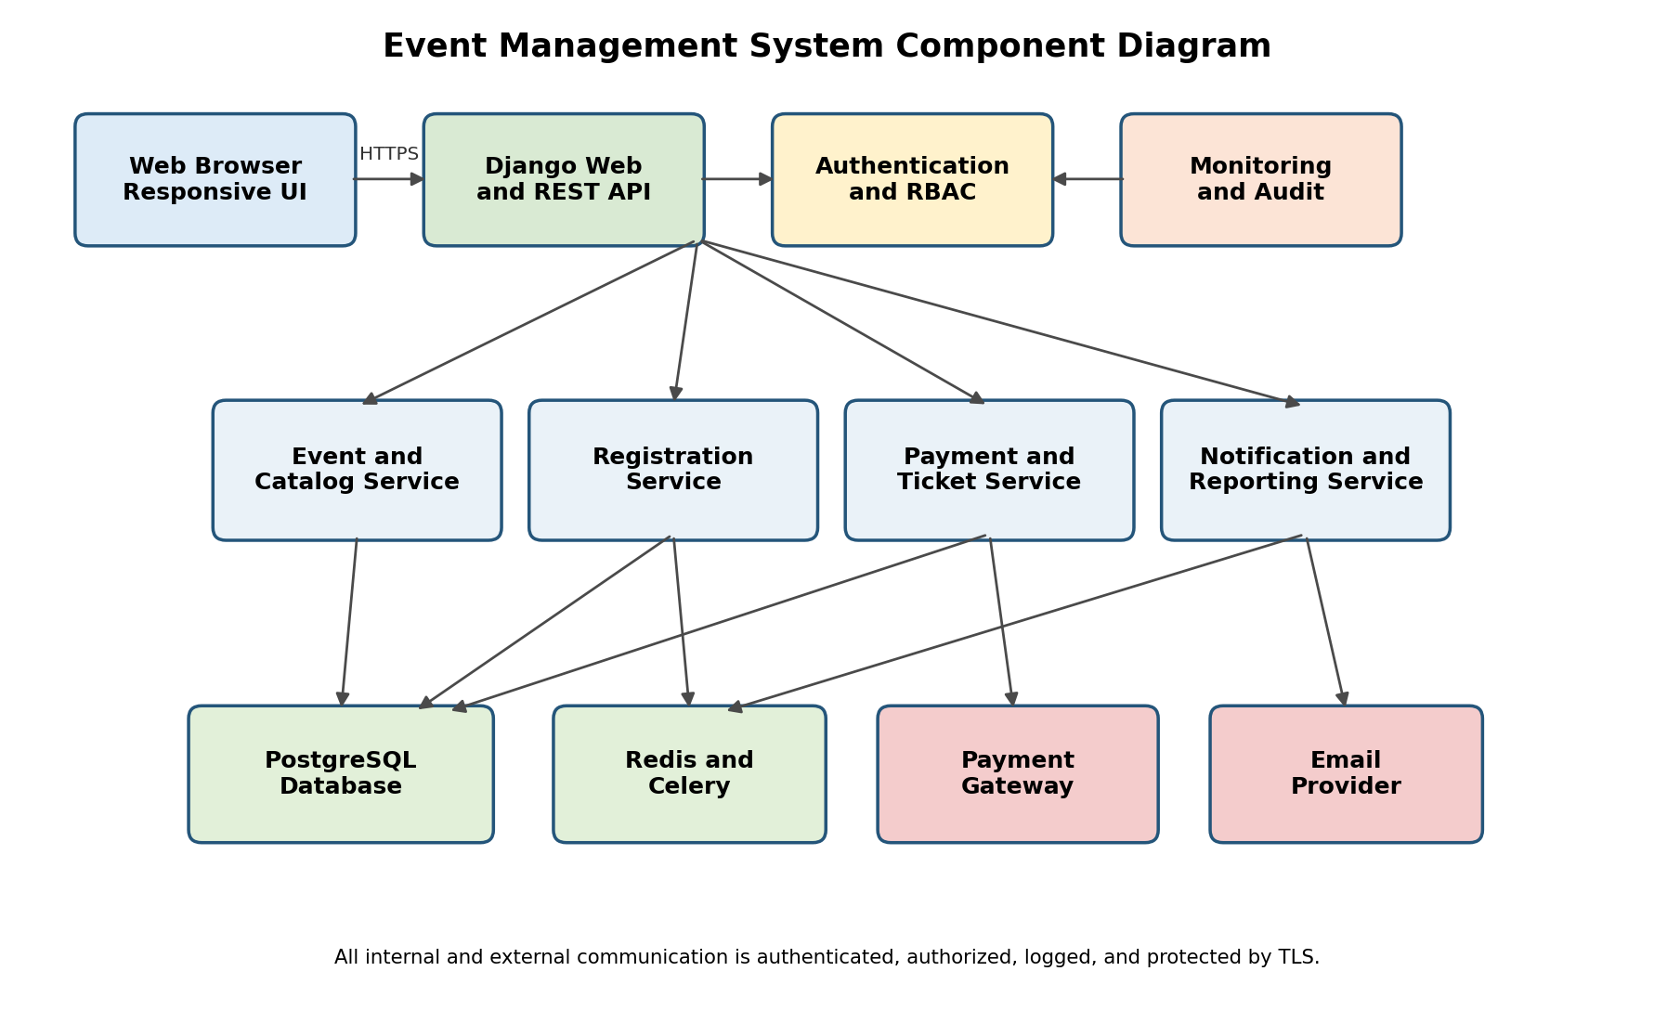
Figure 1 Event Management System component diagram

3.4 Component Descriptions
Component | Primary Responsibility | Key Requirements
Web Browser UI | Responsive attendee, organizer, and administrator interfaces for discovery, registration, management, and reporting. | EMS-F-001, F-010, F-020 to F-024, F-050 to F-051, EMS-NF-004
Django Web and REST API | Routes requests, validates inputs, coordinates domain services, applies CSRF protection, and returns consistent responses. | All functional requirements
Authentication and RBAC | Registration, email verification, sessions, lockout, password hashing, role enforcement, and ownership checks. | EMS-F-001 to F-005, EMS-SR-003 to SR-005
Event and Catalog Service | Creates, edits, publishes, cancels, searches, and lists events and ticket types. | EMS-F-010 to F-014, F-020 to F-021
Registration Service | Creates, cancels, and lists registrations using database transactions and row-level locking. | EMS-F-022 to F-024, EMS-NF-003
Payment and Ticket Service | Creates gateway orders, verifies signed webhooks, performs refunds, and issues signed QR tickets. | EMS-F-030 to F-032, EMS-SR-002
Notification and Reporting | Runs confirmation and reminder jobs and generates attendee and revenue reports. | EMS-F-040 to F-041, EMS-F-050
PostgreSQL | Stores transactional data, constraints, indexes, audit events, and retention records. | EMS-NF-003, EMS-NF-005
Redis and Celery | Provides caching, rate limiting, background jobs, retries, and scheduled reminders. | EMS-F-004, EMS-F-040 to F-041
Monitoring and Audit | Collects operational metrics, security alerts, and administrator-visible audit events. | EMS-NF-002, EMS-SR-005

3.5 Chosen Architecture Pattern and Rationale
The system uses a layered modular-monolith architecture with a client-server deployment. The browser is the presentation client. Django provides the web and REST interface, while domain modules implement authentication, events, registrations, payments, tickets, notifications, reporting, and administration. PostgreSQL stores transactional data, while Redis and Celery support caching and asynchronous work. External payment and email services are accessed through isolated adapters.
This pattern is appropriate for Sprint 1 because it is simpler to develop, test, deploy, and debug than distributed microservices while still enforcing clear module boundaries. If usage grows substantially, high-load modules such as notifications or reporting can later be separated without changing the public API contracts.

3.6 Technology Stack and Data Stores
Layer | Technology | Purpose
Presentation | HTML, CSS, JavaScript and Django templates or a compatible web client | Responsive user interfaces and browser validation.
Application | Python 3 and Django with Django REST Framework | Web routes, REST endpoints, domain rules, authentication, and administration.
Persistence | PostgreSQL | Transactional storage, constraints, indexes, row locks, and audit records.
Background work | Celery and Redis | Email, reminders, retries, scheduled jobs, caching, and rate limits.
External integration | Payment gateway sandbox and transactional email provider | Payment authorization, signed webhooks, refunds, and email delivery.
Version control and CI | GitHub and GitHub Actions | Source history, pull requests, automated build, lint, and test execution.

3.7 Risks and Mitigations
Risk | Impact | Mitigation
Concurrent registration oversells capacity | Incorrect inventory and attendee dissatisfaction. | Use transactions, row-level locks, database constraints, and concurrency integration tests.
Duplicate payment webhook | Duplicate confirmation, ticket, or refund. | Verify signatures and use a unique gateway event ID and idempotency key.
Payment or email provider outage | Incomplete checkout or delayed notification. | Use timeouts, bounded retries, clear pending status, and monitoring alerts.
Unauthorized access | Exposure or modification of restricted records. | Deny-by-default RBAC, ownership checks, automated security tests, and audit logging.
Secret committed to GitHub | Credential compromise. | Use environment variables, .gitignore, secret scanning, and code review.
Sprint 1 scope growth | Delayed delivery and insufficient testing. | Prioritize approved stories, track issues, and defer nonessential enhancements.

3.8 Traceability to Requirements
SRS Area | Architecture Elements | Verification
Authentication and authorization | Web API, Authentication and RBAC, PostgreSQL, Redis | Unit tests for validation and permissions; integration tests for registration, login, lockout, and role access.
Event management and discovery | Web UI, Event and Catalog Service, PostgreSQL, cache | Unit tests for event rules; integration tests for draft, publication, search, and visibility.
Registration and capacity | Registration Service, PostgreSQL transactions and locks | Boundary and concurrency tests for available, final, and sold-out capacity.
Payment and ticketing | Payment and Ticket Service, gateway adapter, notification jobs | Webhook, idempotency, ticket generation, cancellation, and refund integration tests.
Notifications and reports | Celery scheduler, email adapter, reporting module | Job and report tests, including retention and restricted-access checks.
Performance and availability | Indexes, cache, worker queue, health and monitoring components | Response-time, concurrency, health-check, recovery, and backup evidence.
Security | TLS boundary, RBAC, secure secret storage, audit and monitoring | Authentication, authorization, transport, logging, and suspicious-activity tests.

3.9 Security Architecture
Security objectives are to preserve confidentiality of credentials and personal information, maintain integrity of registrations and payments, ensure authorized availability, and provide accountability through protected audit records.
Control Area | Design Control | Requirements
Identity | Verified email, secure cookies, CSRF protection, session expiry, and lockout after five failed attempts. | EMS-F-002 to F-004
Authorization | Deny-by-default RBAC at UI, view, service, and API levels; object ownership checks. | EMS-F-005, EMS-SR-004
Data protection | TLS 1.2+, salted Argon2 or PBKDF2 password hashes, protected secrets, least-privilege database account, and no raw card storage. | EMS-SR-001 to SR-003
Payment integrity | Signed webhook verification, idempotency keys, and amount and event validation before confirmation or refund. | EMS-F-030, EMS-F-032
Monitoring | Structured audit events for login, role, publication, payment, refund, and administrative actions; abnormal-rate alerts. | EMS-F-004, EMS-SR-005
Availability | Health checks, database backups, bounded retries, independently monitored workers, and documented restoration. | EMS-NF-002

3.10 Deployment View
The browser communicates over HTTPS with a reverse proxy and Django application server. The application accesses PostgreSQL through a least-privilege account and Redis over a private network. Celery workers consume background jobs and call the email provider. The payment gateway sends events to a dedicated signed-webhook endpoint. Production secrets are supplied through protected environment configuration and are never committed to GitHub. GitHub Actions runs automated checks on pushes and pull requests before changes are accepted.

4 Design

4.1 Design Overview
The detailed design follows the architecture boundaries described above. Views and API controllers validate transport-level input and delegate business rules to services. Services use repositories or the Django ORM for persistence. External providers are hidden behind adapters so unit tests can replace them with mocks and integration tests can use sandbox environments.

4.2 UML Sequence Diagrams

4.2.1 Attendee Registration and Payment
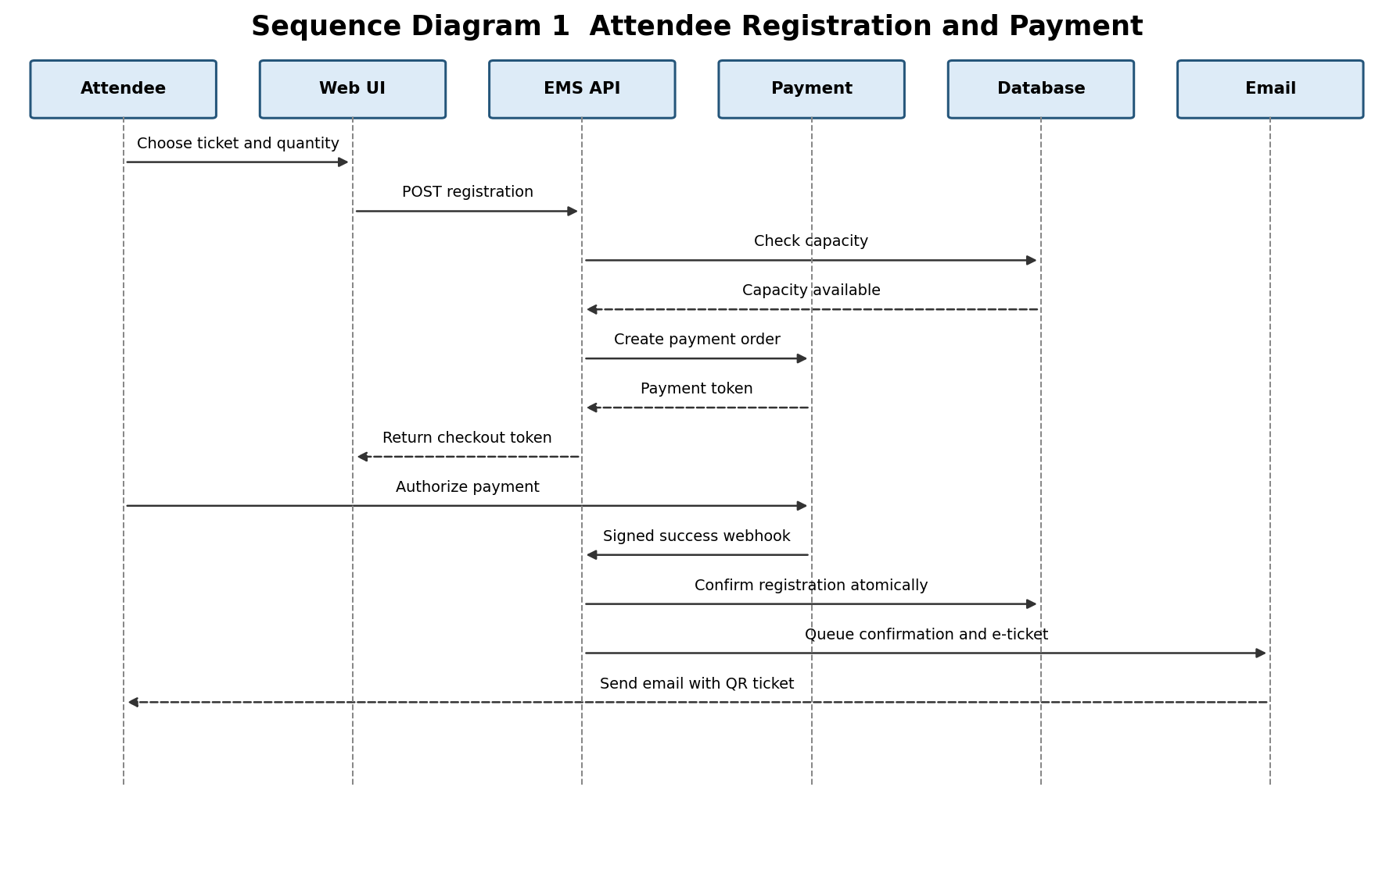
Figure 2 Attendee registration payment confirmation and e-ticket delivery
The registration service validates capacity and creates a pending registration within a database transaction. Payment confirmation occurs only after the webhook signature is verified. The webhook handler uses an idempotency key so duplicate callbacks cannot create duplicate registrations or tickets.

4.2.2 Organizer Event Creation and Publication
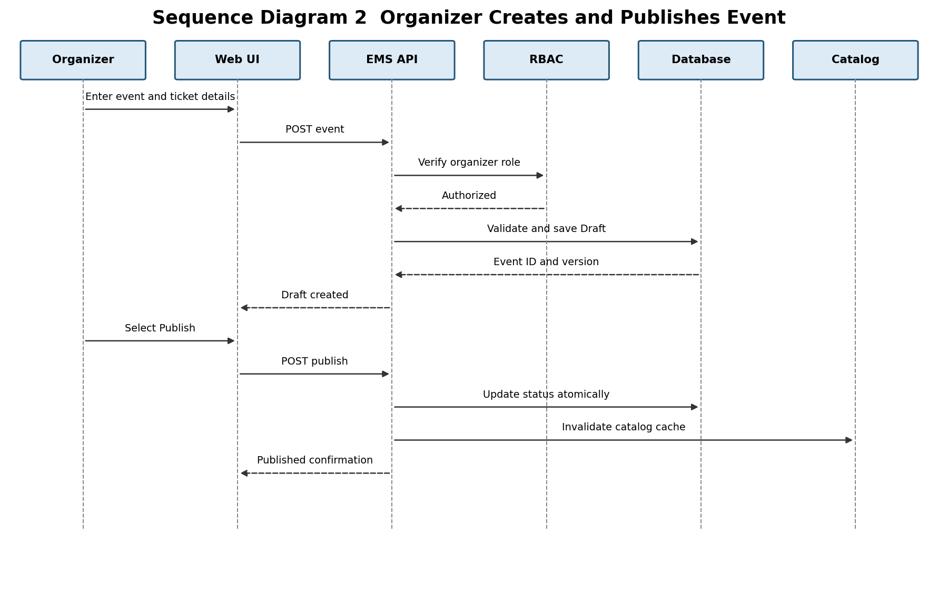
Figure 3 Organizer creates and publishes an event
The service verifies the Organizer role, validates required fields and date rules, and initially stores the event as Draft. Publication requires a separate authorized request and invalidates relevant catalog caches so the event becomes publicly visible within the required time.

4.3 API Design
The REST API uses JSON, HTTPS, UTF-8, ISO 8601 timestamps, resource-oriented URLs, and consistent HTTP status codes. Protected endpoints require an authenticated session or bearer token. State-changing browser requests require CSRF protection. List endpoints support bounded pagination and filtering.
Method and Endpoint | Role | Purpose | Success
POST /api/v1/auth/register | Public | Create an account and send verification. | 201 account ID and verification status
POST /api/v1/auth/login | Verified user | Authenticate and establish a session. | 200 user profile and role
GET /api/v1/events | Public | Search published events. | 200 paginated event list
POST /api/v1/events | Organizer | Create an event in Draft status. | 201 event resource
POST /api/v1/events/{id}/publish | Owning Organizer | Publish a valid event. | 200 Published event
POST /api/v1/events/{id}/registrations | Attendee | Reserve tickets and begin payment. | 201 registration and checkout reference
POST /api/v1/payments/webhook | Gateway | Process a signed payment event idempotently. | 200 acknowledgement
POST /api/v1/registrations/{id}/cancel | Owning Attendee | Cancel and initiate eligible refund. | 200 cancellation and refund status
GET /api/v1/events/{id}/reports/attendees.csv | Owning Organizer | Download attendee and revenue report. | 200 CSV attachment
PATCH /api/v1/admin/users/{id} | Administrator | Activate, deactivate, or change role. | 200 updated user status

4.3.1 API Request and Response Examples
Example | JSON Payload
Registration request | {  "event_id": 104,  "ticket_type_id": 7,  "quantity": 2  }
Successful response 201 | {  "registration_id": 8801,  "status": "PendingPayment",  "checkout_reference": "chk_72A1"  }
Validation error 400 | {  "code": "VALIDATION_ERROR",  "message": "Request validation failed",  "request_id": "req_01HZX",  "field_errors": {"quantity": ["Must be between 1 and 10"]}  }

4.4 Data Design
Entity | Important Fields and Relationships
User | id, name, unique email, password hash, role, verified_at, active flag; owns events and has registrations.
Event | id, organizer_id, title, category, venue, starts_at, capacity, status, cancellation and refund rules.
TicketType | id, event_id, name, price, quantity_limit, sold_count; unique name per event.
Registration | id, attendee_id, event_id, ticket_type_id, quantity, status, total_amount, timestamps; unique business key prevents duplicates.
Payment | id, registration_id, provider reference, token or reference, amount, status, idempotency key; never stores a raw PAN.
Ticket | id, registration_id, signed QR token, issued_at, revoked_at.
AuditEvent | id, actor_id, action, target type and ID, outcome, request ID, IP metadata, timestamp.

4.5 Error Handling Logging and Monitoring
The API returns a stable error object containing code, message, request_id, and optional field_errors. User-visible messages do not expose stack traces, database details, credentials, or whether an email address exists. Logs contain diagnostic context under the same request ID and exclude passwords, tokens, raw payment data, and sensitive personal fields.
Condition | HTTP Status | System Behavior
Invalid input | 400 | Return field-level errors and make no state change.
Unauthenticated request | 401 | Reject and record security-relevant failures.
Unauthorized role or ownership | 403 | Reject without exposing restricted resource data.
Resource not found | 404 | Return a generic not-found response.
Capacity conflict or duplicate request | 409 | Roll back and return a sold-out or duplicate-operation result.
Rate limit exceeded | 429 | Return retry guidance and log abnormal patterns.
Payment or email timeout | 502 or 503 | Do not duplicate work; queue a bounded retry using the same idempotency key.
Unexpected server error | 500 | Roll back, log the request ID, and return a generic message.

Monitoring covers application health, request latency, failed logins, lockouts, registration conflicts, payment failures, webhook retries, worker queue depth, email failures, database availability, and backup status. Audit events are append-only, access-controlled, and retained according to EMS-NF-005.

4.6 UX Design
• Responsive layouts support desktop and mobile browsers.
• Forms use clear labels, keyboard navigation, visible focus states, and field-level validation messages.
• Status values such as Draft, Published, Pending Payment, Confirmed, Cancelled, and Refunded are stated in text and not communicated by color alone.
• Destructive actions require confirmation and explain their effect before submission.
• Search and registration workflows minimize steps and preserve entered data after recoverable validation errors.

4.7 Design Verification
Unit tests verify validators, service rules, permissions, price and refund calculations, idempotency, and error mapping. Integration tests verify registration and login, event publication and search, capacity updates, payment webhooks, ticket generation, cancellation, notifications, and reports. GitHub Actions shall install dependencies, run formatting and static checks, execute unit and integration tests, and report pass or failure on every push and pull request.

4.8 Open Issues and Next Steps
Sprint 1 Action | Expected Evidence
Create the initial Django project and module structure. | Committed project scaffold and README setup instructions.
Implement the approved Sprint 1 features. | Working feature commits linked to GitHub issues or project tasks.
Develop unit tests alongside each module. | Normal, boundary, and error-condition tests with passing results.
Add integration tests for interactions between completed modules. | Automated tests exercising the database and service boundaries.
Configure GitHub Actions CI. | Workflow file and successful build and test run visible under Actions.
Track individual contributions. | Meaningful commits, issue assignments, pull requests, and review history.

5 Appendices

5.1 Glossary
API - Application Programming Interface; CI/CD - Continuous Integration and Continuous Delivery; EMS - Event Management System; RBAC - Role-Based Access Control; REST - Representational State Transfer; RTM - Requirements Traceability Matrix; SAD - Software Architecture and Design Specification; SRS - Software Requirements Specification; TLS - Transport Layer Security.

5.2 References
• IEEE 42010, Systems and software engineering Architecture description.
• OWASP Application Security Verification Standard and OWASP Top 10.
• NIST Secure Software Development Framework.
• Event Management System Software Requirements Specification.
• Event Management System Software Test Plan.

5.3 Tools
Microsoft Word for documentation; diagrams.net or PlantUML for UML diagrams; Git and GitHub for version control and project tracking; GitHub Actions for CI; Python, Django, PostgreSQL, Redis, and Celery for implementation; pytest and Django test utilities for automated testing; Swagger or OpenAPI tools for API documentation.

