1. ***ReactJS-HOL***

***Installing NodeJS:***

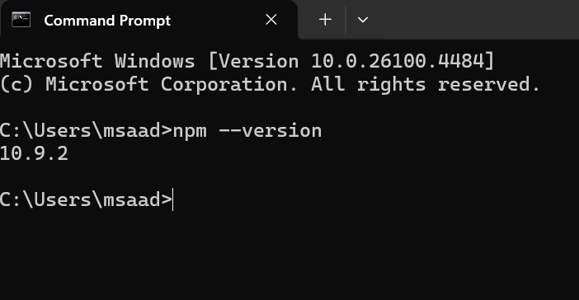

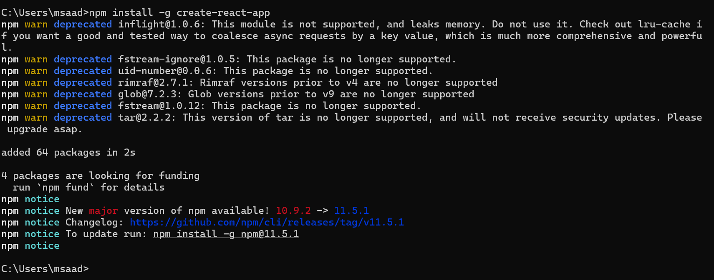

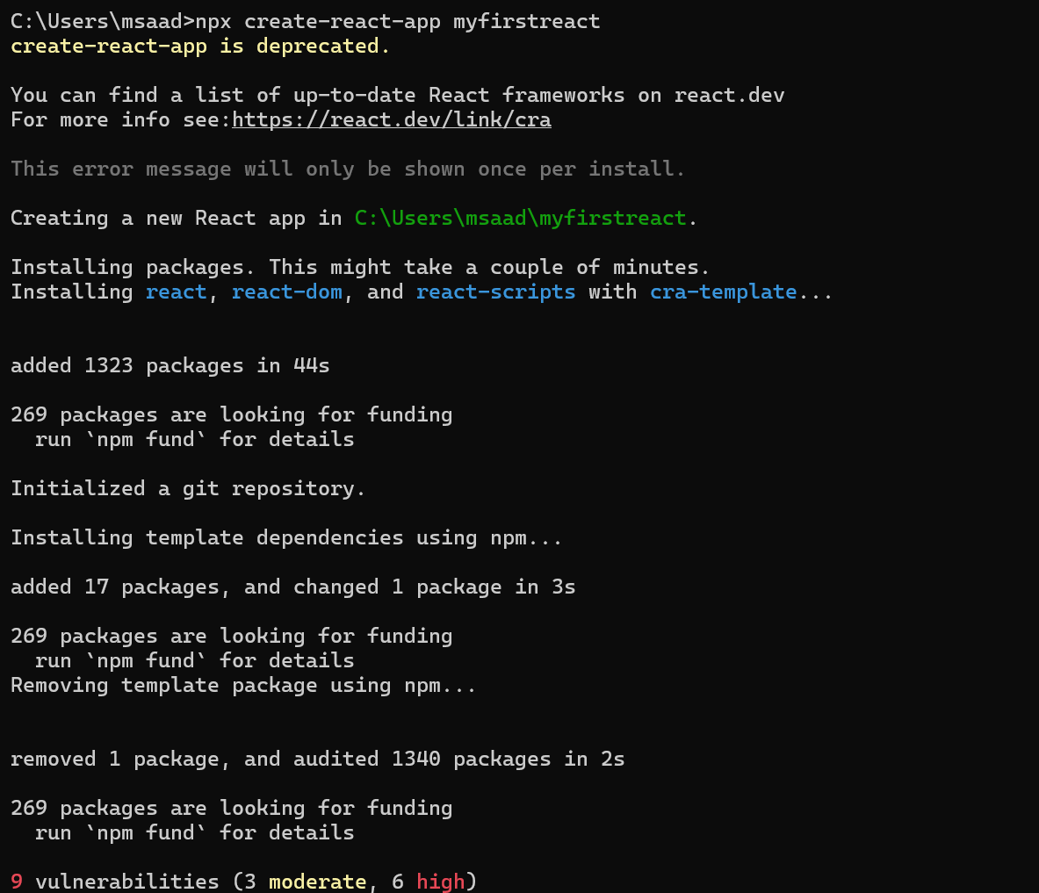

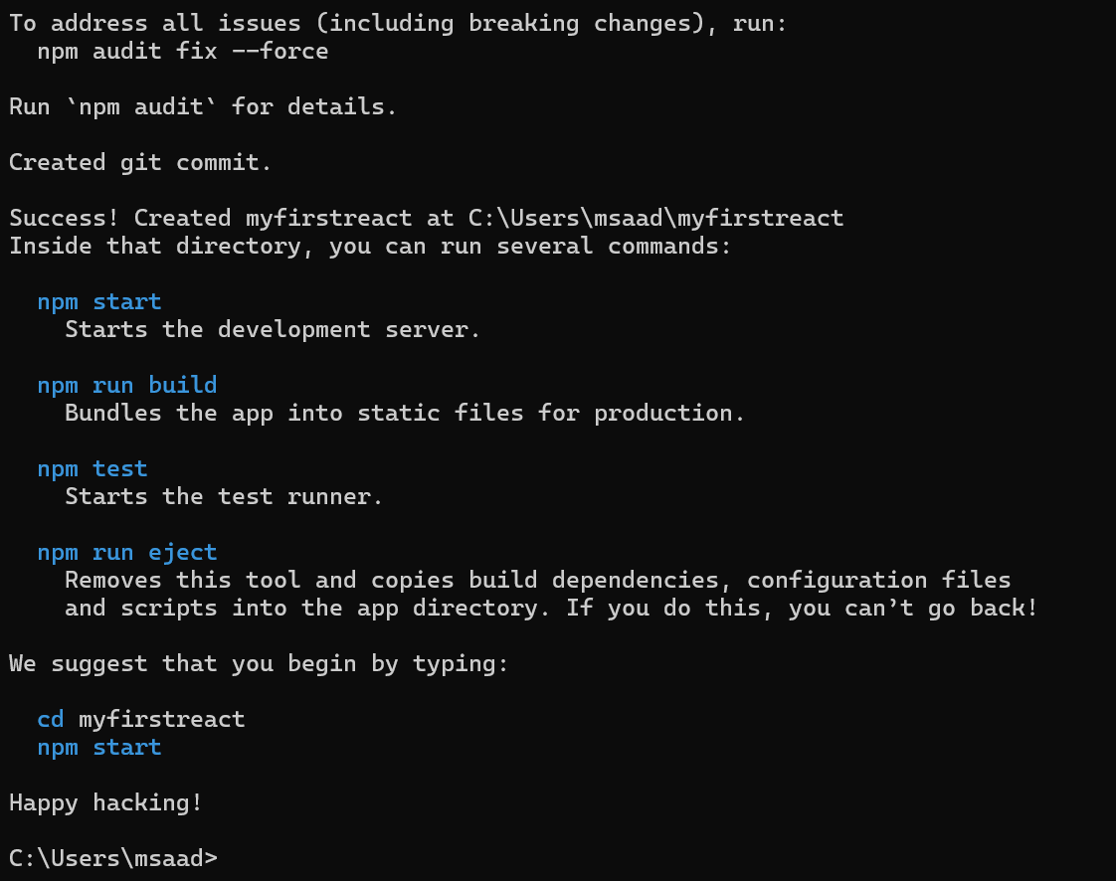

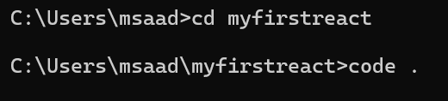

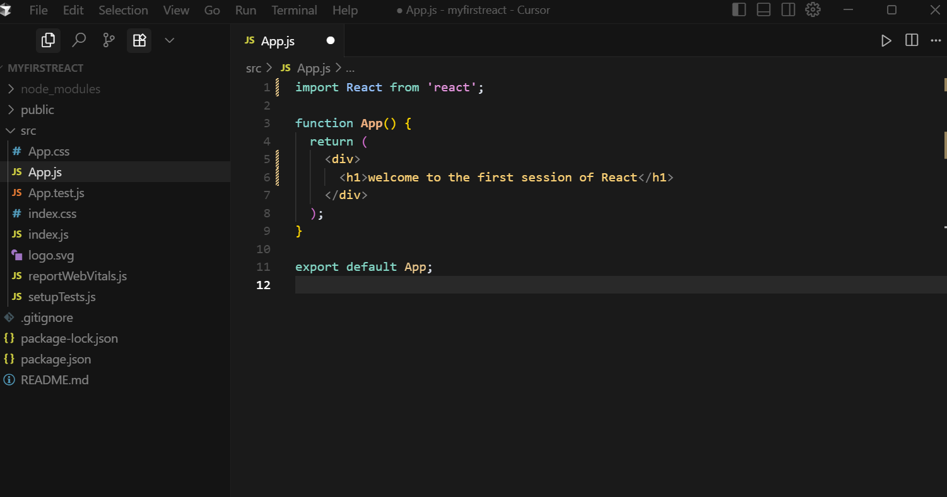

***Output :***

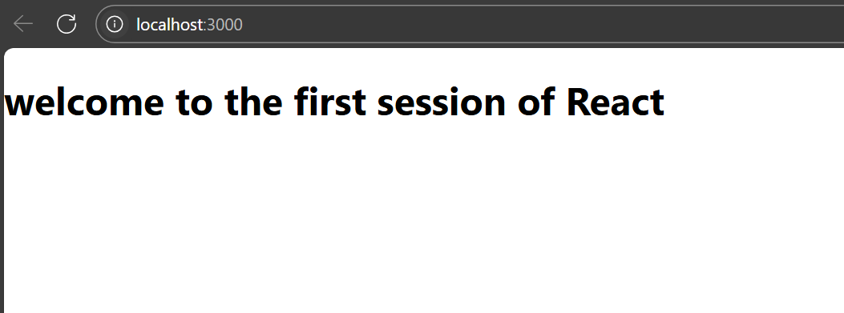

1. ***ReactJS-HOL***

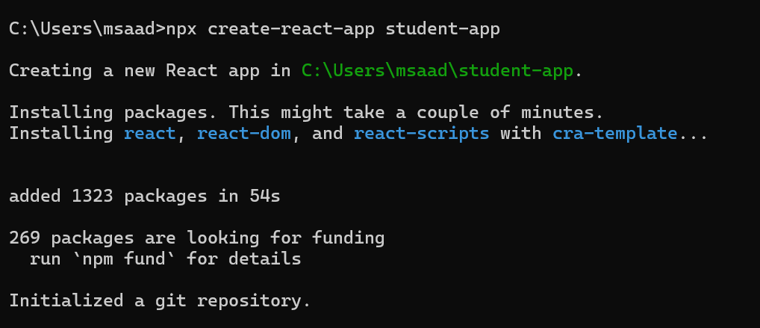

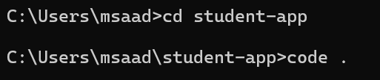

**Home.js**

import React from 'react';

class Home extends React.Component {

  render() {

    return (

      <div>

        <h2>Welcome to the Home page of Student Management Portal</h2>

      </div>

    );

  }

}

export default Home;

**About.js**

import React from 'react';

class About extends React.Component {

  render() {

    return (

      <div>

        <h2>Welcome to the About page of the Student Management Portal</h2>

      </div>

    );

  }

}

export default About;

**Contact.js**

import React from 'react';

class Contact extends React.Component {

  render() {

    return (

      <div>

        <h2>Welcome to the Contact page of the Student Management Portal</h2>

      </div>

    );

  }

}

export default Contact;

**App.js**

import React from 'react';

import Home from './Components/Home';

import About from './Components/About';

import Contact from './Components/Contact';

function **App**() {

  return (

    <div>

      <Home />

      <About />

      <Contact />

    </div>

  );

}

export default App;

***Output:***

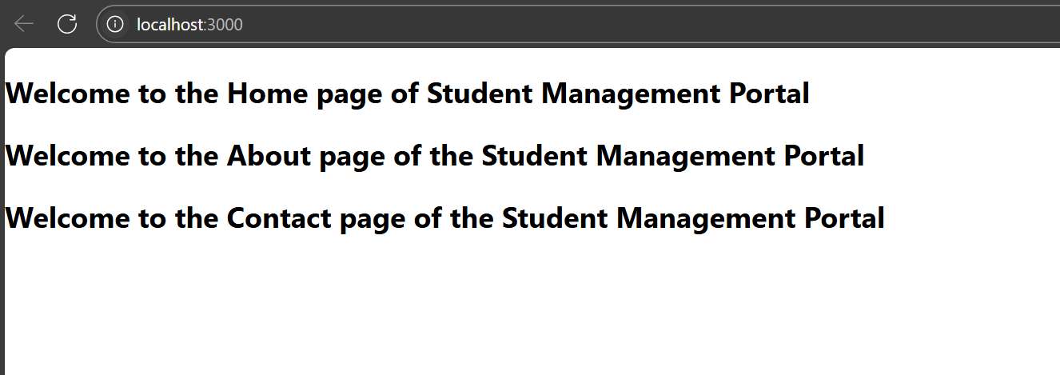

***3. ReactJS-HOL***

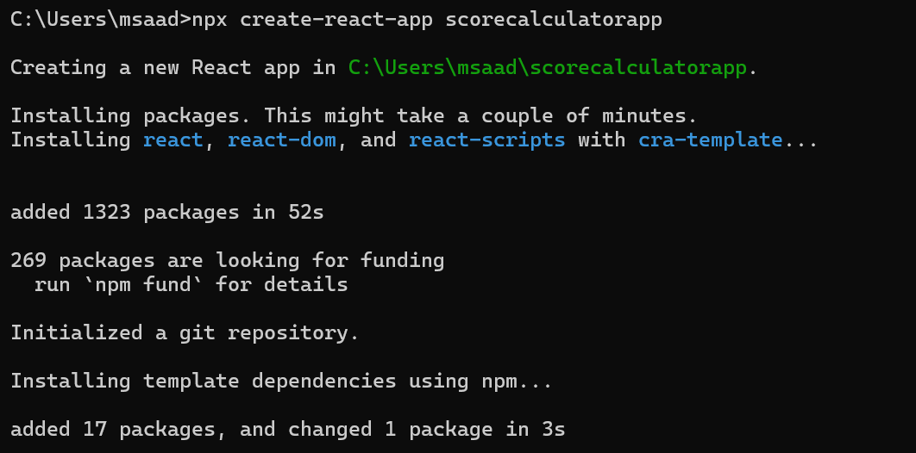

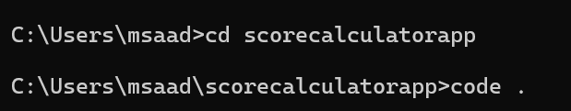

**CalculateScore.js**

import React from 'react';

import '../Stylesheets/mystyle.css';

function CalculateScore(props) {

  const average = props.total / props.goal;

  return (

    <div className="container">

      <h2>Student Score Calculator</h2>

      <p><strong>Name:</strong> {props.name}</p>

      <p><strong>School:</strong> {props.school}</p>

      <p><strong>Total Marks:</strong> {props.total}</p>

      <p><strong>Goal:</strong> {props.goal}</p>

      <p><strong>Average Score:</strong> {average}</p>

    </div>

  );

}

export default CalculateScore;

**mystyle.css**

.container {

    width: 50%;

    margin: 30px auto;

    padding: 20px;

    border: 2px solid #4CAF50;

    border-radius: 10px;

    background-color: #f9f9f9;

    font-family: Arial, sans-serif;

  }

  h2 {

    color: #4CAF50;

    text-align: center;

  }

  p {

    font-size: 16px;

  }

**App.js**

import React from 'react';

import CalculateScore from './Components/CalculateScore';

function **App**() {

  return (

    <div>

      <CalculateScore name="Mohammed Saad" school="ABC Public School" total={450} goal={5} />

    </div>

  );

}

export default App;

***Output:***

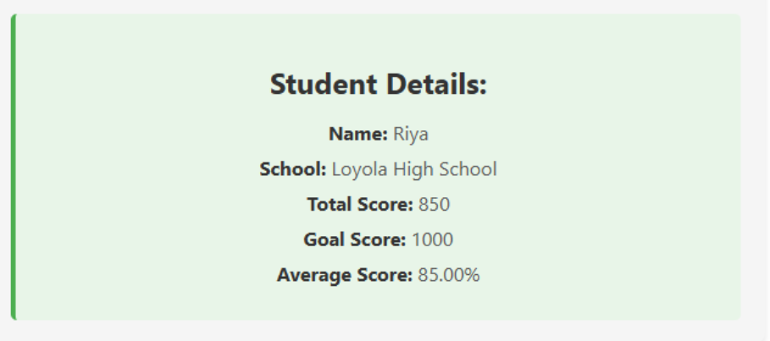

***4. ReactJS-HOL***

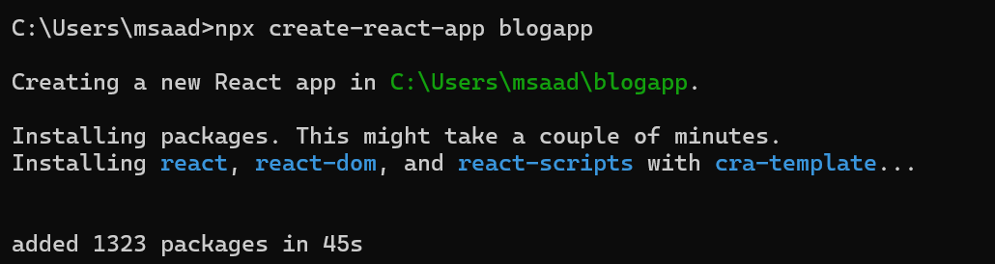

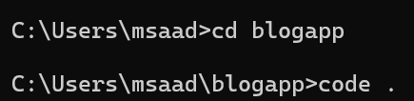

**Post.js**

class Post {

    constructor(userId, id, title, body) {

      this.userId = userId;

      this.id = id;

      this.title = title;

      this.body = body;

    }

  }

  export default Post;

**Posts.js**

import React, { Component } from 'react';

import Post from './Post';

class Posts extends Component {

  constructor(props) {

    super(props);

    this.state = {

      posts: [],

      hasError: false

    };

  }

  // Fetching posts from API

**loadPosts** = () => {

    fetch('https://jsonplaceholder.typicode.com/posts')

      .then((response) => response.json())

      .then((data) => {

        const loadedPosts = data.map(

          (item) => new Post(item.userId, item.id, item.title, item.body)

        );

        this.setState({ posts: loadedPosts });

      })

      .catch((error) => {

        this.setState({ hasError: true });

        console.error('Error fetching posts:', error);

      });

  };

  // Called after component mounts

**componentDidMount**() {

    this.loadPosts();

  }

  // Catch rendering errors

**componentDidCatch**(error, info) {

    alert('An error occurred while rendering posts.');

    console.error(error, info);

  }

**render**() {

    return (

      <div>

        <h2>Blog Posts</h2>

        {this.state.hasError ? (

          <p style={{ color: 'red' }}>Failed to load posts.</p>

        ) : (

          this.state.posts.map((post) => (

            <div key={post.id}>

              <h3>{post.title}</h3>

              <p>{post.body}</p>

            </div>

          ))

        )}

      </div>

    );

  }

}

export default Posts;

**App.js**

import React from 'react';

import Posts from './Posts';

function **App**() {

  return (

    <div className="App">

      <Posts />

    </div>

  );

}

export default App;

***Output:***

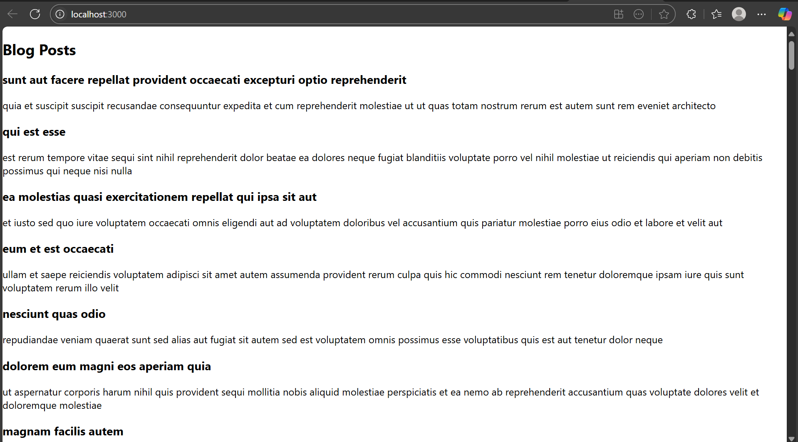

***5. ReactJS-HOL***

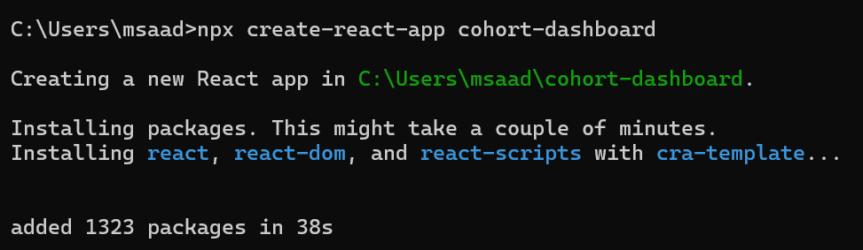

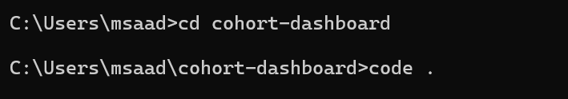

**Folder Structure:**

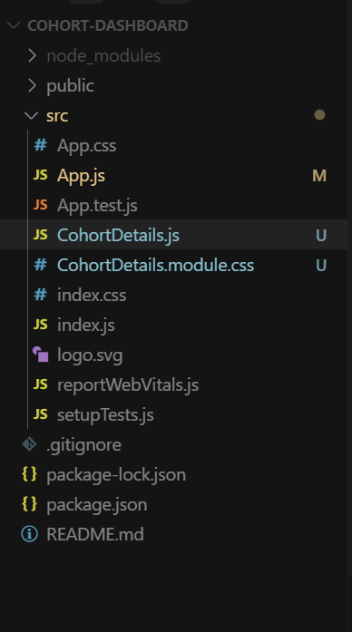

**CohortDetails.js**

import React from 'react';

import styles from './CohortDetails.module.css';

const CohortDetails = ({ name, trainer, status }) => {

  const statusStyle = {

    color: status.toLowerCase() === 'ongoing' ? 'green' : 'blue'

  };

  return (

    <div className={styles.box}>

      <h3 style={statusStyle}>{name}</h3>

      <dl>

        <dt>Trainer:</dt>

        <dd>{trainer}</dd>

        <dt>Status:</dt>

        <dd>{status}</dd>

      </dl>

    </div>

  );

};

export default CohortDetails;

**CohortDetails.module.css**

.box {

    width: 300px;

    display: inline-block;

    margin: 10px;

    padding: 10px 20px;

    border: 1px solid black;

    border-radius: 10px;

  }

  dt {

    font-weight: 500;

  }

**App.js**

import React from 'react';

import CohortDetails from './CohortDetails';

function App() {

  return (

    <div>

      <CohortDetails name="React Bootcamp" trainer="John Doe" status="ongoing" />

      <CohortDetails name="Java Spring Batch" trainer="Jane Smith" status="completed" />

    </div>

  );

}

export default App;

***Output:***

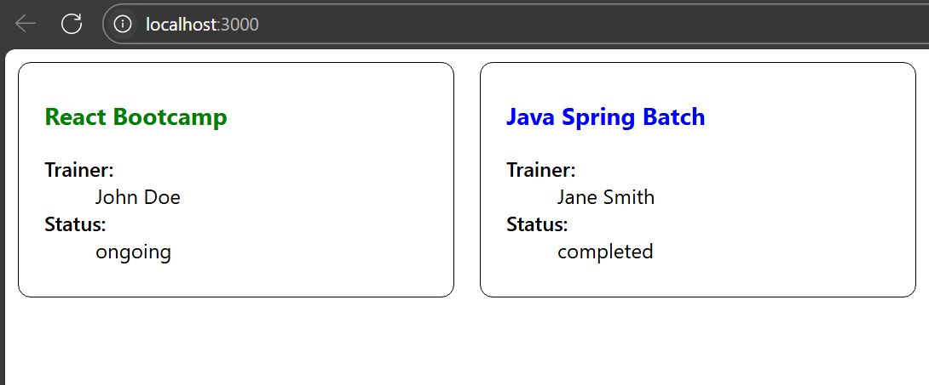

***9. ReactJS-HOL***

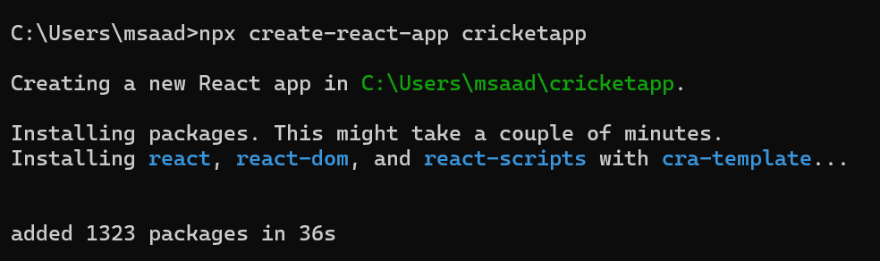

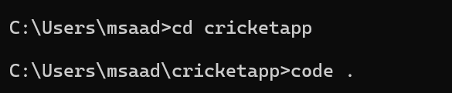

**ListofPlayers.js**

import React from 'react';

const ListofPlayers = () => {

  const players = [

    { name: "Virat Kohli", score: 100 },

    { name: "Rohit Sharma", score: 85 },

    { name: "Hardik Pandya", score: 40 },

    { name: "KL Rahul", score: 75 },

    { name: "Rishabh Pant", score: 60 },

    { name: "Shreyas Iyer", score: 90 },

    { name: "Shubman Gill", score: 50 },

    { name: "Suryakumar Yadav", score: 95 },

    { name: "Jasprit Bumrah", score: 35 },

    { name: "Mohammed Siraj", score: 70 },

    { name: "Ravindra Jadeja", score: 45 }

  ];

  const filteredPlayers = players.filter(player => player.score >= 70);

  return (

    <div>

      <h2>Players with Score ≥ 70</h2>

      <ul>

        {filteredPlayers.map((player, index) => (

          <li key={index}>{player.name} - {player.score}</li>

        ))}

      </ul>

    </div>

  );

};

export default ListofPlayers;

**IndianPlayers.js**

import React from 'react';

const IndianPlayers = () => {

  const team = ["Virat", "Rohit", "Hardik", "Pant", "Bumrah", "Iyer"];

  const [odd1, even1, odd2, even2, odd3, even3] = team;

const T20players = ["Kohli", "Surya", "Gill"];

  const RanjiTrophyPlayers = ["Sarfaraz", "Shaw", "Ishan"];

const allPlayers = [...T20players, ...RanjiTrophyPlayers];

  return (

    <div>

      <h2>Odd Team Players</h2>

      <ul>

        <li>{odd1}</li>

        <li>{odd2}</li>

        <li>{odd3}</li>

      </ul>

      <h2>Even Team Players</h2>

      <ul>

        <li>{even1}</li>

        <li>{even2}</li>

        <li>{even3}</li>

      </ul>

      <h2>All Players (Merged)</h2>

      <ul>

        {allPlayers.map((player, index) => (

          <li key={index}>{player}</li>

        ))}

      </ul>

    </div>

  );

};

export default IndianPlayers;

**App.js**

import React from 'react';

import ListofPlayers from './Components/ListofPlayers';

import IndianPlayers from './Components/IndianPlayers';

function App() {

  const flag = true; // Change to false to switch view

  return (

    <div className="App">

      {flag ? <ListofPlayers /> : <IndianPlayers />}

    </div>

  );

}

export default App;

***Output:***

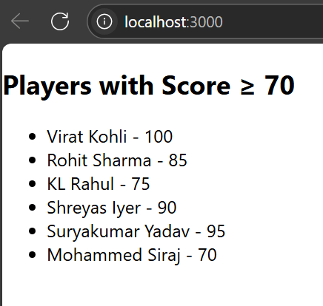

***10. ReactJS-HOL***

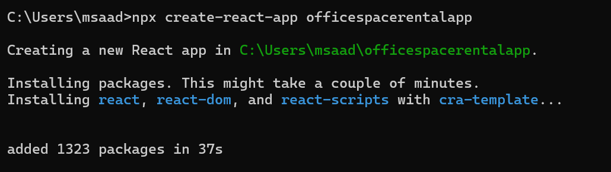

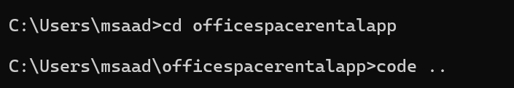

**App.js**

import React from 'react';

function App() {

  // Heading element using JSX

  const heading = <h1>Office Space Rentals</h1>;

  // Office image URL (you can use any placeholder)

  const imageUrl = "https://via.placeholder.com/300x150?text=Office+Space";

  // Single office object

  const office1 = {

    name: "Indiranagar Workspace",

    rent: 55000,

    address: "1st Floor, ABC Building, Indiranagar, Bangalore"

  };

  // Array of office objects

  const offices = [

    {

      name: "Koramangala Hub",

      rent: 45000,

      address: "2nd Floor, XYZ Towers, Koramangala, Bangalore"

    },

    {

      name: "Whitefield Corporate Park",

      rent: 75000,

      address: "Tech Park, Whitefield, Bangalore"

    },

    {

      name: "MG Road View Office",

      rent: 60000,

      address: "3rd Floor, MG Complex, Bangalore"

    }

  ];

  return (

    <div style={{ padding: "20px", fontFamily: "Arial" }}>

      {heading}

      {/* Image element using JSX attribute */}

      <img src={imageUrl} alt="Office Space" style={{ width: "300px", height: "150px", marginBottom: "20px" }} />

      {/* Display single office */}

      <h2>{office1.name}</h2>

      <p>

        <strong>Rent:</strong>{' '}

        <span style={{ color: office1.rent < 60000 ? "red" : "green" }}>

          ₹{office1.rent}

        </span>

      </p>

      <p><strong>Address:</strong> {office1.address}</p>

      <hr />

      {/* Loop through office list */}

      <h2>Available Office Spaces:</h2>

      {offices.map((office, index) => (

        <div key={index} style={{ border: "1px solid #ccc", padding: "10px", margin: "10px 0", borderRadius: "8px" }}>

          <h3>{office.name}</h3>

          <p>

            <strong>Rent:</strong>{' '}

            <span style={{ color: office.rent < 60000 ? "red" : "green" }}>

              ₹{office.rent}

            </span>

          </p>

          <p><strong>Address:</strong> {office.address}</p>

        </div>

      ))}

    </div>

  );

}

export default App;

***Output:***

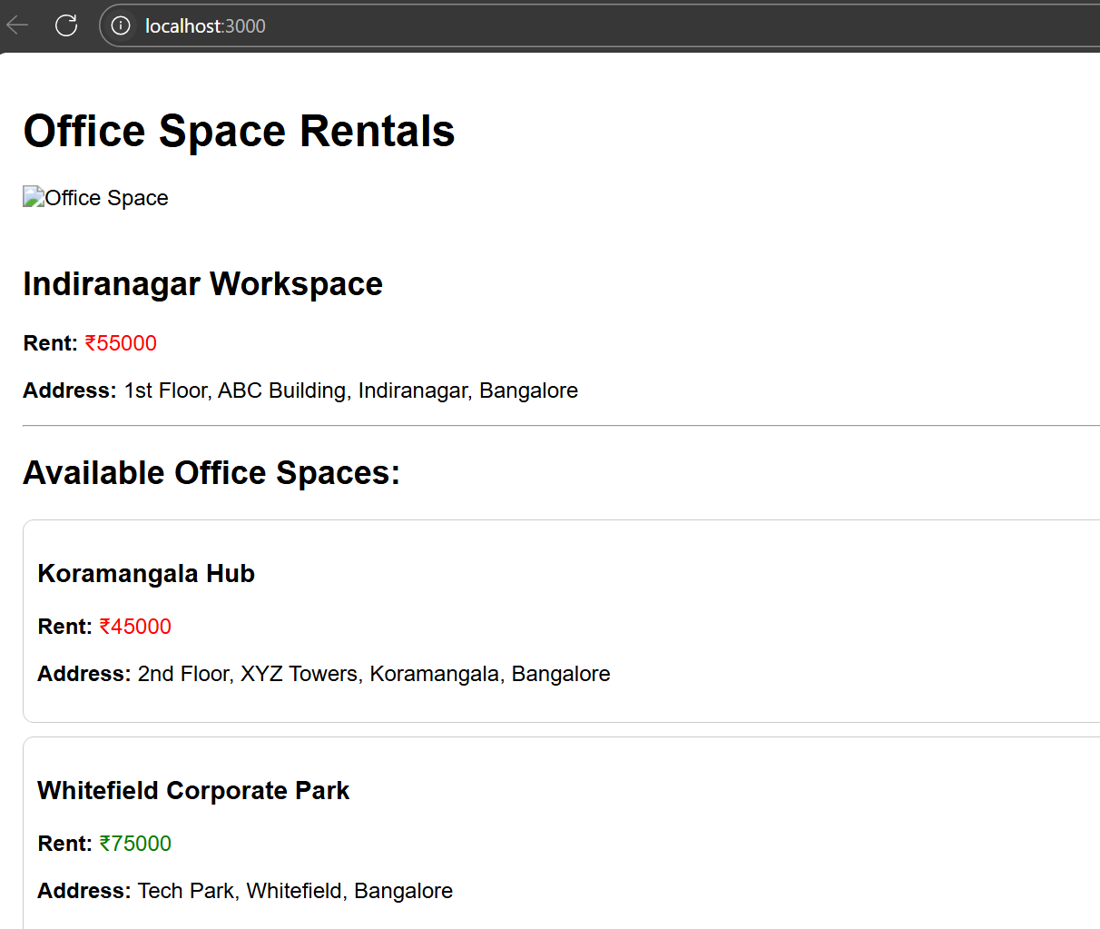

***11. ReactJS-HOLj***

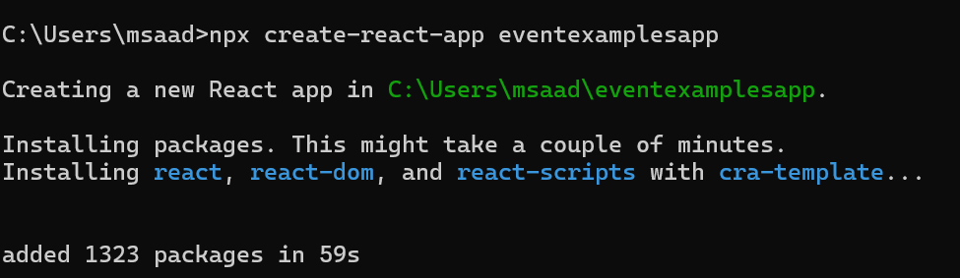

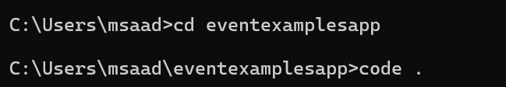

**CounterExample.js**

import React, { Component } from 'react';

class CounterExample extends Component {

  constructor(props) {

    super(props);

    this.state = {

      count: 0

    };

  }

  increment = () => {

    this.setState({ count: this.state.count + 1 });

    this.sayHello();

  };

  decrement = () => {

    this.setState({ count: this.state.count - 1 });

  };

  sayHello = () => {

    alert("Hello! You clicked Increment.");

  };

  sayWelcome = (msg) => {

    alert(`Welcome Message: ${msg}`);

  };

  handleSyntheticEvent = (e) => {

    e.preventDefault(); // Synthetic event usage

    alert("I was clicked (Synthetic Event)");

  };

  render() {

    return (

      <div>

        <h2>Counter: {this.state.count}</h2>

        <button onClick={this.increment}>Increment</button>

        <button onClick={this.decrement}>Decrement</button>

        <br /><br />

        <button onClick={() => this.sayWelcome("Welcome to the Event Example!")}>Say Welcome</button>

        <br /><br />

        <button onClick={this.handleSyntheticEvent}>Synthetic Click</button>

      </div>

    );

  }

}

export default CounterExample;

**CurrencyConverter.js**

import React, { Component } from 'react';

class CurrencyConvertor extends Component {

  constructor(props) {

    super(props);

    this.state = {

      rupees: '',

      euros: ''

    };

  }

  handleChange = (e) => {

    this.setState({ rupees: e.target.value });

  };

  handleSubmit = (e) => {

    e.preventDefault();

    const euroValue = (parseFloat(this.state.rupees) / 90).toFixed(2); // Approx 1 Euro = 90 INR

    this.setState({ euros: euroValue });

  };

  render() {

    return (

      <div>

        <h2>Currency Converter</h2>

        <form onSubmit={this.handleSubmit}>

          <label>Indian Rupees: </label>

          <input type="number" value={this.state.rupees} onChange={this.handleChange} />

          <button type="submit">Convert</button>

        </form>

        {this.state.euros && (

          <p>Equivalent in Euros: €{this.state.euros}</p>

        )}

      </div>

    );

  }

}

export default CurrencyConvertor;

**App.js**

import React from 'react';

import CounterExample from './Components/CounterExample';

import CurrencyConvertor from './Components/CurrencyConvertor';

function **App**() {

  return (

    <div className="App" style={{ padding: "20px" }}>

      <h1>React Event Examples</h1>

      <CounterExample />

      <hr />

      <CurrencyConvertor />

    </div>

  );

}

export default App;

***Output:***

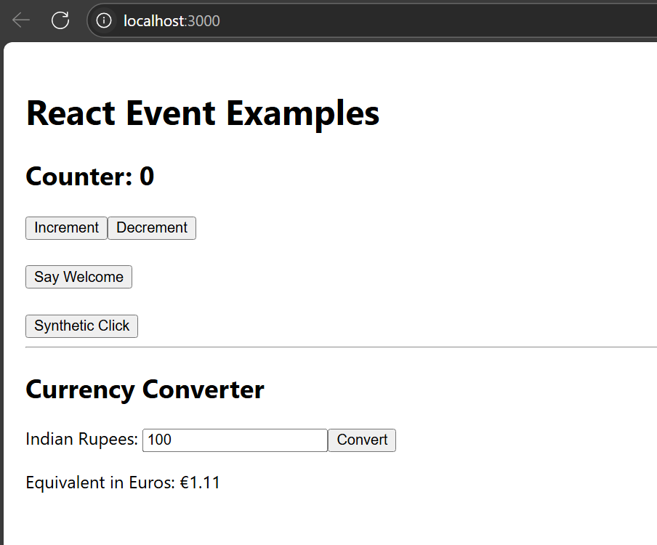

***12. ReactJS-HOL***

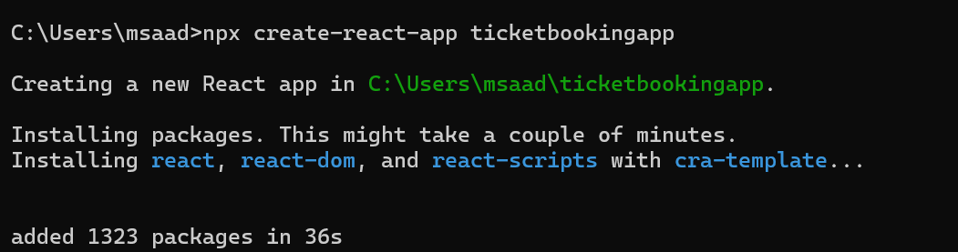

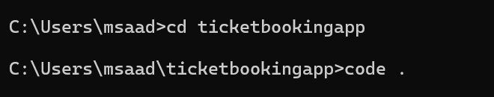

**Guestpage.js**

function GuestPage() {

    return <h2>Welcome Guest! Browse flights below.</h2>;

  }

  export default GuestPage;

**UserPage.js**

function **UserPage**() {

    return <h2>Welcome User! You can now book your tickets.</h2>;

  }

  export default UserPage;

**LoginButton.js**

function **LoginButton**({ onClick }) {

    return <button onClick={onClick}>Login</button>;

  }

  export default LoginButton;

**LogoutButton.js**

function LogoutButton({ onClick }) {

    return <button onClick={onClick}>Logout</button>;

  }

  export default LogoutButton;

**App.js**

import React, { useState } from 'react';

import GuestPage from './GuestPage';

import UserPage from './UserPage';

import LoginButton from './LoginButton';

import LogoutButton from './LogoutButton';

function App() {

  const [isLoggedIn, setIsLoggedIn] = useState(false);

  const handleLogin = () => setIsLoggedIn(true);

  const handleLogout = () => setIsLoggedIn(false);

  let content;

  let button;

  if (isLoggedIn) {

    content = <UserPage />;

    button = <LogoutButton onClick={handleLogout} />;

  } else {

    content = <GuestPage />;

    button = <LoginButton onClick={handleLogin} />;

  }

  return (

    <div>

      <h1>Flight Ticket Booking App</h1>

      {button}

      {content}

    </div>

  );

}

export default App;

***Output:***

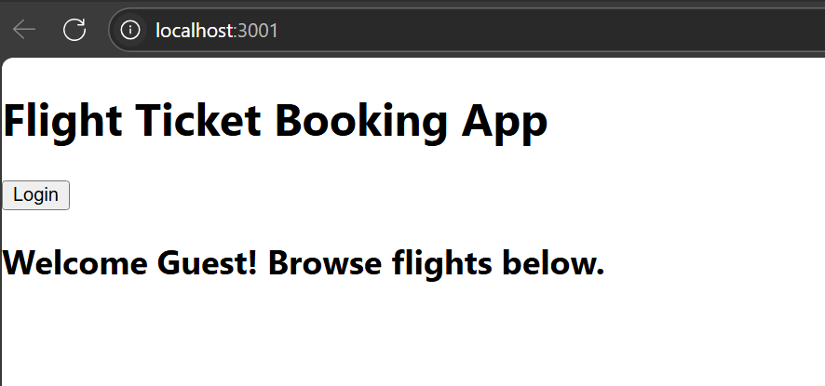

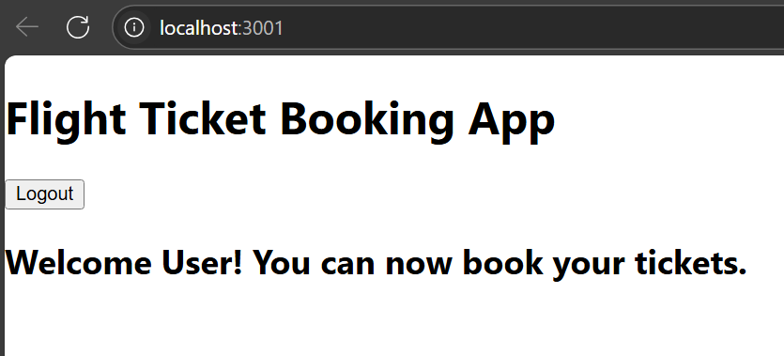

***13. ReactJS-HOL***

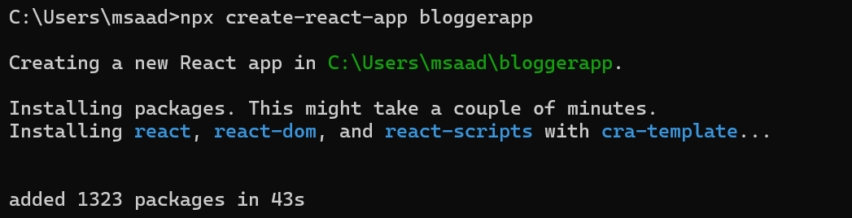

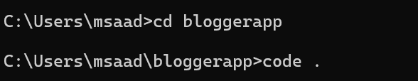

**BookDetails.js**

function BookDetails() {

    return (

      <div>

        <h2>Book Details</h2>

        <p><strong>Master React</strong></p>

        <p>670</p>

        <p><strong>Deep Dive into Angular 11</strong></p>

        <p>800</p>

        <p><strong>Mongo Essentials</strong></p>

        <p>450</p>

      </div>

    );

  }

  export default BookDetails;

**BlogDetails.js**

function **BlogDetails**() {

    return (

      <div>

        <h2>Blog Details</h2>

        <p><strong>React Learning</strong></p>

        <p><em>Stephen Biz</em></p>

        <p>Welcome to learning React!</p>

        <p><strong>Installation</strong></p>

        <p><em>Schwezdenier</em></p>

        <p>You can install React from npm.</p>

      </div>

    );

  }

  export default BlogDetails;

**CourseDetails.js**

function **CourseDetails**() {

    return (

      <div>

        <h2>Course Details</h2>

        <p><strong>Angular</strong></p>

        <p>4/5/2021</p>

        <p><strong>React</strong></p>

        <p>6/3/2020</p>

      </div>

    );

  }

  export default CourseDetails;

**App.js**

import React from 'react';

import BookDetails from './components/BookDetails';

import BlogDetails from './components/BlogDetails';

import CourseDetails from './components/CourseDetails';

function **App**() {

  return (

    <div style={{ padding: '20px' }}>

      <h1 style={{ textAlign: 'center' }}>Blogger App</h1>

      <div style={{ display: 'flex', justifyContent: 'space-around', marginTop: '40px' }}>

        <div style={{ borderRight: '3px solid green', paddingRight: '20px' }}>

          <CourseDetails />

        </div>

        <div style={{ borderRight: '3px solid green', paddingRight: '20px', paddingLeft: '20px' }}>

          <BookDetails />

        </div>

        <div style={{ paddingLeft: '20px' }}>

          <BlogDetails />

        </div>

      </div>

    </div>

  );

}

export default App;

***Output:***

